BESTLINK COLLEGE OF THE PHILIPPINES
College of Information Technology
#1044 Brgy Sta. Monica, Quirino Hi-way Novaliches, Quezon City

Payroll System
(Service Management System)

A project Study Presented to the
IT Project Evaluation Committee
Bestlink College of the Philippines
Quezon City, Philippines

In Partial Fulfillment of the Requirements for the Degree
Bachelor of Science in Information Technology

By:
Ricardo, Myriz Janine C.
Gierza, April D.
Dalanon, Maria. Richel M.
Pimienta, Jovelyn C.
Mendoza, Michael Angelo v.
BSIT-4106

October 7,2014

Chapter 1
- Project Charter……………………………………………………………………………………………………………………1
1.1 Problem/Opportunity Description
  - Benefits……………………………………………………………………………………………………………………2
  - Goals
  - Stake Holders and Clients…………………………………………………………………………………………3
- Project Scope……………………………………………………………………………………………………………………….4-5
  - Objectives (WBS)……………………………………………………………………………………………………..6
2.1.1 Show on how to get the record of the employee from Recruitment……………………..7
2.1.2 The figure show the computation of salary…………………………………………………………...8
2.2 Deliverables…………………………………………………………………………………………………………………………9
2.2.1 Getting the list of the the employee in the recruitment
2.2.2 Compute employee salary
2.3 Out of scope…………………………………………………………………………………………………………………………10
3.0 Project Plan…………………………………………………………………………………………………………………………11
3.1 Approach and Methodology
3.1.1 System Planning
3.1.2 System Analysis……………………………………………………………………………………………………12
3.1.3 System Design and Coding
3.1.4 System Testing and Implementation
3.1.5 System Maintenance
3.2 Project Timeline………………………………………………………………………………………………………………….13-16
3.3 Success Criteria……………………………………………………………………………………………………………………..17
3.4 Issue and Policy implication
3.5 Risk Management Plan
3.6 Service Transition…………………………………………………………………………………………………………………18
3.7 Option Analysis
4.0 Technical Features
5.0 Project Organization and Staffing…………………………………………………………………………………………19-20
6.0 Project Budget………………………………………………………………………………………………………………………21
Chapter 2
- Review of Related Local and Foreign Studies……………………………………………………………………………22
  - Local Studies
    - Cagayan De Oro City Hall Computerized Payroll System
    - Makati Lone gov’t in Metro Using Archaic Payroll System……………………23-25
    - Phil Ecology Systems Corporation Signs SSI Agreement………………………26
With Coco Life
    - HR Specialist-Payroll………………………………………………………………………….27
    - Computerized Payroll System of DOH………………………………………………….28
  - Foreign Studies………………………………………………………………………………………………………29
    - Titus Information Payroll System
    - Canadian Payroll System……………………………………………………………………….30
    - Effects of Information and Communication Technologies on…………………..31
Service Industries in the Asia Pacific Region
    - Case Study: Can the U.S Army Pay Soldiers Correctly……………………………….32
    - Case Study Personnel and Payroll Records and Information
Systems in Tanzania ……………………………………………………………………………..33-34
Synthesis and Analysis…………………………………………………………………………35-37
Local, Foreign

Chapter 3
Risks Mitigation, Monitoring, and Management Plan………………………………………………………………..38
- Introduction
  - Scope and Intent of RMMM Activities
  - Risks Management Organizational Role…………………………………………………..39-40
- Risk Description
2.1. Risk Table
2.1.1 Description of Risk m
2.1.2 Probability and Impact for Risk Management……………………………………………..41
3.0 Risk Mitigation Monitoring and Management…………………………………………………………..42-43
3.1 Risk Mitigation for Risk m
3.1.1 Business Impact
3.1.2 Customer (User) Risks
3.1.3 Process Risks
3.1.4 Technology Risks
3.1.5 Development Risks
3.1.6 Employee Risks
3.2 Risks Monitoring for Risks m…………………………………………………………………………………..44
3.2.1 Business Impact
3.2.2 Customer (User) Risks
3.2.3 Process Risks
3.2.4 Technology Risks
3.2.5 Development Risks
3.2.6 Employee Risks (Teammates)
3.3 Risks Management for Risks n…………………………………………………………………………………45
3.3.1 Business Impact
3.3.2 Customer (User) Risks
3.3.3 Process Risks
3.3.4 Technology Risks
3.3.5 Development Risks
3.3.6 Employee Risks (Teammates)
4.0 Special Conditions………………………………………………………………………………………………..46-47

Software Configuration Management Plan
- Introduction…………………………………………………………………………………………………………48
1.1 Scope and Intent SCM Activities…………………………………………………………………49
1.2 SCM Organizational Role
2.0 SCM Tasks
2.1 Identification…………………………………………………………………………………………….............50
2.1.1 Description………………………………………………………………………………………………51
2.1.2 Work Products and Documentation………………………………………………………….52
2.2 Configuration Control
2.2.1 Description
2.3 Version Control……………………………………………………………………………………………………….53
2.3.1 Description……………………………………………………………………………………………….54
2.3.2 Increasing Version Number
2.3.3 Work Products and Documentation
2.4 Configuration Status and Documentation (CSA)
2.4.1 Description
2.4.2 Work Products and Documentation (CSA)…………………………………………………..55
3.0 Software Quality Assurance Overview
3.1 Generic Review Guidelines……………………………………………………………………………………..56
3.1.1 Conduction a Review…………………………………………………………………………………57
3.1.2 Roles and Responsibilities
3.1.3 Review Work Product……………………………………………………………………………….58
3.2 Formal Technical Reviews
Software Quality Assurance Plan
- Introduction……………………………………………………………………………………………………………………….59
1.1 Scope and Intent of SQA Activities
1.2 SQA Organizational Role……………………………………………………………………………………………60-61
2.0 Software Quality Assurance Tasks…………………………………………………………………………………………62
2.1 Tasks Overview
2.2 Standard, Practices and Conventions
2.3 Software Quality Assurance Resources
3.0 Reviews and Audits…………………………………………………………………………………………………………….63
3.1 Generic Review Guidelines…………………………………………………………………………………………………64
3.1.1 Conducting a Review
3.1.2 Roles and Responsibilities…………………………………………………………………………………….64-65
3.1.3 Review Work Product…………………………………………………………………………………………..67
3.2 Formal Technical Reviews
3.2.1 Software Quality Assurance Audits
4.0 Problem Reporting and Corrective Action/Follow-Up
4.1 Reporting Mechanism
4.2 Responsibilities…………………………………………………………………………………………………………………68
4.3 Data Collection and Valuation…………………………………………………………………………………………..69
4.4 Statistical SQA
5.0 Software Process Improvement Activities………………………………………………………………………..70
5.1 Goal and Object of SPI
Software Requirements Specification
1.0Introduction……………………………………………………………………………………………………………………71
1.1 Goals and Objectives……………………………………………………………………………………………...........72
1.2 Statement of the Scope
1.2.1 General Requirements
1.2.1 Extended Enhancement
1.3 System Context……………………………………………………………………………………………………………..73
1.4 Major Constraints………………………………………………………………………………………………………….74
2.0 Usage Scenario
2.1 User Profiles……………………………………………………………………………………………………………75-79
2.2 Use-Cases
3.0 Data Model and Description
3.1 Data Description…………………………………………………………………………………………………………80-81
3.1.1 Data Objects and Dictionary
3.1.2 Relationships…………………………………………………………………………………………………82-87
4.1 Subsystem Flow Diagrams……………………………………………………………………………………………….92
4.2 Human Interface…………………………………………………………………………………………………………….92
5.0 Restriction, Limitation and Constraints…………………………………………………………………………….92
6.0 Validation Criteria…………………………………………………………………………………………………………..93
Software Design Specification
- Introduction
1.1 Goals and Objectives
1.2 System Statement of Scope………………………………………………………………………………………………94
1.2.1 General Requirements
1.3 System Context……………………………………………………………………………………………………………….95
1.4 Major Constraints
2.0 Data Design……………………………………………………………………………………………………………………..96
2.1 Database Description
3.0 Architectural and Component –Level Design……………………………………………………………………97-98
3.1 Program Structure
3.1.1 Overall
3.1.2 Log in……………………………………………………………………………………………………………….99
3.1.3 Main
3.1.4 Exit
3.2 Description for Components……………………………………………………………………………………………100-101
3.2.1 Log in Form
3.2.2 Employee Record
4.0 User Interface Design…………………………………………………………………………………………………102-107
4.1 Description of the User Interface

4.1.1 Screen Images
4.2 Interface Design Rules……………………………………………………………………………………………………108-109
4.3 Components Available
4.3.2 ActiveX Controls
5.0 Restriction, Limitations, and Constraints……………………………………………………………………………110
6.0 testing and Issues……………………………………………………………………………………………………………111-113
6.1 Classes of Test
Test Specification
- Introduction……………………………………………………………………………………………………………………114
1.1 Goals and Objectives
1.2 Statement of Scope
1.3 Major Constraints………………………………………………………………………………………………………………115
2.0 Testing Plan
2.1 Software
2.1.1 Interface
2.2 Testing Strategy…………………………………………………………………………………………………………………116
2.2.1 Unit Testing
2.2.2 Integration Testing………………………………………………………………………………………………117
2.2.3 Validation Testing
2.2.4 High-Order Testing………………………………………………………………………………………………118
2.3 Testing Resources and Staffing……………………………………………………………………………………………119
2.4 Test Record Keeping
2.5 Testing Tools and Environment
2.6 Test Schedule
3.0 Test Procedure…………………………………………………………………………………………………………………..120
3.1 Software (SCIS) To Be Tested
3.2 Testing Procedure
3.2.1 Unit Testing
3.2.2 Integration Testing……………………………………………………………………………………………..121
3.2.3 Validation Testing……………………………………………………………………………………………….122
3.2.4 High-Order Testing
3.3 Testing Resources and Staffing…………………………………………………………………………………………123-124
3.4 Test Record Keeping and Log

Chapter 1
Project Charter
- Project Background
In this new generation, the technology must be upgraded. When it comes to the business world, they are also facing the rapid change of technology. They are more competitive in a business. Most of them are using some of high technology. As part of the business, Payroll is one of the important bodies in the company. A systematized payroll system will help manage the wage of the employee. It could lessen the time of the bookkeepers to compute the salary of each employee in the company. Having a Computerized Payroll System will improve the business process and it can also avoid some minor problems that the company encountered. This is to provide an accurate computation of salary of the employee and to ensure that employee will receive the right amount. Payroll is essentially how employees are paid. It’s the legal paper that is involved. There’s more to payroll than just handing out cash or cheque. However, after gathering data on what the employee as they compared it to their salaries, some simple pay day mathematics were given to let the employee hand out the dough.
1.1 Problem/Opportunity Description
- The problems on Reports and the Problem Statement of the Existing system to monitor attendance do not exist.
- Computation of payroll, day, time, and night shift working employees of the agency.
- Time consuming in double checking the consistency of all the reports.
- Prone to mathematical errors that could consume much time than it should and could cause financial or legal trouble.
- Prone to human error.
- Inaccurate tax report generation.
- Inaccurate computation of salary due to calculator malfunction.

1.2 Benefits
- The system allows each of the employee to enter his or her time information via corporate internet using a standard web browser.
- All employees accommodating as well as ensuring that our system can accommodate newly created categories of employee in the future.
- Speed in processing payroll will have a faster performance by means of decreasing the manual input areas.
- Mathematical errors will be prevented by automatic computations that the proposed system will provide and you may not have to worry about having financial or legal trouble.
- Less Manpower needs
- Less Human Error

  - Goals
The goal of this project is to develop this payroll system that can solve this entire problem encountered by the company for their payroll system. These are the following:
- To create an organized payroll system that can provide a cost-effective by performing calculations efficiently and not taking more of the bookkeeper's time than necessary.
- Establishing Employee files - As appointments are confirmed, the Human Resources Assistant in either the Human Resources Department will enter the employee’s information into profiling and
Forward a copy of the employee’s status forms to the Payroll Administrator.
- To provide an accurate payroll system that can give a better computation.

1.4 Stakeholders and Clients

Accountant
The one who’s in charge in using the system. He/she must be well trained.

Assistant Accountant
This person is in charge to use the system if the accountant is absent. But there are some forms that only the accountant can view.

The Human Resources
They can also use the system because the payroll system should need keeping in close contact with the human resource, simply because of the volume and complexity of the work.
The Proponents School / Institution
This project study is the proof of better and outstanding education provided by the current school of the proponents which is the Bestlink College of the Philippines. It is a good evidence and result of good teaching-learning activities providing the best workflow that has to be produced by the current school of the proponents.

2.0 Project scope
- Get the list of employees from the Recruitment
The system needs to access the list of employee record from the recruitment system to view the information of the employee. It needs to be obtained because it is one of the essential information and includes it in our main transaction.

- Get the number of working days from Monitoring
Payroll systems need get the summary of employee’s time record from monitoring personnel since they are monitoring the employee’s attendance information. The payroll system needs that time record in order to compute the employee’s salary.

- Add employee wage
The payroll system needs to add employee’s daily rate.

- Compute salary deduction such as SSS, Pagibig, Philheath, Tax
In terms of salary deduction like SSS, Pag-ibig, Philheath and tax, they are deducted to each employee according to their different range of their income or compensation. There is an official table that needs to follow upon deduction. Different ranges of income has different amount of contribution and withholding tax.

- Compute employee salary
Employee’s salary is computed according to the number of days they have work. It could increase by overtime, night differential, holiday, allowance bonus. There are also corresponding amounts to be deducted such as SSS, Pag-ibig, Philheath, withholding tax, late and under time. If the person applies for loan it is also added to his salary deductions.

- Generate and print reports
The payroll system can generate reports such as:
- Semi Monthly and monthly payroll reports
- Statutory reports such as SSS, Pag-ibig, Philhealth and withholding tax.
- Allowance report
- Bonus and 13 Moth pay report
- Incentive leave reports
- Loan payment reports

- Generate and print pay slips
The payroll system can generate and print employee’s pay slips to be distributed to the employees. In pay slips, it states the summary of employee’s compensation such as gross pay, total deduction, and net pay.

- Cut-Off
When hiring a new employee, renewing a contract/appointment, or making a change to a contract/appointment the following submission deadlines apply. If the renewal is not processed and completed in HR PeopleSoft before the expiry date of the appointment, the termination process will be initiated. The cut-off will be 15th of the month and 30th day.

2.1 Objectives (WBS)
This section shows the primary objectives of the payroll management system. The illustration below will help to determine the scope and the boundaries.

Service Management System (Payroll System)

Get the list of Employee from the Recruitment

Compute
Payroll Administrator
HR Recruitment
HR

Basic Salary
Cut Off
Salary Deductions
Saving Record of the Employee

Employee Information

2.1.1 This Figure show on how to get the record of the employee from the recruitment.

Service Management System (Payroll Management System)
Compute Employee Salary

Daily Time Record (DTR)

Retentions
Salary Deduction

-Name
-Employee no.
-Department
-Designation

13th month pay
Bonuses
Incentives
Leaves

Basic Salary
Basic Pay
Holiday (Special/Legal )

-In
-Out
-Break
-Resume
-Overtime (OT)

Benefits:
SSS,PAGIBIG
GSIS,PhilHealth
Tax,
Allowance

2.1.2 This Figure shows the computation of salary.

Initialization Process
System Testing
EEva
System Design
System Planning
System Analysis
Payroll System

Describe test specifications
Describe system specification
Developing a project
Orientation about the Ps1
Collect gathered data from interview & research
Make a testing plan
Determine the functional requirements
Deliverable submit project charter
Pec orientation
With 4th year students
Testing procedure
Determine the problems
Functional data description
State the project scope & objectives
Submit revised project charter
Selection of sub systems per section
Unit testing
Determine the system process and modules
Integration testing
System architecture model
Create the WBS
Selection of team members with role
Validation testing
Data description

Finalize project charter
Draft the WBS
Group meeting
High-order testing
Human interface description
Submit revised WBS
Preparation for project defense
Reviews of related studies and system
Conduct Background of the System
Describe software requirements specification
Research 5 foreign & 5 local related studies
Company interview
Internet Research/ Library research
Project defense
Determine usage scenario
Letter for interview
Construct matrix of related studies
Create interview Questionnaire
Construct Project Proposal
User profiles
Evaluation
Deliverable submit project proposal
Use cases
Document & software revisions
Draft of chap3 E&B project management and development

Look for client & security agencies
Data model & functional model
Schedule interview
Submit revised project proposal
Checking of revise documents with adviser
Identity restrictions & limitations
Develop RMM, SQA & SCM plan
Conduct interview
Construct Project Proposal
Start software prototype
Describe software design specification
Schedule the weekly checking of document with adviser
Submit adviser content

Data design
Weekly consultation
List down the result and make revisions
Schedule weekly consultation with adviser
Architectural and componenet level design
Document the result of consultation

Make necessary changes in project documentation

Document the revision

2.2 Deliverables
2.2.1 Getting the list of the employee in the recruitment

Project Deliverables | Work Products / Description
Hr Recruitment | This is the part where the payroll administrator will get the employee’s basic information.
Payroll Administrator | This is the part where the employee’s basic information will be saved.
Compute | This is the part where all the deduction and all the total wage will be computed.

2.2.2 Compute Employee Salary

Project Deliverables | Work Products / Description
Daily Time Record(DTR) | This part includes the ff:  -Employee no.  -Department  -Designation  -In  -Out  -Break  -Resume  -Overtime (OT)
Salary Deduction | This part is also includes:  -Basic Salary  -Basic Pay  -Holiday (Special/Legal )  -Benefits:  -SSS,PAGIBIG  -GSIS,PhilHealth  -Tax,  -Allowance
Retention | This Part includes the following:  -13th month pay  -Bonuses  -Incentives  -Leaves

2.3 Out of scope

- Payroll disbursement services
- Movement of all payments, calculated during the pay processing cycle net salary, tax, and social security.
- Specified data reports for the Client's accounting.
- Billing and accounts receivable is not included.
- Actual payments of the employee/ allocation pay.
- Daily time record (DTR) extracted file from the hr.

3. 0 Project Plan
3.1 Approach and Methodology
The proponents decided to use some methodologies that will help to understand more the process of payroll. One of basic methodologies that is used in developing software is the System Development Life Cycle (SDLC).We also use some diagram like the use case diagram and the architectural model Relationship diagram Entity(ERD)

3.1.1 System Planning
In this phase, the proponents define the solution for the encountered problem of the existing system. The Planning Phase begins when the project has been formally approved and funded, and the Project Charter is approved. This Phase requires study and analysis culminating in the full Project Management Plan and that may lead to system development activities.
Acquisition activities are performed, if necessary, to obtain contractor support. The project work is broken down into specific tasks and sub-tasks, including the identification of project deliverables and assignment of allocated resources to each task. Control documents relating to that effort are produced. The degree of project management rigor that is to be applied to the project is determined and milestones are established. Specific plans for management and governance of the project are established and documented to guide ongoing project execution and control. The Planning Phase ends with a formal review during which the adequacy of the Project Management Plan is determined.
In the planning phase, sufficient requirements detail is required to support the development of the project's Project Management Plan and permit outside validation of this deliverable.
3.1.2 System Analysis
In this phase, after the system planning, it will include all the data gathered. The proponents analyzed the process and determine all the scope and main goal of software development.
3.1.3 System Design and Coding
Is the process of defining the architecture, components, modules, interfaces, and data for a system to satisfy specified requirements.
3.1.4 System Testing and Implementation
System Testing System testing is simply testing the system as a whole; it gets all the integrated modules of the various components from the integration testing phase and combines all the different parts into a system which is then tested. Testing is then done on the system as all the parts are now integrated into one system the testing phase will now have to be done on the system to check and remove any errors or bugs. In the system testing process the system will be checked not only for errors but also to see if the system does what was intended, the system functionality and if it is what the end user expected. There are various tests that need to be conducted
3.1.5 System Maintenance
The fifth (and final) phase of the systems development life cycle, in which an information system is systematically repaired and/or improved.

3.2 Project timeline

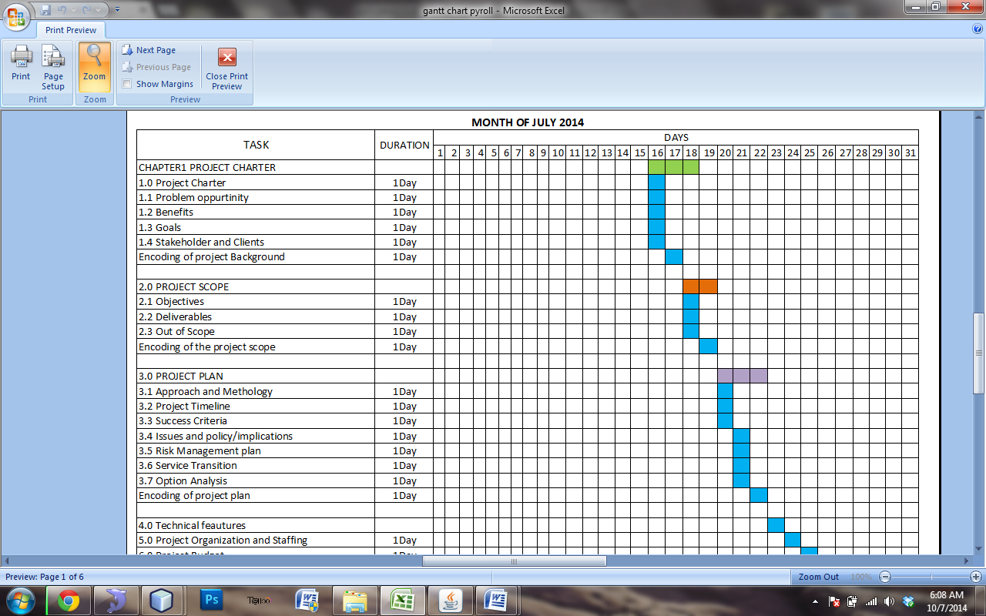

3.3 Success criteria
- Comprehensive payroll system.
- Accuracy of the developed system.
- Efficiency of the system.
- Enough data storage.
- User Friendly.
- Positive feedback of the clients.
3.4 Issue and Policy implication
- General Ledger of the company.
- Billing
- Contract Management between the employee and client.
- Accounts/Payable of the client.

3.5 Risk Management Plan

Risk Factor | Probability  (H-M-L) | Impact  (H-M-L) | Risk Management  Action
Financial Problem | H | H | Savings
Devices and  Software | M | M | Provide quality  Software
Conflict on time | M | M | Time management
Member | M | M | Respect the decision of each other

3.6 Service Transition
- The company must invest new desktop computers.
- At least one (1) Printer for each department
- One computer administrator per department
- Higher Specification of hardware for each computer unit
3.7 Options Analysis
A consultation(s) is an informal discussion with our subject matter experts, where we can assist in framing a proposal or solution design, discuss opportunities and options with regard to new technologies or discuss corners, risk and issues with existing technologies. The client or the company owner will test the proposed system. If there some problems encountered during the system implementation, the developer should have to take the responsibilities. If the propose system met the requirements or the need of the company, then, it will be implemented. But the decision is always on the Owner or the Company.

4.0 Technical Features

Payroll - report or summary of pay slip.

DTR (Daily Time Record) – This is the sequential record of time-in and time-out of an employee within the allotted time span. This is where the salary has to be paid.

Database is an organized collection of data. The data are typically organized to model aspects of reality in a way that supports processes requiring this information. For example, modelling the availability of rooms in hotels in a way that supports finding a hotel with vacancies.

Systems design Systems design is the process of defining the architecture, components, modules, interfaces and data for a system to satisfy specified requirements. Systems design could be seen as the application of systems theory to product development. There is some overlap with the disciplines of systems analysis, systems architecture and systems engineering.

Implementation is the carrying out, execution, or practice of a plan, a method, or any design for doing something. Implementation is the action that must follow any preliminary thinking in order for something to actually happen.

SDLC (System Development Life Cycle)
Is essentially a series of steps, or phases, that provide a model for the development and lifecycle management of an application or piece of software?

5.0 Project Organization and Staffing

Role | Name/contact Information | Responsibilities time
Project manager | Ricardo,Myris Janine C.  09466249200 | -Managing Risk  -Organizing People  -Oversee Project  -Allocate Task  -Control Scope  -Cost Budgeting  -Time Management  Communicate
Business Analyst | Gierza, April D.  09107115683 | -Data Modeling  Structured analysis  -Responsible  for designing  -Developing  -Configuring  -Supporting
System Analyst | Pimienta,Jovelyn C.  09102097707 | -Customer relationship building  -Analytical Ability  -Deductive reasoning  -Accurate reporting  -Analyzing Requirements
Documentation  Specialist | Dalanon,Maria Richel M.  0921390665 | -Create documents  -Release the  documentation  -Drafting  -Supervise production  -Revise and re-write documents
Lead Programmer | Mendoza,Michael Angelo V.  09466575061 | -Produce codes  -System Analyst  -Develop program  -Correct errors

6.0 Project Budget
Budget item | Description | Budgeted cost
Fare | During Interview execution (3 not consecutive days) | 200.00
Food | Lunch  Dinner | 200.00  200.00
Photocopy | Photocopies used as reference | 60.00
Module of Project Study 1 & 2 | A book that will serve as guidance for project execution for the whole year | 300.00
Project Study Fee | In order to qualified for defense all members of the group must pay the fee before the defense | 1000.00
Wi-fi gadget | To have an internet connection. To gather information. | 1800.00
Load | In order to use the wi-fi  Connections. | 100.00 per 3days

Chapter 2
2.0 Review of Related Local and Foreign Studies
Computers nowadays are widely used in every transaction processes. Computerarization makes it easy for a company to their external and internal transactions. Payroll system is one of the many transactions that are being worked on computer. The researcher worked on accustoms- made payroll system done for the specific need of the company.
The researcher searched on related studies that would aid in developing an effective payroll system as one of the research processes followed. These are investigation that are unpublished materials like thesis, manuscript and dissertations that are conducted before to which the present study has similarity
2.1 Local Studies
2.1.1 Cagayan de Oro City Hall Computerized Payroll System
PIA Archive New Reader
The City Accounting Department has introduced an upgraded computerized payroll system for permanent employees in a bid to improve its service and maximizes resources.
This project, which was conceived two years ago, basically aims to our services particularly in the processing of payrolls for permanent employees," City Accountant Wilma Polley-Rugay told payroll in-charge of the different departments and offices at City Hall during a briefing and orientation on the concept of the one-month payroll system held Friday last week at the City Council session hall in Cagayan de Oro City.
With the added features of the new computerized payroll system, Rugay hoped that the preparation, processing and payment of payroll system to permanent employees would be hastened and fast-tracked.
Rugay stressed that the adoption of the one-month payroll system is also beneficial, not only to the City Accounting Department, but also to the payroll-in-charge as it would save time, energy and resources.
"Employees who handle payroll preparation and processing can now attend to other office needs and concerns as the new payroll system will lessen their workload," she added.
Under the new payroll system, preparation and processing of payroll, which reflects the accrued amount payable every 15th and 30th day of the month, is done only once.
Unlike the time-consuming old payroll system, preparation and processing of payroll is done twice a month covering the first half and second half of the month.
It may be recalled that City Mayor Constantino G. Jaraula ordered last week the adoption of the new computerized payroll system which is expected to take effect starting the month of October. (Cagayan de Oro City IO/PIA-MisOrOccCam i-Net)

2.1.2 Makati lone gov’t in Metro using archaic payroll system
URL:http://newsinfo.inquirer.net/556755/makati-lone-govt-in-metro-using-archaic-payroll-system#ixzz3984niu8l
Makati, touted as the country’s thoroughly modern city, remains in the ark ages as far as paying employee salaries goes.
Other local government units (LGUs) in Metropolitan Manila have long adopted the automated teller machine (ATM) system, a stark contrast to Makati City, where wages are still disbursed in archaic pay envelopes.
A telephone inquiry revealed that 16 of the capital’s 17 LGUs have been using the digitized payroll system since 2003.Employees of Manila, Mandaluyong, Marikina, Pasig, Quezon, San Juan, Las Piñas, Muntinlupa, Parañaque, Pasay, Taguig, Caloocan, Malabon, Navotas, Valenzuela and the town of Pateros have ATM cards to be able to draw their pay. In contrast, Makati, the country’s financial hub, has not yet updated its payroll system for about 9,000 employees, according to a 2012 annual audit report by the Commission on Audit (COA).The COA noted that drawbacks to Makati’s payroll system include the high risk of loss or misapplication, loss of working hours for employees, long queues at the teller’s booths, and the tedious manual distribution of cash to 4,024 regular and 4,794 casual employees every payday. Makati has the third-largest workforce with 7,411 regular and casual workers, according to a separate annual financial report on LGUs by the COA in 2012. Quezon City has the biggest number with 13,477 employees, followed by Manila with 10,749.Caloocan has 1,658 employees, Las Piñas–1,997, Malabon–1,614, Mandaluyong–4,412, Marikina–2,485, Muntinlupa–4,457, Navotas–475, Parañaque–5,921, Pasay–3,023, Pasig–5,964, San Juan–1,059, Taguig–973, Valenzuela–7,673 and Pateros–189.
Makati, also considered one of the richest cities in the country, has the second-highest income next to Quezon City. From 2007 to 2009, the city’s average income was P8.51 billion, as shown by a National Statistical Coordination Board (NSCB) data released in 2012.The NSCB said Makati generated the largest revenue in taxes during the same years with an average of P7.08 billion. Makati spokesman Joey Salgado earlier said that the city government had been working on the ATM system since the 1990s, but was being stalled by changes in the personnel department.

National digitized system
Last year, the Aquino administration began implementing the National Payroll System (NPS), which enabled employees of the national government to receive their salaries straight from the Treasury through their bank accounts.
President Aquino directed the Department of Budget and Management to integrate first all employees of the Department of Education (DepEd) in the system, followed by the Philippine National Police (PNP) and the Armed Forces of the Philippines (AFP).Of about 1 million employees of the national government, DepEd’s workforce accounts for the biggest chunk with about 579,000, followed by the PNP with 146,000 people and 125,000 in the AFP.
Budget Secretary Florencio Abad said the NPS will increase transparency and accountability in the bureaucracy, adding that it will be a valuable instrument in eliminating ghost employees and preventing other payroll-related irregularities.
The NPS will also ensure the timely remittance of withholding taxes to the Bureau of Internal revenue, and contributions to the Government Service Insurance System, Pag-Ibig Fund and PhilHealth.
The NPS is a component of the Government Human Resource Information System, which is tasked to harmonize and unify all personnel management operations in the bureaucracy, from recruitment all the way to retirement. It is expected to be completed in the second quarter this year.

2.1.3 Phil. Ecology Systems Corporation Signs SSI Agreement with Coco life
Posted Date 9/25/2012
Phil. Ecology Systems Corporation recently signed a Memorandum of Agreement to engage Coco life as the provider of a voluntary life Insurance, pension and educational plans to its employees through the convenience of automatic payroll deduction scheme.
Phil Ecology Systems Corp is engaged in the business of providing waste management facilities and services and is committed to provide innovative solutions to the country's unmanaged waste. It is currently handling the operation and management of Metro Manila's first sanitary landfill, the Navotas Sanitary Landfil. Phil Eco has 150 employees.
Through the efforts of MMD Account Executive (AE) Ms. Claudine Joyce P. Bioca, Direct Account Executives (DAEs), and MMD Marketing, Franchising & Worksite Head, Senior Manager Nikko de Guzman-Ledesma, Phil Ecology Systems Corp will now enjoy a hassle-free SSI Program that will give their employees the opportunity to purchase life insurance, pension or education plans with premiums paid through automatic payroll deduction.
Present during the MOA-signing were: (Seated from left to right): Phil Ecology Vice Chairman, Mr. Edmond Q. Sese, Senior Manager Ms. Ledesma, and Phil Ecology President, Mr. Carmencito L. Nombres. (Standing from left to right) Direct Account Executive, Mr. MJ Madrideo, Phil Ecology Chief Finance Officer, Mr. Arthur C. Pascua, Phil Ecology HR Manager, Ms. Ninette David, and AE Ms Claudine Bioca.
2.1.4HR Specialist – Payroll
2GO Group, Inc.
URLhttp://www.jobstreet.com.ph/jobs/2013/12/default/80/4454484.htm?fr=J
2GO Group, Inc. is the only integrated transport solutions provider in the Philippines today. Its principal business units are engaged in the movement of people operating under the brand names 2GO Travel, 2GO Distribution and 2GO Supply Chain - 2GO Express, 2GO Logistics and 2GO Freight. 2GO's array of services are geared towards cargo movements includes containerization, RoRo services, logistics and supply chain solutions.
Payroll Processing
Process DTR of employees (by batch), generates, validates and transfer batch Timekeeping Element Entries (overtime, night premium, lop, under time and tardiness in OTL Virtus System. Process Report (DTR, BEE Summary, TK Summary Report), Validates all TK elements through above reports. Prepares and upload all validated manually applied overtime through data loader.
Records all advised deductions from finance, benefits and gaffed including government loans, company loans and others. Submits request on the system to process the assigned payroll group. Produce Pre-payment and reports of processed payroll transaction such as Payroll Register, Bank Advise, and Carbonized Pay slip for validation and as reference for inquiries. Validates process payroll by comparing headcount, basic earnings, deductions and net pay for the purpose of establishing resemblances and differences. Requests for funding of payroll to treasury thru email. Transmits and process approval of Payroll thru BDO Online Internet Banking System and/or thru bank diskette. Prepares and submits bank advice for the rejected payroll transactions to BDO thru fax or messenger. Produce costing process in Virtus system. Validates the report by comparing total with Payroll Register vs. Costing Summary Report, examines report by verifying valid combination of accounting flex field Submits transfer to GL on the system, advice finance thru email and confirm that payroll transaction has been successfully posted in the General Ledger (GL). Prepares reports for Company Loans such as Cash Advance, Health Plans, Coop/Cesla, Slamoe, Bank Loans based on Payroll Register. Prepares and submits RPS for approval and forwards to finance for funding and check preparation. Prepares other reports such as LWOP Report for broadcast of HR Helpdesk and OT Tardy Report for submission to HR Partners. Initiate DTR Access of new hired employees by defining hiring date in OTL (Oracle Time and Labor) based on received SOS from PIS Staff. Classify DTR location and required work schedule. Updates 201 file of new hire employees by encoding SL/VL Plan, basic salary and account number in preparation for payroll

2.1.5 Computerized Payroll System of Department of Health (DOH)
http://gracepioquidgara.blogspot.com/2009/10/chapter-2.html (www2.doh.gov.ph)
The Computerized Payroll System is a window based program especially designed to facilitate and simplify the monthly preparation of general payroll and related reports such as Standard computerized payroll system for use in all DOH offices, Allows faster and more accurate computation of monthly gross income, deductions and net salary, Faster and less-resource-consuming generation of General Payroll and other payroll related reports, Security and integrity of payroll data and information. The Features of computerized payroll system of DOH are Graphical User Interface, Interactive and menu-driven program, Systematic maintenance and retrieval of employee records, Flexible as it provides options to include additional fields for other compensation and deductions unique to an office or unit, Automatic computation of monthly net income, GSIS, PAG-IBIG, Withholding Tax and other deductions, Y2K compliant, Fast and easy generation of the General Payroll and all other payroll related reports which include Monthly reports like GSIS and PAG-IBIG remittances, Denominations Report and Leave Credits Report and annual Year-end Tax Reports, Password security to ensure the integrity of data. General payroll reports such as Payroll Summary sheet, Pay slip, Leave Credits Report, Withholding Tax Statement (W-2), BIR Remittance Reports, GSIS Remittance Reports, PAG-IBIG Remittance Reports, Other User-defined Reports (PERA, ACA, PNB, etc..)
2.2 Foreign Studies
2.2.1Titus
(Www.titusinformationsystems.com)
A Payroll System designed to produce payroll checks with appropriate withholdings, benefits, allowances, and deductions for employees in multiple companies, departments, and/or sub-departments. It has been designed to handle up to 1,000,000 employees in 100 companies, 1,000 departments in each company.
Some of the features and benefits of the Payroll System are multiple cost centers for payroll reporting, will handle special non-taxable benefits for ministers, flexible withholding capability, ability to split payroll expense between different cost centers, complete governmental reporting; FICA, FUTA, SUTA, Workman's Compensation, W-2's, and 1099's, Payroll check reversal, One check capability, Salaried, hourly, and contract employees in the same payroll run, Combined processing for weekly, bi-weekly, semi-monthly, or monthly, Taxable and non-taxable benefits and deductions, Multiple hourly rates for each employee, General ledger interface, Check list UFD file for check reconciliation, Extensive personnel information for each employee, Accrual of sick, vacation, and holiday hours, Flexible federal, state, and local taxation, Multiple company, department, and sub-department capability, Flexible benefit and deduction capability, Easy federal, state, and local tax table maintenance, Split income over multiple companies, departments, sub-departments, Payroll accrual/reversal capabilities, Time card data entry function, Special message function for printing on check stub.

2.2.2 Canadian Payroll System
(www.2020software.com) (www.sunstar.com.ph)
Control over employee earnings and benefits, special payroll situations and government reporting, ensuring that your company's payroll requirements and personnel policies are accurate to the penny. You can enter or import timecards, enter after-the-fact pay cheques, run automatic calculations or even combine all three methods to get your pay data into the system and your pay cheques deployed on time. Payroll handles all pay frequencies; multiple work states; unlimited earnings, deductions, benefits and taxes; and other pay factors such as expense reimbursements, accruals and advances.
2.2.3Effects of Information and Communication Technologies on Service Industries in the Asia Pacific Region
Thomas Wu (02715615G)
Due to the nature of the service industry, in particular for information-based services, ICT can provide many opportunities to leap benefits from its application and use. The ICT technology enabled the firm to overcome some of the limitations for marketing services on a global basis. The coupling of computing and ICT has provided service firms with an opportunity to bridge the geographical and time gap that previously existed in their market space. For example, a bank can provide its services to its customers 24 hours a day through the internet. The services can include access to account balances, previous transactions and account information, payments, answers to inquires, and even application for loans, credit card or new account. It is a win-win situation in that bank customers get easier access to their account information and the bank can reduce its on-going operating costs by automating part of the process. The bank’s structured but comprehensive approach to process can provide both standardization of product offering and customization to suit customer requirements at the same time (Berthon 1999). Another example would be potential customers downloading a sample MP3 song from the internet prior to purchase to lessen the effects of the intangibility factor. For a more risk avoiding customer, the sample provides an opportunity to test the product prior to actual purchase. ICT can also reduce the personnel requirements by automating part of the process. For example, travel agents and airlines allow travelers to check schedules and book their travel arrangements themselves through the internet (Berthon).
2.2.4 Case Study: Can the U.S. Army Pay Soldiers Correctly?
Posted by Polina Malinowski at 3:40 PM
Over the years the Army has been using several separate systems that did not work well with each other, required a lot of manual data entry which resulted in a high percentage of errors. Before 2004 the Army was using the Defense Joint Military Pay System for about 40 years. However, this system needed information from the personnel system, the Regional Level Application Software system, and the two were not well integrated. Manual data entry was required to make any changes in the system which increased the chance of mistakes. It was very difficult to make changes to the system due to its obsolescence. The Army needed a comprehensive, integrated human resources and payroll system. Such a system was under construction since 1998 and its roll out was being constantly delayed. It was noted that the delay was caused by leadership turnover, inconsistent support from senior management as well as by a number of agencies trying to influence the project. The impact of all of these problems was tremendous. Thousands of soldiers were either underpaid or overpaid. Soldiers couldn't easily track mistakes either because their pay often varied due to different entitlements. The Army was wasting a lot of resources trying to fix the mistakes and recover overpayments. The requirements for the new system include complete integration of the payroll and personnel modules, maximum automation, automatic data uploads and user-friendliness.
The Forward Compatible Payroll system was a temporary solution while the Defense Integrated Military Human Resources System was under construction. The FCP was more automated than the previous system. Here is how the system worked: a pay administrator uses a Web browser to access the personnel system and review mobilization orders. The mobilization application requests info, such as dates of deployment before setting the pay rate and adding entitlements. After the pay rate is set, the unit commander has to sign off a hard copy of the mobilization order after which the data are transmitted to a Microsoft SQL Server database at the Reserve headquarters. Then the data are uploaded to the local server at a pay processing center where pay records were manually reviewed by staff. Then the data are transmitted to the payroll system. The process had to be improved to avoid mistakes with adding entitlements and to make the system even more automated to avoid human errors.
When developing and implementing a new information system it is very important that end users and technical specialists work together. Technical specialists need to be there to listen to the users concerns. A lot of times this is a big problem. There often are communication difficulties between the users and IT staff. End users find IT people speaking a different language and not understanding each other. So the two parties need to find a way to communicate effectively.
2.2.5 Case Study Personnel and Payroll Records and
Information Systems in Tanzania
A World Bank/International Records Management
Trust Partnership Project
May 2002
The payroll system supports the monthly remuneration for government employees. The current payroll system is a mainframe system on UNIX servers developed in house in 1985 using COBOL programming. The payroll is batch processed on a monthly basis at the Department of Treasury. There are 20 data entry PCs. Clerks enter the data in the payroll processing system. Payroll reports are then printed out and verified by employers, after which amendments are made as required.
The payroll system will eventually be phased out by the Personnel Control and Information Systems (PCIS) described below. At present data must be batched, recorded on tape and then migrated to the PCIS. This extra step is necessary because the new system is not linked to the budgeting system. A link between the PCIS and the budgeting system is needed to ensure that salary expenditure does not exceed budgeted amounts and it is understood that such a link is planned. This is a short-term situation during the process of system integration and the complete transfer of data. The project team recognizes that a loss of data between the two systems could jeopardize the entire existing payroll system. The team has chosen a conservative approach and will fully integrate the two systems in the next PCIS project phase.

Synthesis and Analysis
Local and Foreign Studies
In a company, payroll is the sum of all financial records of salaries for an employee, wages, bonuses and deductions. In accounting, payroll refers to the amount paid to employees for services they provided during a certain period of time. Payroll plays a major role in a company for several reasons.
From an accounting perspective, payroll is crucial because payroll and payroll taxes considerably affect the net income of most companies and they are subject to laws and regulations. From an ethics in business viewpoint payroll is a critical department as employees are responsive to payroll errors and irregularities: good employee morale requires payroll to be paid timely and accurately. The primary mission of the payroll department is to ensure that all employees are paid accurately and timely with the correct withholdings and deductions, and to ensure the withholdings and deductions are remitted in a timely manner. This includes salary payments, tax withholdings, and deductions from a paycheck
Based on the details that the researcher gathered it may help to develop a better payroll system for the company. We could apply some techniques that they use in our project. Some of them are describing the flow or the process of the current system. The aim of general payroll system is to provide easier and faster way to monitor the movement of salary in the business. It is a proper way to get an exact salary of employee regarding their minimum income. From this documents of payroll the salary will be illustrate the name of employee, the rate, the deductions for their benefits, deduction from damages and cash advance, computing a gross and giving the amount of net income. A payroll system allows the employer to pay employees on time and accurately, plus comply with other statutory regulations. The proponents could get another idea from those articles that can be use in developing the system.

Local
Features | R1 | R2 | R3 | R4 | R5 | SMS(payroll)
hastened and fast-tracked
automatic payroll deduction scheme
Validates process payroll
Graphical User Interface
Systematic maintenance and retrieval of employee
Automatic computation
Security and integrity of payroll data and information
Fast and easy generation of the reports
user-friendliness

Foreign
Features | R1 | R2 | R3 | R4 | R5 | SMS(payroll)
flexible withholding capability
multiple cost centers for payroll reporting
complete governmental reporting
Payroll accrual/reversal capabilities
Special message function for printing on check stubs.
automatic calculations
user-friendliness
maximum automation
Automated and online

Chapter 3
Risk Mitigation, Monitoring, and Management Plan
1.0 Introduction
In this phase gives a general overview of the Risk, Monitoring, and Management Plan for the Payroll Management.
Payroll management is concerned with all aspects of the arrangements that are in place to ensure that employees of an organization receive remuneration which is in accordance with their terms of employment, is lawful and is appropriately recognized in the financial statements of the organization.
. The payroll activity includes all processes required to pay salaries and wages in accordance with organization policies, by its nature, payroll processing is considered by management as a lower risk area given the prevalence of routine transactions associated with such processing. Notwithstanding this risk assessment, payroll management arrangements have not been exempt from the drivers of change within the public sector which present challenges for Chief Executive Officers (CEOs), relevant management and other staff concerned.

  - Scope and Intent of RMMM Activities
The goal of the risk mitigation, monitoring and management plan is to identify as many potential risks as possible.
When all risks have been identified, they will then be evaluated to determine their probability of occurrence, and how Payroll Management will be affected if they do occur. Plans will then be made to avoid each risk, to track each risk to determine if it is more or less likely to occur, and to plan for those risks should they occur.
It is the organization’s responsibility to perform risk mitigation, monitoring, and management in order to produce a quality product. The quicker the risks can be identified and avoided, the smaller the chances of having to face that particular risk’s consequence. The fewer consequences suffered as a result of good RMMM plan, the better the product and the smoother the development process.

  - Risk management organizational role.
Each member of the organization will undertake risk management. The development team will consistently be monitoring their progress and project status as to identify present and future risks as quickly and accurately as possible.
With this said, the members who are not directly involved with the implementation of the product will also need to keep their eyes open for any possible risks that the development team did not spot. The responsibility of risk management falls on each member of the organization

- Risk Description
In these phase it show the risk how to deal with the problems during developing the project.
  - Risk Table
The following table describes the risks associated with the project.
    - Description of Risk m
Risk management refers to the practice of identifying potential risks in advance, analyzing them and taking precautionary steps to reduce/curb the risk

Business Impact Risk:
If the produce product could not meet the needs of the clients or users it might be affect on business. The produce software should need to achieve the goals it is not the software develop will basically failed.

Customer Risk:
This risk is concern in willingness or motivation in the helping of developing the software development team. If the clients failed to attend the meeting regularly they have a possibility that they cannot understand the changes of the software development.
Development Risk:
If the client failed to provide equipment that appropriate for the execution of the software this will cause the software become failure. The costumer should need to give time and recourses for the software development team. If the costumer did not comply all the requirements for the execution of the software this is automatically failed.
Process Risk:
Involving all the risk in developing the software. If the development team could not meet the standard of the costumer the software become failure.
Technology Risk:

The technology plays a vast in our lives. There always change it depend on the demand on the client. Such software will only be functional for short period of time thus taking away resources from the customer. If customers request use of software that soon to be obsolete software development team must argue the call to have pursue customer to keep up with current technology.
Employee Risk:
This risk concerns the ability, willingness and experience of each member of the software development team to create a better output. If the team member are not well trained and lack of knowledge to use those application necessary they might be too late to meet the duration time of the project.
2.1.2 Probability and Impact for Risk management
The following is the sorted version of the above table by probability and impact:
Category | Risk | Probability | Impact
Employee Risk | Lack of training and experience | 40% | 1
Process Risk | Low product quality | 35% | 1
Development Risk | Insufficient Resources | 30% | 2
Customer Risk | Customer may fail to participate | 20% | 3
Technology Risk | Obsolete Technology | 10% | 2
Business Impact | Product may harm the business | 10% | 3
Table- Risk Table (sorted)

Impact Values Description
1 Catastrophic
2 Critical
3 Marginal
4 Negligible

Above is the table that categorized the risk involved in software development. It gives brief description of the risk column and also provides the probability of the risks occurring in percentage s in probability column and also the impact column.

- Risk Mitigation Monitoring and Management
Risks are potential problems that might affect the successful completion of a software project. Risks involve uncertainty and potential losses. Risk analysis and management are intended to help a software team understand and manage uncertainty during the development process. The important thing is to remember that things can go wrong and to make plans to minimize their impact when they do. The work product is called a Risk Mitigation, Monitoring, and Management Plan (RMMM).
3.1Risk Mitigation for Risk m
Risk mitigation is all about understanding those risks that can impact the objectives of the organization, and taking the appropriate steps to reduce the risks to an acceptable level.

Business Impact
In this we are concern about the quality of the product. As mitigation step we will spend more time with the users understand needs. More the time spends with the customer better understanding the team will have regarding the software.

Customer (User) Risks
If the users of the product fail to participate during the different phase of the software development we fail to recognize problems with the software. The team development should have to spend more time to the user to understand the standing of the software develops.
Process Risks
We want to provide a better output. To achieve this, the team member must have guidelines to be followed during the phases of the software development cycle.
Technology Risks
To avoid risk using technology that may become obsolete in few years after the product have been developed. We will have research on what technology to use software development and will use the latest technology (programming language)to avoid this risk
Development Risks
If the necessary tools are not providing to all the team members, their work will lack quantity and quality. As a mitigation phase we will make sure that the budget includes cost for latest technology and tool needed to achieve the desired product
Employee Risks
This risk concerns the knowledge and of the employees and their willingness to help make the project succeed. As mitigation step of the risk we will make sure that someone in all of the project development phases know exactly what to do and the tools to use to achieve the goals.

3.2 Risks Monitoring for Risks m
Risk management is an ongoing, never ending process. Within this process implemented security measures are regularly monitored and reviewed to ensure that they work as planned and that changes in the environment rendered them ineffective. Business requirements, vulnerabilities and threats can change over the time.

Business Impact
In this risk we will set up user meeting to show them the work that has been completed and to get user input on work. We will have a meeting every other week to update the work that has been done by the team.

Customer (User) Risks
To monitor the risk we will have a monitor the success of the meeting by keeping the track of people that have attended the meeting. We will have attendance card to determine those person who attend the meeting and who needs to remind to start the meeting.
Process Risks
To monitor this risk we will review each other works to find the problems and to help each other in achieving better product quality. We will also have guidelines to be followed will compare it for each team member works and we will inform a team member who failing to participate in following the guidelines.
Technology Risks
In this risk we will keep an eye for the new technology. This will help us to keep up with the new technology.
Development Risks
To monitor this risk we will need to give attention to the tools that we needed for the effectiveness of the software development.
Employee Risks (Teammates)
Monitoring and Managing of this risk will include looking out for each other’s works. If other teams have difficulties on their task the other team member could help him out.
3.3 Risk Management for Risks m
The strategies to manage threats (uncertainties with negative consequences) typically include transferring the threat to another party, avoiding the threat, reducing the negative effect or probability of the threat, or even accepting some or all of the potential or actual consequences of a particular threat, and the opposites for opportunities (uncertain future states with benefits).
Business Impact
If a mistake that has been, user input on the completed work will provide us with information to fix or improve the software. We have done very many meeting with the clients and plan to do meeting every two weeks: this should clear any misunderstanding between the software development team customers,
Customer (User) Risks
If the turn out in the meetings is not courage we will pass out the questioners to easily gather customers view. We have them question rather than waiting for them to ask us question.
Process Risk
If the problem exists with the quality of the work, the quality assurance plan will be revised in the risk management phase. Other team will attempt to take over or swap the other work of the member whose work does not meet the quality standards.

Technology Risk
If we spot new techniques that can be implementing without major changes in our project we will include such techniques in development of the project. We will also keep a look out for major shifts in the technology and how it affects the software that we are working on.

Development Risk
In the management phase if the funding for the technology and tools are not enough we will have to reschedule the phase of the software development cycle to allow more time to coding phase. We will provide information on the several different palm –size PC’s and will let the customer to choose the one that is most appropriate for the customer to buy. We will also make sure that the equipment is allowed to be purchased under government controls and contracts.

` Employee Risks (Team Members)
Monitoring and managing of these risks will include looking out for each other that is if some team member is having difficulties in performing some task or using particular tool or techniques other member of that team will help out.

- Special Conditions
Special conditions that are associated with the software are as follow.

- Use of the Palm-size PC:
We need to make sure that our system is comfortable will the use of the PC.
- Login:
Since we are using modular log in we need to make sure that the person logged in will only have access to certain part of the application, this depend on the rights granted to the users. We have to explain to each user why he or she is not able to use certain parts of the application. We also need to make sure that the users with read only write understand why they are unable to make changes to other user’s reports

Software Configuration Management Plan

- Introduction
In a software configuration management (SCM) the identification of the configuration of a system at distinct points in time for the purpose of systematically controlling changes to the configuration, and maintaining the integrity and traceability of the configuration throughout system life cycle. The task of tracking and controlling changes in the software, the management of changes to documents, computer programs, part of the larger cross-discipline field of configuration management. SCM practices include revision control is revision control systems are those used in software development, where a team of people may change the same files and the establishment of baselines. If something goes wrong, SCM can determine what was changed and who changed it. If a configuration is working well, SCM can determine how to replicate it across many hosts.
The acronym "SCM" is also expanded as source configuration management and software change and configuration management. However, "configuration" is generally understood to cover changes typically made by a system administrator; management of source code undergoing software development is considered separately (see revision control).

1.1Scope and Intent SCM Activities
The primary focus of the Software Configuration Management (SCM) is to identify and control major software changes, ensure that change is being proper implemented, and report changes to any other personnel or clients who may have an interest. The objective of SCM is to limit the impact changes may have on the entire system. This will help to eliminate unnecessary changes, and to monitor and control any necessary changes. This allows software development to continue, despite large and/or insignificant changes without significant backtracking, lessening development time and resulting in a higher-quality product.
The SCM team will oversee these activities, and any changes to existing code or architectural design must pass their inspection before they are carried out.
SCM activities are developed to
- Identify change
- Control change
- Ensure that change is being properly implemented
- Also have a way to document the change

  - SCM organizational role
SCM Organizational Role
The SCM team will work closely with the SQA (Software Quality Assurance) team, cross-examining many of the submitted documents and software change requests. Software Engineers will submit change requests directly to the SCM team for their inspection and approval. An SCM leader will be appointed to oversee all SCM activities. He will receive all change requests, and will make any final decisions regarding those changes, including which software engineer will carry out approved changes. The SCM leader also keeps a library of all submitted requests, even those that have been denied.

Adviser the person involve by giving guideline to be followed by the students who develop an information system to meet the customer satisfaction this three person involves in developing a project.
- SCM tasks
Changes are inevitable when software is built. A primary goal of software engineering is to improve the ease with which changes can be made to software. Configuration management is all about change control. Every software engineer has to be concerned with how changes made to work products are tracked and propagated throughout a project. To ensure that quality is maintained the change process must be audited. A Software Configuration Management (SCM) Plan defines the strategy to be used for change management.

Work Products
An SCI document will contain the breakdown of subsystems and how they are interrelated. Any approved changes will be returned to the software engineer with a change approval sheet, a listing of all possible affected subsystems, and any additional information the software engineer may need before he begins changing code
2.1 Identification
To control and manage configuration items, each must be named and managed using an object-oriented approach basic objects are created by software engineers during analysis, design, coding, or testing Aggregate objects are collections of basic objects and other aggregate objects. Configuration object attributes: unique name, description, list of resources, and a realization (a pointer to a work product for a basic object or null for an aggregate object)

2.1.1 Description
The SCM leader will analyze all current design specifications and break down the software into subsystems. All subsystems will consist of major software functions or interface components. Any submitted changes will be connected to its corresponding subsystem, which will be traced backwards though the system to determine its impact.

- Identify change
If the client suggest to change the develop system while in developing process, the whole team must identify what process is needed to be change.

- Approve change
After identifying the change, all team members must agree for the change for the implementation of the change. all team member must be agree the permission is required for the approval to change.

- Ensure that change is being properly implemented
To ensure that the change is implemented all team members must look over the change to ensure that the change is properly implemented.

- Document the change

The change must be documented to time the team member is suggest .To approve a change we will be using change report forms which will be submitted to the control panel (remaining member of the software development team.
2.1.2 Work products and documentation
An SCI document will contain the breakdown of subsystems and how they are interrelated. Any approved changes will be returned to the software engineer with a change approval sheet, a listing of all possible affected subsystems, and any additional information the software engineer may need before he begins changing code

- Identify change
After identifying the change request form will be produced to the client who suggest for the change.
- Control change
After the request has change and identify the change they inform the client for the request they suggest.
- Ensure that change is being properly implemented
Ensure that the change is properly implemented
- Document the change
After the approval of the request we will document the changes and we will change the software version number.

2.2 Configuration Control
2.2.1 Description
Software engineers will submit a change request to the SCM leader. The SCM leader will then analyze the request, using the SCI document, the project design document, and the current prototype of the software. He will base his decision on how severely the change will impact the entire system and, more importantly, on the corresponding subsystem.
Once his decision has been made, he must submit the change to the software engineer of his choice, as well as updating the SCI document to accommodate the change, and the SCM library to record the change request and decision
- Request the change
- Software developer will evaluate the change request
- The result of the evaluation will be presented as change report
- Final decision on change will be made
- If change is approved
- Define constraint
- ”Check out” items for change
- Make necessary change
- Apply SQA activities
- ”Check in” items
- Apply testing activities
- Rebuilt the software
- Distribute the software

2.3 Version Control
The system must be having a version or a buck up when the company request for some changes into the system the system will change the version only and keep the old version.
2.3.1 Description
As a result of changes, the old version will upgrade to higher version and keep the old version.
2.3.2 Increasing Version Number
<Major update>.<minor update><bug fix>
Database Upgrade
When the Database size needs to upgrade a new version is needed.
Minor Update
If the gathered data are not enough ,it will need a minor update.
Major Update
When the form could not meet the company needed. This is the time to make an action.
2.3.3 Work Products and Documentation
By creating a new version you must to document all changes that will be request
2.4 Configuration Status and Documentation (CSA)
2.4.1 Description
- Online help desks
The client can send post through online
- Change request report
Through reports the developers will be updated
- Verbal communication
By using a formal language, like English.

    - Work products and documentation

- Online help desks
- Change request report generator
- Emails
- Test suggestion made during peer review will be noted

- Software Quality Assurance Overview

Scope and Intent of SQA Activities
The objectives of SQA are:
- A quality management approach
- Effective software engineering technology(methods and tools)
- Formal technical reviews that are applied throughout the software process
- A multi testing strategy is draw
- Control of software documentation and the changes made to it
- A procedure to assure compliance with software development standards when applicable
- Measurement and reporting mechanisms

Reviews and Audits
A formal quality review (FTR) is a software quality assurance activity that is performed by software engineers. The objectives of the FTR are:
- To uncover errors in function, logic, or implementation for any representation of the software by the software.
- To verify that the software under review meets its requirements
- To ensure that the software has been repented according to predefined standards
- To achieve make projects more manageable
- To detect effectiveness of a company's internal control over financial reporting.

3.1Generic Review Guidelines
ISO 9001 is the quality assurance standard that applies engineering. The following are the 20 requirements delineated by them. And we are try to follow them as our quality assurance plan
-Management responsibilities
-Quality System
-Contract Review
-Design Control
-Document and Data Control
-Purchasing
-Control of Customer Supplied Product
-Product Identification and Trace Ability
-Process Control
-Inspection and Testing
-Control of Inspection, Measuring, and Test equipment
-Inspection and Test Status
-Control of Nonconforming Product
-Corrective and Preventive Action
-Handling, Storage, Packaging, Preservation, and Delivery
-Control of quality Audits
-Training
-Servicing
-Statically Techniques
3.1.1 Conduction a Review
For the changes that will affect the client’s performance when they use the software, we have to consult them first. But before take the cases to the client, the entire team member has to agree with the change.
3.1.2 Roles and Responsibilities
Project Manager- Managing risks organizing people oversee project allocate task control scope cost budgeting, time management communicate.
Ricardo Myris Janine C.

System Analyst- Data structured analysis responsible for designing developing configuring supporting.
Piemienta, Jovelyn C.
Business Analyst- Customer relationship building analytical, ability deductive reasoning accurate reporting analyzing requirements.
Gierza. April D.

Document Specialists- Create documents release the documentation drafting supervise production revise and re-write documents
Dalanon.Maria Richel M.
Lead Programmer- Produce codes system Analyst develop program correct errors.
Mendoza, Micahel Angelo V.

3.1.3 Review Work Product
Generate a work report from each member. In the work report, we will state each member’s work for the past week, problems that encounter, problem that can’t be solved, any cautions to remind. This report will be extremely helpful when comes to documentation and writing the help menu.
3.2 Formal Technical Reviews
To ensure that the software has been represented according to predefined standards; to achieve software that is developed in a uniform manner and to make projects more manageable.

Software Quality Assurance Plan
- Introduction
SQA or known as software quality assurance is most important for software engineering they are involves in Management issue and process specification of the Activities, is a way of preventing mistakes or defects in manufactured process and avoiding problems when delivering solutions or services to customers. Software quality Assurance is applied to physical process in pre-production to verify what will be made meets specifications and requirements, and during manufacturing processing runs by validating lot samples meet specified quality controls.

1.1Scope and Intent of SQA Activities
The objectives of SQA are:
- A quality management approach
Procedures, rules, criteria, tools and verification instruments and mechanisms that together ensure and enhance the quality provided.
- Effective software engineering technology (methods and tools)
Methods for the development of information systems together with automated tools that can be used in the software development process.
- Formal technical reviews that are applied throughout the software process
An acquisition life cycle event or Design review.
- A multi testing strategy is draw
- Control of software documentation and the changes made to it
- A procedure to assure compliance with software development standards when applicable
- Measurement and reporting mechanisms
1.2 SQA Organizational Role
Project Manager
System Analyst

Business Analyst
Document Specialist
Lead Programmer

- Project Manager: Ricardo, Myris Janine C.
- System Analyst: Gierza, April D.
- Business Analyst: Pimienta, Jovelyn C.
- Document Specialist: Dalanon, Maria Richel M.
- Lead Programmer: Mendoza, Micahel Angelo V.

Project Manager
Managing risks organizing people oversee project allocate task control scope cost budgeting, time management communicate and which will bring involvement from them as well as complete information to manage the project. In addition, the PM must keep documentation updated in order to have justification for each major action taken for future reference.
System Analyst
May identify, understand and plan for organizational and human impacts of planned systems, and ensure that new technical requirements are properly integrated with existing processes and skill sets, Plan a system flow from the ground up and Interact with internal users and customers to learn and document requirements that are then used to produce business requirements documents.
The Business Analyst
Will be the one who will communicate with the client and attending the meetings with them and negotiate about the changes that the client might be requested to the development team.
The Document Specialist
Will be the one who will document every change, and updates regarding the software development and right down all the corrections to the documents.
The Lead Programmer
Will be the one who assigned in designing and coding of the programs during the software development phase. It is his/her responsibility for developing the software and revise the software when there are changes just to make sure that the software hits the objective and assess with the quality of the software.

2.0 Software Quality Assurance Tasks
- Voting System
- Communication with the client
- Gathering of information
- Research, Surveys and Interviews
- Close Contact with Client
2.1 Task Overview
An activity that needs to be accomplished within a defined period of time or by a deadline, described above all will cover the quality services, saving design time and cost, minimize uncertainty and task execution.
  - Standard, Practices and Conventions
Voting System
The Payroll has only five members, the project manager will be the leader of the group and the final decision would fall under his/her authority. The project manager depends on the best option before come up a final decision. Majority vote among the members has been the basis of the project manager decision making.
Communication with the client
The communication with the client will fall under the responsibility of the Business Analyst. The Business Analyst is the one who is responsible for analyzing and detemine all the data information about the payroll system process and can organize the problem of the company the business rules of the company and he/she is the one that is able to attending meetings together with the client and the other member of the payroll system, when there are major concerns regarding with the software development.Gathering of all information about the payroll
It is the most important activity that will have to conduct in each of the software development. It is the foundation for the development team to come up an idea on how the business processes flows.
Close Contact with the client
The proponents is already conducted a second meeting with the client about the data information for the company process. The entire proponent’s of the Service Management System have met the Security Agency together with their company general manager and HR manager. They have been very helpful and cooperative to the proponents. They are giving an honest answer to every question that has been given to them.
  - Software Quality Assurance Resources
NO external SQA resources are defined for this project
3.0 Reviews and Audits
A formal technical review (FTR) is a software quality assurance activity that is performed by software engineers. The objectives of the FTR are:
- To uncover errors in function, logic, or implementation for any representation of the software;
- To verify that the software under review meets its requirements;
- To ensure that the software has been represented according to predefined standards;
- To achieve software that is developed in a uniform manner;
- To make projects more manageable.

3.1Generic Review Guidelines
3.1.1Conducting a Review
The most important aspect of a performance review conversation is that it is a conversation. The purpose of any documents, forms, or other materials is to help guide the conversation.
During the review conversation, the manager and employee should:
- Review any agreed-upon "next steps" or commitments from the most recent performance planning and review conversation.
- Review successes since the last conversation, making sure to identify specific results achieved.
- Review any obstacles encountered since the last conversation. Why did they arise? What are some possible ways to deal with them?
- Prepared to provide and receive good feedback.
- Set SMART goals.
- The accomplished reviewer:
- Focuses on observable behavior
- Listens well
- Maintains an atmosphere of open honest dialogue
- Documents the review
Conducting a review are tools to help that have a productive conversation with the employee and also to document the conversation. The conversation is the point of the performance review, so select a form that helps you have the most effective conversation.

3.1.2 Roles and Responsibilities
The proponents select a leader which is the Project Manager. The Project Manager is the head of the team, on which he/she is the one that is responsible for creating the final decision. Each member has its own role for the software development life cycle.

Project Manager: Ricardo, Myris Janine C.
- Manages the team
- Project Execution
- Planning Strategy
- Project Initiation
- Project Control throughout the software development
- Risk Management
- Resolving the issues within the client and team members
- Budget the project costing
- Scheduling of tasks for the project team members
- Leader of the team
System Analyst: Gierza, April D.
- Handling of business Rules
- System Design Document
- Technology Analysis
- Document Framework
- Business Requirements interpreter
- Investigate the business requirements
Business Analyst: Pimienta, Jovelyn C.
- Analyze business process
- Business plans Monitoring
- Translate Business process
- Requirement management
- Requirement Analyst
- Analyze Requirement
- Communicate w/ clients

Document Specialist:
- Analyze the audience
- Documenting the business process
- Craft the right message
- Distil the message into effective documents
- Release the documentation
- Evaluate the results
- Check the changes in documents
Lead Programmer: Mendoza, Micahel Angelo V.
- Correct errors on the system coding
- Handling System Software
- Program Development
- Perform System Analysis
- Train subordinates in programming
- Develops programming methods

3.1.3 Review Work Product
Creating a questionnaire before meeting the Client, creating reports for recording the encountered problems, is a designation requirement intended to provide the payroll system requirements with a better understanding. The review work product also aims to assist in maintaining and/or enhancing quality of work while reducing risk liability. The reviews are meant to be a positive learning experience that provide guidance and support the project study while also offering an opportunity for educating the providing system.
  - Formal Technical Reviews
3.2.1Software Quality Assurance Audits
The proponents are given a certain task to comply within the development phase. All of the activities that have been scheduled throughout the software development have been documented. Reporting on the client when there are changes in the project should be from time to time to avoid conflicts between the project team and the client. If there are new technology, techniques and tools to use to improve the performance of the HR system it must have been discussed from the project members and consult the client’s approval. Weekly report individual performance should be documented here. Any request for change must present to all team member minor or major request. Any changes on the system must notify the client first. Change version must document must note the changes any changes must be recorded for a new version.
4.0 Problem Reporting and Corrective Action/Follow-up
This section will describe problem reporting mechanisms that occur as a consequence of the FTRs that are conducted and the means for corrective action and follow-up.
4.1 Reporting Mechanism
The proponents will use verbal communication, phone calls and meetings with the client to clarify the needs and requirements of the software. Since the software is created through a LAN-based, the project team decides to report mostly in person. The project team will provide the report concerning the development of the software on which it is documented in step by step process. The client will receive a hard copy for them to review the changes and added request for the software development. The result will be sent to all of the project team members for reference and to evaluate the client’s feedback.
4.2 Responsibilities
Project Manager
Managing risks organizing people oversee project allocate task control scope cost budgeting, time management communicate and which will bring involvement from them as well as complete information to manage the project. In addition, the PM must keep documentation updated in order to have justification for each major action taken for future reference.
System Analyst
May identify, understand and plan for organizational and human impacts of planned systems, and ensure that new technical requirements are properly integrated with existing processes and skill sets, Plan a system flow from the ground up and Interact with internal users and customers to learn and document requirements that are then used to produce business requirements documents.
The Business Analyst
Will be the one who will communicate with the client and attending the meetings with them and negotiate about the changes that the client might be requested to the development team.
The Document Specialist
Will be the one who document every changes and updates regarding with the software development and right down all the corrections to the documents.
The Lead Programmer
Will be the one who assigns for designing and coding of the programs during the software development phase. It is his/her responsibility for developing the software and revise the software when there are changes just to make sure that the software hits the objective and assess with the quality of the software.
4.3 Data Collection and Valuation
During the planning phase of the proponents, general meeting has been conducted from time to time to come up a good strategy and procedure to work with. Every task has been given to each of the team member and it has a corresponding deadline. The planning phase has been discussed within the project team members, collection of ideas, brainstorming and then finalizes the scheduling.

4.4 Statistical SQA
Statistical quality assurance reflects a growing trend throughout industry to become more quantitative about quality. For software, Statistical quality assurance implies the following steps.
- Information about software defects is collected and categorized.
- An attempt is made to trace each defect it its underlying cause

5.0 Software Process Improvement Activities
5.1Goal and Object of SPI
A distinction can be made between structures, objectives, functions, processes, outputs, and outcomes of SPIs. Objectives may be
Flexible, and in some cases participants may not agree on
Details, or may have conflicting goals or hidden activity.
Here are some of the goals of SPI:
1. All errors and defects are categorized by origin.
2. The cost to correct each error and defect is recorded.
3. The number of errors and defects in each category are counted and ordered in depending order.
4. The overall cost of errors and defects in each category is computed.
5. Resultant data are analyzed to uncover the categories that result in highest cost to the organization.
6. Plans are develop to modify the process with the intent of eliminating (or reducing the frequency of occurrence of) the class of errors and defects that is most costly.

System Requirements Specification
- Introduction
Computer has the great impact on accountants in the terms of payroll processing, this proposed payroll system will not only resolve difficult problems in calculating process, but also provide fast and convenient performance. Payroll can be done with the guide of the program, just by having all employees’ information like name working hour, deductions, etc. Information like also allows the monthly payroll schedule. Payroll consists of the process by which a business pays its employees for work performed during a specific period. A payroll system allows businesses to follow a set series of processes in order to make timely, correct payments incompliance with government regulations.
The payroll process typically includes calculating employee pay, recording payroll transactions and determining and paying payroll taxes. A company must have in place a timekeeping system that accurately reflects the hours put in by non exempt employees as well as the regular salary payments for exempt workers. Employers typically withhold federal income tax from employee earnings; at the end of the year, they must report all wages, tips and other compensation paid. Companies also must withhold Social Security System and Medicare contributions from employees' wages and pay a matching amount.
As the student of Information Technology I have asked with building a new payroll system to replace the existing system which is hopelessly out of date. As a proponents needs a new system to allow client and employees to record daily time record information and automatically generate paychecks and pay slip based on the number of hours worked.

1.1 Goals and Objectives
As the student of Information Technology As a proponent I have asked with building a new Payroll Management System to replace the existing system which is hopelessly out of date. As a proponents needs a new system to allow client and employees to record daily time record information and automatically generate paychecks and pay slip based on the number of hours worked.

1.2 Statement of the Scope:
This study is designed to develop a Computerized Payroll System. It covers the process of preparing the Pay slip of each employee, the regular and job order employee, keeping of records safety and computing the exact wages of each employee. Including the stored report list of employee such as Monthly Salary, Basic salary, overtime, Gross payment.Net pay, and Deduction such as withholding tax, SSS, and Medicare, SSS loan, Advances, PAG-IBIG Contribution, Cash Advance, under time, retirement benefits and value added tax. Social security fee depends upon employee age and the status. Hence, percentage on the salaries would be variable. The proponent totally depending on the first one by taking data as input from work management software and calculating the salary on the basis of the profiling data information of the employee hired in the company and the deployed guards to the client.

1.2.1 General Requirements
- Could monitor the attendance from the client
- The way to auto-generate the reports of employee
- The way to view the client daily time record and the pay slip report
- To stored the data into the database to secure the details salary information
- Automatically calculate the gross total and net pay salary of the employee
- Performance and efficiency
The system should perform according to the requirements and provide appropriate and accurate results.

Interface Enhancements
The payroll proponent’s will provide an interface enhancement to achieve the user-friendliness and usability functionality that is requested by the client / users.

- Database Administrative Interface
Payroll Management Plan will provide a secured database on which the user could retrieve and save data and information at ease with the use of MS SQL database.
1.2.2 Extended Enhancement
Unique process for the company, the proponent’s use java neat beans platforms, auto generated reports.
1.3 System Context
Illustrate all the process of payroll system some data information, and Gathered to the salary info in a good way/processing.

1.4 Major Constraints
The software is to run on a system, with SQL Therefore the systems should be properly connected to the server to access database. The Systems should be good enough to perform all the actions fast for example it is recommended that system should be no older than PII .The RAM should be not less than 128 MB.
- Time
We only have about two months to finish all documentation, software creation and enhancements. We have a lot of ideas but cannot implement them due to time constraint. One of the major ones is to move the application to be completely browser-based.
- Workforce- Funding
To develop and implement the integration, we will need funding to buy at least one set of computer. We will request the funding from MARBAN that should we decide to pursue this function.
- Usage Scenario
Payroll management system process has been the most common accounting function to outsource for many years. However, it suffers from several from several deficiencies, such as having to send in information to the payroll supplier only on certain days, or waiting for a supplier representative to call, so that the information can be conveyed over the phone. In addition, any information that is verbally conveyed to the supplier runs the risk of being incorrect, since an additional person involved in the data entry.
A particular benefit to this approach is the lack of need for any software that must be installed on a computer in the accounting department. This software is needed for traditional outsourced payroll processing, where the data-entry is conducted by an accounting clerk into a local computer.

- Full Control (User)
- Read/Write/Modify own(Admin)
- Read/Write/Modify Own(HR Manager)
- Read only (Encoder)
2.1User Profiles
Administrator the administrator is responsible for entering employee’s payroll information
Accountant Accountant process employees payroll, encode

2.2 Use-Cases
Use Case diagrams show three actors the various activities the users can perform on the system. The System is something that performs a function. They model the dynamic aspects of the system. It provides a user’s perspective of the system.

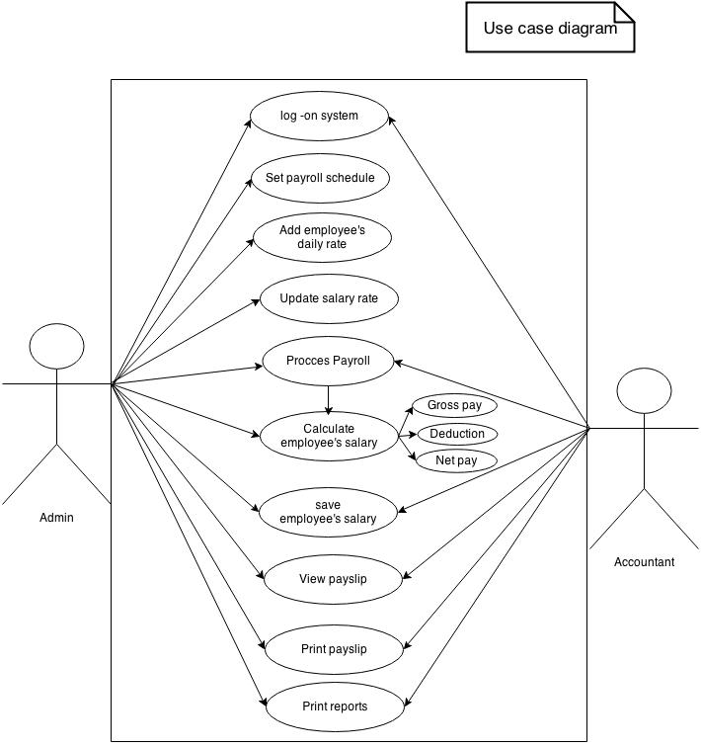

Read only Users
Read/Write/Modify Own Users
Full Control Users
- Data Model and Description

13 Month Pay Data Object

13mp_id | Unique identification for 13 month pay record
Empid | Employees identification number
Name | Employees name
Amount | 13 month pay amount
date_pay | Date of 13 month pay release

Allowance Data Object
allowance_id | Unique identification for allowance record
Empid | Employees identification number
Name | Employees name
allowance_type | Type of allowance
allowance_amount | Amount of allowance to be given
date_paid | Date that allowance release

Bonus Data Object
bon_id | Unique identification for bonus record
Empid | Employees identification number
Name | Employees name
bon_amount | Amount of bonus to be given to employee
date_pay | Date of bonus release

Pagibig Collection Data Object
pi_colect_no |  | Unique identification number for pagibig collection record
Empid |  | Employees identification number
Name |  | Employees name
ee_contri |  | Amount of employees contribution
er_contri |  | Amount of employer contribution
Total |  | Total amount of employee and employer contribution
Date |  | Date deducted

philhealth contribution Data Object
ph_colec_no | Unique identification number for philhealth collection record
Empid | Employees identification number
Name | Employees name
ee_share | Amount of employee share
er_share | Amount of employer share
Total | Total amount of employee and employer contribution share
Date | Date deducted

SSS Contribution Data Object
sss_colec_no | Unique identification number for SSS collection record
Empid | Employees identification number
Name | Employees name
ee_cotri | Amount of employees contribution
er_contri | Amount of employer contribution
Date | Date deducted

wtax Collection Data Object
 | wtax_colec_no |  |  | Unique identification number for tax record
Empid |  |  | Employees identification number
Name |  |  | Employees name
Tax |  |  | Amount of withholding tax deducted from gross pay
Date |  |  | Date deducted

Deduction Data Object
deduc_id |  | Unique identification number for deduction record
emp_id |  | Employees identification number
Late |  | Employees amount deducted for being late
undertime |  | Amount deducted on employees gross pay for undertime
Loan |  | Amount deducted for loan payment
Sss |  | Amount deducted for sss contribution
philhealth |  | Amount deducted for philhealth contribution
pagibig |  | Amount deducted for pagibig contribution
Tax |  | Amount deducted for tax contribution
totaldeduc |  | Total of all deduction

payroll_loan Data Object
loan_id | Unique identification number for loan record
emp_id | Employees identification number
date_loan | Employees name
loan_amount | Amount loan
start_deduc | Date to start the loan payment
loan_status | Payment status
amortization | Amount to be paid every payday.

payroll_login Data Object
userId |  |  |  |  |  |  | Unique identification number for login
User |  |  |  |  |  |  | Unique username
Pass |  |  |  |  |  |  | Password
Name |  |  |  |  |  |  | Name of user
Des |  |  |  |  |  |  | Designation of user

Pay compute Data Object
payrol_id |  | Unique identification form payroll records
Empid |  | Employees identification number
date_fr |  | Date of payroll period that employees start to work
date_to |  | Date of payroll period end
pay_date |  | Payroll date
no_day_work |  | Number of days that an employee had work
daily-rate |  | Employees daily rate
basic_pay |  | Employees basic pay
Ot |  | Employees overtime pay
Otnd |  | Employees night differential pay
duty_on_dayoff |  | Duty on day off pay
sp_holiday |  | Special holiday pay
l_holiday |  | Legal holiday pay
total_alowance |  | Total of allowance an employee recieve
total_bunus |  | Total of all bonus an employee
13mp |  | 13 month pay
leave_pay |  | Employees leave pay
deduction |  | Total of all deduction
gross_pay |  | Employees total compensation
net_pay |  | Employees net salary

salary_rate Data Object
rate_id | Unique identification form employees salary rate records
Empid | Identification number of employee
Name | Employees name
Status | Employees civil status
position | Employees position
employeer | Person where the employee is working
daily_rate | Employees daily rate
effective_date | Date

3.1 Data Description
    - Data Objects and Dictionary
- Login Form
Username – an identification used by a person with access to a computer, network, or online service.

Password – a string of characters that allows access to a computer, interface, or system. This is a unique codename or anything personalized data used to verify the access attempt of the user or the system administrator.
User Type – This is used to differentiate the accessibility level of the person who wants to enter into the system.

2. Main Menu Form
Toolbar - a strip of icons used to perform certain functions.
Menu Bar – typically located at the top of the screen below the title bar, containing drop-down menus.
Status Bar – typically at the bottom of the screen or window, showing information about a document being edited or a program running. This panel is used to display the time, username, date and some controls like uppercase and the scrollbar and it is located on the bottom of the main window
3. Payroll Reports
Employee Record- an official personal document recording the employment status of its owner over time.
Employee Salary Rate- is a form of periodic payment from an employer to an employee, which may be specified in an employment contract. Contrasted with piece wages, where each job, hour or other unit is paid separately, rather than on a periodic basis.
Pay record- To view the transaction of the each employee record for the loan process.
Payroll Compute- it is overall computation that can calculate the basic salary rate, overtime e-cola, regular over-time, Sunday/rest day overtime, holiday overtime, deduction and withholding tax.
Monitoring- Monitoring attendance given by the human resource
Payroll record- To view the information of each employee, like direct employee part time, regular, full-time, casual or professional.
Allowance- An amount of money that is given to someone regularly for a specific purpose
Bonus- Additional compensation given to an employee above his/her normal wage. It can be used as a reward for achieving specific goals set by the company, or for dedication to the company.
Salary Deduction- Amount withheld by an employer from employee's earnings. It typically includes income tax, national insurance or social security contributions, and may also include groupinsurance or pensionfund contributions, union or association dues, authorized wage.
13Month Pay- is an extra month salary paid to employees by their employers, In countries where it is law, the salary is equivalent to a month's pay. It however excludes all allowances, benefits and bonuses.
Pay slip- a note given to an employee when they have been paid, detailing the amount of pay given and the tax and insurance deducted.
    - Relationships
To compute employee’s salaries there must be one accountant representative that will be log on to the system. One administrator may add many employees to the payroll records so the relationships exist are one-to-many relationship. If the system is not having a payroll records the administrator cannot update while the accountant can’t compute payroll.
As an employee has been hired in a company he/she is given only one daily rate. The relation between employee and rate is one-to-many relationships. Since an employee cannot have many daily rate, wage rate, same as the relationship between employee and the salary. Since each employee can get only one salary every pay day.

13 Month Pay Data Object
13mp_id | Unique identification for 13 month pay record
Empid | Employees identification number
Name | Employees name
Amount | 13 month pay amount
date_pay | Date of 13 month pay release

Allowance Data Object
allowance_id | Unique identification for allowance record
Empid | Employees identification number
Name | Employees name
allowance_type | Type of allowance
allowance_amount | Amount of allowance to be given
date_paid | Date that allowance release

Bonus Data Object
bon_id | Unique identification for bonus record
Empid | Employees identification number
Name | Employees name
bon_amount | Amount of bonus to be given to employee
date_pay | Date of bonus release

Pagibig Collection Data Object
pi_colect_no |  | Unique identification number for pagibig collection record
Empid |  | Employees identification number
Name |  | Employees name
ee_contri |  | Amount of employees contribution
er_contri |  | Amount of employer contribution
Total |  | Total amount of employee and employer contribution
Date |  | Date deducted

philhealth contribution Data Object
ph_colec_no | Unique identification number for philhealth collection record
Empid | Employees identification number
Name | Employees name
ee_share | Amount of employee share
er_share | Amount of employer share
Total | Total amount of employee and employer contribution share
Date | Date deducted

SSS Contribution Data Object
sss_colec_no | Unique identification number for SSS collection record
Empid | Employees identification number
Name | Employees name
ee_cotri | Amount of employees contribution
er_contri | Amount of employer contribution
Date | Date deducted

wtax Collection Data Object
wtax_colec_no |  | Unique identification number for tax record
Empid |  | Employees identification number
Name |  | Employees name
Tax |  | Amount of withholding tax deducted from gross pay
Date |  | Date deducted

Deduction Data Object
deduc_id |  | Unique identification number for deduction record
emp_id |  | Employees identification number
Late |  | Employees amount deducted for being late
Undertime |  | Amount deducted on employees gross pay for under time
Loan |  | Amount deducted for loan payment
Sss |  | Amount deducted for sss contribution
Philhealth |  | Amount deducted for philhealth contribution
Pagibig |  | Amount deducted for pagibig contribution
Tax |  | Amount deducted for tax contribution
Totaldeduc |  | Total of all deduction

payroll_loan Data Object
loan_id | Unique identification number for loan record
emp_id | Employees identification number
date_loan | Employees name
loan_amount | Amount loan
start_deduc | Date to start the loan payment
loan_status | Payment status
Amortization | Amount to be paid every payday.

payroll_login Data Object
userId |  |  |  |  |  |  | Unique identification number for login
User |  |  |  |  |  |  | Unique username
Pass |  |  |  |  |  |  | Password
Name |  |  |  |  |  |  | Name of user
Des |  |  |  |  |  |  | Designation of user

payrol_id |  | Unique identification form payroll records
Empid |  | Employees identification number
date_fr |  | Date of payroll period that employees start to work
date_to |  | Date of payroll period end
pay_date |  | Payroll date
no_day_work |  | Number of days that an employee had work
daily-rate |  | Employees daily rate
basic_pay |  | Employees basic pay
Ot |  | Employees overtime pay
Otnd |  | Employees night differential pay
duty_on_dayoff |  | Duty on day off pay
sp_holiday |  | Special holiday pay
l_holiday |  | Legal holiday pay
total_alowance |  | Total of allowance an employee recieve
total_bunus |  | Total of all bonus an employee
13mp |  | 13 month pay
leave_pay |  | Employees leave pay
Deduction |  | Total of all deduction
gross_pay |  | Employees total compensation
net_pay |  | Employees net salary

salary_rate Data Object
rate_id | Unique identification form employees salary rate records
Empid | Identification number of employee
Name | Employees name
Status | Employees civil status
Position | Employees position
Employeer | Person where the employee is working
daily_rate | Employees daily rate
effective_date | Date

Functional model and Description
Subsystem Flow Diagrams
Login
Logo in to System
Activity Diagram

Choose the Login Category

>3
attempt
Enter the User and Password
NO YES

System Shutdown

NO
Verify Login Combination

Try again
Correct Login combination

Correct Login Combination

Access Granted
Log in to system

Log in to the system

Delete
Input Employee
Details
No

Yes
ClickAdd
No
Save
Yes
Update

Employee Salary

Log on to System

Select
New salary rate

Determine User
Authorization

Employee
ID

Search

Salary rate

Log in
System
Input Salary
Rate

Yes
Save
No

Update

4.1Subsystem Flow Diagram
Log in to System Activity
Log in to System
Employee Salary
Salary Rate

4.2 human Interface
Main menu window
Employee daily time record form (DTR)
Update Employee Daily time record
Search Employee Daily time record

5.0 Restriction, Limitation and Constraints

Time
Employees and non-employees do not automatically participate in the Time and Labor system when added to the Human Resources data base.

Funding
Shall be paid and/or transferred monies from the various departmental funds of the company and which warrants may be drawn and cashed for the purposed of paying any monies due companies employee for salaries and wages.

6.0 Validation Criteria

Payroll s related to HR in mainly the flow of GL accounts and that stage is posting, which is after live payroll. The client is running their payroll in legacy; they need to match when it’s generated.
Review a list of HR/Pay and financial data about a specific payroll. Data includes payroll name, gross pay amounts, cost distribution data, and fringe benefits charges.
Summary the listing of employees that will be paid.
This will be show the employee, net pay amount, and direct deposit or check indicator.

Software Design Specification
- Introduction
This section describes the software designs for the Payroll management System under the service management system.
1.1 Goals and objectives
The main purpose of the Payroll management plan is to provide a computerized hiring and profiling of the security agency. The goals and objectives of Payroll Management System are the following:

- To create a secured database for employees requirements and training records of employees consistently
- Speed in processing payroll will have a faster performance by means of decreasing the manual input areas.
- Mathematical errors will be prevented by automatic computations that the proposed system will provide and you may not have to worry about having financial or legal trouble.
- All employees accommodating as well as ensuring that our system can accommodate newly created categories of employee in the future.
- Less time consumed.

1.2 System Statement of Scope
The general statement of the Payroll Management System should be specified and provided in this section. That is the information has to be produced, what the major functions are implemented and what data are provided as the input to Payroll management System.

1.2.1 General Requirements
The following general requirements were identified and specified for the Payroll Management System.

- A way in which the company could update an employee salary record
- A way in which the admin could search the employee all data records from clients to employee
- A way in which the system could generate all data information of the clients
- A way in which the data and information could be saved in a secured database
- The system could print the necessary information needed by the user / administrator / HR manager
- The system could manage the employees performance daily time record.
- The system could handle an employee’s leave information

Interface Enhancements
The Payroll Management System will provide an interface enhancement to achieve the user-friendliness and usability functionality that is requested by the client / users.

Database Administrative Interface
The Payroll Management System will provide a secured database on which the user could retrieve and save data and information at ease with the use of MS SQL database.
1.3 System context
Developing this payroll software will process payroll in a timeliness manner, it is efficient and reduce cost since it does not need lot of payroll master in computing employee’s salary. This software is develop using Java language, mySql for database and connector/J for the connection.

1.4 Major Constraints
The software is to run on a system, with SQL Therefore the systems should be properly connected to the server to access database. The Systems should be good enough to perform all the actions fast for example it is recommended that system should be no older than PII .The RAM should be not less than 128 MB.

Time
The proponents only have an approximately five months to finish all documentation, software and interface enhancements. This is a disadvantage for the proponents knowing that the system development and documentation has to finish within five months at the same time the proponents are still studying on their classes and still searching on how the software development will takes place.
Funding
Funding is the worst possible constraints for the proponents, the funds that the proponents are only limited considering they are currently dependent as a students who lacks on personal fund to support the expenses for developing the HRMS. However, this constraint will not be an issue for not pursuing the objectives for the development of the Payroll management System.
- Data Design
  - Database Description
EMLOYEE
EMLOYEE TYPE
EMPLOYEE ID
SALARY RATE
# DAYS WORK
PAYROLL COMPUTATION
MODULE
ACCESS
STAFF
PAYROLL SYSTEM

- Architectural and Component-Level Design

  - Program Structure
    - Overall

Log in
Main Screen

View
Exit
Help
Date
Update
File

File
- Employee Record
- Employee Salary Rate
- Payroll Compute
- Pay Record
- Exit

View
- Payroll Records
- Allowance
- Bonus
- Statutory
- 13 month pay
- Pay Slip
Date
- Update Date
Time
- Update Time
Help
- Tutorial
Exit
- Switch User
- Exit System

3.1.2

LOG IN
MAIN
YES OR NO
ADMIN ACCOUNTANT
LOG IN

3.1.3

MAIN
View
-Reports –Payroll Record Allowance – Bonus
-Statutory - 13 Month Pay
- Pay Slip

FILE
-Emp Record - Emp Salary
- Payroll Compute
-Pay Record - Exit

-update

MAIN
-View - Update – Date
- Time - Help - Exit

3.1.4
EXIT
Exit System
Switch User
Exit

3.2. Description for Components
3.2.1 Login Form
Main form: frm login
Main Action: login
This is the first form to appear after the user run the system. The user enters their username to the txtUsername and the password to the txtPassword to verify their accounts in order to access the system. The user must click the OK butoon which is the cmdOK. User will be logged in if it is valid username and password pair. If the user clicks the cancel button, the application will end if they confirmed their action.
3.2.2 Employee Record
Major Form: frmEmployeeRecord, frmUpdateEmployee Record
Main actions: Update and Search employee record
This form keep and maintaining records of the dates and hours your employees work for you and how much they're paid. The Act also requires giving employees regular pay slips with these details.

File
Employee Record
Employee Salary Rate
Payroll Compute
Pay Record
Exit
View
Payroll Records
Allowance
Bonus
Statutory
13 month pay
Pay Slip
Update
Pay Rate
Employee Record
Date
Update Date
Time
Update Time
Help
Tutorial

Exit
Switch User
Exit System

- User Interface Design
Operational but also usable and adaptable to changing user needs.
4.1Description of the User Interface
The user interface, in the industrial design field of human–machine interaction, is the space where interactions between humans and machines occur. The goal of this interaction is an effective operation and control of the machine on the user's end, and feedback from the machine, which aids the operator in making operational decisions. Examples of this broad concept of user interfaces include the interactive aspects of computer operating systems, hand tools, heavy machinery operator controls, and process controls. The design considerations applicable when creating user interfaces are related to or involve such disciplines as ergonomics and psychology.
4.1.1Sreen Images
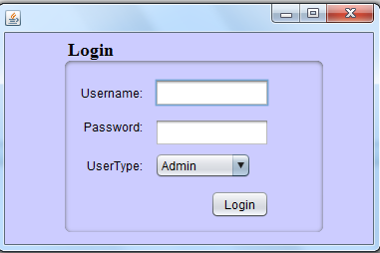

-This Form Provide a Username and Password to access the MAIN FORM
This Form Have 3 Three Times Attempt if you fail to access in three Re-try the
System will SHOTDOWN or EXIT automatically.

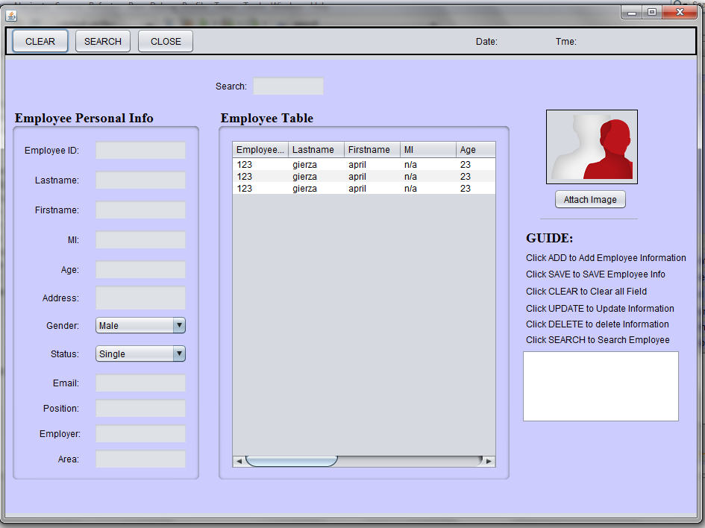
The Employee Record
-In this form you can SEARCH, and ADD IMAGE of the employee, on the table below you can see the details of the employee who already hired.

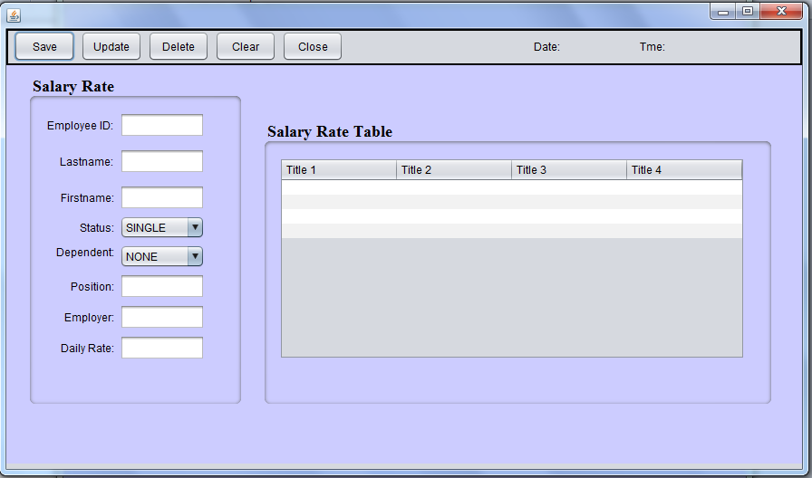
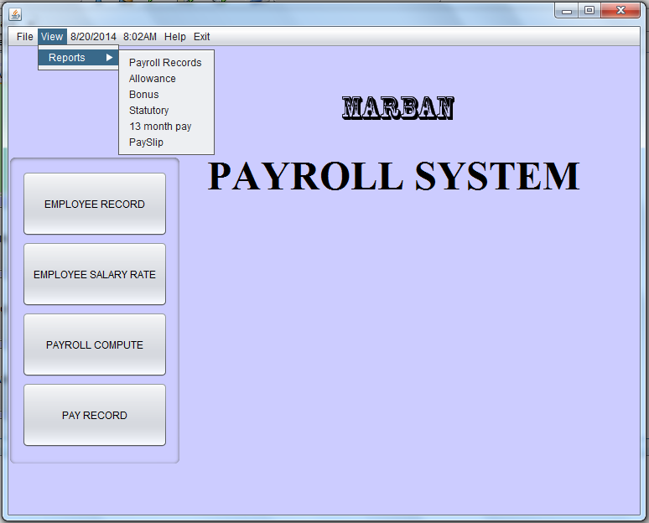
The Payroll Record Form
In this form you can view and print the employee “Pay Record” by entering the date from when the employee is start at work and the Date to when the employee stop to work at 15th days of work or cut-off.

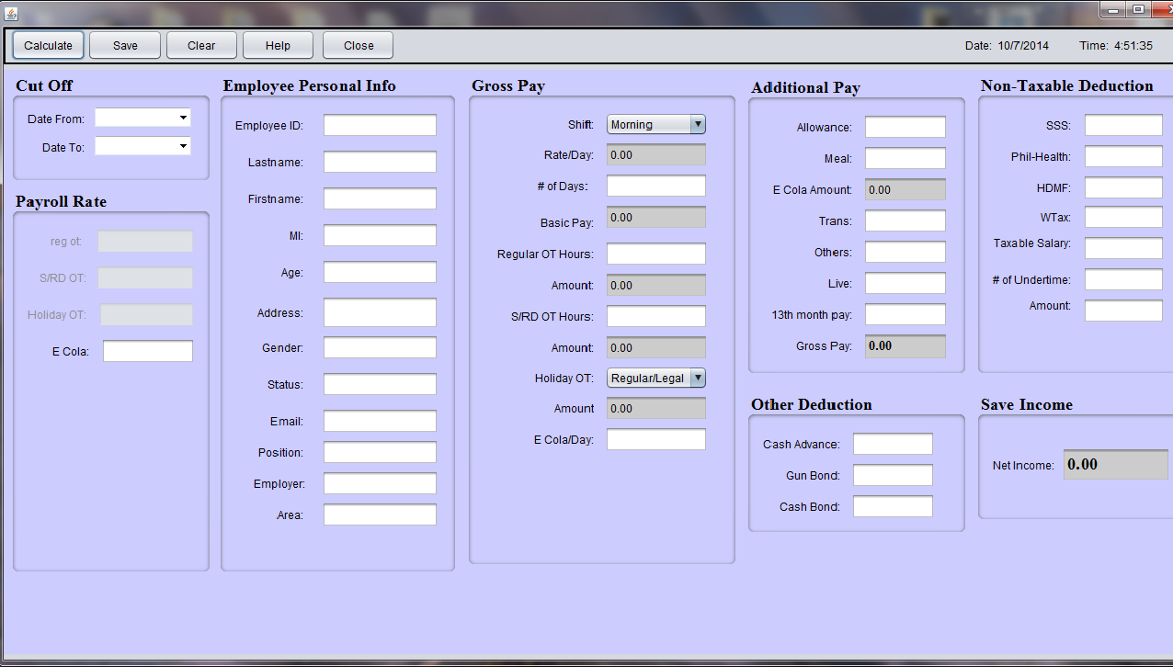
It shows the computation of basic rate of the employee. This is the entire computation of payroll.
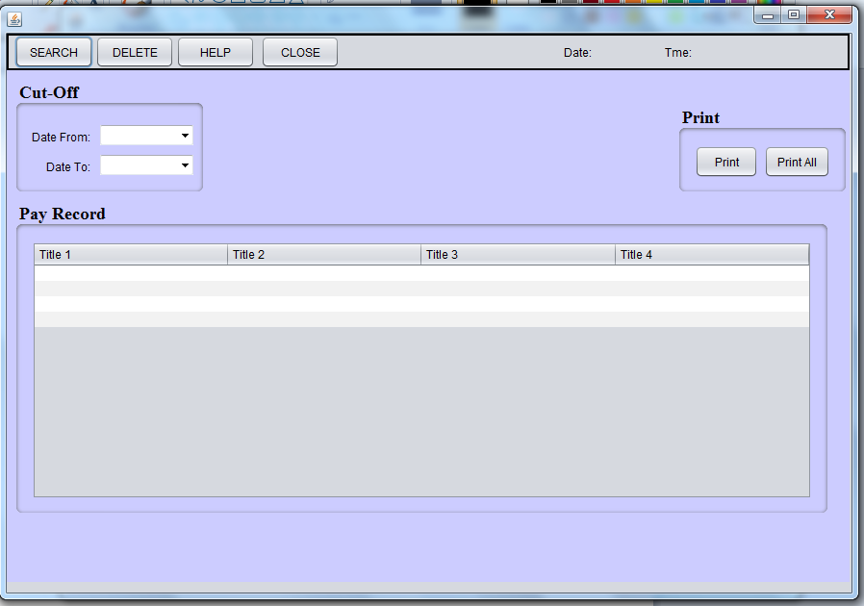

This form is the viewing of the record of the employee salary when you can print the reports also.

Changes of the salary of the employee could update in this form.

4.2 Interface Design Rules
4.3 Components Available
4.3.1 Intrinsic Controls
Textbox
A Textbox control, sometimes called field an edit control, display’s information entered at design time, entered by the user, or assigned to the control in code at run time.

Label
A label control is a graphical control you can use to display text that a user can’t directly.
Image
Use the image control to display a graphic, an image control can display a graphic from a bitmap, icon, or metafile, as well as enhanced metafile, PEG or GIF files.
List Box
A list box control displays a list of items from which the user can select one or more. If the number of items exceeds the number that can be displayed, a scroll bar is automatically added to the list box control.

Scroll bars
Scroll bars provide easy navigation through a long list of items or a large amount of information. They can also provide an analog representation of current position. You can use a scroll bar as an input device or indicator of speed or quantity- for example to control the volume for a computer game or to view the time elapsed in a time process.

COMMANDBUTTON
Use a Command Button control to begin, interrupt, or end a process. When chosen, a Command Button appears pushed in and so is sometimes called a push button.

MENU
A Menu control displays a custom menu for your application .A menu can include commands, submenus, and separator bars. Each menu you create can have up to four levels of submenus.
Combo Box
A Combo Box control combines the features of a team Textbox control and a List Box control- users can enter information in the text box portion or select an item from the list portion of the control.
Checkbox
A Checkbox control displays an X when selected; the X disappears when the Checkbox is cleared. Use this control to give the user a True/False or Yes/No option. You can use Checkbox controls in groups to displays multiple choices from which the user can select one or more. You can also set the value of a Checkbox programmatically with the value property.
Option Button
An Option Button control displays an option that can be turned on or off.

4.3.2 ActiveX Controls
5.0 Restriction, Limitations, and Constraints
Time
Time is so for the biggest restriction or constraint for our project as we only have around three months to finish entire project .It is very important for us watch the time we spend over every phase of the software development project. We could have included many more components it three software like online help menu but time restricts us from doing so.
Employee Skills
Employee programming and design skills are also one of the restriction. It does it does not have as big of an impact on the project as time but it sure does limit us from doing more addition to the projects.
Insufficient Resources
Not having all the necessary instruments also is a problem for our software .We planned to use latest equipment for the project like hand held pc with keyboard etc. but the employees cannot afford to provide such tools to all their employees so we had to abandon the plants.

6.0 Testing Issues
To validate the software we need to test the software. During the testing we will be concerned about the inputs and their expected outputs. We emphasize on the testing where we will input the data and will compare the output with the expected results. Emphasize on the testing where we will input the data and will compare the output with the expected results. At this stage, we are concerned about the process; we are only looking for the correct outputs.

6.1 Classes of Test
The software has many different additions and new interfaces/ functions added to it. We will go through each of the new interface and other software function to describe different outputs of data event types of test performed on them.
Interface
We are creating new user interface using java language .This interface allow user to easily fill the employee record and thus enter data regarding update into the database. The older system makes the proponent work very tedious with use of several different windows to complete a form. The interface that we will design will enable user to complete the entire form with use of single .The tests to be carried on these interface windows.
Black Box testing
We are concern about inputs of data into the software and their expected outputs. So we will carry out black box testing where several different steps will be taken to test the software so that when we use the software with specific data all the given out puts will match our expected results. We will compare the output with our expected output list and will find out credibility of the software.

Login Window
We will make use several different names to the system. We will use correct and incorrect passwords to access the software and thus access database. We will not be allowed to log in using incorrect passwords and error message will be shown. When correct password is presented we will be able to log in be able to next window. (java –net beans platform window). We will also test OK and Cancel buttons on this window by performing test above.

Java Net beans Platform
This is the main window that we will use to access the database using java language. We will have several different drop down menu in this window, File ,view, update ,time ,date ,help exit, are the drop down menu that will available in this window we will try to use all the menus and then different options available in each of the window.

File: When the file button is clicked user will be shown to choices
Employee Record
Employee Salary Rate
Payroll Compute
Pay Record
Exit
View
Employee Record
Payroll Records
Allowance
Bonus
Statutory
13 month pay
Pay Slip
Date
Update Date
Time
Update Time
Help
Tutorial

Exit
Switch User
Exit System
Test Specification
- Introduction
1.1 Goals and Objectives
It is a graphical tool used to aid in the design and creation of a Payroll system. A user with more experience with java language programming can construct his or her subsystem created. Payroll system assists experienced programmers by generating the integration by the subsystem overhead necessary for basic construction, allowing them to concentrate on more detailed system design issues and implementation. The idea is to limit the amount of actual code written by the user, while providing an interface that is
easy to use yet complex enough to remain functional.

The testing process for payroll system has a number of goals. The software will be thoroughly tested for coding bugs and logic errors. In addition to testing for bugs, Payroll system will be tested to ensure that it is of the utmost quality. It will be expected Exhibit the following qualities: well-executed software, high production values, easy to use interface with a common Windows ‘feel’, and a full featured engine with reasonable performance on wide variety of machines.

  - Statement of scope
Payroll System will be tested on a number of levels, beginning with unit testing
(Using white box testing methods), integration testing (using black box testing methods), validation testing, and ending with high order system testing with a public beta. A number of design principles will be validated during the testing process. The interface should be easy to use. Data should read and write flawlessly from the database. The creation of monitoring employee data, computation, and data must export flawlessly to the system. The system unaltered code should produce bug free results. Data files created by the world builder must be read in flawlessly. The process should also maintain a reasonable frame rate on various machine speeds.
The help files must be automatic generate and easy to view of all information of each employee. Tutorials must be complete and easy to understand. The manual must sufficiently compliment the help files. The software should install easily and flawlessly, and the installation is must be part of the install. UN installation must completely uninstall only the files that are part of the system.

  - MAJOR CONSTRAITS
  - Net Beans
  - Xammp
  - MySQL Server
  - Dual Core
  - OS Windows XP,W7,W8
  - RAM 2GB
  - Processor 3.0GHZ

2.0Testing Plan
We want the product to be bug free. We also want to make sure that there are no defects in the product. So we will be spending large amount of the total software development team on the testing. Below is the description of the testing procedure and strategy. We will also be presenting the timing and scheduled of the tests to be carried out.
2.1Software
    - Interface
Login window
We will make use of several different names to login to the system, so will be testing login window. We will also test OK and Cancel Buttons on this window by performing test above.

Net beans IDE 8.0 [Design] Window
This window is the main window that will use to access the database using net beans. We will have several different menu bar in this window File, view, Date, Time, Help and Exit. Are menu bar that will be available in this window we will try to use all the menus and then different option available in each of the window.
File:
When file button is clicked user will show four choices.
Employee Record:
The function of this is to search, update, and delete of employee information.
Employee Salary Rate:
The function of this is to update the salary wage base on the status of the employee.
Payroll Compute:
The function of this is to compute the salary of the employee base on the day’s work.
Pay Record:
The function of this is to view and print the record of employee salary computed.

  - Testing Strategy
2.2.1 Unit Testing
The Object Handler will be tested in a white box fashion. It will be tested with various forms of data to determine data flow through the software architecture (data must be passed into the proper components.)

2.2.2 Integration Testing
Integration testing in the software testing model comes before system testing and after the unit testing has been done. The way that integration testing works is by, getting the individual modules that have been through the unit testing phase and integrating each module into a group, the integration testing phase will make sure when the modules are being integrated together that any problems, for example errors or bugs, caused due to the integration of the modules are eliminated. Integration testing does not deal with the integration of the whole system but deals with the integration of a process in the system. In the integration testing stage there are three things that are created, to ensure that the integration of the modules is successful and that it runs successfully as well, a test plan, test cases and test data is produced to effectively test that the integration is successful. Test data is normally used by test cases but I have mentioned each type below
2.2.3 VALIDATION TESTING
Integration testing in the software testing model comes before system testing and after the unit testing has been done.
The way that integration testing works is by, getting the individual modules that have been through the unit testing phase and integrating each module into a group, the integration testing phase will make sure when the modules are being integrated together that any problems, for example errors or bugs, caused due to the integration of the modules are eliminated. Integration testing does not deal with the integration of the whole system but deals with the integration of a process in the system.
In the integration testing stage there are three things that are created, to ensure that the integration of the modules is successful and that it runs successfully as well, a test plan, test cases and test data is produced to effectively test that the integration is successful. Test data is normally used by test cases but I have mentioned each type below;
2.2.4 High-order Testing
- Recovery Testing
No Recovery testing will occur. While system failures are Undesirable, termination of the program in the event of a crash is acceptable.
- Security Testing
No Security testing will occur. There are no security issues with Payroll system.
- Stress Testing
The world builder and the engine will be loaded with abnormally
High sprite counts (with attributes and sounds) to determine how
Much payroll can handle.
- Performance Testing
The engine will be loaded with an increasing number of sprites
While the frame rate is monitored using the Frame Rate Counter.

  - TESTING RESOURCES AND STAFFING
We will use several different resources to carry out the test on our software. Since the time is constrains for us we will try to use help from everyone that we can. Following is non-Detailed description of the test resources
- Marban Staff
- Marban hr Resources
- Marban Computer Resources
- Accountant

  - TEST RECORD KEEPING
Microsoft Excel will be used to evaluate immediate test results. After the results
Have been evaluated, they will be submitted to a Microsoft Access database for
Storage.
2.5 TESTING TOOLS AND ENVIRONMENT
Testing Tools will involve the computer resources from the Bestlink College of the Philippines Labs and the computer resource of the marban security agency for the Environmental quality.
2.6 TEST SCHEDULE
The following is the Assuming schedule only of the PRIS.
Project Test Plan
-12/12/2014 – 12/18/2014
Theory stage. No any real actions will be performing.
System Testing
-1/15/2014 – 1/19/2014
Generate Testing Report
-1/16/2014 – 2/16/2014

- TEST PROCEDURE

3.1 SOFTWARE (SCIS)TO BE TESTED
Items refer to section 2.1 from the test specification document.

3.2 TESTING PROCEDURE

2.2.1 UNIT TETSTING
Login window
We will make use of several different names to login to the system, so will be testing login window. We will also test OK and Cancel Buttons on this window by performing test above.
Netbeans IDE 8.0 [Design] Window
This window is the main window that will use to access the database using netbeans. We will have several different menu bars in this window File, view, Date, Time, Help and Exit. Are menu bar that will be available in this window we will try to use all the menus and then different option available in each of the window.

File:
When file button is clicked user will show four choices.
Employee Record:
The function of this is to search, update, and delete of employee information.
Employee Salary Rate:
The function of this is to update the salary wage base on the status of the employee.
Payroll Compute:
The function of this is to Compute the salary of the the employee base on the day’s work.
Pay Record:
The function of this is to view and print the record of employee salary computed.

3.2.2 INTEGRATION TESTING
Integration testing in the software testing model comes before system testing and after the unit testing has been done. The way that integration testing works is by, getting the individual modules that have been through the unit testing phase and integrating each module into a group, the integration testing phase will make sure when the modules are being integrated together that any problems, for example errors or bugs, caused due to the integration of the modules are eliminated. Integration testing does not deal with the integration of the whole system but deals with the integration of a process in the system. In the integration testing stage there are three things that are created, to ensure that the integration of the modules is successful and that it runs successfully as well, a test plan, test cases and test data is produced to effectively test that the integration is successful. Test data is normally used by test cases but I have mentioned each type below;

3.2.3 VALIDATION TESTING
Integration testing in the software testing model comes before system testing and after the unit testing has been done.
The way that integration testing works is by, getting the individual modules that have been through the unit testing phase and integrating each module into a group, the integration testing phase will make sure when the modules are being integrated together that any problems, for example errors or bugs, caused due to the integration of the modules are eliminated. Integration testing does not deal with the integration of the whole system but deals with the integration of a process in the system.
In the integration testing stage there are three things that are created, to ensure that the integration of the modules is successful and that it runs successfully as well, a test plan, test cases and test data is produced to effectively test that the integration is successful. Test data is normally used by test cases but I have mentioned each type below;

3.2.4 HIGH – ORDER TESTING
- Recovery Testing
No Recovery testing will occur. While system failures are
Undesirable, termination of the program in the event of a crash is acceptable.
- Security Testing
No Security testing will occur. There are no security issues with Payroll system.
- Stress Testing
The world builder and the engine will be loaded with abnormally
High sprite counts (with attributes and sounds) to determine how
Much Game Forge can handle.
- Performance Testing
The engine will be loaded with an increasing number of sprites
While the frame rate is monitored using the Frame Rate Counter.

3.3 TESTING RESOURCES AND STAFFING
Testing Resources
No special resources are required for testing beyond those already needed for development.
Test Staff
Project Manager – Myris Janine Ricardo
Business Analyst – April Gierza
Document Specialist – Maria Richel Dalanon
System Analyst – Jovelyn Pemienta
Lead Programmer – Michael Angelo Mendoza

3.4 TEST RECORD KEEPING AND LOG
Test Record Keeping
Microsoft Excel will be used to evaluate immediate test results. After the results
have been evaluated, they will be submitted to a Microsoft Access database for Storage.
A test log is kept to monitor the tests that have been applied. An error, or ‘bug’
Log is kept to monitor any problems that have arisen during testing. Also, a beta
Tester report form exists to aid beta testers in organizing their communication with PA Software.

