CHAPTER 3.0 EIS PROJECT MANAGEMENT AND DEVELOPMENT
3.1 RISK MITIGATION, MONITORING AND MANAGEMENT PLAN
1.0 Introduction
This chapter will give the specific explanation mitigation monitoring and management plan for the service management system on which project has to come up a briefly overview of the project study.
1.1 Scope and intent of RMMM activities
The goal of the risk mitigation, monitoring and management plan is to identify as many potential risks as possible.
When all risks have been identified, they will then be evaluated to determine their
probability of occurrence, and how General Ledger will be affected if they do occur.
Plans will then be made to avoid each risk, to track each risk to determine if it is more or less likely to occur, and to plan for those risks should they occur.
It is the organization’s responsibility to perform risk mitigation, monitoring, and
management in order to produce a quality product. The quicker the risks can be
identified and avoided, the smaller the chances of having to face that particular
risk’s consequence. The fewer consequences suffered as a result of good RMMM plan, the better the product, and the smoother the development process.
1.2 Risk management organizational role
Production Team – the production team will be the group assigned on the creation of the system.
Company – also called as the End-User they provide the efficient process of the system for the clients. Through the help of the automated billing system the clients will be able to serve well by the company through sending invoices to them, calculate customer’s cost for each billing record; periodically generate invoices and collecting payments received from the customer.

Adviser – the person who will be supervising the production team and gives them advises and techniques.
2.0 Functional Data Description
In this section the proponents have to identify the possible risks,conditions and events that may occur and it may have a positive or negative impact on the project. Encountering a number of risks upon the development phase is absolutely possible. The proponents have to identify this risk and better yet come up a strategy by reducing of the risk avoiding and eliminating the possible cause, ships impact and transfer it to a third party and must have will to accept the consequences.
2.1 Description of Risk Management
The identification, analysis, assessment, control, and avoidance, minimization, or elimination of unacceptable risks. An organization may use risk assumption, risk avoidance, risk retention,risk transfer, or any other strategy (or combination of strategies) in proper management of future events.
- Business Impact Risk: this concerns about not coming up or produced a product that will greatly affect the client’s business. If the software produced can’t meet the expectations and improve the business. The created system was useless.
- Customer Risk: is a potential risk found in all consumer-oriented products, that a product not meeting quality standards will pass undetected though the manufacturer's quality control system and enter the consumer market place.
- Development Risk: The client must provide the necessarily needs to create and produce the system that the company needs. Taking quick response on the need of products to produce the system will lessen the risk on developing the system.
- Employee Risk: Focuses on the willingness, experience and the ability of the employee’s to create a product that will enhance the business. If the team was not fit on to produce the system it will cause a lot of risk on the production of the product.
- Process Risk: Regards on the product quality. A system must have a good quality on improving a business. A few standards and criteria’s must attain the system.
- Product Size: if we say size it is not only the space used by the system. It also means range of capacity of the system requirements. The client must provide the proper equipment depending on the system requirements.
- Technology Risk: Must ensure that the technology used in producing the system must not be outdated. To expand the life span of the system and to ensure that the software will function in long terms.

2.2 Probability and Impact for Risk Management
Category | Risk | Probability | Impact
Employee Risk | There may be conflicts between team members | 40% | 1
Process Risk | Quality of product documentation and coding that must be produced may be low. | 35% | 1
Product Size | Size estimate maybe significantly low | 30% | 2
Development Risk | Lack of training on java | 30% | 2
Customer (User) Risk | Customer may change the project’s requirements | 20% | 3
Technology Risk | Technology will not meet expectation | 10% | 2
Business Impact | Product may harm the company | 10% | 3
Risks Table
Legend
Impact Values Description
- Catastrophic
- Critical
- Marginal
- Negligible

3.0 Risk Mitigation, Monitoring and Management
This Section details and describes Risk Mitigation, Monitoring and Management in every possible risk that would occur, how you will manage to give a solution and monitor if there are other circumstances that the risk might occur again.

3.1 Risk Mitigation for Risk Management
This section is where the team will identify the software development risk. And a plan as a counter measures the risk. So that the risk would never appear again.
3.1.1 Product Size
There might be some chances that the product would be over or underestimated; to reduce the risk on this matter the team will be conserving its resources to minimum level.
3.1.2 Business Impact
Business impact concerns about the final product. In this phase the team will spend time with the users to identify their needs. So that the team will identify the data and processes that the company needs.
3.1.3 Customer (User) Risk
If the client cannot attend a meeting how can we identify their needs? This will result a failure on the system. It may also cause that they don’t need the product that you have manufactured.

3.1.4 Process Risk
We want provide a high quality product the team must have proper guidelines to follow. To ensure that the task of every member of the team is precise and time managed

3.1.5 Technology Risk
In order to prevent this from happening, meetings (formal and informal) will be Held with the customer on a routine business. This ensures that the product we are producing, and the specifications of the customer or equivalent.
3.1.6 Development Risk
In order to prevent this happening, the development team will be required to learned the languages and techniques necessary to develop this software the member of the team that is the most experienced in a particular facet of the development tools will need to instruct those who are not as well versed.

3.1.7 Employee Risk (Team Mates)
To provide a high class service the team must have proper knowledge, experience and willingness to assure the success of the project. To avoid this, the team should always gather a meeting to talk about their performance and evaluate each other so they know where they should focus on the project.

3.2 Risk Monitoring for Risk Management

3.2.1 Product Size
The team will be on track of using JAVA programming language. To monitor the amount of functions used in the project this will help us notify us if the project will have a risk in the future.

3.1.3.2.2 Business Impact
In this phase the team will conduct weekly meetings to monitor the user’s information in the needs of the business this will be a very efficient way to know the users insights in the project that will help the team improve the system requested by the client’s request.

3.1.3.2.3 Customer (User) Risk
To monitor the risk on the client we will be conducting weekly meetings keep the records of their activity. Check the outcome of the activities to acknowledge the people who are attending and active on improving the project.
3.1.3.2.4 Process Risk
To manage this risk our team will be cross checking each of our work, another advantage of this is that we can give each other a suggestion based on our opinions to improve one self and monitor our works.
3.1.3.2 .5 Technology Risk
During this phase of development the team should always been aware of the latest items or gadgets.
3.1.3.2 .6 Development Risk
Each member of the team should watch and see areas where another team member maybe weak. Also if one of the members is weak in a particular area It should be brought to the attention by that member, to the other members.
3.1.3.2 .7 Employee Risk (Team Mates)
Monitoring the teammates with difficulties on their task. This will notify the team on who shall be helped and specify what part of the team should be improved.
3.1.3.3 Risk Management for Risk Management
This section is where we will identify several software development risk and make a plan to give a solution to the risk if they occur.
3.1.3.3.1 Product Size
After the monitoring of the process if the project end up over or under estimation the team will be conducting a few more studies to find a better solution to manage the risk on space.

3.1.3.3.2 Business Impact
If an error has occurred, the collected data given by the users will be used to improve the managing of the system.

3.1.3.3.3 Customer (User) Risk
When the customers are not very satisfying the team can conduct surveys and give questionnaires to manage the development of the system.
3.1.3.3.4 Process Risk
If the problem was still inside the team the only answer is to manage a swapping of that particular member so that the team can move forward the project.
3.1.3.3.5 Technology Risk
On monitoring technology the team must manage to recommend items and equipments that will be applicable to the project.
3.1.3.3.6 Development Risk
The members who have the most experience in a particular area will be required to help those who don’t out should it come attention of the team that a particular member needs help
3.1.3.3.7 Employee Risk (Team Mates)
On managing the risk on the team every team member will help each other to lessen the problems on that specified area on the team.

3.2 Software configuration management plan

3.2.1.0 Introduction
At the stage of software development there will be a point where the proponent will make a revisions and changes to the concept. SCMP is developed so that we can identify and control changes and assure that the plan is implemented and reported the changes to the team.

3.2.1.1 Scope and intent of SCM activities
As what has said to the introduction the SCM plans purpose is to report and tract the changes on the software development plan. The procedures will give us an outlook of the software that should be changed and went to changes.
SCM Activities are develop to
- Identify changes
- Control changes
- Ensure the changes is being properly implemented
- Also have a way to document the changes
3.2.1.2 SCM organization role
Production Team – the production team will be the group assigned on the creation of the system.
Company – also called as the End-User they provide the efficient process of the system for the clients. Through the help of the automated billing system the clients will be able to serve well by the company through sending invoices to them, calculate customer’s cost for each billing record; periodically generate invoices and collecting payments received from the customer.
Adviser – the person who will be supervising the production team and gives them advises and techniques.
3.2.2.0 SCM Tasks
In this section we will determine the prioritized task and distribute responsibilities to the member. Assigning personnel’s on each task will reduce time consumption and confusion to their target assignments. In every meeting we will be discussing every changes reported on their SCM task and allocate the priorities to finish the product.
3.2.2.1 Identification
This section the team will be detailing the parts of the system that will undergo to the process of SCMP.

3.2.2.1.1 Description

*Identify change
On identify the change the production team will be discussing about the on the system if it is needed or not.
*Approve change
If the change is needed the team will be discussing the implementation of the change how to document the changes and how the changes will be submitted to the other production team so that they can adjust to the adjustment of your team.
*Ensure
Setting a day where the team would conduct a meeting to check each other’s work or if their works are compromising this way we will be reducing the conflict and unnecessary information on the documents and finalize it.
*Document
Since the documents has been finalized. We will be using that opportunity to generate the report and pass the work to the software development team to implement it to the produc

3.2.2.1 .2 Works Products and Documentation
Identify change
At the time the change request form has been issued and to be given to the SCM team personnel’s, control change often evaluation, the change form will be generated.
Ensure
The team will be implementing changes and checking each other’s task.
Document Change
Finalizing all changes and documents then add it to the compilation

3.2.2.2 Configuration Control
3.2.2.2.1 Description A discipline applying technical and administrative direction and surveillance to: (1) identify and document the functional andphysical characteristics of a configuration item; (2) control changes to those characteristics; and (3) record and report changesto processing and implementation status.
3.2.2.3
3.2.2..2 Increasing Version number
The team creates a proto type of the system till the process and functions will be completed.
3.2.2.2.3 Works Products and Documentation
A part of documentation will be named version revision history this will be used to document the revisions, bug report; system tracking this will be the basis on monitoring the bug fixes and upgrades.
3.2.2.4 Configuration Status Accounting
3.2.2.4.1 Description
- Verbal Communication –

3.2.2.3.2 Works Products and Documentation
- Testing of Errors
3.3 Software Quality Assurance Plan
3.3.1.0 Introduction
3.3.1.1 Scope and Intent of SQA Activities
- Trial and Error
- Documentation

3.3.1.2 SQA Organizational Role
Project Manager Soriano Jennilyn A. Manages the team
System Analyst Peque Mark Jason V. Handling of business Rules
Business Analyst Groyon George S. Analyze business process
Documentary Specialist Aquino Abigail G. Documenting the process
Lead Programmer Nitoral Jr. Wilfredo H. Handling System Software

3.3.2.0 SQA Task
- Develop the design plan and test plan for testing the tool
- Provide feedback and advice

3.3.2.1 Task Overview
Gathering (brainstorming/meeting)
Contacting Client
The client’s opinion is our top priority because they will be the ones who will use the system. Detailing their ideas and innovating it will raise your success rate.

Detailing the design
Showing your sample design to the client will also help them decide on what was needed or not in the system. Showing them your overview is a great option.

3.3.2.2 Standard, Practices and Convention (SPC)
Gathering
Our team was consist of five(5) members meeting about the agendas of our system. Every members task was well distributed by our PM so that every work was evenly done.
Contacting Client
The client was our end user that’s why their cooperation was very needed in order to finish our project. Every meeting with them we propose an agenda on what should be done or what was the process they want to their system.
Detailing
Letting them decide on what should be seen on their interface will lighten the teams work and setting it to their needs is a great success.
3.3.2.3 SQA Resources
3.3.3.0 Reviews and Audit
A formal technical review (FTR) is a software quality assurance activity that is
performed by software engineers. The objectives of the FTR are:
(1) to uncover errors in function, logic, or implementation for any representation of the
software;
(2) To verify that the software under review meets its requirements;
(3) To ensure that the software has been represented according to predefined standards;
(4) To achieve software that is developed in a uniform manner;
(5) To make projects more manageable.
3.3.3.1 Generic Review Guideline
Our review will focus first on the clients overview and next was to the project teams overview. Because every meeting with the client there are high chances of changes depending on their needs the teams overview should be presented to the client so that every sides can give their ideas before changing and documenting the details.
3.3.3.2 Formal Technique Review
3.3.3.3 SQA Audits
Team members will have a weekly report on their individual performance for the past
week. Any problems, question regardless on the performance of other team members
will also noted there.

· Members will write part of the help menu that relates to their design work. And they
also share between members.

· Any changes that will affect the project will be presented to other team members
before doing any changes. These are the changes that are minor or require little code
change, but still are different from the original architectural design.
· The client should be notified of all changes made to the. For minor changes, we will
just notify a reprehensive from the client instead of the whole team from the client.
This rule only applies to the minor changes or cosmetic changes, or minor functional
changes. Any major functional change will still require the agreement from the
whole team from the client side

3.3.4.0 Problem Reporting and Corrective Action/ Follow Up
3.3.3.4.1 Reporting Mechanisms
The first change given to the billing system was the cashier was changed to our system. We will be conducting cashier duties rendering of Official Receipt to the clients reimbursement and disbursement of funds.

3.3.3.4.2 Responsibilities

Project Manager Soriano Jennilyn A.
System Analyst Peque Mark Jason V.
Business Analyst Groyon George S.
Documentary Specialist Aquino Abigail G.
Lead Programmer Nitoral Jr. Wilfredo H.

GENERAL LEDGER WITH ASSET ACCOUNTING

Nitoral Wilfredo jr - Lead Programmer
Peque Mark jason v. – System Analyst
george Groyon – Business Analyst
Abigail Aquino – Document Specialist
Soriano jennilyn – Project Manager

Chapter III
3.4- System Specification
3.5- Software Requirements Specification
3.6- Software Design Specification
3.7- Test Specification

1.0 Introduction
This section gives a general overview of the General ledger system under the Service Management System.

  - Goals and Objectives
The main purpose of GENERAL LEDGER SYSTEM is the collecting point for all
financial data of a business. A chart of accounts and a ledger of
transaction entries are maintained in the database.
The goals of general ledger are:

- General Ledger Statement
- Balance Sheet
- Income Statement

  - System Statement of Scope
The general statement of GL must be specified and provided in this section. That is the information has to be produced, what the major functions are implemented and what data are provided as the input GL.

    - General Requirements
The following general requirements were laid out of our project named general ledger
With asset accounting
- A way to create financial statement
- A way to update receivables to g/l
- A way to update payables to g/l
- A way to update payroll to g/l
- A way to have income statement

- Interface Enhancements

Staff members of the security agency have some enhancement requests
To have easy in access of the product

- Database Administrative Interface
The general ledger will provide a secured database on which the user could retrieve and save data and information at ease with the use of MS SQL database.

- Online Help
To make a complete help menu for the user assistance and also
Be used to present information on board range of subjects

- Training
training is as important as the software itself in the success of implementing a new general ledger system. Your system is set up with your institutional data, business rules, and variables from your migrated data. Using financial data makes the training more relevant for staff members and provides a better opportunity to review and become comfortable with
Training typically takes place over a two month period and has two phases about a month apart. This allows staff members to try out new skills, practice on the non-production database, ask questions, and become familiar with the system. They receive exceptional, personalized training at a comfortable pace.

  - System Contex

General Ledger Accounts are used to identify balance sheet classifications, revenue classifications, or expenditure classifications. Balance Sheet accounts include Asset accounts, Liability accounts, and Net Assets and Reserves. The development of the general ledger is actually for academic purposes only to begin with. It is necessary or mandatory for the proponents to have a client on which the proponents will gather data and information needed to establish and develop a correct business processes. If there is no client, the proponents will have a hard time for identifying the needed data and information for the GL development. Furthermore, if the development of the GL will be a success, it is a good example of a teaching-learning method provided by the current school on which the proponents are studying while developing the GL. More importantly, the client will be benefitted the most when the GL will be implemented on their respective company / agency. With this, the client will upgrade their business transaction using the latest technology provided by the GL. The system will make sure that the processes of the company are still the same, the thing is, it will now a computerized rather than the previous manual process that they had.
  - Major Contriants
- Funding
Funding is the worst possible constraints for the proponents, the funds that the proponents are only limited considering they are currently dependent as a students who lacks on personal fund to support the expenses for developing the GL. However, this constraint will not be an issue for not pursuing the objectives for the development of the GL.

- Time
The project only have an approximately five months to finish all documentation, software and interface enhancements. This is a disadvantage for the proponents knowing that the system development and documentation has to finish within five months at the same time the proponents are still studying on their classes and still searching on how the software development will takes place.

2.0 Functional Data Description
All of the functions in the system and information also the process
Are identified and describe
2.1 System Architecture Model
Enter user type, name, Password
START
User type, name, password that register
Valid User type, name, password from DB
Menu appear with option to select
MENU
Select option
EXIT
^{Chart of accounts}
END
Monthly Updates
Monthly Reports
General ledger
Chart of account
Monthly Updates
Monthly Reports
General ledger
2.2.1 Architecture Model

2.2.1 Subsystem Overview

Edit Ledger Transactions
Program is used to add, change, view
or delete any transaction in the ledger database.
• Used to post standard monthly periodic journal and recurring entries.
• Security permission modes to prevent
Modification except by authorized per- sonnel.
• Batch posting totals maintained throughout the editing session ,with warning generated if attempting to leave program out of balance.
• Audit journal produced at end of editing session.

General Ledger Reports
The GENERAL LEDGER JOURNAL
Provides a list of ledger transactions in journal (numerical) order .
The ACCOUNT TRIAL BALANCE
Provides a list of ledger transactions by account, in chronological order with
account subtotals.

The GENERAL LEDGER ANALySIS
Provides a list of each account balance in a monthly spreadsheet .Balance
• Detailed mode:Lists transaction ID, date, account, debit and credit and
balance amounts, and description for each transaction.
• Summary mode : Lists debit and credit totals only.
• Output can be directed to the screen,
.PDF preview, any printer, fax, email or a net-
worked harddrive on the server.

Balance Sheet Income Statement
The BALANCE SHEET program
Provides a letter-perfect balance sheet , produced according to your accountant’s specifications.

• Can be produced for individual subsidiaries or combined.
• Customized layouts available.
• Related accounts can be combined for less detailed format.
• Output can be directed to the screen, PDF preview, any printer, fax modem,
Email or a networked harddrive on the server

Monthly Updates

The UPDATE INVOICES TO G/L Program updates a selected range of
invoices as a transaction in the General Ledger database.
The UPDATE RECEIVABLES TO G/L Program updates a selected range of
receivables transactions as a transaction in the General Ledger database.
The UPDATE RENT/LEASES TO G/L Program updates a selected range of
rent/lease invoices as a transaction in the General Ledger database.
The UPDATE PAyABLES TO G/L program updates payables transactions
(vouchers and checks) for a given period as a transaction(s) to the General Ledger database. The result-ing G/L Transaction will be distributed to the appropri-ate
G/L Account/Subsidiary code.
The UPDATE PAyROLL TO G/L program updates A selected range of payroll
checks as a transaction in the General Ledger database

2.2 Data Description
2.2.1 Major Data Objects
Edit ledger transaction

- Transaction no:
This is the number of the transaction
- Account sub:
- Date:
This is the date of the transaction
- Description:
This is the description of the transaction
- Debit:
- Credit:
- Total:

General ledger journal
- Transaction id:
This is the number of the transaction
- Date:
This is the date of the transaction
- Description:
The description of the product
- Amount sub:
- Debit:
- Credit:
- Balance:

Account Trial Balance
- Transaction id:
- Date:

This is the date of the transaction
- Descripton:
This emphasize the kind of transaction
- Amount sub:
- Debit:
- Credit:
- Balance
- Grand total:
General ledger Analysis
- Amount:
- Sales:
- Total sales:
- Cost of goods:
- Total cost of goods:
- Gross profit:
- Expenses:
- Total expenses:
- Net operating income:
- Month:
- Total:

General ledger Statement
- Transaction id:
- Account sub:
- Date:
- Sub Description:
- Beginning Balance:
- Current Debit/Credit:
- Amount Total:
Balance Sheet

- Transaction id:
- Description:
- Total fixed assets:
- Total other assets:
- Total assets:

Income Statement
- Transaction id:
- Description:
- Total operating income:
- Net operating income:
- Discounts earned:
- Interest expenses:
- Total other income expenses:
- Federal icome tax:
- Other taxes and licences:
- Total taxes:
- Net income after taxes:

Monthly Updates
- ID:
- Description:
- Order:
- Less:
- Solid:
- Volume:
- Price:
- Mark-up:
- Grand Total:
Chart of Accounts
- Account id:
- Descriptive name:
- Sequence code:

2.2.2 Relationships
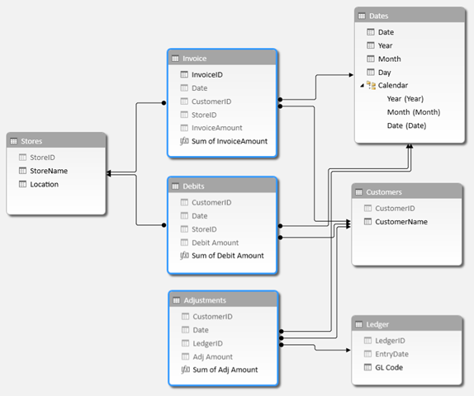

2.3 Human Interface Description
With a General Ledger interface you no longer have to fumble through payroll reports and manually enter data into your accounting package. JetPay Payroll Services, formerly A D Computer, can create a custom interface that works with the accounting software you already use so that your payroll items are posted to your GL quickly, easily, and accurately.

Save time...simply export your payroll data from our system and import it to the accounting package you use.
Increase accuracy... eliminate the human errors associated with manual entry (you also save time spent on reconciling discrepancies).
Take Control... no more worries about changes made to your GL/chart of accounts. You and your authorized users retain control!
Main Menu Window
GENERAL LEDGER MENU
• The EDIT LEDGER TRANSACTIONS Program is used to add, change, view or delete any transaction in the ledger database.
• The GENERAL LEDGER JOURNAL
Lists ledger transactions in journal (numerical) order.
• The ACCOUNTTRIALBALANCE
Lists ledger transactions by account in
chronological order with account subtotals.
• The GENERALLEDGERANALYSIS
Lists each account balance in a monthly spreadsheet.
MONTHLY REPORTS
•Letter-Perfect GENERALLEDGER
STATEMENT, BALANCESHEET
And INCOMESTATEMENTS can be
Produced according to your accountant’s specifications.
MONTHLY UPDATES
• Monthly updates from all subsidiary software packages including, order invoicing, receivables, cylinder control, payables and
Payroll can be run in summary or detailed mode to automatically
Create General Ledger entries.
CHART OF ACCOUNTS
• The EDITCHART OF ACCOUNTS program allows you to
add, change, view or delete records in the chart of accounts file.
• The CHART OF ACCOUNTSLIST shows the complete chart
Of accounts.
• The CHANGE G/L ACCOUNT I.D. is used to change a G/L
Account ID throughout the system.
MISCELLANEOUS
• The VERIFY LEDGER DATA program is a maintenance program to ensure the internal integrity of the General Ledger data.

Other window are also explain in the
Main menu window

3.3 Subsystem Description
3.1 Subsystem Flow Diagram

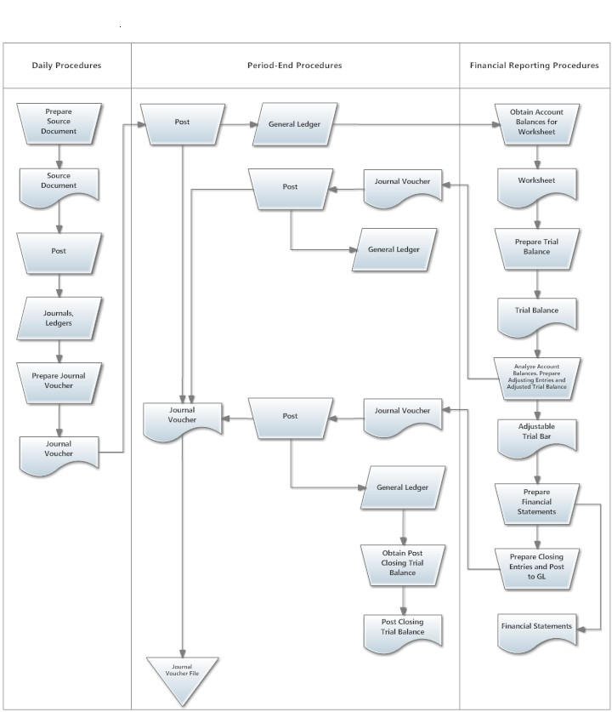

4.0 Enhanced Interface Prototyping
4.1 Prototyping Requirements

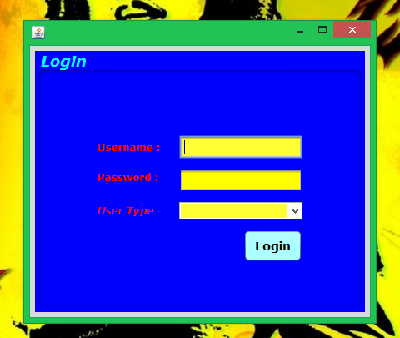

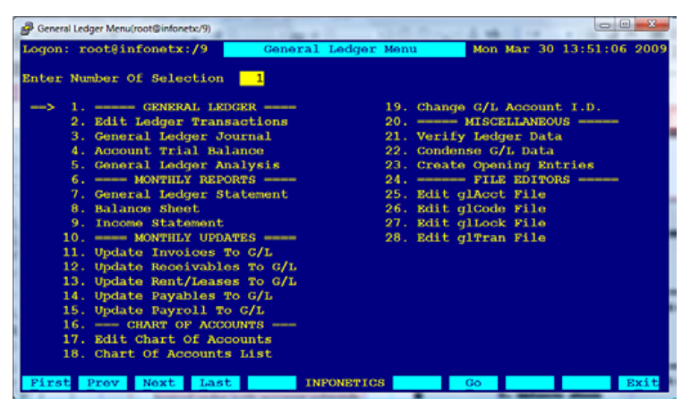

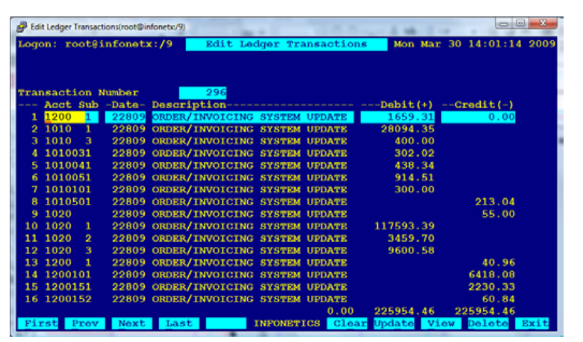
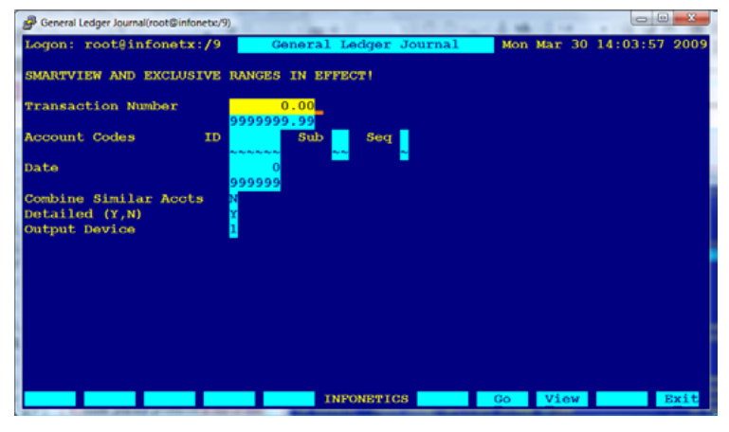

Software Requirements Specification
  - Goals and Objectives
The primary objective of the General Ledger System from Legler Systems is to process accounting information. This GL System performs the basic general ledger objectives by providing a complete and accurate bookkeeping record of all accounting transactions affecting each ledger account and supports either the cash accounting method or the accrual accounting method.
The goals of general ledger are:

- To provide complete financial statement
- To lessen the amount of paper work
- To provide all total of expenses in the company
- To validetate the balance/expenses
- No re-keying - Save time and effort and eliminate redundancies
- Access 24/7 - Convenient and flexible
- Quick mapping - CPS will customize your interface so it works for you.

  - System Statement of scope
    - General requirements
The following general requirements were laid out of our project named general ledger
With asset accounting
- A way to create financial statement
- A way to update receivables to g/l
- A way to update payables to g/l
- A way to update payroll to g/l
- A way to have income statement

- Interface Enhancements

Staff members of the security agency have some enhancement requests
To have easy in access of the product

- Database Administrative Interface

- Online Help
To make a complete help menu for the user assistance and also
Be used to present information on board range of subjects

- Training
training is as important as the software itself in the success of implementing a new general ledger system. Your system is set up with your institutional data, business rules, and variables from your migrated data. Using financial data makes the training more relevant for staff members and provides a better opportunity to review and become comfortable with

Training typically takes place over a two month period and has two phases about a month apart. This allows staff members to try out new skills, practice on the non-production database, ask questions, and become familiar with the system. They receive exceptional, personalized training at a comfortable pace.

  - System Contex

General Ledger Accounts are used to identify balance sheet classifications, revenue classifications, or expenditure classifications. Balance Sheet accounts include Asset accounts, Liability accounts, and Net Assets and Reserves. The development of the general ledger is actually for academic purposes only to begin with. It is necessary or mandatory for the proponents to have a client on which the proponents will gather data and information needed to establish and develop a correct business processes. If there is no client, the proponents will have a hard time for identifying the needed data and information for the GL development. Furthermore, if the development of the GL will be a success, it is a good example of a teaching-learning method provided by the current school on which the proponents are studying while developing the GL. More importantly, the client will be benefitted the most when the GL will be implemented on their respective company / agency. With this, the client will upgrade their business transaction using the latest technology provided by the GL. The system will make sure that the processes of the company are still the same, the thing is, it will now a computerized rather than the previous manual process that they had.

  - Major Contriants
Funding
Funding is the worst possible constraints for the proponents, the funds that the proponents are only limited considering they are currently dependent as a students who lacks on personal fund to support the expenses for developing the GL. However, this constraint will not be an issue for not pursuing the objectives for the development of the GL.

Time
The project only have an approximately five months to finish all documentation, software and interface enhancements. This is a disadvantage for the proponents knowing that the system development and documentation has to finish within five months at the same time the project are still studying on their classes and still searching on how the software development will takes place.

2.0 Usage Scenario
2.1 User Profiles
There will be four levels of users:
- Full access/control(administrator)
- Read/Write/edit/add(staff)
- Read only(public)
- Read/write modify(client)
2.2 Use-cases
Read only users
He/she connot edit,add or modify any transaction
Full control
This type of user can do whatever he/she wants to the software
Read/Write/edit/add(staff)
they can modify the records of the users they created
Read/write
This user can only add details but cannot delete

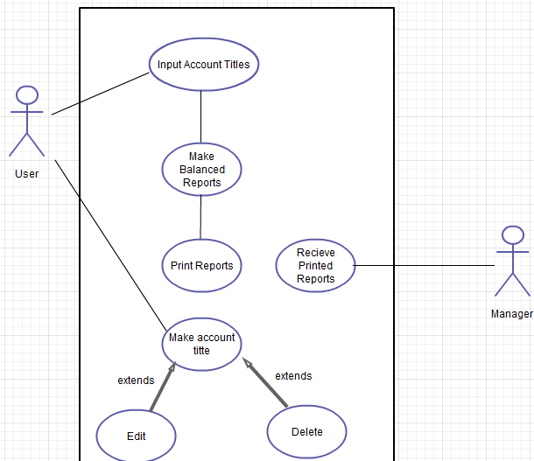

  - Data model and Description
  - Data Description

3.2.1 Data objects and dictionary
Edit ledger transaction
- Transaction no:
This is the number of the transaction
- Account sub:
- Date:
This is the date of the transaction
- Description:
This is the description of the transaction
- Debit:
- Credit:
- Total:

General ledger journal
- Transaction id:
This is the number of the transaction
- Date:
This is the date of the transaction
- Description:
The description of the product
- Amount sub:
- Debit:
- Credit:
- Balance:
Account Trial Balance
- Transaction id:
- Date:
This is the date of the transaction
- Descripton:
This emphasize the kind of transaction
- Amount sub:
- Debit:
- Credit:
- Balance
- Grand total:
General ledger Analysis
- Amount:
- Sales:
- Total sales:
- Cost of goods:
- Total cost of goods:
- Gross profit:
- Expenses:
- Total expenses:
- Net operating income:
- Month:
- Total:
General ledger Statement
- Transaction id:
- Account sub:
- Date:
- Sub Description:
- Beginning Balance:
- Current Debit/Credit:
- Amount Total:
Balance Sheet
- Transaction id:
- Description:
- Total fixed assets:
- Total other assets:
- Total assets:
Income Statement
- Transaction id:
- Description:
- Total operating income:
- Net operating income:
- Discounts earned:
- Interest expenses:
- Total other income expenses:
- Federal icome tax:
- Other taxes and licences:
- Total taxes:
- Net income after taxes:
Monthly Updates
- ID:
- Description:
- Order:
- Less:
- Solid:
- Volume:
- Price:
- Mark-up:
- Grand Total:
Chart of Accounts
- Account id:
- Descriptive name:
- Sequence code:

3.1.2 Relationships

4.0 Functional Model and Description
The function and purpose of the general ledger in accounting - Foundation level
The general ledger is the central core of the accounting information system where all of the financial transactions of a business are categorized and summarized into accounts. These accounts in the general ledger group similar transactions into individual records producing a continually updated credit/debit balance for each. The number and type of accounts that make up the general ledger is determined by the chart of accounts. The general ledger contains a permanent history of all the financial transactions that have taken place in the business since its first day of operation.

4.1 Subsystem Flow Diagram

4.2 Human Interface Description
With a General Ledger interface you no longer have to fumble through payroll reports and manually enter data into your accounting package. JetPay Payroll Services, formerly A D Computer, can create a custom interface that works with the accounting software you already use so that your payroll items are posted to your GL quickly, easily, and accurately.
Save time...simply export your payroll data from our system and import it to the accounting package you use.
Increase accuracy... eliminate the human errors associated with manual entry (you also save time spent on reconciling discrepancies).
Take Control... no more worries about changes made to your GL/chart of accounts. You and your authorized users retain control!

Main Menu Window
GENERAL LEDGER MENU
• The EDIT LEDGER TRANSACTIONS Program is used to add, change, view or delete any transaction in the ledger database.
• The GENERAL LEDGER JOURNAL
Lists ledger transactions in journal (numerical) order.
• The ACCOUNTTRIALBALANCE
Lists ledger transactions by account in
chronological order with account subtotals.
• The GENERALLEDGERANALYSIS
Lists each account balance in a monthly spreadsheet.
MONTHLY REPORTS
•Letter-Perfect GENERALLEDGER
STATEMENT, BALANCESHEET
And INCOMESTATEMENTS can be
Produced according to your accountant’s specifications.
MONTHLY UPDATES
• Monthly updates from all subsidiary software packages including, order invoicing, receivables, cylinder control, payables and
Payroll can be run in summary or detailed mode to automatically
Create General Ledger entries.
CHART OF ACCOUNTS
• The EDITCHART OF ACCOUNTS program allows you to
add, change, view or delete records in the chart of accounts file.
• The CHART OF ACCOUNTSLIST shows the complete chart
Of accounts.
• The CHANGE G/L ACCOUNT I.D. is used to change a G/L
Account ID throughout the system.
MISCELLANEOUS
• The VERIFY LEDGER DATA program is a maintenance program to ensure the internal integrity of the General Ledger data.

Other window are also explain in the
Main menu window

5.0 Restrictions, Limitations and Constraints
Time
only have an approximately five months to finish all documentation, software and interface enhancements. This is a disadvantage for the proponents knowing that the system development and documentation has to finish within five months at the same time the proponents are still studying on their classes and still searching on how the software development will takes place.

Workforce

only have a maximum of five members. That is why the number of people who work for the development of the software comes up in a disadvantage in terms of the numbers. The project have to double time regarding of the execution of the project documentation and requirements specification regardless of the shortage of the manpower of the project team.

Funding
Funding is the worst possible constraints for the proponents, the funds that the proponents are only limited considering they are currently dependent as a students who lacks on personal fund to support the expenses for developing the GL. However, this constraint will not be an issue for not pursuing the objectives for the development of the GL.

Resources
The software and hardware that the proponents used to develop the GL are also limited. The proponents only have one laptop and one desktop to be able to use in developing and documenting the software. It is more efficient for having at least one laptop / desktop per member of the project team to be able to execute the software development on time.

  - Validation Criteria
You use validation options to specify how GL accounts are validated. GL accounts are validated when they are used in GL account fields.
Typical validation tests include checking for missing data items, valid codes, and valid values. More extensive validation may entail authorization of the transaction based on the customers record and available inventory.
creating new user interface using Java Programming to develop the system’s front-end interface and MS SQL for the database or the back-end interface of the GL. This interface allows the users to The proponents are concerned about the input of data into the software and their expected outputs. This is the reason why the proponents will design an interface that is easily read by the user, creating a tool tip text in every fields and buttons to be able to identify the data to be input in every field to avoid errors on the data inputs.

Software Design Specification
  - Goals and Objectives
The main purpose of GENERAL LEDGER SYSTEM is the collecting point for all
financial data of a business. A chart of accounts and a ledger of
transaction entries are maintained in the database.
The goals of general ledger are:
- General Ledger Statement
- Balance Sheet
- Income Statement
- Chart of accounts
  - System Statement of Scope
The general statement of GL must be specified and provided in this section. That is the information has to be produced, what the major functions are implemented and what data are provided as the input GL.

    - General Requirements
The following general requirements were laid out of our project named general ledger
With asset accounting
- A way to create financial statement
- A way to update receivables to g/l
- A way to update payables to g/l
- A way to update payroll to g/l
- A way to have income statement

- Interface Enhancements

Staff members of the security agency have some enhancement requests
To have easy in access of the product

- Database Administrative Interface
The general ledger will provide a secured database on which the user could retrieve and save data and information at ease with the use of MS SQL database.

- Online Help
To make a complete help menu for the user assistance and also
Be used to present information on board range of subjects

- Training
training is as important as the software itself in the success of implementing a new general ledger system. Your system is set up with your institutional data, business rules, and variables from your migrated data. Using financial data makes the training more relevant for staff members and provides a better opportunity to review and become comfortable with
Training typically takes place over a two month period and has two phases about a month apart. This allows staff members to try out new skills, practice on the non-production database, ask questions, and become familiar with the system. They receive exceptional, personalized training at a comfortable pace.

  - System Contex

General Ledger Accounts are used to identify balance sheet classifications, revenue classifications, or expenditure classifications. Balance Sheet accounts include Asset accounts, Liability accounts, and Net Assets and Reserves. The development of the general ledger is actually for academic purposes only to begin with. It is necessary or mandatory for the proponents to have a client on which the proponents will gather data and information needed to establish and develop a correct business processes. If there is no client, the proponents will have a hard time for identifying the needed data and information for the GL development. Furthermore, if the development of the GL will be a success, it is a good example of a teaching-learning method provided by the current school on which the proponents are studying while developing the GL. More importantly, the client will be benefitted the most when the GL will be implemented on their respective company / agency. With this, the client will upgrade their business transaction using the latest technology provided by the GL. The system will make sure that the processes of the company are still the same, the thing is, it will now a computerized rather than the previous manual process that they had

  - Major Contriants
- Funding
Funding is the worst possible constraints for the proponents, the funds that the proponents are only limited considering they are currently dependent as a students who lacks on personal fund to support the expenses for developing the GL. However, this constraint will not be an issue for not pursuing the objectives for the development of the GL.

- Time
The project only have an approximately five months to finish all documentation, software and interface enhancements. This is a disadvantage for the proponents knowing that the system development and documentation has to finish within five months at
the same time the proponents are still studying on their classes and
still searching on how the software development will takes place.
- Data Design
  - Database Description
- Architectural and Component-Level Design
Enter user type, name, Password
START
User type, name, password that register
Valid User type, name, password from DB
Menu appear with option to select
MENU
Select option
EXIT
Chart of accounts
END
Monthly Updates
Monthly Reports
General ledger
Chart of account
Monthly Updates
Monthly Reports
General ledger
  - Program Structure
    - Overal

Menu Items
The following shows the architecture of the main menu:
Edit ledger transactions
- View
- Print
- Update

General ledger journal
- View
- Print
- Update

Account trial balance
- View
- Print
- Update

Chart of accounts
- Add
- change
- view
- delete

Description for Components
Login Form
Main form: frmLogin
Main actions: Login

This is the first form to appear after the user run the system. The user enters their username to the txtUsername and the password to the txtPassword to verify their accounts in order to access the system. The user must click the OK butoon which is the cmdOK. User will be logged in if it is valid username and password pair. If the user clicks the cancel button, the application will end if they confirmed their action.

Save
Object name: cmdSave, cmdCancel
form will be disabled unless the fields are all filled up with the data needed. When the save button is clicked, new record will be generated. If the user clicked the cancel button, the adding of record has canceled.

Delete
Object name: cmdDelete, cmdCancel
The delete button has been activated when the delete records in the chart of accounts file. If the user is not sure to delete, they can simply click the cancel button.

Update
Object name: cmdUpdate, cmdCancel
The update button allows the user to edit the employee records and then save the changes immediately. The cancel button is to cancel the update of the journal records.

View
Object name: cmdView
The use of this nutton is to view the financial statement
,balance,expenses and chart of accounts

Edit
Object name: cmdEdit
The edit button allows the user to records in the chart of accounts file.

Print
Object name: cmdPrint
This button allows the user to print the financial statement
General ledger journal and balance sheet.

    - Leave Monitoring
Main forms: frmCreateLeave, frmUpdateLeave
Main action: Print, Save and Update

Save
Object name: cmdSave
When the user clicks on the cmdSave button, all of the data that has been filled in the textbox provided in the form will be saved in the database. After the button has been clicked, a confirmation message will pop-up to the window that tells the user that there was new leave information has been created.

Update
Object name: cmdUpdate
The user allows modifying the leave information of the accounts. This function allows the user to change the data of the employee’s leave information when the employees intend to file their leave benefits.

Print
Object name: cmdPrint
The user allows printing the leave information of the selected employee. This function could be achieved by clicking the print button.

    - Reports
Main forms: frmReports
Main actions: View, Print

View
Object name: cmdPreview
This button allows the user to view the performance appraisal of the employee. This includes the comments and feedback of the client to the employee about their performance while working in the client’s provisions.

Print
Object name: cmdPrint
This button allows the user to print a hard copy including the reports selected by the user.

    - Help
Main forms: frmAbout, frmContents, frmTutorials
Main actions: Browse, View

Browse
Object name: cmdBrowse
The help function allows the user to browse the instructions on how to operate the system well. The about function on the help menu displays the information of the proponents and the information of the client. Contents function displays the system specification of the GL. Browsing of the tutorial function allows the user to learn some of the system’s functionalities by telling the user on how to manage the system process when there are errors occurs on the system.

View
Object name: cmdView
The view button allows the user to select on the help menu on which they want to view on the instruction that they want to know.

- User Interface Design

The GL have a lot of interface that hasn’t to be designed yet. The proponents are still researching for the additional scope of the system and obviously other interface will be developed also. The client also have a lot of ideas for the interface that’s why the proponents have to discuss to see rather they can be combined form of the forms for the GL project.

- Description of the User Interface
The following image represents the forms in the GL. After running the GL, the login screen will appear. If the user enters the right username and password, it will immediately take them to the main interface of the GL which is the main menu window.

    - Screen Images

    - Objects and Actions
- Login Form
Username
Username can be ranged from 6-15 letters or numbers, as the industry standards. No special characters and space.
Password can be ranged from 6-20 letters and numbers, as the industry standard. No special characters and spaces.

User type
This field consists of the level of the user to access the system. The level of accessibility and functionality of the system depends on the user type given.

Menu Items
The following shows the architecture of the main menu:
Edit ledger transactions
- View
- Print
- Update

General ledger journal
- View
- Print
- Update

Account trial balance
- View
- Print
- Update

Chart of accounts
- Add
- change
- view
- delete

Menu bar
The GL provides a menu bar which contains the icons that equivalent to the commands in the menu items. These icons are selected according to the function that they represent. These icons will be the other way to connect into the different functionalities of the system. These icons serve as the main attraction to the main menu window of the system.

  - Interface Design Rule
Interface design rules are focused on these areas of concerns:
- The system must be user-friendly
- The system must be easy to navigate
- The system should be readable
- The system should be easy to learn
- The system should be maintainability
- The system should use a maximum of three colors
- The system must be reliable

  - Components Available
The project are allowed to use Java Programming language as a general rule given by the project evaluation committee. The Java Net beans chose by the proponents to develop the GL and as a reference for creating the system’s front-end. Basically, the projects are already having a lot of ready-made components available to develop the proposed system. The following is a list that the proponents will use for the software development.

    - Java Swing Controls
- JTextField
- JLabel
- JButton
- JPanel
- JFrame
- JPasswordField
- Etc.

    - Java Swing Menus
- Menu Bar
- Menu Item
- Pop-up Menu
- Etc.
    - Java Swing Container
- JPanel
- Toolbar

- Restriction, Limitations and Constraints
- Time
Time is so far the biggest restriction or constraints for the project to developed the proposed system. The projects only have an approximately five months to finish the entire project. It is very important for the projects to watch the time to spend over the phase of the software development project. The projects could have included many components to the project like online GL but time restricts the project team from doing so.

- Individual Skills
Skills in computer programming and design skills are also one of the restrictions. It does not have as big of an impact on the project as time but it sure does limit the proponents from doing more addition to the project functions and components.

- Insufficient Resources
The project only have limited equipment for the software development. The proponents planned to develop an android application by using tablet PC but for now, it is impossible to be implemented because the financial status of the project limited. That’s why the proponents will have to abandon the plan.

- Testing Issues
The purpose of this phase is to identify as far as possible any errors and deficiencies in the system prior to its final release into production use. For instance errors in

- User interface
- Procedure manuals
- Job design
- Organizational structure design

In reality all system features cannot be checked at the outset. For instance, users might realize that the
system has inadequate procedures manual only after the system has been properly implemented.

  - Classes of Test

In reality all system features cannot be checked at the outset. For instance, users might realize that the
system has inadequate procedures manual only after the system has been properly implemented.
Interface / Forms
The project are creating new interface using the Java Net Beans. This interface allows the user to manage the General ledger particularly in computing the total expenses of the company to save new data and to be able to print necessary documents.

Login Window
The project will use several different username and password. The proponents will have to use either correct and incorrect username or password to access the GL and thus access its database. The user will not be logged in if they insert the wrong username or password. When the correct username and password will be inserted, the user will be able to log into the next window. This will be possible upon checking the OK button by performing a proper testing of the function.

GL (Main Form)
This is the main window of the GL that the user will use to access the database using the Java Net Beans. The main window has a several drop down menu in this window.
The EDIT LEDGER TRANSACTIONS, GENERAL LEDGER JOURNAL, ACCOUNTTRIALBALANCE, CHARTOFACCOUNTS

  - Identification of Critical Component

- Appendices

Chapter III - Test Specification
- Introduction
This section gives the general overview of the test specification for the GL under the service management. This includes the methods used by the proponents to identify the outcome of the software when it is being used. The tools and equipment used to test the software and the windows of the GL to b tested.

  - Goals and Objects
The main purpose of GENERAL LEDGER SYSTEM is the collecting point for all
financial data of a business. A chart of accounts and a ledger of
transaction entries are maintained in the database.
The goals of general ledger are:
- General Ledger Statement
- Balance Sheet
- Income Statement

  - Statement of Scope
This section gives the overall plan for integration of the software and a description of specific test is being implemented here. The following are the different kinds of tests that the proponents will take to ensure the quality of the GL.

- Unit Testing
- MS SQL Database
- PC Application
- Java Net Beans

Unit test will be performed using black box testing methods.

- Integration Testing
- MS SQL Database
- PC Application
- Java Net Beans
- Portability Testing
- MS SQL Database
- GL
- PC Application
- Security Testing
- MS SQL Database
- GL
- PC Application
- Performance Testing
- MS SQL Database
- GL
- PC Application

  - Major Constraints
In this section, the project will talk about the business, technical or resource related constraints that may keep the project team from performing all test necessary.

- The project have limited funds for testing the proponents only have one laptop to make software testing for gl. This means that the proponents cannot test the software using laptop / PC from other brand and other hardware specification that is lower / lesser price than of the laptop / PC that the proponents are currently using.
- The project have a limited access to the client, for this reason the software testing with the clients. The client also has to set an appointment with the proponents. Unfortunately, the discussion between the client and proponents regarding the results of software testing are vulnerable and inconsistent.
- The project don’t have enough manpower to perform the software testing and identify the results. This might be the reason for not be able to test the GL into the larger user base.
- The project haven’t enough time to perform the while software testing due to schedule conflict. The project will only have to test the most important parts that are hard to fix rather than to test the smallest parts that are easy to repair.

- Testing Plan
The project want the Gl to be bug five and lesser error on the processes. The project also want to make sure that there are no defects in the system. This is the reason why the proponents have to spend large amount of the total software development time on the testing. The following are the description of the testing procedure and strategy. The project also be presenting the timing and scheduled of the tests to be carried out.

  - Software to be Tested
    - Interfaces
Login Window
The project make sure to deal with the possibilities of error occur on this window. The project use several username and password to tests the security level of the GL if it is working. The project also have to test the OK button and Cancel button on this window by clicking these button and try to find out if it is working properly.

SMS – GL (Main Window)
This is the main window of the GL that the user will use to access the database using the Java Net Beans. The main window has a several drop down menu in this window.
The EDIT LEDGER TRANSACTIONS, GENERAL LEDGER JOURNAL, ACCOUNTTRIALBALANCE, CHARTOFACCOUNTS The project will try to use all the menus and the different options available in each of the window.

- Journal Information
When Journal informatio button is clicked, user will be shown three choices.
- Add Entries
This function can add journal ebtries and the date of transaction
- Update ledger transaction
This function could update the ledger transaction and make some changes on it
- Delete transaction
This function allows the user to delete the transaction information if they are not a part of the company or the contract has been terminated.

- Leave
When the user selects the leave button, the user allows creating leave

- Reports
The user allows viewing some of the reports that is required for the GL department. The user also allowed printing these reports.

- Help
When the user clicked this button, the user will be shown three choices
- Contents
This window allows the user to learn the systems processes and functions
- About
This window allows the user to learn about the project information and the information of the client that is using the GL
- Tutorials
This window gives the user to learn the steps or the ways on how the system will be used. This window consists of the tutorials on the system

  - Testing Strategy

This section will describe the testing strategy. The project will use these following testing methods to test the GL and the proponents decided to use black box testing methods. The following are the testing strategies for the GL.
    - Unit Testing
In this unit testing case, the proponents will be separately testing the different modules on the system. The proponents will carry out black box methods where each component of the software is tested individually. The proponents will test the components by testing the inputs and identify the expected output and the output that is generated by the system. The test will be carried out by the programmer who designed and implemented the module. The system analyst will carry out the test on the modules to finalize the testing.

    - Integration Testing
Sending payroll data to General Ledger is one of the final steps in the payroll cycle. When you integrate Global Payroll and General Ledger, you can automatically post earnings and deductions that are associated with a finalized calendar run to your General Ledger system.

    - Portability Testing

the process of testing an existing software component or application in a new environment.The test results, defined by the individual needs of the system, are some measurement of how easily the component or application will be to integrate into the environment and these results will then be compared to the software system's non-functional requirement of portability for correctness. The levels of correctness are usually measured by the cost to adapt the software to the new environment compared to the cost of redevelopment.
.

    - Security Testing
User access to Financial information and records should be highly secure. Compulsory password settings to include letters as well as numbers, and upper case will ensure that access to the e-Bis and Open Accounts systems remain secure.
Audit review found that passwords were not required to be alphanumeric or contain upper case characters.
Passwords with no preconditions expose the system and the Authority to unauthorised user access.

- Confidentiality among the username and password of the user
- Authentication for every user type to logged into the system
- Authorization for the usernames and password before accessing into the system
- The GL is secured against known and unknown vulnerabilities
- Securing of data by using a high-level database security measures.
- Availability of the system’s functions according to the type of user

    - Performance Testing

It is important to have testing before using the system to know
If it is performed well of responsiveness and stability under various workload and the quality attributes of the system, such as scalability, reliability and resource usage. Inorder to do this you must have the following:
the desktop / laptops to be used, computer resources, application needed, hardware specification,

  - Testing Resources and Staffing
The proponents will use several different resources to carry out the test on the GL. Since the time is a part of project constraint, the proponents will try to use help from everyone that is essential to take the responsibility and evaluate the software during the testing phase.

- The Company Staff
- The Proponents
- Laptop / Desktop
- Software Applications

  - Test Record Keeping
Test record keeping and test work products are described in section 3.4 of the test specification document. For further information regarding section 3.4 of the test specification document.

Testing Tools and Environment
The project will have to provide the testing tools such as the desktop / laptops to be used, computer resources, application needed, hardware specification, other devices and the company office that serves as the main venue for the testing of the GL. The proponents will also use resources available to software development team outside of the client’s facilities.

  - Test Schedule
The following is the schedule for the testing of the HRMS.

Project Test Plan
- To be scheduled
System Testing
- To be scheduled
Generating the test reports
- To be scheduled
System Implementation
- To be scheduled

- Test Procedure
In this section the proponents will describe the test procedures in detail.

  - Software to be Tested
The following software that has to be tested is listed on the section 2.1 from the test specification document. For detailed list of the software component items you can refer to the previous section of the document.

  - Testing Procedures
In this section, the project will describe the overall software specification of the GL. It includes the description of the methods for all the different tests to be performed and will also declare the expected outputs.

    - Unit Testing
In this unit testing case, the proponents will be separately testing the different modules on the system. The proponents will carry out black box methods where each component of the software is tested individually. The proponents will test the components by testing the inputs and identify the expected output and the output that is generated by the system. The test will be carried out by the programmer who designed and implemented the module. The system analyst will carry out the test on the modules to finalize the testing.

    - Integration Testing
Sending payroll data to General Ledger is one of the final steps in the payroll cycle. When you integrate Global Payroll and General Ledger, you can automatically post earnings and deductions that are associated with a finalized calendar run to your General Ledger system.

    - Portability Testing
the process of testing an existing software component or application in a new environment.The test results, defined by the individual needs of the system, are some measurement of how easily the component or application will be to integrate into the environment and these results will then be compared to the software system's non-functional requirement of portability for correctness. The levels of correctness are usually measured by the cost to adapt the software to the new environment compared to the cost of redevelopment.

    - Security Testing
User access to Financial information and records should be highly secure. Compulsory password settings to include letters as well as numbers, and upper case will ensure that access to the e-Bis and Open Accounts systems remain secure.
Audit review found that passwords were not required to be alphanumeric or contain upper case characters.
Passwords with no preconditions expose the system and the Authority to unauthorised user access.
- Password Login

Passwords used to log into Open Accounts system should be alphanumeric and contain upper case, in addition to being over six characters long.

- Modular Access
The GL identifies the user and allows him/ her to access only certain modules. The proponents will try to see if the software restricts unauthorized users from accessing
certain modules of the software.

    - Performance Testing
It is important to have testing before using the system to know
If it is performed well of responsiveness and stability under various workload and the quality attributes of the system, such as scalability, reliability and resource usage. Inorder to do this you must have the following:
the desktop / laptops to be used, computer resources, application needed, hardware specification.

Login
The user should be able to log on within 0.2 second
Save Function
Best Case Scenario – Immediate
Worst Case Scenario – 3 seconds
Search Function
Best Case Scenario – Immediate
Worst Case Scenario – 3 seconds
Print Function
Best Case Scenario – Immediate
Worst Case Scenario – 2 seconds
Browse Function
Best Case Scenario – Immediate
Worst Case Scenario – 2 seconds
Delete Function
Best Case Scenario – Immediate
Worst Case Scenario – 3 seconds
Exit Function
Best Case Scenario – Immediate
Worst Case Scenario – 3 seconds

Cancel Function
Best Case Scenario – Immediate
Worst Case Scenario – 2 seconds
Next List of Records
Best Case Scenario – Immediate
Worst Case Scenario – 3 seconds

  - Testing Resource and Staffing
installation options. Select System, Business Unit or Type in the GL Options group box on the Billing Integration Options page. Define installation options and mobile approval options for General Ledger. Grants.Define Staffing Front Office and Pay/Bill Management installation options.

- Client Staff / Employees
The project ask for help to test the GL with the participation of the security agency personnel. The employees / staff are allowed to use the full function of the GL as part of its validation testing. The employees are allowed to record any errors that they encounter during the software testing on hand.

- Handheld PC / Desktop / Laptop
The project will have to use the clients PC or laptops after installing the GL. This will allow the user / employee to test the GL with one or more tester at the same time. With this, the data from one computer to the other are also identified through the system integration functionalities of GL.

- Error Reporting
The project provide a reports manual on which the employee and staff are required to list down the error and bugs that they may encounter during the testing activity.

- Other Devices
The project will also have to use other devices that is necessary for the functionalities of the GL like printer, Scanner and other devices that supports the GL processes.

