Bestlink College of The Philippines

1071 Brgy. Kaligayahan Quirino Highway, Novaliches Quezon City

Service Management System

(General Ledger with Asset Accounting)

A Project Study
Presented to the IT Project Evaluation Committee
Bestlink College of the Philippines
Quezon City, Philippines

In Partial Fulfillment of the Requirements for the Degree
Bachelor of Science in Information Technology

Submitted by:
Jennilyn Soriano A.
Abigail Aquino G.
Nitoral Wilfredo Jr. H.
Groyon Jorge
Peque Mark Jason V.

Date to be Submitted:
October

TABLE OF CONTENTS

CHAPTER I – Project Charter Pages

PROJECT
BACKGROUND - - - - - - - - - - - - - - - - - - - - - - - - - - - - - - - - - - - - - - - - 1
  - Problem/Opportunity Description
  - benefits
  - Goals
  - Stakeholders and Client
- PROJECT SCOPE
2.1 Objective
2.2 Deliverables
2.3 Out of Scope
- PROJECT PLAN
3.1 Approach and Methodology
3.2 Project Timeline
3.3 Success Criteria
3.4 Issues and policy Implications
3.5 Risk Management Plan
3.6 Service transition
3.7 Options Analysis

- TECHNICAL FEATURES
- PROJECT ORGANIZATION AND STAFFING
- PROJECT BUDGET
- APPENDIX A-ADDITIONAL INFORMATION

CHAPTER II

Review Related Literature

Introduction

Local and Foreign Studies and Synthesis
(Matrix)

CHAPTER III

Risk Mitigation,Monitoring and Management Plan
1.0 Introduction
1.1 Scope and Intent of RMMM Activities
1.2 Risk Management Organization
2.0 Functional Data Description
2.1 Risk Table
    - Description of Risk M
    - Probability And Impact for Risk M
- Risk Mitigation and Monitoring and Management

  - Risk Mitigation for Risk M
    - Product Size
    - Business Impact
    - Customer (user) Risk
    - Process Risk
    - Technology Risk
    - Development Risk
    - Employee Risk(Team Members)
3.2 Risk Monitoring for Risk M
    - Product Size
    - Business Impact
    - Customer (user) Risk
    - Process Risk
    - Technology Risk
    - Development Risk
    - Employee Risk(Temmates)
3.3 Risk Management for Risk M
    - Product Size
    - Business Impact
    - Customer (user) Risk
    - Process Risk
    - Technology Risk
    - Development Risk
    - Employee Risk(Team Members)

Software Configaration Management Plan
- Introduction
  - Scope and Intent of SCM Activities
  - SCM Organization Role

- SCM Tasks
2.1 Identification
2.1.1 Description
2.1.2 Work Products and Documentation
2.2 Configuration Control
2.1.1 Description
2.3 Version Control
2.4 Configuration Status Accounting (CSA)
2.4.1 Description

Software Quality Assurance Overview
- Introduction
1.1 Scope and Intent of SQA Activities
1.2 SQA Organization Role
2.0 SQA Task
2.1 Task Overview
3.0 Problem Reporting and Corrective Action/Follow Up
3.1 Reporting Mechanism
3.2 Responsibilities
3.3 Data Collection and Valuation

System Specification

1.0 Introduction
1.1 Goals and Objectives
1.2 System Statement of Scope
1.2.1 General Requirements
1.3 System Context
1.4 Major Constraints

2.0 Functional Data Description
2.1 System Architechture
2.1.1 Architechtural Model
2.1.2 Subsystem Overview

2.2 Data Description
2.2.1 Major Data Object
2.2.2 Relationships

3.0 Subsystem Description
3.1 Subsystem Requirements Flow Diagrams
3.1.1 Create Checklist
3.1.2 Print Checklist
3.1.3 Generate Letter

Software Requirements Specification
  - Goals and Objective
  - System Statement Requirements
    - General Requirements
    - Extended Enhancements
  - System Context
  - Major Constraints

- Usage Scenario
  - User Profiles
  - Use - Cases
- Data Model and Description
  - Data Description
    - Data Object and dictionary
    - Relationships
- Functional Model and Description
  - Subsystem Flow Diagram
    - Create Checklist
    - Print Checklist
    - Generate letter
  - Human Interface
- Restrictions, Limatations and Contains
- Validation Criteria

- Introduction
  - Goals and Objectives
  - Statement of Scope
  - Major Constraints
- Testing Plan
  - Software (SCIS) To be test
    - Interfaces
2.2 Testing Plan
    - Unit Testing
    - Integration Testing
    - Validation Testing
    - High-Order Testing

2.3 Testing Resources and Environment
2.4 Testing Record Keeping
2.5 Testing Tools and Environment
2.6 Test Schedule (WBS)
3.0 Test Procedure
3.1 Software (SCIS) to be tested
3.2 Testing Procedures
3.2.1 Unit testing
3.2.2 Integration Testing
3.2.3 Validation Testing
3.3 Testing Resources and Staffing
3.4 Test Record Keeping and Logs

GENERAL LEDGER WITH ASSET ACCOUNTING

- Project Background
A general ledger is a complete record of financial transactions over the life of a company. The ledger holds account information that is needed to prepare financial statements, and includes accounts for assets, liabilities, owners' equity, revenues and expenses. a general ledger is typically used by businesses that employ the double-entry book keeping method - where each financial transaction is posted twice, as both a debit and a credit, and where each account has two columns. Because a debit in one account is offset by a credit in a different account, the sum of all debits will be equal to the sum of all credits.

  - Problem/ Opportunity Descriptions
Ledger System not fully integrated real-time general ledger you know up to the second how your business is affecting your profit and loss and balance sheet. Drill down to transaction level information showing subsidiary journals and original documents. Set budgets for your departments and monitor how well they are being followed. A flexible GL account setup allows for profit centers and sub-accounts. GL accounts can be attached to vendors, allowing you to properly allocate expenses in your financials. You can even track your fleet expenses down to the individual truck.

    - View General Ledger information in real time
    - Drill down to transaction level information showing subsidiary journals and original document
    - Generate fully customizable profit & loss statements and balance sheets
    - Flexible GL account setup allows for profit centers and sub-accounts
    - Create multiple GL entries by peso value or percentage for all transaction types

1.2 Benefits

Electronic Review

Making the review electronic allows for the system to do some of the work previously done manually (see features below). In addition, it reduces the need for paper - saving resources and reducing filing space. Even if a department decides to continue manual review, the certification is still captured electronically, ensuring that it won't get lost in a shuffle of paper.

Ongoing Annotation

Departments no longer must wait until the end of the month to perform their review and certification of the ledgers. Annotation enables reviewers to review the general ledger during the month, thereby eliminating the peak in workload at the end of the month.

Track and keep good record of your receivables and customers.
Business software can also help you to stay up to date with overdue payments, and even generate payment reminder letters for your customers. Calculate taxes quickly and efficiently. In addition, you will be able to compare the current year’s tax with the previous year’s tax amount, which will give you valuable insight in terms of what to expect for the next year.

1.3 Goals
- to understand the elements of a responsibility accounting system
- to know the different report types and the attributes common to all reports
- to understand the management decision-making process
- to understand the operational features of the general ledger system, the financial reporting system, and the management reporting system
- to be able to identify the principal operational controls governing the general ledger
- These system provide financial or operational reports for business
Owners to make decisions.
- Manage general ledger (GL) with financial controls and procedures.
- Manage accounts payable (AP), including payments, journal entries, and tax reporting.
- Manage accounts receivable (AR), including invoices, receipts, and journal entries.
- Facilitate multiple payments, types, receipt types and journal entries.
- Automated workflow processes to enforce control requirements.
- Reduced reliance or manual process.

1.4 Stakeholders and Clients

The Proponents
The proponents will have the opportunity to enhance the The GL system of the company by undertaking a project study and produce an up-to-date information system that will surely helps the General Legder Process and able to answer the company problem regarding of handling its manpower.

The User
The user of the GL system will be the employee or anyone who is authorized for handling and managing the financial and accounting process. The General Ledger will help to manage all financial Process of the company efficiently and accurately.

The Proponents School / Institution
This project study is the proof of better and outstanding education provided by the current school of the proponents which is the Bestlink College of the Philippines. It is a good evidence and result of good teaching-learning activities providing the best workflow that has to be produced by the current school of the proponents.

Business/Industry
involved in the system’s transactions. It may refer to the suppliers, sponsors, wages and others.
- Project Scope

The general ledger is comprised of all the individual accounts needed to record the assets, liabilities, equity, revenue, expense, gain, and loss transactions of a business. In most cases, detailed transactions are recorded directly in these general ledger accounts. In some cases where the volume of transactions would overwhelm the record keeping in the general ledger, transactions are shunted off to a subsidiary ledger, from which just the account totals are recorded in a control account in the general ledger.

  - Objectives

This section describes the components or parts of the General Ledger System to be accomplished. Objective statements on this section will clarify and demonstrate the boundaries of the scope under the GL with Asset Accounting. This will be illustrated as the Work Breakdown Structure (WBS) under the GL with Asset Accounting.
2.1.1 Service Management System – GL with Asset Accounting

2.1.1 shows the whole module of the GL with Asset Accounting. Which is the GL function and report, and also the function of communication to other sub-system.
    - GL with Asset Accounting – (Work Breakdown Structure )
The figure below shows the tasks under the initialization process, system planning, system analysis, system design and system testing and evaluation that the proponents has to be accomplished in order to make the GL with Asset Accounting successful.

- Deliverables
Project Deliverables | Work products/Description
Expenses | Charge codes defined as expense charge codes are automatically assigned in this tab when selected for the deliverable. Expense estimates are entered and actual tracked in this tab by charge code.
Capital | Charge codes defined as capital charge codes are automatically assigned in this tab when selected for the deliverable. Capital estimates are entered and actuals tracked in this tab by charge code.
Benefits | When expense and capital charge codes that have been configured (Application Administration) with associated benefit charge codes are selected, the associated benefit.
Time-Phased | All charge codes selected for the deliverable are automatically assigned to the time-phased tab. Estimates entered in the expense, capital and benefits tabs are automatically time-phased based on the estimated start and estimated finish date for the deliverable. If no estimated dates are entered, the amount will be displayed in the month of the project start date.
Summary | This tab displays aggregate totals for expenses, capital expenditures and benefits. It also displays the gross profit and simple ROI.
Charge Codes | Displays the name of the charge code.
Associated Charge Code | Displays the name of the associated benefit charge code.

Project Deliverables | Work products/Description
Rev / Rec (Revenue Recognition) | Is used to define whether an expense will flow through to an associated benefit charge code. When a selected expense or capital charge code has an associated benefit charge code, this field is enabled to permit the selection of calculation method used to aggregate the benefit values based on the actual expense or capital cost.
N/A | no benefit recognition
Ratio | The actual benefit aggregation is based on the ratio: estimated expense divided by the estimated benefit. As expense actuals are entered, this ratio is used to calculate the actual benefit
Flow-thru  Estimate | the actual expense is used as the actual benefit.  This is an editable field used to estimate the budgeted amounts per selected charge code.
Baseline | This is a non-editable field that displays the current baseline amounts per selected charge code.
Actual | This is an editable field that displays the manually entered actual amounts per selected charge code. Also supports a negative value, this allows for the correction in subsequent months of values entered in previous months.
Billed | DiDisplays the amount billed for the selected charge code.

  - Out of Scope

    - Recruitment and Assignment of personnel monitoring
    - Training and development
    - Contract management
    - Determine the numbers of employees
    - Employees profiles
    - Recruiting Employees

3.0 Project Plan

3.1 Approach and Methodology

In this phase, the proponents discuss the possible ways of solving the problems and the steps on which the proponents will require accomplishing for the succession of the GL system. The proponents decide to use the System Development Life Cycle (SDLC) to determine the possible way for solving the problems.

Project Planning
The proponents also have to conduct surveys and interviews to gather the necessary data that will surely help to determine the business processes involve in the GL system. The proponents have to create long-term plans for the tasks that they have to comply within the first day of the development to the implementation phase of the software.

System Design

This is the process of defining the architecture,components,modules,interfaces and data for a system to satisfy specified requirements.

System Analysis

Gathering of data and information is the most important task that the proponents must comply. It is acquired by conducting several company interviews, providing questionnaires, surveys, term papers and research. Data gathering is essential for studying the business process that can be helpful for the developing of the software.

Testing and integration

In the testing and integration, the whole system is test one by one. The modules of the executable code are tested individually. The developed modules are integrated with external modules, systems, and components.

Implementation
In this phase, the transformations of the high-level design into an executable code occur. The code is developed according to the coding, standards adapted by the development firm. Includes implementation preparations, implementation of the system into a production environment and resolution of the problems identified in the integration and test phases.

Operation and Maintenance

The system operation, support and maintenance aims to satisfy the needs and of the client by maintaining the GL system to its workable status without errors and bugs.

3.2 Project Timeline

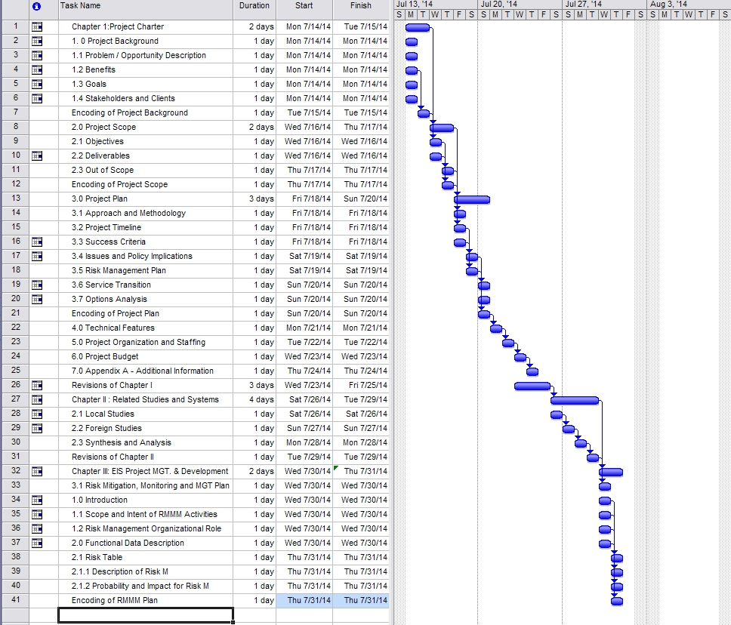
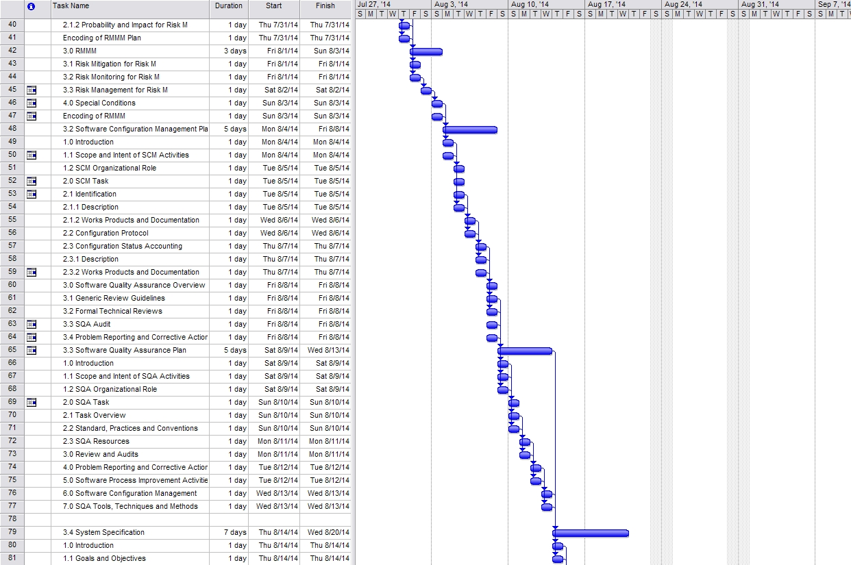

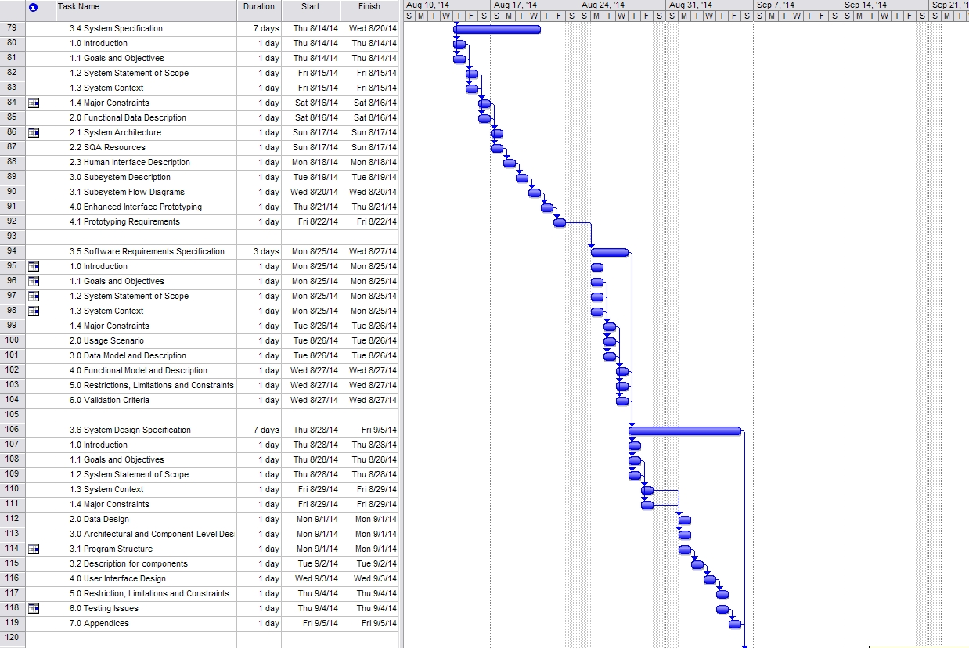
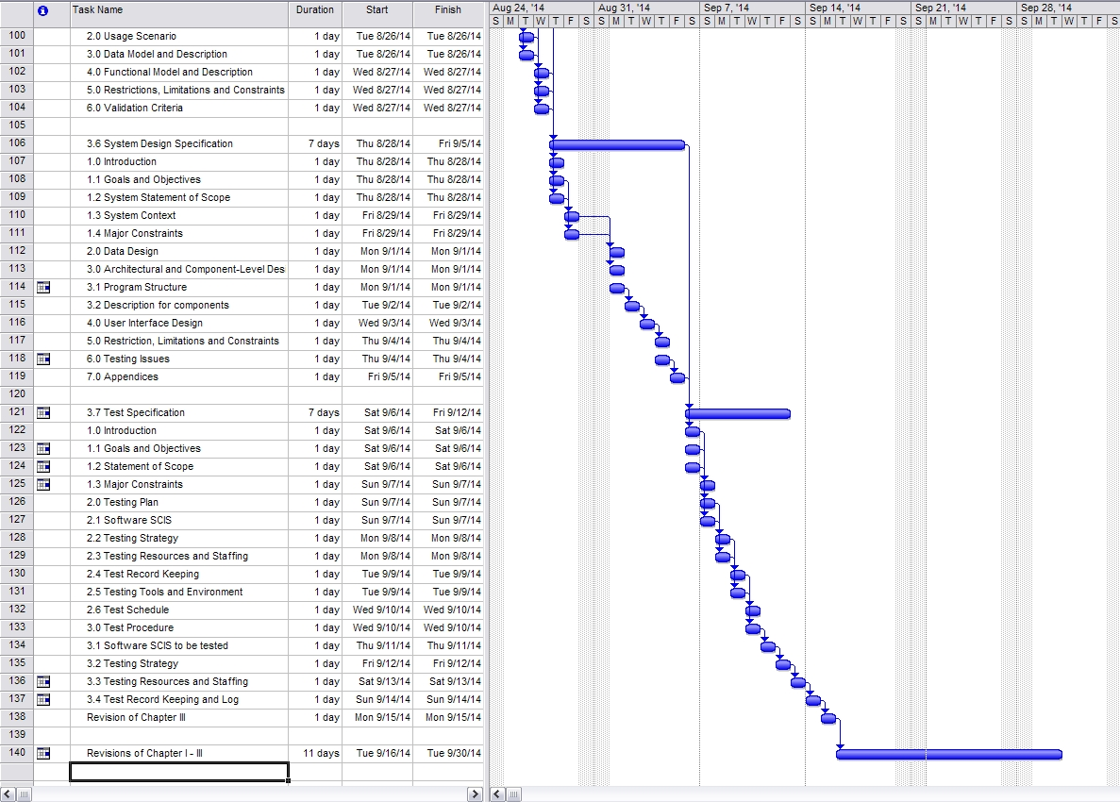

  - Success Criteria

- Accuracy of fact-finding techniques
- Correct interpretation of business rules and processes
- Attractive System Designs
- The system can lessen the time needed to finish transaction. There’s more time saved.
- Lock budgets to prevent unauthorized changes
- Suitable Database for data storage
- Positive Outlook and Feedback of the clients
- Create alphanumeric account numbers as long as 50 characters
- Reliable password security

- Issues and Policy Implementations

  - Unauthorized use of an accounting system

  - Payroll of the employees

  - Theft of social security numbers from employees and contractors

3.5 Risk Management Plan
Risk Factor | Probability  H-M-L | Impact  H-M-L | Risk Management Action
Financial Risk | H | H | Cost efficient options. Every company has been facing this kind of risk. The company must procure the best hardware and software specification to support the development of GLwith Asset Accounting.
Strategic Risk | H | H | The proponents must strategize the development of the GL to provide satisfaction to the client and the user of the software. When there are some changes, the proponents will have to communicate well to the client to avoid conflict.
Operational Risk | M | M | The proponents must have an agreement between the clients to have system maintenance at least once a month. This will ensure that the GL is working properly without any possible errors and bugs. Definitely, this is actually one of the responsibilities of the proponents – software maintenance.
Compliance Risk | M | M | The proponents must identify the proper scoping of the project. Determining also the project limitations and out of scope is one of the best way to avoid further costing regarding with the GL project.
Technical Risk | M | M | The proponents suggest for having an Uninterruptible Power Supply when there are power interruptions occur. Power generator is also advisable to avoid this kind of technical problems. This may be a little bit expensive but reliable.
Business Impact Risk | H | H | The proponents must identify the exact business processes and requirements specification in order to develop the best workflow of the GL.
System Risk | M | M | To manage this risk, the Project team will assure that each one of the proponent is have a fine GL back-up that is ready to use.
Technology Risk | M | M | This risk can happen during the system development of the GL system. The proponents must identify the possible errors and bugs that may occur and find a possible solution to avoid it.

- Service Transition

These are the following activities that the company will surely comply regarding with the system’s software, hardware, system specifications, computer personnel, system requirements and implementation procedure.
- The company must invest new desktop computers
- At least one (1) Printer for each department
- One computer administrator per department
- Higher Specification of hardware for each computer unit

- Options Analysis

  - The company has option to use the system or not
  - If the system was rejected, we will going to

                                offer it into other company
  - If the system met the requirements and did hit the project budget, the cost savings will be settled according to the deal between the company and the project team.

- Technical Features

Technical features provide the possible identification and description of the applications, software, hardware, features, peripherals and some devices that will support the GL with Asset Accounting . The following are the possible technical features under GL with Asset Accounting:

- The General Ledger System (GLS) by Ledger Systems is based on the client-server model and supports many special features for handling the general ledger and financial reporting functions in small businesses and midsize companies

- Java Net-beans is one of the best programming languages for developing system software. The proponents will use the Java Net beans 8.0 for developing the front-end of the GL. The PEC is requiring the proponents for using only Java language for the GL project.

- The MS SQL will serve as the back-end of the GL. This application is the database of the GL that will store all of the data and information coming from the front-end of the GL. Although there are many of the database application to choose from, the proponents will use the MS SQL as a part of requirements given by the PEC panels.

- Operating System: Windows 7 Ultimate 64bit/ 32bit / Windows XP
The proponents will use Windows 7 and Windows XP as operating system to develop the GL. This is very commonly used operating system today for desktops and laptops.

5.0 Project Organization and Staffing
ROLE | NAMES & CONTACT INFORMATION | RESPONSIBILITIES
Project Manager | Soriano, Jennilyn A. | - Manage the team.  - Report and receive direction from client.  - Prioritize the team project.  - Manage the work plans.
Lead Programmer | Nitoral jr. Wlifredo H. | - System development  - Responsible for coding and design of the system.
System Analyst | Peque Mark Jason | - Investigate the system.  - Analyze and manage the system process  - Analyze system features.
Documentation Specialist | Aquino Abigail G. | - Documenting the system study  - Research about the system process.
Business Analyst | Groyon George | - Investigate  - Analyze business transaction, flow, procedure and methods.

6.0 Project Budget

Budget Item | Description | Budget Cost
Project Study Module | The book that the researchers use as a guide in creating their documentation. | ₱1,500.00
Internet load | Use to search and submit our project | 50/day
Transportation | The researchers contributed 15.00 each for searching available Service Management / Agency that can be asked for an interview. | ₱150.00

Budget Items |  |  | Description |  | Budget Cost
Ongoing Cost
Food |  | Food expenses are absolutely important for the proponents to avail. This will also included into the ongoing cost for the project development |  | Php 1,500 / month
Electricity |  | Electricity expenses also included in the ongoing cost. This includes the usage of the electricity service for the development of GL. |  | Php 1,000 / month
Printing of Documents |  | The development of the GL system must be documented. Therefore, this includes the printing expenses of the documents that will be presented upon defense. |  | Php 1,000 / sem
Broadband Load |  | Broadband Load expenses also included in the ongoing cost. This includes the usage of the internet service for the development of GL. |  | Php 1,000 / month
Transportation |  | Transportation expenses when the proponents are going to meet the client or going from other place in relation of the project development |  | Php 2,000 / month
Total Ongoing Cost |  |  |  | Php 6,500

APPENDIX A
Attributes- a characteristic of an object.
Account Builder -Table-driven tool to define groups of accounts.
Account Number - The number that stores information about transactions to an
account.
Additional Data Items - Data items are pieces of information that can be included in
account definition or in a transaction. Typically they are used to store non-financial
information. Transactional data items are defined in Journal Maintenance.
Adjustment Period - Periods added to the end of each year in the date table. These
periods are designed specifically for audit and year-end adjustments.
Attribute Positions - Each account string allows up to 15 attribute values. The first
position is required by the system.
Business Date - The date used to post an entry to a ledger. It must be a valid calendar
date that exists in the date table.
Chart of Accounts - List of your accounts. From this window, you can add, edit, and
delete accounts or view account information.
Clearing Account - An account defined in each fund to maintain the balance due to or
from an individual fund or from the clearing fund. Also called a “due to/from account”.
Cost Allocation - Cost allocation lets you easily distribute indirect expenses and
revenues from pooled accounts to specific cost centers or designated accounts.
Clearing Fund - This is a fund designated as the “Fund Manager” or clearing fund for
all other funds. It is usually a general, operating, or unrestricted fund that contains the
primary checking account, asset, and liability accounts. A clearing fund balances
transactions that cross funds. See due to/from account.
Closed Period - The last closed period is always the last day of a date table period. That
day, along with all dates prior, is closed to data entry. The first day of the next period,
and all dates thereafter, are open to data entry. By closing a period, all information is still available for reporting, but additional transactions may not be posted. It is possible to open a closed period if additional transactions are required.
Current Balance - The net current total of debits and credits for the first ID type. It is
the number used to verify that entries are made correctly.
Date Table - The date table contains the fiscal-period ending dates for each year.
Default - A value supplied by the General Ledger if you do not enter your own value.
Credit - An increase to a liability or to an equity account is a credit.

Debit - A decrease to a liability or equity account is a debit
Emergence - the process of coming into view or becoming exposed after being concealed.

Fiscal Period - The period and year in which transactions are grouped for reports. For
monthly reporting systems, it is the month and year. For weekly reporting systems, it is
the week and year. The date table determines the beginning and ending dates of fiscal
years and periods. Fiscal periods can be created in intervals of one, two, three, or four
weeks, or by month.

Project Manager:
Jennilyn Soriano A.

Document Specialist:
Abigail Aquino G.

Lead Programmer:
Nitoral Wilfredo Jr. H.

Business Analyst:
Groyon Jorge

System Analyst:
Peque Mark Jason V.

CHAPTER II
2.0 INTRODUCTION
The influenced of information system has arose the eagerness of discovering more things that will make everything easy for client in such different aspects. It only shows that Information system is not only for business purposes, it can be for personal use or it depends on the user. It might be different from one another however the objective is to create a user friendly system example of this is local government unit. In order to reduced the paper works of the employees and to avoid the lost of important documents the government decided to used computerized system. All the transaction will be systematically organized. The traditional way of handling documents which is manually encoding and compiling of it will be deducted. Since there is no perfect system that exist the agency have to adapt the changes and take the risk because the problems might occur while the system is in used. It is a good idea to use a system to manage all the transaction and give accurate report to the public and transparency. Like any other organization the emerging needs of fast and reliable system is what strengthen the foundation of information technology. This chapter is the guideline to understand the succeeding chapters. Below are the different researched literature and studies that will establish the knowledge of the readers.

2.1 Related Literature
2.1.1 Foreign Literature

URL:http://www.colorado.edu/abs/sites/default/files/attached-files/fin_training_manual

1. University of Colorado Financial System and General Ledger
Then University of Colorado has implemented this financial system. According to the administration “The Finance System team provides support for PeopleSoft Finance users including the areas of general accounting, accounts payable, project accounting, billing, accounts receivable, and asset management. We are also responsible for ensuring data integrity between all University financial systems including Concur Expense and CU Marketplace, and other systems such as HRMS, ISIS, and COFRS. We are also responsible for design, testing, and project management of fixes, enhancements, and system upgrades.” The goals of the school are to:
• A rudimentary understanding of higher education fund accounting.
• An overview of campus budget theory and practices.
• An understanding of how we use the Finance System general ledger to record and report on financial transactions.
There are two keys to understanding Finance System. The first is to be really comfortable with the chart of account structure and how it is used in higher education fund accounting to identify the resources available to the department, and for what activities the resource were spent. The second then is learning the technical structure of Finance System how to enter transactions into and get reports out of Finance System. Each Financial system transaction line is comprised of various fields of information referred to as a “ChartField.” ChartFields are classified as:

• Mandatory and must be completed by the user.
• Mandatory but their value defaults in and is not changed by the user.
• Optional to be used at the user’s discretion.

These fields are common to all Finance System module transactions, general ledger actual and budget journal entries; Purchasing system purchase orders, requisitions and vouchers; Payroll system funding distribution, etc. However, the client order of presentation may vary from screen to screen.

URL: http://www.fas.lsu.edu/acctservices/forms/far

2. Louisiana State University General Ledger System
The General Ledger System (GLS) is the core system to the integrated Financial Accounting System of the University. All the financial data of the University is stored in this system. Some of the data is fed to the GLS from other financial systems, as depicted on the chart below, while other data is entered directly into the GLS system via on-line screens. This User's Guide should provide you with the information necessary to use the University Financial Accounting System and the GLS. Under the integrated system there are 8 subsystems also called Subsidiary Ledger. Before getting the general ledger report which is the last part of the integrated system, the subsidiary ledger must be complete and updated to make the report accurate. The account code structure at LSU consists of two different types of accounts; a general ledger (G/L) account and a subsidiary ledger (S/L) account. The general ledger accounts are further divided into three types; assets, liabilities and mapping accounts. Each of these types of accounts is explained in detail in the pages that follow. A separate G/L mapping account is established for each fund/campus, or for each entity within a fund for which fund balances are maintained or for which separate financial statements are needed. Each S/L account is "mapped" to a specified G/L mapping account, and all budget, encumbrances, revenues, expenditures and pre-encumbrances in S/L accounts are recorded in summary in the G/L mapping account. Each S/L account maps to a single G/L mapping account while one G/L mapping account represents summary information for a group of related S/L accounts. Summary entries to these G/L mapping accounts are system generated and are not the responsibility of the personnel in the departments. To determine the mapping account for a specific S/L account, view the "Basic Account Information" in the Chart of Accounts (COA) system. See the appropriate section of this guide for how to use the COA. The LSU Chart of Accounts system (COA) was developed to maintain the University's valid general ledger and subsidiary ledger account numbers. These numbers are structured nine digit numbers that are unique across the system. The account structure section of this guide explained in detail the meaning of the digits and the relationship between subsidiary ledger and general ledger accounts. This section of the guide is provided to aid the user in how to inquire into the COA and to interpret the information. There are two different menus that relate to the University account numbers. The first is the COAMENU which is used to inquire into specific accounts and review the attributes associated with specific accounts. The second is the COA/GLS MENU, which is used to review the relationship that has been established between an account number and specific objects, transaction types and project numbers. There are many options available from this menu. Begin by typing the Account Type (G or S for general ledger or subsidiary ledger accounts), the nine-digit account number, and the appropriate fiscal year. If fiscal year is not entered, it will default to current fiscal year. The first three options provide the user with screens displaying the attributes that have been established for an account. For example, the Basic Account Information screen shown on the next page displays the account title, distribution code, begin date, expire date, and other generic account information normally captured on most University accounts.

URL: http://www.uwsa.edu/fadmin/sfs/glddict

3. University of Wisconsin Financial and General Ledger system

The General Ledger module is the core of the SFS system. Many of the tables set up here are used by other modules throughout the system. This is where data from all modules comes together and where most of the financial reporting is done. Ledgers store posted general ledger journals for a set of Chartfield values by accounting period and fiscal year. The admin represent a set of books for each business unit and are usually populated by journal entries. There are several ledgers that are delivered with the SFS system. Most campuses are currently using the actual ledger, which stores all transactions except budgets and the student budget Ledger, which stores budget information. Before looking at the ledger the user must familiarized itself in the unique chart of fields and different acronyms that the admin provided. In order to understand the flow of processing general ledger reports, the business process of the system is included as well as screenshot of different forms.

URL:http://www.appx.com/ftp/appx/documents/manuals/appx/t-apps/character

4. APPX Software Inc.
General Ledger is a means by which you can measure the financial health of your company. In accounting terms, the “General Ledger” records each transaction coming into or going out of your company that involves the exchange of money, or involves an increase or decrease in the overall value of your company. These transactions can include everything from cash receipts to depreciation on equipment; all such transactions should be reflected in General Ledger. In order to record a transaction, you enter the amount into an “account”. The full set of your accounts is called the “Chart of Accounts”. There are many types of accounts in the Chart of Accounts. The broadest subdivision of accounts separates them into “Assets”, which are generally tangible, valuable items that your company owns; “Liabilities”, which are legal obligations your company owes to its creditors; and “Owners’ Equity”, which reflects the amounts that various individuals or companies have invested in your business. When a business first begins, the only equity available is the initial investment made by the owner of the business (the Owner’s Equity). As the company grows, it purchases goods, services, supplies, and equipment; these items are necessary to conduct business. In order to achieve transparency of the reports, the data that extract in the ledger must be accurate and balance.

URL:http://www.whiteware.com/support/Manuals%20and%20Documents/Open%20Systems/OSAS%206.1

5. Open Systems Accounting Software
The Open Systems Accounting Software (OSAS) product line consists of several accounting applications. Each application addresses a different phase of your financial operations; together, they form a powerful accounting solution to your daily and periodic accounting needs. Open Systems has a strong commitment to customer service and product quality. The Resource Manager application is the foundation or shell of OSAS; it provides the operating environment that holds the other applications. Resource Manager also includes three powerful business features: Global Inquiry, Executive Information Summary (EIS) and Print Manager. With Global Inquiry, you can drill around your accounting data to find selected information throughout your system. With EIS, you can access company information quickly and view summaries of all aspects of a company or a group of companies. With Print Manager, when you print reports to file, your reports can be stored, sorted, printed, and searched for specific text. Base applications are designed and produced with the largest possible number of industries in mind. They are most effective when you interface them with each other. Base applications are usually named after common accounting operations. Examples are: General Ledger, Accounts Payable, Purchase Order, Accounts Receivable, Sales Order, Payroll, and Inventory. General Ledger can be used as a standalone application, but you get optimal use from it when you interface it with other applications. Interfacing applications means that the information you enter in one application can be transferred to and used in other applications. So, interfacing your applications reduces data entry time and the number of possible errors that might creep in along the way.

2.1.2 Local Literature

URL: http://www.maniladoctors.com.ph

1. Manila Doctors Hospital Financial System
In 1989 is the birth of automated processes at the Manila Medical Service Incorporated (MMSI) with Sycip, Gorres, Velayo as the commissioned systems developer. MMSI implemented their first stand alone computerized business application: the Patient Account Receivable System (PARS) with Metrobank, Incorporated taking the lead in the project. PARS, DOS base accounts receivable (A/R) system was managed by an Accounting staff, trained at the Meralco Foundation Incorporated to provide internal systems support. In year 1992, the General Ledger System developed by Innovative Concepts Software House was implemented. At that time, computerization projects were still managed by the Accounting Department. It was in year 1994 that the Electronic Data Processing (EDP) came into form as a section unit of the Finance Division; with the Accounting staff manning the section and the Assistant Financial Controller as the Head. This also marked the start of the Local Area Network environment in the hospital. The main focus of the EDP operations at that time is in the DOS base financial applications covering General Ledger, Billing, Check Vouchers and Payroll modules.

URL : http://www.winmedhis.com/financialsystems

2. WinMed Hospital Information System (HIS)
The General Ledger application is multi company and accommodates the AHA chart of accounts. There is a monthly closing to retained earnings, with a yearly closing to retained earnings. The system will allow postings to previous periods, current period, and future periods. The system includes a report writer for tailoring financial statements. The balance sheet is free format, designed for total control by the user. There are several formats for income and expenses statements which lists previous periods and/or years with budget information. The system has 10 years of history for accounts and all detailed transactions processed in the General Ledger application with reports showing the beginning balances, all detail transactions processed, with the closing balance. The application also accommodates statistic information such as patient days or payroll FTE's. The Accounts Payable application is designed to process vendor invoices and patient refunds. This application will track vendor invoices, payments, 1099 information and refunds to patients. Cash requirements reports are produced upon demand and can also include an ageing. A history database of vendor invoices and payments is a base part of the system. System bank reconciliation and check registry are done online. Printing of checks with a laser printer can also include signatures and bank routing information. The system also allows flexible distribution of invoices. Payroll / Personnel were designed to be very flexible for hospitals use. There are many type of earnings, pay periods, multi-company, and user defined accruals of benefits. The hospital defines their deductions and accrual of additional compensation. The payroll checks are printed on a laser printer which includes signatures and bank routing information. Also available as a standard feature is direct deposit. The system produces all required state and federal reporting. As part of the pay period processing, all financial information is interfaced to general ledger with accrual data, and automatic reversal of the accrual data the next general ledger period. The system contains history databases of all employees pay information for each check/direct deposit issued. There is also a history database of each pay period labor distribution for each division, department, and position the hospital has defined in their payroll. The personnel system allows for personnel actions to be documented on the employee record. The system tracks licenses, leave, physical examine, education, and user defined fields for tracking. The Depreciation application is an addition to the general ledger system, and will track the depreciation of any asset of the hospital. There a many conventions and methods to select from for deprecation of the assets. The application tracks book value and tax value if the user chooses these options. The depreciation is calculated each month and posted to general ledger. As new assets are added during the year, they will be calculated based on the method and convention selected and posted to general ledger. Assets are tracked by division and classification. Material Management application will maintain inventory for multi departments within the hospital. The system can track both billable and non-billable inventory items. The purchasing can process both inventory and non-inventory items. The system also tracks inventory uses by department and maintains a stock level for each hospital departments. The system generates automatic re-orders based on information on each item. Physical inventory can be done at any time, or as many times during the year the users chooses. The material management department can continue to operate during physical inventory and when the reports are produced will calculate any activity that occurred during that taking of the physical inventory.

URL: http://www.cms.gov/

3. Center for Medicare and Medical Services
The Centers for Medicare & Medicaid Services (CMS) has implemented the Healthcare Integrated General Ledger Accounting System (HIGLAS). HIGLAS is an integrated, dual-entry, general ledger accounting system to manage healthcare outlays. CMS has 45 million providers and beneficiaries, and it uses HIGLAS to process approximately 4.5 million claims daily. HIGLAS improves accountability for Medicare payments to physicians, hospitals, and other providers servicing Medicare beneficiaries. HIGLAS is also used to support accounting for Medicaid and Children’s Health Insurance Program (CHIP) grants and to generate the CMS Financial Statements, including all vendor payments, payables, and receivables. The Healthcare Integrated General Ledger Accounting System (HIGLAS), a single integrated Internet-based accounting system, leverages the very latest in commercial off-the-shelf (COTS) software to support CMS' mission to:

- Collect standardized accounting data from Medicare
- Contractors for Part A and Part B claims
- Process Medicaid and CHIP grants
- Perform internal administrative program accounting
HIGLAS is responsible for performing seven major financial functions: Accounts Payable for disbursing payments owed to providers, physicians, suppliers, beneficiaries, insurers, employers, and other entities. Accounts Receivable for collection of overpayments made to providers, physicians, suppliers, beneficiaries, insurers, employers, and other entities. General Ledger for posting and recording all financial transactions summarizing and maintaining account balances by the fund structure and individual general ledger accounts. Cash Management for reconciling Medicare Contractors' bank statements. Administrative Program Accounting for maintaining data used to generate CMS' financial statements. Supporting the issuance of grants and subsidiaries made to other organizations or Individuals supporting budget formulation and execution. Audit Control for auditing the integrity of the data as it is entered, altered or deleted performed financial statement audits. Healthcare Transaction Base for providing a federal document view of the data in HIGLAS. The Healthcare Integrated General Ledger Accounting System (HIGLAS) is a new dual-entry accounting system that replaces and modernizes the existing fee for service Medicare Contractor accounting systems with a single standardized system. In addition to processing Medicare claims, HIGLAS will replace the legacy Financial Accounting and Control System (FACS), which accumulates CMS' financial activities, both programmatic and administrative, in its general ledger.
Benefits
HIGLAS, a component of the Department of Health and Human Services (DHHS) Unified Financial Management System (UFMS), will:
- Improve accountability for Medicare's payments to physicians, hospitals, and other providers servicing Medicare beneficiaries.
- Eliminate redundant accounting systems.
- Allow more timely and effective collection activities on outstanding debts
- Pay nearly 3 Million healthcare claims a day.
- Result in additional interest earned to the Medicare Trust Funds.
- Meet government financial regulations including the Joint Financial Management Improvement Program (JFMIP) and the Federal Financial Management Improvement Act of 1996 (FFMIA)

URL:http://www.p2energysolutions.com/excalibur/financial-accounting/general-ledger-and-financial-reporting#sthash.IbCofUAq

4. P2 energey solution
EXCALIBUR Financial System is a powerful and comprehensive General Ledger module is a flexible accounting and reporting system with special emphasis placed on the requirements of the oil and gas industry. All financial transactions entered or created in other Excalibur systems automatically flow to the General Ledger. The General Ledger system contains extensive standard financial reports and also allows you to customize financial reports to your specific requirements: Journal Voucher Data Entry Features, Duplication features to speed data entry, Unlimited detail transaction descriptions, Copy feature for automatic duplication of any current, historical or template journal voucher, Autoprompt feature for changing voucher detail line amounts only while leaving all other coding intact, Reversal feature for automatic reversal of any current or historical journal voucher, Accrual feature for automatically creating reversing journal vouchers in a user-specified accounting period, Recurring feature for automatically creating duplicate journal vouchers in any number of user-specified accounting periods, Journal voucher upload functionality from Excel template, Internal and Accounting Controls, Flexible chart of accounts structure to accommodate company preferences, Balanced journal entries are required (one-sided or out-of-balance entries are not permitted) Automatic generation of intercompany payable and receivable entries Journal voucher review/approval required, at your option, prior to creation of transactions, Multiple accounting periods open simultaneously at an entity and system-specific level, Simplified automatic year-end closing of P&L accounts, Bank account reconciliation for outstanding checks and deposits, Automatic entry cutback from partnerships or subsidiaries books to parents or partners books, Automatic company vehicle mileage allocation to AFEs, properties, leases or cost centers based on PMTA mileage rates.
Reporting
Extensive standard financial reports, including trial balances, general ledger activity, and comparative general ledger and financial reports Extensive user-formatted financial reports including balance sheet, statement of earnings (P&L), statement of cash flows, and comparative financial statements and reports. Direct integration with desktop PC reporting tools (such as Excel) for customized reporting without having to rekey or download data from the system. User-defined groupings of accounts for spreadsheet and user-formatted financial reports. Multiple company reporting including consolidations. Detail transaction reports with all relevant source document information. Extensive online inquiries including general ledger balances, general ledger detail and drill-down from balance to underlying detail transactions. Audit lead schedules online history information available for prior periods.
5. Government Integrated Financial Management Information System
The Government of the Philippines (GOP) launched a comprehensive public financial management (PFM) reform program in February 2011. The details of the reform program are provided for in the Philippine Public Financial Management Reform Roadmap, a strategic plan for a whole-of-government approach to PFM reforms, which aims to clarify, simplify, improve and harmonize the financial management processes and information systems of the civil service. This includes reengineering business processes, integrating relevant systems in the Department of Budget and Management (DBM), Commission on Audit (COA), Department of Finance (DOF), Bureau of Treasury (BTr), and implementing agencies, as well as, reassigning functions between the oversight agencies. The desired results are improvements in fiscal discipline, fund allocation efficiency, and operational efficiency for the effective delivery of public services. A major reform of the Roadmap is the development of a Government Integrated Financial Management Information System (GIFMIS), an integrated IT solution that can collect and organize financial information in a central database to support, at a minimum, budget preparation, execution and financial reporting. President Benigno Simeon C. Aquino III, issued an Executive Order in September 2011 directing GIFMIS system development. In line with this, a two-track approach is being implemented by the GOP.
2.2 Related Study
2.2.1 Foreign Study

URL: http://www.glassoc.com/resource_center_case_studies.php?id=2

1. General Ledger associates streamlines a shipping company
The client's internally developed operational systems each had its own supporting financial system. It had separate accounts payable systems to pay for terminal and depot expenses, truckers, agency commissions, repair work orders and administrative expenses. Plus there were separate accounts receivable systems for shipments originating overseas and for those originating domestically. Separate, internally developed general ledgers were maintained for corporate and the operating units. While these operating ledgers satisfied financial requirements they were of little value to the operating regions that maintained their own expense analysis systems. The task for GL Associates was to integrate all these systems into one compliant financial systems product. First, we implemented new corporate accounts payable and general ledger systems by designing a new corporate chart of accounts (COA) and table of organization. New "coding structures" supported an annual budgeting cycle even before we implemented the new corporate ledger. This was especially critical, as the company had started a major reorganization that was not supported by the existing budgeting process. Next, we implemented the new corporate ledger and accounts payable systems. These contained a level of reporting detail and drill-down capabilities that far exceeded those of the legacy system. We then put into place the financial systems for the operating regions. This involved redesigning the COA so that it provided financial reporting and meaningful analysis to operational personnel. It was implemented concurrently with the elimination of all legacy accounts payable systems and the accounts receivable system for domestically originated shipments. The implementation was unusual because of the large number of interfaces to legacy operational systems that had to be built, the need to reassign vendor codes and the conversion of multiple payable files, each with its own format. It also had to satisfy complex accrual requirements to account for extensive delays in before submissions of invoices by terminals, depots and truckers. The streamlined systems developed by GL Associates greatly reduced the need for internal training, eliminated most of the previous system maintenance efforts, consolidated bank accounts, accelerated the closing cycle and provided management with more meaningful financial reporting and greatly enhanced analytical capabilities.

URL:http://www.vivantech.com/case-studies/case-study-kuali-financial-system-implementation-project

2. Kuali Financial System Implementation Project
USC´s existing financial system (EFS) is based on aging technologies and is in need of replacement. Their Enterprise Information Systems department provides core services to many USC organizations by effectively managing EFS. However, while EFS is a collection of stable applications that are adequate today, this aging system is at the heart of USC’s financial operations. This means that over time, EFS will become increasingly discordant with the business needs of USC. There are high risks associated with continuing to employ this aging technology. In addition to the severe lack of documentation, the development platform is old, and few experienced developers are available today. To address the increasing risks associated with EFS, USC decided to migrate to Kuali Financial System (KFS). The migration first addressed the General Ledger and Chart of Accounts modules, followed by Financial Processing and Vendor (Cashiering), Purchasing and Accounts Payable, Capital Assets, Budget Construction, and Accounts Receivable. With the help of Vivantech, USC identified 525 business functions required by their financial departments. The majority of the functions are available in KFS and a small number of functions required modification to the KFS software. Additionally, 138 functions in KFS are new to USC and considered enhancements to the USC systems Vivantech mapped more than 40 peripheral systems from EFS to KFS. USC chose a phased implementation, bringing General Ledger and Chart of Accounts online first at the beginning of a new fiscal year. Three months later they followed with Financial Processing, and then two months after that added Purchasing and Accounts Payable. The entire KFS suite migration is scheduled to span three years and four months. Resources used depended upon the number of modules and customization requirements; however, Vivantech has become an extension of the USC team, successfully executing the migration plan. Additionally, Vivantech´s onshore and offshore resources have allowed USC to scale up and down depending on the phase of the migration.

URL: http://www.glassoc.com/resource_center_case_studies.php?d=7

3. Major financial institution put its trust in general ledger associates
Account administrators needed to accurately track the investments and instructions of institutional customers in order to allocate funds for maximum investment return. Institutional investment account managers wanted to accurately record the current status of a client’s account, as well as any investment instructions that the client may have issued. The instructions ranged from securities buy/sells, cash transfers to wire transfers and check writing. Since billions of dollars were under management, some of the instructions dictated that money be moved overnight, and returned in the morning to gain the maximum in overnight interest. Accuracy depended on being able to properly calculate each account’s projected cash balance from a variety of different sources. These included pending trades, cancelled trades and settled transactions. Additionally, customer instructions and other extraordinary events needed to be figured into the cash balance calculation. GL Associates implemented a custom Intranet-based application that provided account administrators with an efficient means of viewing all the required data and inputting transactions and instructions in a simple yet elegant interface. This Cash Management System provides an orderly process for gathering and acting on cash balance information. An administrator logs onto the system and views a grid with summary account information. A click on any account results in a worksheet where details on account positions, instructions and cash balances can be easily viewed. A series of navigation buttons leads to screens that reveal more extensive details and entry areas for account rules, instructions and adjustments. The system also has extensive reporting capabilities including a tool for producing custom “ad hoc” reports. GL Associates relied on Microsoft technologies to implement what was an n-tiered solution. We started with a Microsoft SQL Server database that we populate nightly from the client’s mainframe system through IBM’s MQSeries for Windows NT. In the middle tier, the business processes were implemented using COM objects developed with Microsoft Visual Basic and managed by COM+. Web pages that comprise the system’s top tier are Active Server Pages. During the day MQSeries was also used to perform interactive messaging with a number of back-end custody and trust accounting systems.

URL: http://www.glassoc.com/resource_center_case_studies.php?id=9

4. General ledger associates provides the right formula to solve accounting crisis

The post-merger company found itself with over 40 separate general ledger databases, one each for its various plants, divisions and corporate entities. The general ledgers used different Charts of Accounts (COAs) operated on different software products that ran on diverse hardware platforms scattered across the country. Further complicating the situation, the corporate ledger interfaced to yet another software product that provided consolidation and corporate reporting. Divisional summary data entry into the consolidated ledger was time consuming. Last minute budget changes and adjusting entries resulted in significant discrepancies between plant/divisional, corporate and consolidated ledgers. Frequent business unit restructuring made ledger maintenance extremely difficult. Month-end general ledger runs took many hours with out-of-balance conditions frequently occurring. The various COAs not only were incompatible but also were applied inconsistently and could not adequately support management reporting and financial analysis. GL Associates first performed a two-week study to determine the best solution. We recommended the design of a uniform COA and the implementation of a single, integrated general ledger database using CA's Masterpiece for both general ledger maintenance and reporting. Each operating entity, using its local terminals, could interact with its part of the total general ledger database. The design phase that included pro-forma reports, the new COA and reporting structures took three months. System implementation with all operating units was completed over 18 months. Every phase of the project was completed on time and within budget. We also were responsible for system documentation and user training. Turnover was completely successful with no operating problems experienced by the many groups assuming ledger responsibility. With our proprietary software tools, COA maintenance on organization changes turned into a minor task. Manual entries of divisional summary data and discrepancies between divisional and corporate reports were eliminated. This combination of a report-oriented COA, new relationship structures, effective use of summary accounts and the elimination of separate consolidation systems achieved dramatic reductions in the time needed to produce end of month closings and reports. In one instance, the time was reduced from 7.5 hours to a few minutes. Additionally, a number of automated processes (validation of relationships, checks for completeness of allocations, variance reports) were implemented to assure ledger integrity. The general ledger system now simultaneously maintains summary accounts for financial responsibility center, legal entity and other management reporting. A vastly improved series of reports are produced directly from the ledger with CA's VRW report writer. Besides significantly reducing month end closing times, a very fragile financial reporting system was transformed into a rock solid one with unlimited growth potential.

URL: http://www.glassoc.com/resource_center_case_studies.php

5. General ledger associates provides the right prescription for Merck
Change always seems to bring unintended consequences. The drug company Merck was converting from a legacy financial system to JD Edwards General Accounting. The change included adoption of new Business Unit Codes and a new Charts of Accounts. Merck had to provide managers with the ability to look up new account numbers along with submitting and uploading budgets quickly and easily. All modifications and extensions to the JD Edwards system were written to run exclusively on the AS/400 with a character-based green screen interface. For users to have access to the AS/400 through their PCs, Merck had to install and pay licensing fees for a copy of Rumba on every PC. Plus, users who were accustomed to the Windows interface were forced to learn to use the green screen interface. When Merck realized the conversion caused the unintended consequence that account look-up and budget applications could not be implemented using the JD Edwards standard approach, they turned to GL Associates for a solution. The problem was solved when GL Associates used the existing Merck Intranet to build a series of database-driven interactive web sites on the AS/400. Their web sites contain applications that access the JD Edwards data on the AS/400 and present it to the user in a graphical user interface. The user could access the web sites through the Internet browser on their PC. This solution resolved all of Merck's concerns. It eliminated the need to train users on the JD Edwards application. Since data access was obtained through the corporate Intranet, software distribution was unnecessary and there was no need to buy software licenses for Rumba to provide connectivity to the AS/400. Because it is a huge global company, Merck's completely redesigned Chart of Accounts (COA) was long, complex and subject to change. Merck's budget holders around the world needed access to the new business unit and account numbers when calculating and submitting departmental budgets. They needed a way to look up these numbers on the COA without having to distribute hard copies to each user. GL Associates developed the Account Lookup System on the Merck Intranet. The user entered old business and account numbers via the PC's graphical user interface. Then, the system queried the account-mapping database on the AS/400 and presents the user with the new numbers. It also permitted drilling down to the account balances in the General Ledger. Query response time was instantaneous and the information was always up to date because the data came directly from the JD Edwards system. The solution was such a success that Merck requested a second, larger Intranet-based budgeting system. GL Associates provides the right prescription to make Merck healthy.
Budgeting System Merck department heads from all over the world submitted budgetary information to the finance department by emailing Excel spreadsheets. The spreadsheets were uploaded into the JD Edwards system. This method became unmanageable because the department heads changed the spreadsheet format before returning them. The finance department then would have to manually repair each spreadsheet before uploading to the general ledger system. Again, GL Associates used an Intranet-based solution. Users could access those accounts over which they have budgetary authority using a password. Once an account is selected, the system displays a spreadsheet-like interface that provides enhanced functionality. Users can build budget based upon past actuals or budgets or they can start from scratch. Budgets can be entered by year, quarter or month with features such as inflation rates and growth rates provided for ease of use. Users can then save multiple alternative budgets on the server until choosing one to submit. A single button click then uploads the budget into the JD Edwards database. Total development time for the budgeting application was only two months. The cost was less than the one-year maintenance charge for the old mainframe-based budgeting system. The Merck financial team now requires that all new in-house applications be developed as Intranet applications.

2.3 Synthesis and Relevance of the study
it is common to deal with a system that consists of many elements or subsystems. Most of us engage in the study of system components and their elements by dividing and subdividing them, leading to the trend of infinite specialization. However, at a certain point during the course of the development of a scientific discipline, a grand synthesis enables the distillation and coalescence of disparate results into a coherent understanding of the system as a whole.
These studies contributed a lot to the group as well as to the project. It gives idea and enlightened the group perspective to the general ledger as a system. In reality general ledger is one of the features of integrated financial system however its stand at the center and the end point of the system. In regards to the relevance of the study, many of the organization as of now are using the automated system to improve the progress of the giving a good service to the clients and to the reduced the manual activities. There is organization that used general ledger however it is not integrated on the other hand the user needed to encode the data manually. There is some organization that separates the general ledger from the financial system however it is integrated with the other subsystems or features, some of features are budget preparation, payroll, Inventory etc. The thing is the all the input data will be merge into one database and the ledger will extract and ready to print the report. There is organization that using general ledger as an independent system. As the new researchers the entire group decided to continue what being started in order to achieved a quality general ledger system. There is case study stated that “general ledger will be more functional if it is integrated to the other system”. For the future researchers the group will ensured to make this project as a good reference.

2.3.1 Synthesis and Analysis for Local and Foreign Studies

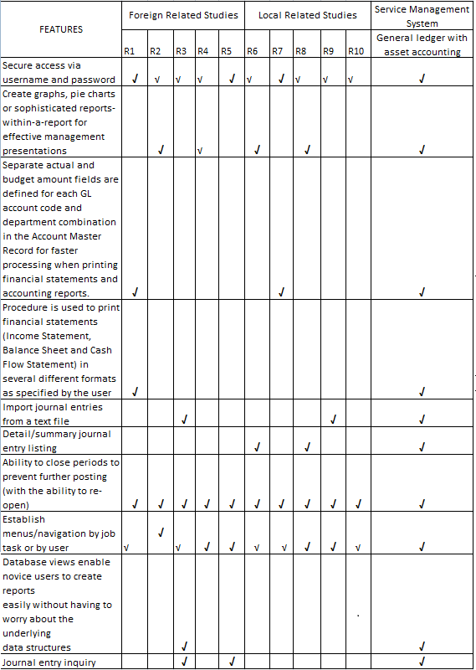

Conclusion:
The General Ledger of the proponents is being illustrated in the figure 2.3.1. It’s all about the difference between the foreign and local project study of the systems. There are some similarities between the functionalities, features, components and modules.

CHAPTER 3.0 EIS PROJECT MANAGEMENT AND DEVELOPMENT
3.1 RISK MITIGATION, MONITORING AND MANAGEMENT PLAN
1.0 Introduction
This chapter will give the specific explanation mitigation monitoring and management plan for the service management system on which project has to come up a briefly overview of the project study.
1.1 Scope and intent of RMMM activities
The goal of the risk mitigation, monitoring and management plan is to identify as many potential risks as possible.
When all risks have been identified, they will then be evaluated to determine their
probability of occurrence, and how General Ledger will be affected if they do occur.
Plans will then be made to avoid each risk, to track each risk to determine if it is more or less likely to occur, and to plan for those risks should they occur.
It is the organization’s responsibility to perform risk mitigation, monitoring, and
management in order to produce a quality product. The quicker the risks can be
identified and avoided, the smaller the chances of having to face that particular
risk’s consequence. The fewer consequences suffered as a result of good RMMM plan, the better the product, and the smoother the development process.
1.2 Risk management organizational role
Production Team – the production team will be the group assigned on the creation of the system.
Company – also called as the End-User they provide the efficient process of the system for the clients. Through the help of the automated billing system the clients will be able to serve well by the company through sending invoices to them, calculate customer’s cost for each billing record; periodically generate invoices and collecting payments received from the customer.

Adviser – the person who will be supervising the production team and gives them advises and techniques.
2.0 Functional Data Description
In this section the proponents have to identify the possible risks,conditions and events that may occur and it may have a positive or negative impact on the project. Encountering a number of risks upon the development phase is absolutely possible. The proponents have to identify this risk and better yet come up a strategy by reducing of the risk avoiding and eliminating the possible cause, ships impact and transfer it to a third party and must have will to accept the consequences.
2.1 Description of Risk Management
The identification, analysis, assessment, control, and avoidance, minimization, or elimination of unacceptable risks. An organization may use risk assumption, risk avoidance, risk retention,risk transfer, or any other strategy (or combination of strategies) in proper management of future events.
- Business Impact Risk: this concerns about not coming up or produced a product that will greatly affect the client’s business. If the software produced can’t meet the expectations and improve the business. The created system was useless.
- Customer Risk: is a potential risk found in all consumer-oriented products, that a product not meeting quality standards will pass undetected though the manufacturer's quality control system and enter the consumer market place.
- Development Risk: The client must provide the necessarily needs to create and produce the system that the company needs. Taking quick response on the need of products to produce the system will lessen the risk on developing the system.
- Employee Risk: Focuses on the willingness, experience and the ability of the employee’s to create a product that will enhance the business. If the team was not fit on to produce the system it will cause a lot of risk on the production of the product.
- Process Risk: Regards on the product quality. A system must have a good quality on improving a business. A few standards and criteria’s must attain the system.
- Product Size: if we say size it is not only the space used by the system. It also means range of capacity of the system requirements. The client must provide the proper equipment depending on the system requirements.
- Technology Risk: Must ensure that the technology used in producing the system must not be outdated. To expand the life span of the system and to ensure that the software will function in long terms.

2.2 Probability and Impact for Risk Management
Category | Risk | Probability | Impact
Employee Risk | There may be conflicts between team members | 40% | 1
Process Risk | Quality of product documentation and coding that must be produced may be low. | 35% | 1
Product Size | Size estimate maybe significantly low | 30% | 2
Development Risk | Lack of training on java | 30% | 2
Customer (User) Risk | Customer may change the project’s requirements | 20% | 3
Technology Risk | Technology will not meet expectation | 10% | 2
Business Impact | Product may harm the company | 10% | 3
Risks Table
Legend
Impact Values Description
- Catastrophic
- Critical
- Marginal
- Negligible

3.0 Risk Mitigation, Monitoring and Management
This Section details and describes Risk Mitigation, Monitoring and Management in every possible risk that would occur, how you will manage to give a solution and monitor if there are other circumstances that the risk might occur again.

3.1 Risk Mitigation for Risk Management
This section is where the team will identify the software development risk. And a plan as a counter measures the risk. So that the risk would never appear again.
3.1.1 Product Size
There might be some chances that the product would be over or underestimated; to reduce the risk on this matter the team will be conserving its resources to minimum level.
3.1.2 Business Impact
Business impact concerns about the final product. In this phase the team will spend time with the users to identify their needs. So that the team will identify the data and processes that the company needs.
3.1.3 Customer (User) Risk
If the client cannot attend a meeting how can we identify their needs? This will result a failure on the system. It may also cause that they don’t need the product that you have manufactured.

3.1.4 Process Risk
We want provide a high quality product the team must have proper guidelines to follow. To ensure that the task of every member of the team is precise and time managed

3.1.5 Technology Risk
In order to prevent this from happening, meetings (formal and informal) will be Held with the customer on a routine business. This ensures that the product we are producing, and the specifications of the customer or equivalent.
3.1.6 Development Risk
In order to prevent this happening, the development team will be required to learned the languages and techniques necessary to develop this software the member of the team that is the most experienced in a particular facet of the development tools will need to instruct those who are not as well versed.

3.1.7 Employee Risk (Team Mates)
To provide a high class service the team must have proper knowledge, experience and willingness to assure the success of the project. To avoid this, the team should always gather a meeting to talk about their performance and evaluate each other so they know where they should focus on the project.

3.2 Risk Monitoring for Risk Management

3.2.1 Product Size
The team will be on track of using JAVA programming language. To monitor the amount of functions used in the project this will help us notify us if the project will have a risk in the future.

3.1.3.2.2 Business Impact
In this phase the team will conduct weekly meetings to monitor the user’s information in the needs of the business this will be a very efficient way to know the users insights in the project that will help the team improve the system requested by the client’s request.

3.1.3.2.3 Customer (User) Risk
To monitor the risk on the client we will be conducting weekly meetings keep the records of their activity. Check the outcome of the activities to acknowledge the people who are attending and active on improving the project.
3.1.3.2.4 Process Risk
To manage this risk our team will be cross checking each of our work, another advantage of this is that we can give each other a suggestion based on our opinions to improve one self and monitor our works.
3.1.3.2 .5 Technology Risk
During this phase of development the team should always been aware of the latest items or gadgets.
3.1.3.2 .6 Development Risk
Each member of the team should watch and see areas where another team member maybe weak. Also if one of the members is weak in a particular area It should be brought to the attention by that member, to the other members.
3.1.3.2 .7 Employee Risk (Team Mates)
Monitoring the teammates with difficulties on their task. This will notify the team on who shall be helped and specify what part of the team should be improved.
3.1.3.3 Risk Management for Risk Management
This section is where we will identify several software development risk and make a plan to give a solution to the risk if they occur.
3.1.3.3.1 Product Size
After the monitoring of the process if the project end up over or under estimation the team will be conducting a few more studies to find a better solution to manage the risk on space.

3.1.3.3.2 Business Impact
If an error has occurred, the collected data given by the users will be used to improve the managing of the system.

3.1.3.3.3 Customer (User) Risk
When the customers are not very satisfying the team can conduct surveys and give questionnaires to manage the development of the system.
3.1.3.3.4 Process Risk
If the problem was still inside the team the only answer is to manage a swapping of that particular member so that the team can move forward the project.
3.1.3.3.5 Technology Risk
On monitoring technology the team must manage to recommend items and equipments that will be applicable to the project.
3.1.3.3.6 Development Risk
The members who have the most experience in a particular area will be required to help those who don’t out should it come attention of the team that a particular member needs help
3.1.3.3.7 Employee Risk (Team Mates)
On managing the risk on the team every team member will help each other to lessen the problems on that specified area on the team.

3.2 Software configuration management plan

3.2.1.0 Introduction
At the stage of software development there will be a point where the proponent will make a revisions and changes to the concept. SCMP is developed so that we can identify and control changes and assure that the plan is implemented and reported the changes to the team.

3.2.1.1 Scope and intent of SCM activities
As what has said to the introduction the SCM plans purpose is to report and tract the changes on the software development plan. The procedures will give us an outlook of the software that should be changed and went to changes.
SCM Activities are develop to
- Identify changes
- Control changes
- Ensure the changes is being properly implemented
- Also have a way to document the changes
3.2.1.2 SCM organization role
Production Team – the production team will be the group assigned on the creation of the system.
Company – also called as the End-User they provide the efficient process of the system for the clients. Through the help of the automated billing system the clients will be able to serve well by the company through sending invoices to them, calculate customer’s cost for each billing record; periodically generate invoices and collecting payments received from the customer.
Adviser – the person who will be supervising the production team and gives them advises and techniques.
3.2.2.0 SCM Tasks
In this section we will determine the prioritized task and distribute responsibilities to the member. Assigning personnel’s on each task will reduce time consumption and confusion to their target assignments. In every meeting we will be discussing every changes reported on their SCM task and allocate the priorities to finish the product.
3.2.2.1 Identification
This section the team will be detailing the parts of the system that will undergo to the process of SCMP.

3.2.2.1.1 Description

*Identify change
On identify the change the production team will be discussing about the on the system if it is needed or not.
*Approve change
If the change is needed the team will be discussing the implementation of the change how to document the changes and how the changes will be submitted to the other production team so that they can adjust to the adjustment of your team.
*Ensure
Setting a day where the team would conduct a meeting to check each other’s work or if their works are compromising this way we will be reducing the conflict and unnecessary information on the documents and finalize it.
*Document
Since the documents has been finalized. We will be using that opportunity to generate the report and pass the work to the software development team to implement it to the produc

3.2.2.1 .2 Works Products and Documentation
Identify change
At the time the change request form has been issued and to be given to the SCM team personnel’s, control change often evaluation, the change form will be generated.
Ensure
The team will be implementing changes and checking each other’s task.
Document Change
Finalizing all changes and documents then add it to the compilation

3.2.2.2 Configuration Control
3.2.2.2.1 Description A discipline applying technical and administrative direction and surveillance to: (1) identify and document the functional andphysical characteristics of a configuration item; (2) control changes to those characteristics; and (3) record and report changesto processing and implementation status.
3.2.2.3
3.2.2..2 Increasing Version number
The team creates a proto type of the system till the process and functions will be completed.
3.2.2.2.3 Works Products and Documentation
A part of documentation will be named version revision history this will be used to document the revisions, bug report; system tracking this will be the basis on monitoring the bug fixes and upgrades.
3.2.2.4 Configuration Status Accounting
3.2.2.4.1 Description
- Verbal Communication –

3.2.2.3.2 Works Products and Documentation
- Testing of Errors
3.3 Software Quality Assurance Plan
3.3.1.0 Introduction
3.3.1.1 Scope and Intent of SQA Activities
- Trial and Error
- Documentation

3.3.1.2 SQA Organizational Role
Project Manager Soriano Jennilyn A. Manages the team
System Analyst Peque Mark Jason V. Handling of business Rules
Business Analyst Groyon George S. Analyze business process
Documentary Specialist Aquino Abigail G. Documenting the process
Lead Programmer Nitoral Jr. Wilfredo H. Handling System Software

3.3.2.0 SQA Task
- Develop the design plan and test plan for testing the tool
- Provide feedback and advice

3.3.2.1 Task Overview
Gathering (brainstorming/meeting)
Contacting Client
The client’s opinion is our top priority because they will be the ones who will use the system. Detailing their ideas and innovating it will raise your success rate.

Detailing the design
Showing your sample design to the client will also help them decide on what was needed or not in the system. Showing them your overview is a great option.

3.3.2.2 Standard, Practices and Convention (SPC)
Gathering
Our team was consist of five(5) members meeting about the agendas of our system. Every members task was well distributed by our PM so that every work was evenly done.
Contacting Client
The client was our end user that’s why their cooperation was very needed in order to finish our project. Every meeting with them we propose an agenda on what should be done or what was the process they want to their system.
Detailing
Letting them decide on what should be seen on their interface will lighten the teams work and setting it to their needs is a great success.
3.3.2.3 SQA Resources
3.3.3.0 Reviews and Audit
A formal technical review (FTR) is a software quality assurance activity that is
performed by software engineers. The objectives of the FTR are:
(1) to uncover errors in function, logic, or implementation for any representation of the
software;
(2) To verify that the software under review meets its requirements;
(3) To ensure that the software has been represented according to predefined standards;
(4) To achieve software that is developed in a uniform manner;
(5) To make projects more manageable.
3.3.3.1 Generic Review Guideline
Our review will focus first on the clients overview and next was to the project teams overview. Because every meeting with the client there are high chances of changes depending on their needs the teams overview should be presented to the client so that every sides can give their ideas before changing and documenting the details.
3.3.3.2 Formal Technique Review
3.3.3.3 SQA Audits
Team members will have a weekly report on their individual performance for the past
week. Any problems, question regardless on the performance of other team members
will also noted there.

· Members will write part of the help menu that relates to their design work. And they
also share between members.

· Any changes that will affect the project will be presented to other team members
before doing any changes. These are the changes that are minor or require little code
change, but still are different from the original architectural design.
· The client should be notified of all changes made to the. For minor changes, we will
just notify a reprehensive from the client instead of the whole team from the client.
This rule only applies to the minor changes or cosmetic changes, or minor functional
changes. Any major functional change will still require the agreement from the
whole team from the client side

3.3.4.0 Problem Reporting and Corrective Action/ Follow Up
3.3.3.4.1 Reporting Mechanisms
The first change given to the billing system was the cashier was changed to our system. We will be conducting cashier duties rendering of Official Receipt to the clients reimbursement and disbursement of funds.

3.3.3.4.2 Responsibilities

Project Manager Soriano Jennilyn A.
System Analyst Peque Mark Jason V.
Business Analyst Groyon George S.
Documentary Specialist Aquino Abigail G.
Lead Programmer Nitoral Jr. Wilfredo H.

GENERAL LEDGER WITH ASSET ACCOUNTING

Nitoral Wilfredo jr - Lead Programmer
Peque Mark jason v. – System Analyst
george Groyon – Business Analyst
Abigail Aquino – Document Specialist
Soriano jennilyn – Project Manager

Chapter III
3.4- System Specification
3.5- Software Requirements Specification
3.6- Software Design Specification
3.7- Test Specification

1.0 Introduction
This section gives a general overview of the General ledger system under the Service Management System.

  - Goals and Objectives
The main purpose of GENERAL LEDGER SYSTEM is the collecting point for all
financial data of a business. A chart of accounts and a ledger of
transaction entries are maintained in the database.
The goals of general ledger are:

- General Ledger Statement
- Balance Sheet
- Income Statement

  - System Statement of Scope
The general statement of GL must be specified and provided in this section. That is the information has to be produced, what the major functions are implemented and what data are provided as the input GL.

    - General Requirements
The following general requirements were laid out of our project named general ledger
With asset accounting
- A way to create financial statement
- A way to update receivables to g/l
- A way to update payables to g/l
- A way to update payroll to g/l
- A way to have income statement

- Interface Enhancements

Staff members of the security agency have some enhancement requests
To have easy in access of the product

- Database Administrative Interface
The general ledger will provide a secured database on which the user could retrieve and save data and information at ease with the use of MS SQL database.

- Online Help
To make a complete help menu for the user assistance and also
Be used to present information on board range of subjects

- Training
training is as important as the software itself in the success of implementing a new general ledger system. Your system is set up with your institutional data, business rules, and variables from your migrated data. Using financial data makes the training more relevant for staff members and provides a better opportunity to review and become comfortable with
Training typically takes place over a two month period and has two phases about a month apart. This allows staff members to try out new skills, practice on the non-production database, ask questions, and become familiar with the system. They receive exceptional, personalized training at a comfortable pace.

  - System Contex

General Ledger Accounts are used to identify balance sheet classifications, revenue classifications, or expenditure classifications. Balance Sheet accounts include Asset accounts, Liability accounts, and Net Assets and Reserves. The development of the general ledger is actually for academic purposes only to begin with. It is necessary or mandatory for the proponents to have a client on which the proponents will gather data and information needed to establish and develop a correct business processes. If there is no client, the proponents will have a hard time for identifying the needed data and information for the GL development. Furthermore, if the development of the GL will be a success, it is a good example of a teaching-learning method provided by the current school on which the proponents are studying while developing the GL. More importantly, the client will be benefitted the most when the GL will be implemented on their respective company / agency. With this, the client will upgrade their business transaction using the latest technology provided by the GL. The system will make sure that the processes of the company are still the same, the thing is, it will now a computerized rather than the previous manual process that they had.
  - Major Contriants
- Funding
Funding is the worst possible constraints for the proponents, the funds that the proponents are only limited considering they are currently dependent as a students who lacks on personal fund to support the expenses for developing the GL. However, this constraint will not be an issue for not pursuing the objectives for the development of the GL.

- Time
The project only have an approximately five months to finish all documentation, software and interface enhancements. This is a disadvantage for the proponents knowing that the system development and documentation has to finish within five months at the same time the proponents are still studying on their classes and still searching on how the software development will takes place.

2.0 Functional Data Description
All of the functions in the system and information also the process
Are identified and describe
2.1 System Architecture Model
Enter user type, name, Password
START
User type, name, password that register
Valid User type, name, password from DB
Menu appear with option to select
MENU
Select option
EXIT
^{Chart of accounts}
END
Monthly Updates
Monthly Reports
General ledger
Chart of account
Monthly Updates
Monthly Reports
General ledger
2.2.1 Architecture Model

2.2.1 Subsystem Overview

Edit Ledger Transactions
Program is used to add, change, view
or delete any transaction in the ledger database.
• Used to post standard monthly periodic journal and recurring entries.
• Security permission modes to prevent
Modification except by authorized per- sonnel.
• Batch posting totals maintained throughout the editing session ,with warning generated if attempting to leave program out of balance.
• Audit journal produced at end of editing session.

General Ledger Reports
The GENERAL LEDGER JOURNAL
Provides a list of ledger transactions in journal (numerical) order .
The ACCOUNT TRIAL BALANCE
Provides a list of ledger transactions by account, in chronological order with
account subtotals.

The GENERAL LEDGER ANALySIS
Provides a list of each account balance in a monthly spreadsheet .Balance
• Detailed mode:Lists transaction ID, date, account, debit and credit and
balance amounts, and description for each transaction.
• Summary mode : Lists debit and credit totals only.
• Output can be directed to the screen,
.PDF preview, any printer, fax, email or a net-
worked harddrive on the server.

Balance Sheet Income Statement
The BALANCE SHEET program
Provides a letter-perfect balance sheet , produced according to your accountant’s specifications.

• Can be produced for individual subsidiaries or combined.
• Customized layouts available.
• Related accounts can be combined for less detailed format.
• Output can be directed to the screen, PDF preview, any printer, fax modem,
Email or a networked harddrive on the server

Monthly Updates

The UPDATE INVOICES TO G/L Program updates a selected range of
invoices as a transaction in the General Ledger database.
The UPDATE RECEIVABLES TO G/L Program updates a selected range of
receivables transactions as a transaction in the General Ledger database.
The UPDATE RENT/LEASES TO G/L Program updates a selected range of
rent/lease invoices as a transaction in the General Ledger database.
The UPDATE PAyABLES TO G/L program updates payables transactions
(vouchers and checks) for a given period as a transaction(s) to the General Ledger database. The result-ing G/L Transaction will be distributed to the appropri-ate
G/L Account/Subsidiary code.
The UPDATE PAyROLL TO G/L program updates A selected range of payroll
checks as a transaction in the General Ledger database

2.2 Data Description
2.2.1 Major Data Objects
Edit ledger transaction

- Transaction no:
This is the number of the transaction
- Account sub:
- Date:
This is the date of the transaction
- Description:
This is the description of the transaction
- Debit:
- Credit:
- Total:

General ledger journal
- Transaction id:
This is the number of the transaction
- Date:
This is the date of the transaction
- Description:
The description of the product
- Amount sub:
- Debit:
- Credit:
- Balance:

Account Trial Balance
- Transaction id:
- Date:

This is the date of the transaction
- Descripton:
This emphasize the kind of transaction
- Amount sub:
- Debit:
- Credit:
- Balance
- Grand total:
General ledger Analysis
- Amount:
- Sales:
- Total sales:
- Cost of goods:
- Total cost of goods:
- Gross profit:
- Expenses:
- Total expenses:
- Net operating income:
- Month:
- Total:

General ledger Statement
- Transaction id:
- Account sub:
- Date:
- Sub Description:
- Beginning Balance:
- Current Debit/Credit:
- Amount Total:
Balance Sheet

- Transaction id:
- Description:
- Total fixed assets:
- Total other assets:
- Total assets:

Income Statement
- Transaction id:
- Description:
- Total operating income:
- Net operating income:
- Discounts earned:
- Interest expenses:
- Total other income expenses:
- Federal icome tax:
- Other taxes and licences:
- Total taxes:
- Net income after taxes:

Monthly Updates
- ID:
- Description:
- Order:
- Less:
- Solid:
- Volume:
- Price:
- Mark-up:
- Grand Total:
Chart of Accounts
- Account id:
- Descriptive name:
- Sequence code:

2.2.2 Relationships
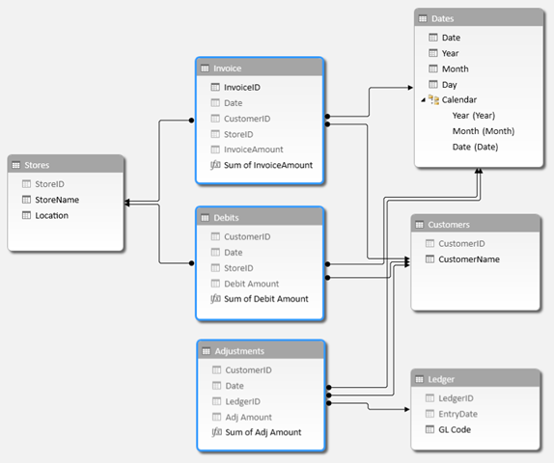

2.3 Human Interface Description
With a General Ledger interface you no longer have to fumble through payroll reports and manually enter data into your accounting package. JetPay Payroll Services, formerly A D Computer, can create a custom interface that works with the accounting software you already use so that your payroll items are posted to your GL quickly, easily, and accurately.

Save time...simply export your payroll data from our system and import it to the accounting package you use.
Increase accuracy... eliminate the human errors associated with manual entry (you also save time spent on reconciling discrepancies).
Take Control... no more worries about changes made to your GL/chart of accounts. You and your authorized users retain control!
Main Menu Window
GENERAL LEDGER MENU
• The EDIT LEDGER TRANSACTIONS Program is used to add, change, view or delete any transaction in the ledger database.
• The GENERAL LEDGER JOURNAL
Lists ledger transactions in journal (numerical) order.
• The ACCOUNTTRIALBALANCE
Lists ledger transactions by account in
chronological order with account subtotals.
• The GENERALLEDGERANALYSIS
Lists each account balance in a monthly spreadsheet.
MONTHLY REPORTS
•Letter-Perfect GENERALLEDGER
STATEMENT, BALANCESHEET
And INCOMESTATEMENTS can be
Produced according to your accountant’s specifications.
MONTHLY UPDATES
• Monthly updates from all subsidiary software packages including, order invoicing, receivables, cylinder control, payables and
Payroll can be run in summary or detailed mode to automatically
Create General Ledger entries.
CHART OF ACCOUNTS
• The EDITCHART OF ACCOUNTS program allows you to
add, change, view or delete records in the chart of accounts file.
• The CHART OF ACCOUNTSLIST shows the complete chart
Of accounts.
• The CHANGE G/L ACCOUNT I.D. is used to change a G/L
Account ID throughout the system.
MISCELLANEOUS
• The VERIFY LEDGER DATA program is a maintenance program to ensure the internal integrity of the General Ledger data.

Other window are also explain in the
Main menu window

3.3 Subsystem Description
3.1 Subsystem Flow Diagram

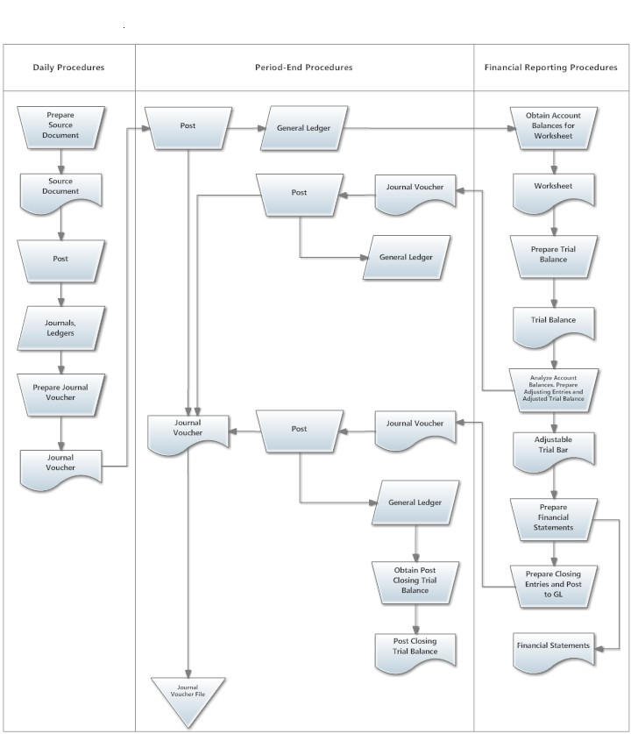

4.0 Enhanced Interface Prototyping
4.1 Prototyping Requirements

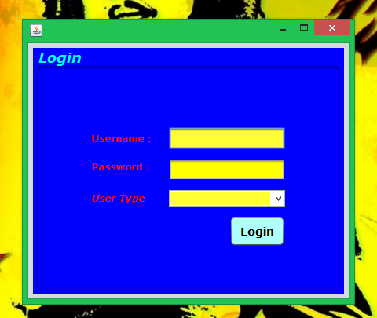

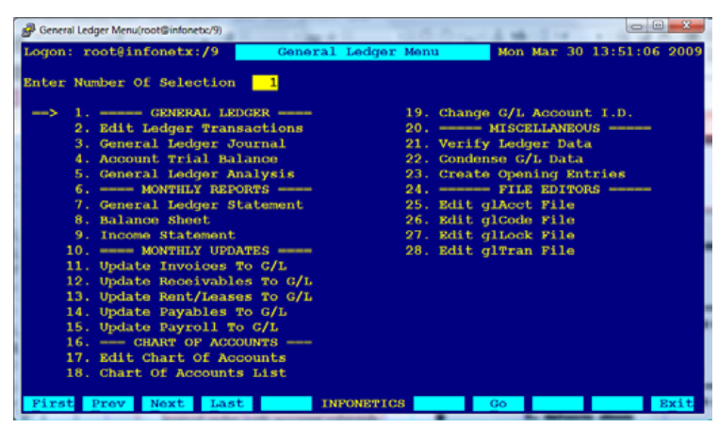

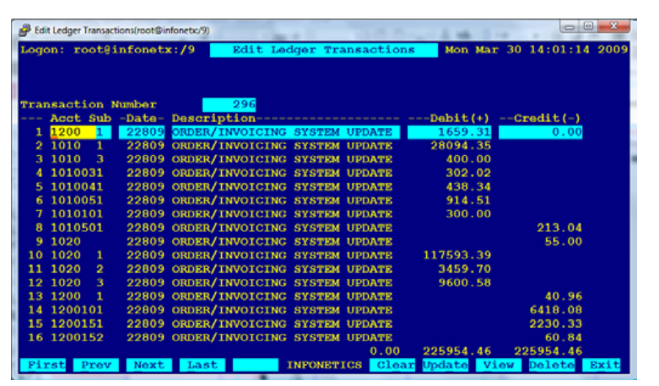
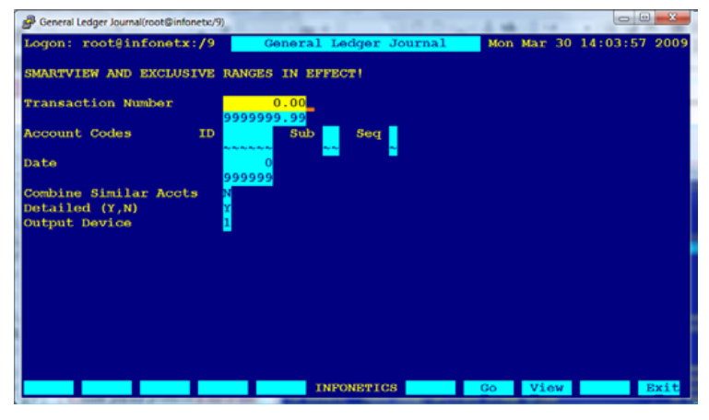

Software Requirements Specification
  - Goals and Objectives
The primary objective of the General Ledger System from Legler Systems is to process accounting information. This GL System performs the basic general ledger objectives by providing a complete and accurate bookkeeping record of all accounting transactions affecting each ledger account and supports either the cash accounting method or the accrual accounting method.
The goals of general ledger are:

- To provide complete financial statement
- To lessen the amount of paper work
- To provide all total of expenses in the company
- To validetate the balance/expenses
- No re-keying - Save time and effort and eliminate redundancies
- Access 24/7 - Convenient and flexible
- Quick mapping - CPS will customize your interface so it works for you.

  - System Statement of scope
    - General requirements
The following general requirements were laid out of our project named general ledger
With asset accounting
- A way to create financial statement
- A way to update receivables to g/l
- A way to update payables to g/l
- A way to update payroll to g/l
- A way to have income statement

- Interface Enhancements

Staff members of the security agency have some enhancement requests
To have easy in access of the product

- Database Administrative Interface

- Online Help
To make a complete help menu for the user assistance and also
Be used to present information on board range of subjects

- Training
training is as important as the software itself in the success of implementing a new general ledger system. Your system is set up with your institutional data, business rules, and variables from your migrated data. Using financial data makes the training more relevant for staff members and provides a better opportunity to review and become comfortable with

Training typically takes place over a two month period and has two phases about a month apart. This allows staff members to try out new skills, practice on the non-production database, ask questions, and become familiar with the system. They receive exceptional, personalized training at a comfortable pace.

  - System Contex

General Ledger Accounts are used to identify balance sheet classifications, revenue classifications, or expenditure classifications. Balance Sheet accounts include Asset accounts, Liability accounts, and Net Assets and Reserves. The development of the general ledger is actually for academic purposes only to begin with. It is necessary or mandatory for the proponents to have a client on which the proponents will gather data and information needed to establish and develop a correct business processes. If there is no client, the proponents will have a hard time for identifying the needed data and information for the GL development. Furthermore, if the development of the GL will be a success, it is a good example of a teaching-learning method provided by the current school on which the proponents are studying while developing the GL. More importantly, the client will be benefitted the most when the GL will be implemented on their respective company / agency. With this, the client will upgrade their business transaction using the latest technology provided by the GL. The system will make sure that the processes of the company are still the same, the thing is, it will now a computerized rather than the previous manual process that they had.

  - Major Contriants
Funding
Funding is the worst possible constraints for the proponents, the funds that the proponents are only limited considering they are currently dependent as a students who lacks on personal fund to support the expenses for developing the GL. However, this constraint will not be an issue for not pursuing the objectives for the development of the GL.

Time
The project only have an approximately five months to finish all documentation, software and interface enhancements. This is a disadvantage for the proponents knowing that the system development and documentation has to finish within five months at the same time the project are still studying on their classes and still searching on how the software development will takes place.

2.0 Usage Scenario
2.1 User Profiles
There will be four levels of users:
- Full access/control(administrator)
- Read/Write/edit/add(staff)
- Read only(public)
- Read/write modify(client)
2.2 Use-cases
Read only users
He/she connot edit,add or modify any transaction
Full control
This type of user can do whatever he/she wants to the software
Read/Write/edit/add(staff)
they can modify the records of the users they created
Read/write
This user can only add details but cannot delete

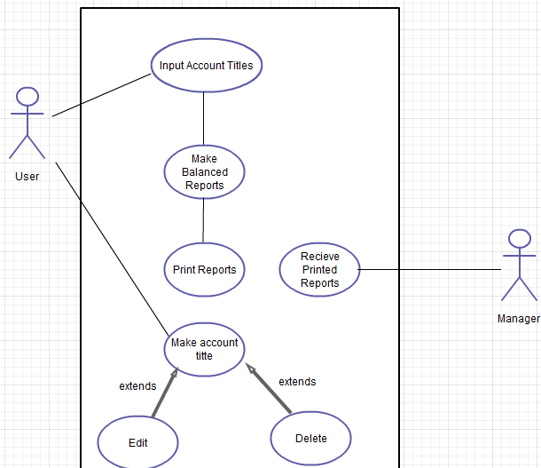

  - Data model and Description
  - Data Description

3.2.1 Data objects and dictionary
Edit ledger transaction
- Transaction no:
This is the number of the transaction
- Account sub:
- Date:
This is the date of the transaction
- Description:
This is the description of the transaction
- Debit:
- Credit:
- Total:

General ledger journal
- Transaction id:
This is the number of the transaction
- Date:
This is the date of the transaction
- Description:
The description of the product
- Amount sub:
- Debit:
- Credit:
- Balance:
Account Trial Balance
- Transaction id:
- Date:
This is the date of the transaction
- Descripton:
This emphasize the kind of transaction
- Amount sub:
- Debit:
- Credit:
- Balance
- Grand total:
General ledger Analysis
- Amount:
- Sales:
- Total sales:
- Cost of goods:
- Total cost of goods:
- Gross profit:
- Expenses:
- Total expenses:
- Net operating income:
- Month:
- Total:
General ledger Statement
- Transaction id:
- Account sub:
- Date:
- Sub Description:
- Beginning Balance:
- Current Debit/Credit:
- Amount Total:
Balance Sheet
- Transaction id:
- Description:
- Total fixed assets:
- Total other assets:
- Total assets:
Income Statement
- Transaction id:
- Description:
- Total operating income:
- Net operating income:
- Discounts earned:
- Interest expenses:
- Total other income expenses:
- Federal icome tax:
- Other taxes and licences:
- Total taxes:
- Net income after taxes:
Monthly Updates
- ID:
- Description:
- Order:
- Less:
- Solid:
- Volume:
- Price:
- Mark-up:
- Grand Total:
Chart of Accounts
- Account id:
- Descriptive name:
- Sequence code:

3.1.2 Relationships

4.0 Functional Model and Description
The function and purpose of the general ledger in accounting - Foundation level
The general ledger is the central core of the accounting information system where all of the financial transactions of a business are categorized and summarized into accounts. These accounts in the general ledger group similar transactions into individual records producing a continually updated credit/debit balance for each. The number and type of accounts that make up the general ledger is determined by the chart of accounts. The general ledger contains a permanent history of all the financial transactions that have taken place in the business since its first day of operation.

4.1 Subsystem Flow Diagram

4.2 Human Interface Description
With a General Ledger interface you no longer have to fumble through payroll reports and manually enter data into your accounting package. JetPay Payroll Services, formerly A D Computer, can create a custom interface that works with the accounting software you already use so that your payroll items are posted to your GL quickly, easily, and accurately.
Save time...simply export your payroll data from our system and import it to the accounting package you use.
Increase accuracy... eliminate the human errors associated with manual entry (you also save time spent on reconciling discrepancies).
Take Control... no more worries about changes made to your GL/chart of accounts. You and your authorized users retain control!

Main Menu Window
GENERAL LEDGER MENU
• The EDIT LEDGER TRANSACTIONS Program is used to add, change, view or delete any transaction in the ledger database.
• The GENERAL LEDGER JOURNAL
Lists ledger transactions in journal (numerical) order.
• The ACCOUNTTRIALBALANCE
Lists ledger transactions by account in
chronological order with account subtotals.
• The GENERALLEDGERANALYSIS
Lists each account balance in a monthly spreadsheet.
MONTHLY REPORTS
•Letter-Perfect GENERALLEDGER
STATEMENT, BALANCESHEET
And INCOMESTATEMENTS can be
Produced according to your accountant’s specifications.
MONTHLY UPDATES
• Monthly updates from all subsidiary software packages including, order invoicing, receivables, cylinder control, payables and
Payroll can be run in summary or detailed mode to automatically
Create General Ledger entries.
CHART OF ACCOUNTS
• The EDITCHART OF ACCOUNTS program allows you to
add, change, view or delete records in the chart of accounts file.
• The CHART OF ACCOUNTSLIST shows the complete chart
Of accounts.
• The CHANGE G/L ACCOUNT I.D. is used to change a G/L
Account ID throughout the system.
MISCELLANEOUS
• The VERIFY LEDGER DATA program is a maintenance program to ensure the internal integrity of the General Ledger data.

Other window are also explain in the
Main menu window

5.0 Restrictions, Limitations and Constraints
Time
only have an approximately five months to finish all documentation, software and interface enhancements. This is a disadvantage for the proponents knowing that the system development and documentation has to finish within five months at the same time the proponents are still studying on their classes and still searching on how the software development will takes place.

Workforce

only have a maximum of five members. That is why the number of people who work for the development of the software comes up in a disadvantage in terms of the numbers. The project have to double time regarding of the execution of the project documentation and requirements specification regardless of the shortage of the manpower of the project team.

Funding
Funding is the worst possible constraints for the proponents, the funds that the proponents are only limited considering they are currently dependent as a students who lacks on personal fund to support the expenses for developing the GL. However, this constraint will not be an issue for not pursuing the objectives for the development of the GL.

Resources
The software and hardware that the proponents used to develop the GL are also limited. The proponents only have one laptop and one desktop to be able to use in developing and documenting the software. It is more efficient for having at least one laptop / desktop per member of the project team to be able to execute the software development on time.

  - Validation Criteria
You use validation options to specify how GL accounts are validated. GL accounts are validated when they are used in GL account fields.
Typical validation tests include checking for missing data items, valid codes, and valid values. More extensive validation may entail authorization of the transaction based on the customers record and available inventory.
creating new user interface using Java Programming to develop the system’s front-end interface and MS SQL for the database or the back-end interface of the GL. This interface allows the users to The proponents are concerned about the input of data into the software and their expected outputs. This is the reason why the proponents will design an interface that is easily read by the user, creating a tool tip text in every fields and buttons to be able to identify the data to be input in every field to avoid errors on the data inputs.

Software Design Specification
  - Goals and Objectives
The main purpose of GENERAL LEDGER SYSTEM is the collecting point for all
financial data of a business. A chart of accounts and a ledger of
transaction entries are maintained in the database.
The goals of general ledger are:
- General Ledger Statement
- Balance Sheet
- Income Statement
- Chart of accounts
  - System Statement of Scope
The general statement of GL must be specified and provided in this section. That is the information has to be produced, what the major functions are implemented and what data are provided as the input GL.

    - General Requirements
The following general requirements were laid out of our project named general ledger
With asset accounting
- A way to create financial statement
- A way to update receivables to g/l
- A way to update payables to g/l
- A way to update payroll to g/l
- A way to have income statement

- Interface Enhancements

Staff members of the security agency have some enhancement requests
To have easy in access of the product

- Database Administrative Interface
The general ledger will provide a secured database on which the user could retrieve and save data and information at ease with the use of MS SQL database.

- Online Help
To make a complete help menu for the user assistance and also
Be used to present information on board range of subjects

- Training
training is as important as the software itself in the success of implementing a new general ledger system. Your system is set up with your institutional data, business rules, and variables from your migrated data. Using financial data makes the training more relevant for staff members and provides a better opportunity to review and become comfortable with
Training typically takes place over a two month period and has two phases about a month apart. This allows staff members to try out new skills, practice on the non-production database, ask questions, and become familiar with the system. They receive exceptional, personalized training at a comfortable pace.

  - System Contex

General Ledger Accounts are used to identify balance sheet classifications, revenue classifications, or expenditure classifications. Balance Sheet accounts include Asset accounts, Liability accounts, and Net Assets and Reserves. The development of the general ledger is actually for academic purposes only to begin with. It is necessary or mandatory for the proponents to have a client on which the proponents will gather data and information needed to establish and develop a correct business processes. If there is no client, the proponents will have a hard time for identifying the needed data and information for the GL development. Furthermore, if the development of the GL will be a success, it is a good example of a teaching-learning method provided by the current school on which the proponents are studying while developing the GL. More importantly, the client will be benefitted the most when the GL will be implemented on their respective company / agency. With this, the client will upgrade their business transaction using the latest technology provided by the GL. The system will make sure that the processes of the company are still the same, the thing is, it will now a computerized rather than the previous manual process that they had

  - Major Contriants
- Funding
Funding is the worst possible constraints for the proponents, the funds that the proponents are only limited considering they are currently dependent as a students who lacks on personal fund to support the expenses for developing the GL. However, this constraint will not be an issue for not pursuing the objectives for the development of the GL.

- Time
The project only have an approximately five months to finish all documentation, software and interface enhancements. This is a disadvantage for the proponents knowing that the system development and documentation has to finish within five months at
the same time the proponents are still studying on their classes and
still searching on how the software development will takes place.
- Data Design
  - Database Description
- Architectural and Component-Level Design
Enter user type, name, Password
START
User type, name, password that register
Valid User type, name, password from DB
Menu appear with option to select
MENU
Select option
EXIT
Chart of accounts
END
Monthly Updates
Monthly Reports
General ledger
Chart of account
Monthly Updates
Monthly Reports
General ledger
  - Program Structure
    - Overal

Menu Items
The following shows the architecture of the main menu:
Edit ledger transactions
- View
- Print
- Update

General ledger journal
- View
- Print
- Update

Account trial balance
- View
- Print
- Update

Chart of accounts
- Add
- change
- view
- delete

Description for Components
Login Form
Main form: frmLogin
Main actions: Login

This is the first form to appear after the user run the system. The user enters their username to the txtUsername and the password to the txtPassword to verify their accounts in order to access the system. The user must click the OK butoon which is the cmdOK. User will be logged in if it is valid username and password pair. If the user clicks the cancel button, the application will end if they confirmed their action.

Save
Object name: cmdSave, cmdCancel
form will be disabled unless the fields are all filled up with the data needed. When the save button is clicked, new record will be generated. If the user clicked the cancel button, the adding of record has canceled.

Delete
Object name: cmdDelete, cmdCancel
The delete button has been activated when the delete records in the chart of accounts file. If the user is not sure to delete, they can simply click the cancel button.

Update
Object name: cmdUpdate, cmdCancel
The update button allows the user to edit the employee records and then save the changes immediately. The cancel button is to cancel the update of the journal records.

View
Object name: cmdView
The use of this nutton is to view the financial statement
,balance,expenses and chart of accounts

Edit
Object name: cmdEdit
The edit button allows the user to records in the chart of accounts file.

Print
Object name: cmdPrint
This button allows the user to print the financial statement
General ledger journal and balance sheet.

    - Leave Monitoring
Main forms: frmCreateLeave, frmUpdateLeave
Main action: Print, Save and Update

Save
Object name: cmdSave
When the user clicks on the cmdSave button, all of the data that has been filled in the textbox provided in the form will be saved in the database. After the button has been clicked, a confirmation message will pop-up to the window that tells the user that there was new leave information has been created.

Update
Object name: cmdUpdate
The user allows modifying the leave information of the accounts. This function allows the user to change the data of the employee’s leave information when the employees intend to file their leave benefits.

Print
Object name: cmdPrint
The user allows printing the leave information of the selected employee. This function could be achieved by clicking the print button.

    - Reports
Main forms: frmReports
Main actions: View, Print

View
Object name: cmdPreview
This button allows the user to view the performance appraisal of the employee. This includes the comments and feedback of the client to the employee about their performance while working in the client’s provisions.

Print
Object name: cmdPrint
This button allows the user to print a hard copy including the reports selected by the user.

    - Help
Main forms: frmAbout, frmContents, frmTutorials
Main actions: Browse, View

Browse
Object name: cmdBrowse
The help function allows the user to browse the instructions on how to operate the system well. The about function on the help menu displays the information of the proponents and the information of the client. Contents function displays the system specification of the GL. Browsing of the tutorial function allows the user to learn some of the system’s functionalities by telling the user on how to manage the system process when there are errors occurs on the system.

View
Object name: cmdView
The view button allows the user to select on the help menu on which they want to view on the instruction that they want to know.

- User Interface Design

The GL have a lot of interface that hasn’t to be designed yet. The proponents are still researching for the additional scope of the system and obviously other interface will be developed also. The client also have a lot of ideas for the interface that’s why the proponents have to discuss to see rather they can be combined form of the forms for the GL project.

- Description of the User Interface
The following image represents the forms in the GL. After running the GL, the login screen will appear. If the user enters the right username and password, it will immediately take them to the main interface of the GL which is the main menu window.

    - Screen Images

    - Objects and Actions
- Login Form
Username
Username can be ranged from 6-15 letters or numbers, as the industry standards. No special characters and space.
Password can be ranged from 6-20 letters and numbers, as the industry standard. No special characters and spaces.

User type
This field consists of the level of the user to access the system. The level of accessibility and functionality of the system depends on the user type given.

Menu Items
The following shows the architecture of the main menu:
Edit ledger transactions
- View
- Print
- Update

General ledger journal
- View
- Print
- Update

Account trial balance
- View
- Print
- Update

Chart of accounts
- Add
- change
- view
- delete

Menu bar
The GL provides a menu bar which contains the icons that equivalent to the commands in the menu items. These icons are selected according to the function that they represent. These icons will be the other way to connect into the different functionalities of the system. These icons serve as the main attraction to the main menu window of the system.

  - Interface Design Rule
Interface design rules are focused on these areas of concerns:
- The system must be user-friendly
- The system must be easy to navigate
- The system should be readable
- The system should be easy to learn
- The system should be maintainability
- The system should use a maximum of three colors
- The system must be reliable

  - Components Available
The project are allowed to use Java Programming language as a general rule given by the project evaluation committee. The Java Net beans chose by the proponents to develop the GL and as a reference for creating the system’s front-end. Basically, the projects are already having a lot of ready-made components available to develop the proposed system. The following is a list that the proponents will use for the software development.

    - Java Swing Controls
- JTextField
- JLabel
- JButton
- JPanel
- JFrame
- JPasswordField
- Etc.

    - Java Swing Menus
- Menu Bar
- Menu Item
- Pop-up Menu
- Etc.
    - Java Swing Container
- JPanel
- Toolbar

- Restriction, Limitations and Constraints
- Time
Time is so far the biggest restriction or constraints for the project to developed the proposed system. The projects only have an approximately five months to finish the entire project. It is very important for the projects to watch the time to spend over the phase of the software development project. The projects could have included many components to the project like online GL but time restricts the project team from doing so.

- Individual Skills
Skills in computer programming and design skills are also one of the restrictions. It does not have as big of an impact on the project as time but it sure does limit the proponents from doing more addition to the project functions and components.

- Insufficient Resources
The project only have limited equipment for the software development. The proponents planned to develop an android application by using tablet PC but for now, it is impossible to be implemented because the financial status of the project limited. That’s why the proponents will have to abandon the plan.

- Testing Issues
The purpose of this phase is to identify as far as possible any errors and deficiencies in the system prior to its final release into production use. For instance errors in

- User interface
- Procedure manuals
- Job design
- Organizational structure design

In reality all system features cannot be checked at the outset. For instance, users might realize that the
system has inadequate procedures manual only after the system has been properly implemented.

  - Classes of Test

In reality all system features cannot be checked at the outset. For instance, users might realize that the
system has inadequate procedures manual only after the system has been properly implemented.
Interface / Forms
The project are creating new interface using the Java Net Beans. This interface allows the user to manage the General ledger particularly in computing the total expenses of the company to save new data and to be able to print necessary documents.

Login Window
The project will use several different username and password. The proponents will have to use either correct and incorrect username or password to access the GL and thus access its database. The user will not be logged in if they insert the wrong username or password. When the correct username and password will be inserted, the user will be able to log into the next window. This will be possible upon checking the OK button by performing a proper testing of the function.

GL (Main Form)
This is the main window of the GL that the user will use to access the database using the Java Net Beans. The main window has a several drop down menu in this window.
The EDIT LEDGER TRANSACTIONS, GENERAL LEDGER JOURNAL, ACCOUNTTRIALBALANCE, CHARTOFACCOUNTS

  - Identification of Critical Component

- Appendices

Chapter III - Test Specification
- Introduction
This section gives the general overview of the test specification for the GL under the service management. This includes the methods used by the proponents to identify the outcome of the software when it is being used. The tools and equipment used to test the software and the windows of the GL to b tested.

  - Goals and Objects
The main purpose of GENERAL LEDGER SYSTEM is the collecting point for all
financial data of a business. A chart of accounts and a ledger of
transaction entries are maintained in the database.
The goals of general ledger are:
- General Ledger Statement
- Balance Sheet
- Income Statement

  - Statement of Scope
This section gives the overall plan for integration of the software and a description of specific test is being implemented here. The following are the different kinds of tests that the proponents will take to ensure the quality of the GL.

- Unit Testing
- MS SQL Database
- PC Application
- Java Net Beans

Unit test will be performed using black box testing methods.

- Integration Testing
- MS SQL Database
- PC Application
- Java Net Beans
- Portability Testing
- MS SQL Database
- GL
- PC Application
- Security Testing
- MS SQL Database
- GL
- PC Application
- Performance Testing
- MS SQL Database
- GL
- PC Application

  - Major Constraints
In this section, the project will talk about the business, technical or resource related constraints that may keep the project team from performing all test necessary.

- The project have limited funds for testing the proponents only have one laptop to make software testing for gl. This means that the proponents cannot test the software using laptop / PC from other brand and other hardware specification that is lower / lesser price than of the laptop / PC that the proponents are currently using.
- The project have a limited access to the client, for this reason the software testing with the clients. The client also has to set an appointment with the proponents. Unfortunately, the discussion between the client and proponents regarding the results of software testing are vulnerable and inconsistent.
- The project don’t have enough manpower to perform the software testing and identify the results. This might be the reason for not be able to test the GL into the larger user base.
- The project haven’t enough time to perform the while software testing due to schedule conflict. The project will only have to test the most important parts that are hard to fix rather than to test the smallest parts that are easy to repair.

- Testing Plan
The project want the Gl to be bug five and lesser error on the processes. The project also want to make sure that there are no defects in the system. This is the reason why the proponents have to spend large amount of the total software development time on the testing. The following are the description of the testing procedure and strategy. The project also be presenting the timing and scheduled of the tests to be carried out.

  - Software to be Tested
    - Interfaces
Login Window
The project make sure to deal with the possibilities of error occur on this window. The project use several username and password to tests the security level of the GL if it is working. The project also have to test the OK button and Cancel button on this window by clicking these button and try to find out if it is working properly.

SMS – GL (Main Window)
This is the main window of the GL that the user will use to access the database using the Java Net Beans. The main window has a several drop down menu in this window.
The EDIT LEDGER TRANSACTIONS, GENERAL LEDGER JOURNAL, ACCOUNTTRIALBALANCE, CHARTOFACCOUNTS The project will try to use all the menus and the different options available in each of the window.

- Journal Information
When Journal informatio button is clicked, user will be shown three choices.
- Add Entries
This function can add journal ebtries and the date of transaction
- Update ledger transaction
This function could update the ledger transaction and make some changes on it
- Delete transaction
This function allows the user to delete the transaction information if they are not a part of the company or the contract has been terminated.

- Leave
When the user selects the leave button, the user allows creating leave

- Reports
The user allows viewing some of the reports that is required for the GL department. The user also allowed printing these reports.

- Help
When the user clicked this button, the user will be shown three choices
- Contents
This window allows the user to learn the systems processes and functions
- About
This window allows the user to learn about the project information and the information of the client that is using the GL
- Tutorials
This window gives the user to learn the steps or the ways on how the system will be used. This window consists of the tutorials on the system

  - Testing Strategy

This section will describe the testing strategy. The project will use these following testing methods to test the GL and the proponents decided to use black box testing methods. The following are the testing strategies for the GL.
    - Unit Testing
In this unit testing case, the proponents will be separately testing the different modules on the system. The proponents will carry out black box methods where each component of the software is tested individually. The proponents will test the components by testing the inputs and identify the expected output and the output that is generated by the system. The test will be carried out by the programmer who designed and implemented the module. The system analyst will carry out the test on the modules to finalize the testing.

    - Integration Testing
Sending payroll data to General Ledger is one of the final steps in the payroll cycle. When you integrate Global Payroll and General Ledger, you can automatically post earnings and deductions that are associated with a finalized calendar run to your General Ledger system.

    - Portability Testing

the process of testing an existing software component or application in a new environment.The test results, defined by the individual needs of the system, are some measurement of how easily the component or application will be to integrate into the environment and these results will then be compared to the software system's non-functional requirement of portability for correctness. The levels of correctness are usually measured by the cost to adapt the software to the new environment compared to the cost of redevelopment.
.

    - Security Testing
User access to Financial information and records should be highly secure. Compulsory password settings to include letters as well as numbers, and upper case will ensure that access to the e-Bis and Open Accounts systems remain secure.
Audit review found that passwords were not required to be alphanumeric or contain upper case characters.
Passwords with no preconditions expose the system and the Authority to unauthorised user access.

- Confidentiality among the username and password of the user
- Authentication for every user type to logged into the system
- Authorization for the usernames and password before accessing into the system
- The GL is secured against known and unknown vulnerabilities
- Securing of data by using a high-level database security measures.
- Availability of the system’s functions according to the type of user

    - Performance Testing

It is important to have testing before using the system to know
If it is performed well of responsiveness and stability under various workload and the quality attributes of the system, such as scalability, reliability and resource usage. Inorder to do this you must have the following:
the desktop / laptops to be used, computer resources, application needed, hardware specification,

  - Testing Resources and Staffing
The proponents will use several different resources to carry out the test on the GL. Since the time is a part of project constraint, the proponents will try to use help from everyone that is essential to take the responsibility and evaluate the software during the testing phase.

- The Company Staff
- The Proponents
- Laptop / Desktop
- Software Applications

  - Test Record Keeping
Test record keeping and test work products are described in section 3.4 of the test specification document. For further information regarding section 3.4 of the test specification document.

Testing Tools and Environment
The project will have to provide the testing tools such as the desktop / laptops to be used, computer resources, application needed, hardware specification, other devices and the company office that serves as the main venue for the testing of the GL. The proponents will also use resources available to software development team outside of the client’s facilities.

  - Test Schedule
The following is the schedule for the testing of the HRMS.

Project Test Plan
- To be scheduled
System Testing
- To be scheduled
Generating the test reports
- To be scheduled
System Implementation
- To be scheduled

- Test Procedure
In this section the proponents will describe the test procedures in detail.

  - Software to be Tested
The following software that has to be tested is listed on the section 2.1 from the test specification document. For detailed list of the software component items you can refer to the previous section of the document.

  - Testing Procedures
In this section, the project will describe the overall software specification of the GL. It includes the description of the methods for all the different tests to be performed and will also declare the expected outputs.

    - Unit Testing
In this unit testing case, the proponents will be separately testing the different modules on the system. The proponents will carry out black box methods where each component of the software is tested individually. The proponents will test the components by testing the inputs and identify the expected output and the output that is generated by the system. The test will be carried out by the programmer who designed and implemented the module. The system analyst will carry out the test on the modules to finalize the testing.

    - Integration Testing
Sending payroll data to General Ledger is one of the final steps in the payroll cycle. When you integrate Global Payroll and General Ledger, you can automatically post earnings and deductions that are associated with a finalized calendar run to your General Ledger system.

    - Portability Testing
the process of testing an existing software component or application in a new environment.The test results, defined by the individual needs of the system, are some measurement of how easily the component or application will be to integrate into the environment and these results will then be compared to the software system's non-functional requirement of portability for correctness. The levels of correctness are usually measured by the cost to adapt the software to the new environment compared to the cost of redevelopment.

    - Security Testing
User access to Financial information and records should be highly secure. Compulsory password settings to include letters as well as numbers, and upper case will ensure that access to the e-Bis and Open Accounts systems remain secure.
Audit review found that passwords were not required to be alphanumeric or contain upper case characters.
Passwords with no preconditions expose the system and the Authority to unauthorised user access.
- Password Login

Passwords used to log into Open Accounts system should be alphanumeric and contain upper case, in addition to being over six characters long.

- Modular Access
The GL identifies the user and allows him/ her to access only certain modules. The proponents will try to see if the software restricts unauthorized users from accessing
certain modules of the software.

    - Performance Testing
It is important to have testing before using the system to know
If it is performed well of responsiveness and stability under various workload and the quality attributes of the system, such as scalability, reliability and resource usage. Inorder to do this you must have the following:
the desktop / laptops to be used, computer resources, application needed, hardware specification.

Login
The user should be able to log on within 0.2 second
Save Function
Best Case Scenario – Immediate
Worst Case Scenario – 3 seconds
Search Function
Best Case Scenario – Immediate
Worst Case Scenario – 3 seconds
Print Function
Best Case Scenario – Immediate
Worst Case Scenario – 2 seconds
Browse Function
Best Case Scenario – Immediate
Worst Case Scenario – 2 seconds
Delete Function
Best Case Scenario – Immediate
Worst Case Scenario – 3 seconds
Exit Function
Best Case Scenario – Immediate
Worst Case Scenario – 3 seconds

Cancel Function
Best Case Scenario – Immediate
Worst Case Scenario – 2 seconds
Next List of Records
Best Case Scenario – Immediate
Worst Case Scenario – 3 seconds

  - Testing Resource and Staffing
installation options. Select System, Business Unit or Type in the GL Options group box on the Billing Integration Options page. Define installation options and mobile approval options for General Ledger. Grants.Define Staffing Front Office and Pay/Bill Management installation options.

- Client Staff / Employees
The project ask for help to test the GL with the participation of the security agency personnel. The employees / staff are allowed to use the full function of the GL as part of its validation testing. The employees are allowed to record any errors that they encounter during the software testing on hand.

- Handheld PC / Desktop / Laptop
The project will have to use the clients PC or laptops after installing the GL. This will allow the user / employee to test the GL with one or more tester at the same time. With this, the data from one computer to the other are also identified through the system integration functionalities of GL.

- Error Reporting
The project provide a reports manual on which the employee and staff are required to list down the error and bugs that they may encounter during the testing activity.

- Other Devices
The project will also have to use other devices that is necessary for the functionalities of the GL like printer, Scanner and other devices that supports the GL processes.

