CHAPTER I – PROJECT CHARTER

- PROJECT BACKGROUND

Companies around the world used strategies to maintain its profitability and flexibility. They often provide service for the benefits of their clients and the company itself. To maintain its profitability, the company must secure the good communication to their clients while also securing their financial status. Billing and Collection System must be effective and accurate to be able to assure the revenue. Problems arise in terms of billing like calculating the outgoing bills and summarizing the incoming bills which is the primary concern on this study.
The researchers proposed this automated billing and collection system in order to help the company’s growth. A system that will manage all the incoming and outgoing bills of the company. And also a system that will serve as storage of billing information on a centralized database wherein, whenever the accounting department ask for billing reports periodically billing and collection has the ability to produce reports immediately. And a system that is accurate enough to meet client’s demand.
The said clients are either be schools, drugs stores, subdivisions, factory and other companies that are in need of service of security. Billing and Collection is the process of creating an invoice to customers for goods or services. Process of Billing and Collection focused on Generating of Bills and Collecting of money according to the contract of agreement to the clients who will benefit by their service provider. The system shows the transaction between the admin, the clients, the accounting department and the system itself.

  - Problems and Opportunity
Billing and Collection considered many circumstances such as assuring the financial flow wherein company relies on the client’s payment through their bills and payment collection. Problems arise in terms of billing like calculating the outgoing bills, summarizing the incoming bills, secured collection of payments and not a generating a reports that fit into periodical reports. To develop a system means turning it into something much convenient to manipulate and easy to execute the process thus avoid the conflicts and confusion in billing and collection process. Because before the Accounts Receivable calculate data that will be pass on next to General Ledger the process will begin first from billing and collection because without it the productivity of financial process may slowed the production of the company.

- Incoming Bills
Considering the company has many expenditure such as paying for utility bills and other type of bill within the company, these bills are one of those fixed cost in a company which is the company will be paid for whether they like it or not. Keeping of records of incoming bills may cause longer the process of Accounts Receivable because the company doesn’t have a centralized record of bills that they have received from different service providers too. Volume of data receiving is also considered here thus producing volume of papers in a company.

- Outgoing Bills
Primary concern on this study is assuring the good cash flow of profit that the company will gain through their payment as exchange for the service that rendered by the company to their clients. Billing and collection may affect the productivity of the company if the billing process in inaccurate and not reliable especially in making invoices, calculating bills based on the contract agreement between the company and the clients. These processes also may also apply to other departments in a company whenever they will be having transaction or billing rather with outside suppliers if it’s in terms of supplies and equipment which is the procurement handles the supplies. And in terms of creating invoices for the client, end-user used to input invoice number and may lead to data redundancy because the system doesn’t notify the user if it has record on file already.
The process during the calculation of bills is inefficient because current system used to calculate bills using MS Excel wherein user needs to input data one by one and writing only other charges listed on the created billing form.

- Collection
As part of billing is the collection thus transferring the billing into cash or money upon payment. Issuance of official receipt on the collection is also a problem because the agency relies only on writing other information in the receipt. This may lead to unacceptable process of this matter because once and for all financial aspect of one company must be prioritize first that is why all the information that must be inputted in the Official Receipt must be true, correct and exact without omission, illegal alteration or anything that may considered and may reduced credibility of a company.

- Reports
Current system has no ability to produce auto-generated reports that will show status of the client, their balances, amount does the client has paid and other penalties and a report of all invoices and also report of all the collected revenues from the client. It is essential to establish a centralized reports of records from incoming and outgoing bills from the company. Unfortunately most billing departments find some difficultness in updating client’s especially in terms of their status of their accounts.

- Security Risk to the billing information
And in terms of confidentiality of information especially in billing, anyone can access the database because all the information regarding billing transaction is only accessible in MS Excel.
Such an outsourced solution will not only offer better economics but also better security.
Also, when more than one person handles billing data, it is important to have fine grained access control to ensure that data is protected from unwanted access.
It is important that not only the infrastructure housing the billing solution is securing but also the flow of financial data, thereby ensuring data security standards.

- Notification of Processed Bills
Once the Bill has been processed, notification of the processed can be considered as problems because still it is a part of the billing process. Client is aware of his status of his account they must be notify before the due date of payment will expired.

  - Benefits
A system that will give agency access to billing with a high level of system security. It provides storing of billing documents and data from a full range of sources and in a variety of formats, and automatically calculates client’s bill. The user doesn’t need to input data one by one to fill all the Text Field of the billing form because the system has an ability to process the bill automatically. The administrator will be also benef0ited on this project because since administrator is only the person who is authorized to access the system, staff is prohibited to access other transaction rather than billing this will also help the company to avoid anomalies especially when it comes to financial aspects.
By automating document processes instead of relying on manual methods, businesses reduce the cost, increase the Speed and improve the quality of information exchange with clients. These Outcomes result in greater efficiency in billing and collections, ultimately contributing to overall profitability and return on IT investments.
The following personnel are the ones who will be benefited on this system project.
- Accounting Department
This system project would contribute a lot to Accounting Department for handling financial aspects. This will help the efficiency of billing and collection process. Thus resulting a reliable and convenient transactions with other sub-systems that integrated with billing and collection.
- Accounting Staff
The person who usually manipulate the system in terms of financial aspects is the staff from Accounting Department because they are the ones who are only given the authority to monitor, update billing transaction, make invoices for the outgoing bills, record the incoming bills and calculate the bills in a way where staff will lessen the human resource because the system will be develop from process improvement.

- The Employees within the company
Since the process will not be well function without human interact with the system, employees inside the company will be benefited also by this system project through system integration this will result to efficiency growth and company production.
- Project Team/The Researchers
As part of academic requirements this study will benefit the Project Team who dedicate their time and exert effort and knowledge for this system project. This serves as the stepping stone of the Group to their chosen field of profession. From almost 4 years of studying this field, the group applied all the knowledge that they have learned from those past years of learning and teaching of hardworking professors especially despite difficultness or setbacks.
- Future Researchers
For the future researchers who will soon come up to this moment like this, this will serve as the guidelines and reference for more improvements of their system. Knowledge application from what they have learned and learning from their research will be sum up into a success project for the future.
- Clients
As part of the project, clients also the ones who will be benefited on this project because they will be serve by the company with high reliability with high system functionality.

  - GOALS
The following describe the goals of the Billing and Collection System to be implemented, installed and addressing the problem and finding the best solution to the problem.

- A system that will centralized all the records of incoming bills
This process refers to all the bills that company will be responsible to pay whether they like it or not. The system will record all the incoming bills thus creating centralized records of incoming bills and will send the Obligation Request to Accounts Receivable and Accounts Payable.

- A system that Assures Accurate Outgoing Bills and Automated Calculation
The auto-generated data will be then present on the proposed system. From creating an invoice varying sequence number to avoid confusion and less redundant to the records whenever the end-user create an invoice. And an auto-generated billing form wherein calculation of bills will be automatically computed whenever others charges has been updated.

- To develop a system that ease process of Collection and Official Receipt Issuance
The group develops the system to ease the process of collection and the issuance of official receipt as soon the clients pays their account.

- Reports Generation
The proposed system has the ability to produce auto-generated reports on collection, invoices, and client’s status and there’s no need to input the information to create reports.

- To secured the financial information and ensure data protections
Considering security is one of priority of an organization thus the developers creates the system with a high level of security while limiting the persons who are only authorized to manage the system. When more than one person handles billing data, it is important to have fine grained access control to ensure that data is protected from unwanted access.

- A system that will notify the client in regards of their statement of account.
It is possible to send notification to clients in many ways. In order to notify the client, the billing section is responsible to notify client through electronic mail.
  - STAKEHOLDERS AND CLIENT
- Company/Service Provider
- also called as the End-User they provide the efficient process of the system for the clients. Through the help of the automated billing system, the clients will be able to serve well by the company through creating custom invoices to them, calculate client’s cost for each billing record, periodically generate invoices and collecting payments received from the clients.

- Instructors/Professors
- persons who discuss the overall system process. They are the ones who teach what will be the process of the entire system.

- System Advisers
- persons who guide the researchers to meet the requirements of their system project. The advisor is an individual who provides advice, information, or suggestions to the group.

- Customers/Clients
- who will received service from their service provider and also benefited to the system depends on their demands to the company. The one that will be billed, pays and issued receipt as a proof of payment.

- Researchers
- people who contribute knowledge, time and effort to be able to help the company. Team who dedicate their time and exert effort and knowledge for this system project. This serves as the stepping stone of the Group to their chosen field of profession. From almost 4 years of studying this field, the group applied all the knowledge that they have learned from those past years of learning and teaching of hardworking professors especially despite difficultness or setbacks.

- Future Researchers
- people that may use this project as their references and guidance towards their future system project development.

- PROJECT SCOPE
Each system falls within a specific scope and experiences certain limitations. Service Management System needs to understand the scope and limitations of each sub-system in order to avoid conflicts to its other sub-systems.
Billing and Collection System focuses on recording of incoming bills, generating outgoing bills, collection process and issuance of official receipt to client. Billing System processes only the transaction between the agreed contracts by the client and as soon as the payment process is done the collection information will be forwarded to Account Receivable. The proposed system design to improve the current billing and collection process. It also focuses on matters of security ensuring that the authorized persons only are allowed to access the system.
2.1 Objectives
This section describes the components or parts of the Billing and Collection System to be accomplished. Objective statements on this section will clarify and demonstrate the boundaries of the scope under the BCS. This will be illustrated as the Work Breakdown Structure (WBS) under the Billing and Collection System.

2.1.1 The figure shows the integration of other sub-system to Billing and Collection System
This figure shows how does the process billing and collection integration with other sub-systems. It shows getting the data from payroll system wherein the billing section will rely on the data that will be sent by payroll system to billing before generating the bills for the client. And it also shows the integration of other sub-system through making obligation request for all the transactions regarding billing inside the company which is also called incoming bills.

2.1.2 Service Management System – Billing

2.1.2 The figure shows the functions of Billing Process in the Billing and Collection System
This figure shows the function of billing. The different function incoming bills and outgoing bills and how its process flow before reach the end process of billing.
2.1.3 Service Management System - Collection

2.1.3 The figure shows the functions of Collection Process in the Billing and Collection System
This figure shows the function of collection. The client will present their Statement of Account upon Payment. And then Accounting Staff will verify the Statement of Account, check the Account No, Billing Information, Company Information and then issues the Official Receipt. The transaction will be recorded and will be added to reports that will be generated. After the payment process, the information will be forwarded to Accounts Receivable.

2.1.4 Work Breakdown Structure - BCS
The figure shows the tasks under the initialization process, system planning, system analysis, system design and system testing and evaluation that the proponents has to be accomplished in order to make the BCS successful.

2.2 Deliverables
Objective 1: Sub-System Integration with other sub-system
Project Deliverables | Work Products//Description
Payroll | Part of the Billing and Collection is payroll because before the billing perform its process, payroll should post the data to billing base on the employees performance.
Billing and Collection | Billing and Collection process all the transaction with incoming and outgoing bills. Before the process ends to Accounts Receivable/ Accounts Payable, it will undergo record to billing section before it will process by AP/AR
Property | All the matters that belongs to property like allowing limited and temporary but potentially renewable, exclusive use of property, but in exchange for compensation. Before they make action with these matters, they also comply with billing and collection before it will process too by AP/AR
Case Docket | All the legal matters will be posted by Case Docket not only to employees and other personnel inside the company but also the suppliers and client. It is essential to give attention to these matters to identify status with the client and company.
Procurement | All the supplies that the company will be needed for the use of the employees before deployment, will be process first by Billing and Collection to notify the AP/AR that the company has an obligation to do.
Client Information | This will only includes getting the information of the client who has a contract to the company.
Accounts Receivable/Accounts Payable | On this last part of the process of Billing and Collection System, all the information that has been processed by BCS will be then forward to Accounts Receivable/Accounts Payable to make an action.

Objective 2: Service Management System – Functional Billing Process
Project Deliverable | Work Products/Description
Incoming Bills | Its function is receive all the incoming bills like electricity bill, water bills etc., record it and then will be forwarded to AP/AR .
Outgoing Bills | Its function is to create an invoice for the client that has a contract between the company and the client that serve as an obligation for the client that they has need to pay for the service that they get from the company.
Bills Receive that consider as fixed cost in the company | This refers to:  - Utility Bills  - Other Bills
Integrate with other sub-system | Its function is to notify the billing that other sub-system has an obligation to take an action by AP/AR
Posting of data | Its function is to post the data either by billing to other sub-system or other sub-system to billing to inform each system that they have to take an action for a specific task like posting the data of employees from payroll to billing in order to make an invoice for the client.
Obligation request | This form will serve as a formal obligation that will be forwarded to AP/AR
Record the bills | All the process that has been made by the billing and collection system will be recorded and file to the database.
Create invoice | This include to billing process wherein total amount of cost from service is calculated including the penalty if the client failed to pay their bills on time and other charges.
Post to AP/AR | All the transaction made by billing and collection will be forwarded to AP/AR
Calculate total amount based on Service Rendered to client | Auto calculation of amount that based on the service rendered to client.
Other Charges | This includes Penalties and VAT and other charges that may refers to a punishment, or fine for failing to fulfill the terms of a legal agreement.

Objective 3: Service Management System – Functional Collection Process
Project Deliverable | Work Products/Description
Client | The ones who has an obligation to pay in return for the service rendered by the company
Statement of Account | a statement of recent transactions and the resulting balance.
Invoice Number | Invoices will track the client status, the total cost that they has pay, balances
Official Receipt | A receipt is a written acknowledgment that a specified article or payment has been received
Post to AP/AR | All the transaction made by billing and collection will be forwarded to AP/AR

Objective 4: Work Breakdown Structure – Billing and Collection System
Project Deliverable | Work Products/Description
Initialization Process | This is the initial process wherein, the project orientation is held, selection of sub-system study the sub-system and project background, prepare project proposal and choose project team adviser.
PS1 Preliminary Orientation | This deliverable pertains to feasibility orientation regarding the project.
Project Background | The group will study the project background, research for more ideas.
System Planning | This include meeting up with the group, clarification about the system, in this phase also the sub-system of the entire system will prepare for the company interview, and data analysis and finalizing the results.
Group meeting with the members | This process of system planning include system clarification.
Conduct Interview | The group prepares questionnaire that pertains to specific function of the assigned sub-system and good flow of process.
Checking of Document by adviser | This include the suggestions of adviser for some revision of the process in the documentation.
System Analysis | In this deliverable of BCS, the group study analyze the process of the sub-system.
Study and Analyze the system process | In this phase of system planning, the group determine the problems, make solution for the problems, state the project scope and out of scope in the process.
Review of Related Studies | This include researching for the related studies, constructing of matrix
Draft of Chapter 3 EIS Project Management & Development | In this phase, the group develop SQA and SCM Plan, start prototyping and document the rest of the documentation.
System Design | In this deliverable of BCS, it describe the system specification, the software and hardware specification, Data Models, Software Design, Architectural Design of the system project.
System Testing and Evaluation | As part of the deliverable of BCS, the group describe test specifications, performs testing procedures, evaluation of system project, and presents revised documentation of the system.

2.3 Out of Scope
Billing System doesn’t cover the process of client’s information because it only focused on billing and collection process. Its concern is to calculate every bill of client’s account but not the company’s financial statement. It doesn’t cover employee’s information like how many days of their attendance and absences when they start working to their assign duties.
It doesn’t cover the client’s information, employee’s information and other transaction. It only covers the billing and collection transaction between the company and the agency. The system received only the incoming bills and record it but not process it.

3.0 PROJECT PLAN
3.1 Approach and Methodology
The researchers used strategies, tools and techniques to meet the system requirements. In this part of documentation, the researchers present the method used to develop the System. The method used is called System Development Life Cycle (SDLC).
The SDLC parts are System Planning, System Analysis, System Coding and Design, System Testing and Implementation and System Maintenance. The SDLC method is the one that most IT programmers used in gathering and creating System.
3.1.1 System Planning
On this process a system must be well planned before proceeding to the next process. First, the researchers identify what are the problems that occur in the billing and collection process of their current system. After identifying the problem and its process, the developers started to think of the possible features and improvements of the system to be able to help the company.
3.1.2 System Analysis
On this stage, the developers analyze the information gathered during the planning phase, study the flow of the current system and then started creating charts, diagrams and uses other tools to create a good flow of the proposed system. The researchers analyze the process on how it works and even the simplest problems that must give prioritize. And through these the researchers identify what are tools, software that they may use to proposed system. Who will be benefited in this project and how it will be implemented while limiting the cost of the project.
3.1.3 System Design and Coding
On this stage, the developers started programming the proposed system. From the design of user interface and identification of all the inputs, outputs and processes that are needed to create the system project.
3.1.4 System Testing and Implementation
To test system functionality and free from errors system project must undergo system test to determine its system quality, efficiency and effectiveness.
This is the hardest stage of the SDLC because the researchers must ensure the system functionality should meet the client’s demands for their system. Ensuring that it could handle all the information and process that the users need. The developers decided to make the user interface easy to navigate so that the user could use it easily and avoid confusion to the end-users. Now that system is done of coding the next step is to show our system with its documents to our adviser in case that there are still revisions to be made.
On this stage, the system is now ready for a trial run and now ready to be use.
3.1.5 System Maintenance
Once the system was done executed and uses already by the company, the developers has the responsibility in the system maintenance and system improvements.
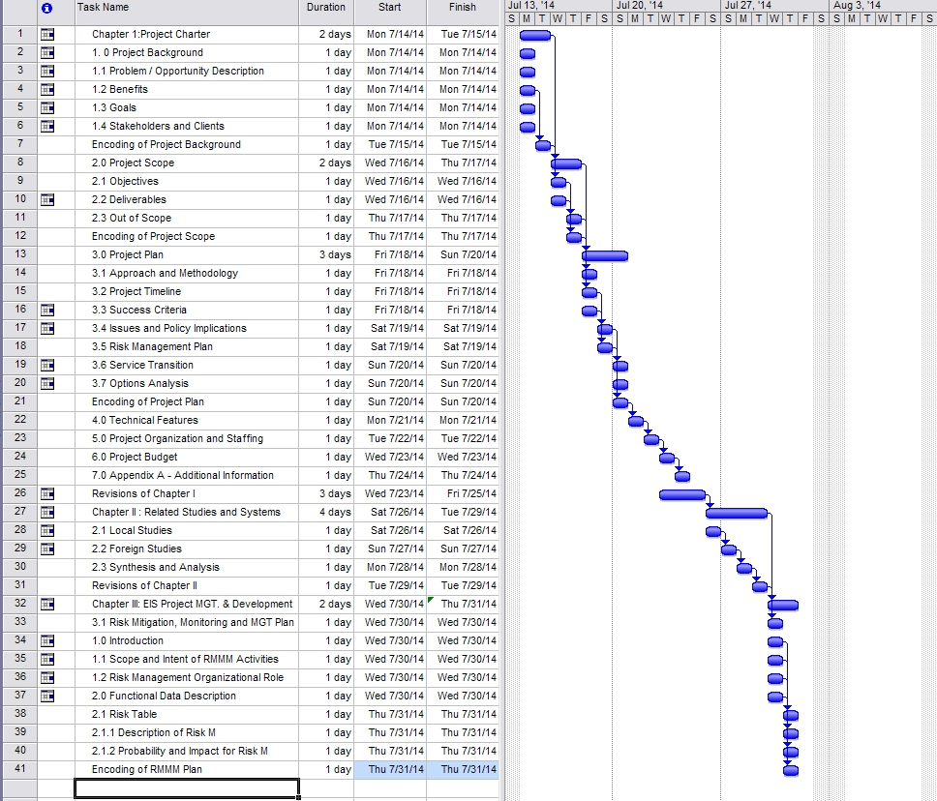
3.2 Project Timeline
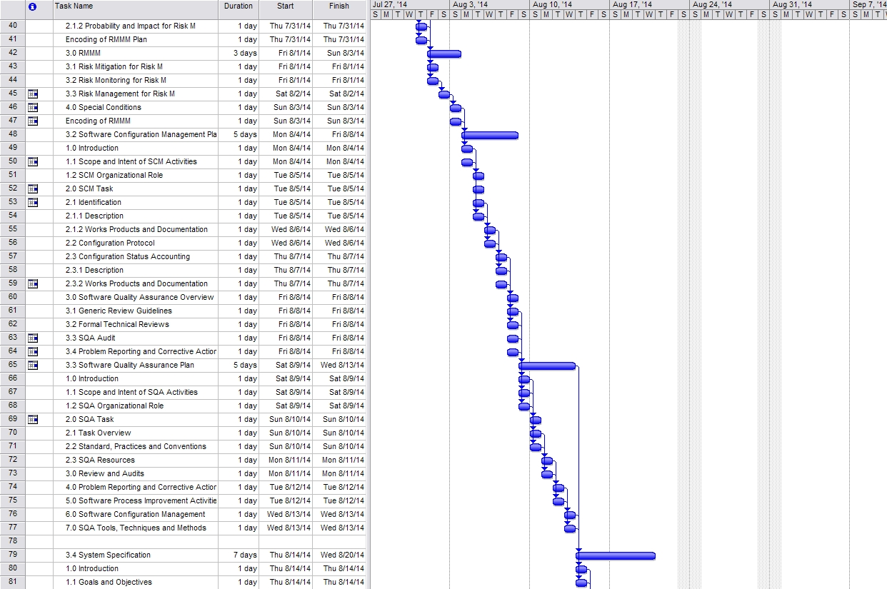
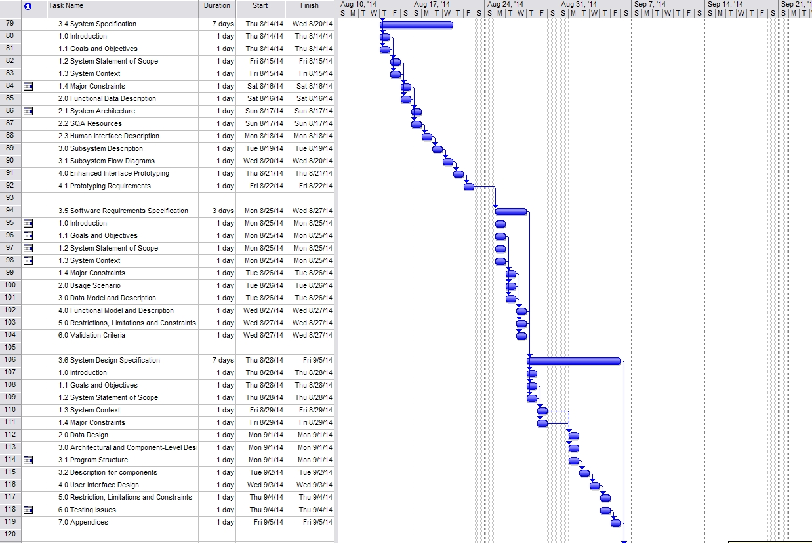
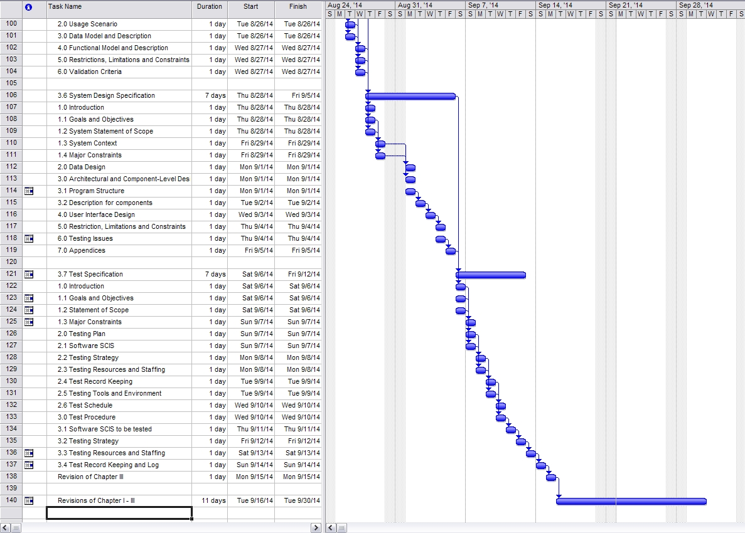
3.3 Success Criteria
- Automated Documentary Process
- Auto-Calculation Billing Process
- Record incoming bills
- Generates invoices
- Fast and accurate system process
- Reduce human resource
- Ease of calculation of service usage
- User-friendly interface
- Unique features
- Produce output
- High level of secured information
- Accumulate Volume of Data
- Notification through electronic mail
- Collection procedure is efficient and comprehensive

  - Issues and Policy Implementation

- Viewing of complete information of clients
- Only the authorized personnel such as administrator authorized person in the accounting department is allowed to access the billing system.
- The system transact only between client and service provider.
- Payroll of the Employees excluded
- Billing of other sub-system before process by Accounts Receivable/Accounts Payable
- Receiving of incoming bills

  - Risk Management Plan

Risk Factor | Probability H-M-L | Impact H-M-L | Risk Management Action
Financial Risk | H | H | It is necessary to give full attention to this kind of risk especially those company that handles financial management service. The probability of vulnerability in financial aspects is high because some uncertainties may happen unexpectedly if the management won’t give attention to this. To avoid further conflicts and future problems, all the financial matters must well manage whatsoever.
Strategic Risk | H | M | A possible source of loss that might arise from the pursuit of an unsuccessful business plan. One example of this, strategic risk might arise from making poor business decisions, from sub-standard execution of decisions, from inadequate resource allocation or from a failure o respond well to changes in the business environment. In order to avoid this kind of risk, management should always think twice in making decisions.
Operational Risk | M | M | This is the probability of loss occurring from the internal inadequacies of a firm or a breakdown in its controls, operations, or procedures. System developers my encounter system failure during or after system execution because some uncertainties may also happens unexpectedly. But those problems may avoid if everything is under control which the system maintenance should be always presents thus also avoid further costing for this. After the system enhancement, the system will then undergo testing so that if ever there’s an error is not that difficult to operate.
Compliance Risk | M | H | Compliance risk arises in situations where the laws or rules governing certain activities of the clients may be ambiguous or untested. This risk exposes both parties to fines, civil money penalties, payment of damages, and the voiding of contracts. Compliance risk can lead to diminished reputation, reduced franchise value, limited business opportunities, reduced expansion potential, and an inability to enforce contracts. When this risk occurs, the best action is comply and understand the importance of calling the attention of those people who has the responsibility in the system project.
Technology Risk | M | H | Businesses rely on technology that helps their business growth. But innovation of technology has a high impact because of the continuous changes of technology. And in order to avoid technology risk, it’s a must to maintain and upgrade the system.
Security Risk | H | H | Security is a big issue in every aspect of business. The system’s security has a username and password protected.

  - Service Transition
These are the following activities that the company will surely comply regarding with the system’s software, hardware, system specifications, computer personnel, system requirements and implementation procedure.

- Clients would maintain system requirements either software/hardware to maintain its functionality.
- Clients would reserve a capital or fund for the system implementation
- Clients would ask for system update.
- Clients would hire persons who will operate the system.

  - Option Analysis
In this section describe the alternative options that have been considered as other approaches prior to the work that have been made any importance between the client and the proponents.

- If client doesn’t like system’s user-interface and its process, it will undergo system re-design and system improvements.
- If the system was rejected the system can be sold on the market.
- The company must comply on the system requirements.
- The client has the right to change or improve the system development if the client doesn’t like the current system.

- TECHNICAL FEATURES
In this section, the proponents identified the possible technical features that will be needed to develop the Service Management System – Billing and Collection System successfully. Technical features provide the possible identification and description of the applications, software, hardware, features, peripherals and some devices that will support the BCS. The following are the possible technical features under BCS:

Front - End: Java Netbeans IDE 7.3 version
- Java is one of the best programming languages for developing system software. The proponents will use the Java Net beans 8.0 for developing the front-end of the BCS. The PEC is requiring the proponents for using only Java language for the BCS project.
Back – End: MS SQL
- The MS SQL will serve as the back-end of the BCS. This application is the database of the BCS that will store all of the data and information coming from the front-end of the BCS. Although there are many of the database application to choose from, the proponents will use the MS SQL as a part of requirements given by the PEC panels.
Operating System: Windows 7 Ultimate 64bit/ 32bit / Windows 8
- The proponents will use Windows 7 and Windows 8 operating system to develop the BCS. This is very commonly used operating system today for desktops and laptops.
Memory Capacity: 2GB RAM
- The memory capacity of the laptop or desktop must be at least 2GB to avoid system error like loading of the applications.
HDD Capacity: 320GB
- This is the capacity of the laptop that the proponents currently using to develop the BCS. The applications like Java Netbeans and MS SQL requires a huge amount of storage capacity.
Printer
- The proponents will need a printer for printing of reports processed by the BCS. Printer is essential for printing the documentation of the BCS project.

5.0 PROJECT ORGANIZATION AND STAFF
ROLE | NAME | RESPONSIBILITIES
Project Manager | Gentugao, Lovely P. | - Leader of the team  - Manages the team  - Project Execution  - Plan Strategy  - Project Initiation  - Project Control  - Risk Management  - Resolving the issues  - Budget the project  - Scheduling of tasks
System Analyst | Baclas, Roma Joy A. | - Responsible in Analyzing the System Process  - Analyze System Design  Technology  - Document Framework Business Requirements  - Software and hardware specifications
Business Analyst | Monsanto, Jomar B. | - Handling of Business Rules  - Analyze business process  - Business plans  - Translate Business process  requirement  - Analyze Requirement Communicate w/ clients
Document Specialist | Pasicolan, Jaycell D. | - Document the system process  - Concise the message into effective documents  - Release the documentation  - Evaluate the results
Lead Programmer | Ogatis, Mark Anthony V. | - Program Development  - Perform System Analysis  - Train subordinates in  programming  - Develops programming methods  - Correct errors on the system coding
Advisors and Resources | Ms. Lavinia Bigornia | - Support the proponents  - Give instructions and execution procedures to the proponents  - Check the documentations and system development  - Correct the proper documentation processes  - System Development advisor  - Acts as the consultant of the project team

6.0 PROJECT BUDGET

Budget Item | Description | Budget Cost
Transportation | Group Study including making o documentation | 8,000.00
Food | Food expenses during group study | 7,000.00
Photocopy | Photocopies including reference for the study and another copy for documentation during the defense | 300.00
Printing of Documentation | Including all the parts of entire documentation of the system project upon presentation. | 1000.00
Module of Project Study 1 & 2 | A book that will serve as guidance for project execution for the whole year | 1500.00
Project Study Fee | In order to qualified for defense all members of the group must pay the fee before the defense | 5000.00
TOTAL ESTIMATED COST |  | 22,800.00

CHAPTER 2

2. REVIEW OF RELATED LITERATURES AND STUDIES
In this chapter, the researchers present a review of different studies and literature, which are related to the proposed study.

2.1 FOREIGN STUDIES
2.1.1 COMPUTERIZED WATER BILLING SYSTEM
SITE BY: Pradeep Gokhale
DATE PUBLISHED: Saturday, February 23, 2008
URL: http://totalgravity.blogspot.com/2008/02/computerized-water-billing-system.html
According to Pradeep Gokhale, Water Billing and Revenue Management System is the most important Aspect of any Water Supply Scheme as it governs the financial aspect, which is the most important factor.
Amaravati water supply scheme is the only urban water supply scheme in Maharashtra which has been getting the facility of computerized water billing system continuously since 1991. The operating of the system has been outsourced. The software development has not been in a year or two, but it has been in process years together and proudly contributed by generously from meter readers, counter clerks, fitters, plumbers, clerical staff in the office, and auditors and accountants, to the higher officers, engineers at all levels, and most of consumers of the scheme. It has become most intelligent software in the country and now it is not only utility software but it is management software. It is in use in number of cities in Vidarbha and has to share the experience of managing more than 800000 consumers in the Delhi, the Capital city of the Country, since 1995. Following script has been included in the Maintenance Manual for urban areas.
The base of Water Billing System can be any one or more of the following:
A. Metered System
1. Actual Consumption of Water
2. Minimum Fixed Charge
B. Non-Metered System
1. Fixed Charge Per Month
2. Fixed Charge Per Family
3. Fixed Charge Per Tap
4. Percentage of Annual Letting Value of Property
The various stages in the Water Billing Process are:-
1. Data Gathering (Meter Reading in case of Metered Billing)
2. Generation of Bill based on this Data
3. Distribution of Bill to Consumer
4. Payment of the Bill by the Consumer
5. Sending the receipt details to Billing Section
6. Related Accounting

Irrespective of the basis of the Billing Metered/Unmetered, the Computerized Billing System needs Three major databases:-

1. Master Data – This is the data, which needs to be entered only one time when the Consumer/Connection is added into the database. This data is relatively static in nature and does not change time to time. Various data required to be stored are:-
Consumer Number, Name of Consumer, Address, Type of Use, Type of Consumer, Tap Size, Date of Connection, Details of Feeder Line, Locality, House No., Ward No., No. of taps, No. of Families, Meter Make, Meter Number, First Reading, Ownership of Meter, Deposit Amount etc.

2. Data for each Billing Round – This data will be entered for every
consumer for every round and will be used for calculating the demand of that billing round. Various data items required to be stored are :–
Consumer Number, Date of Meter Reading/Period for which Billed,
Status of the Connection and any changes in Master Data etc.
3. Receipt Data – This data will be the data related to the payments made by the consumers against the bill issued. This data will be entered on daily basis irrespective of the billing frequency. Various data required to be stored are:- Consumer Number, Date of Receipt, Receipt Number, Details of the collection Centre, Cash/Cheque (If Cheque- Cheque No., Bank, Branch) Part Payment/Adhoc Payment/Deposit, Account Head for posting etc.

BILLING PROCESS:

A. Data Gathering: - For better administrative control over the complete billing process the City/Town is divided into various Zone/Sections geographically or as per the distribution network ESR wise. It is observed that the Cities already have ward numbers or localities which can be used as they are but if the billing is as per the distribution network the billing system can provide very important feed back as far as Water/Revenue losses are concerned (Water Unaccounted for).
These zones are further divided into smaller areas (Wards) for better control. The Person responsible for gathering data from these is the Meter Reader/Ward Clerk. In case of Metered System the suggested Number of Consumers which can be handled by one Meter Reader may vary from 1000 to 1500 Consumers per month depending on the geographical spread of the area and other office jobs to be performed by the person. In case of unmetered System the Number can be doubled.
The prime responsibility of this person will be,
1. to gather all the data related to the water connections in given area,
2. to collect all the data related to New Connections/Disconnection
3. to point out any change in the Master data of these connections.
This person will also be responsible for communicating this data, in given formats to the Billing Section.

B. Generation of Bills:
The Water Rates/Tariff structure may have one or more aspects from the following – Consumption Based, Flat Rate, Minimum Charges, Fixed Charges, Average Consumption Based etc.
Depending on the data gathered the demand for a particular billing period is calculated by the Computerized System. The outstanding amount is worked out on the basis of details of payments received. The charges for delayed payments or amounts not paid are calculated as per the rules given and the Bills are generated areawise.
C. Distribution of Bills to Consumer:

The distribution of bills can be done using any one of the following
a. By Post or Courier
b. By Persons specially appointed for this purpose
c. By Concerned Meter Readers/Ward Clerks
i) In a special round for distribution of bills
ii) At the time of Meter Reading for next round.
(This option saves effort/manpower but there is delay on one complete cycle in meter reading and distribution of bills)

D. Payment of Bills by the Consumer
The payments can be accepted at any one or more of the following:
a. Counters at various offices of the Board/Corporation
b. Various branches of Bank/Banks authorized for accepting payments
c. Door to door/on the spot recovery by concerned person/team.
d. Electronic fund transfer through various banks offering such option

E. Sending Receipt Details to Billing Section:
The collection counter/Bank/person shall send the receipt details to the billing section periodically (preferably daily basis) and the same is entered into the system and the totals cross checked.

F. Related Accounting:
The billing section also carries out the accounting related to these receipts such as posting of receipts, generation of demand registers or ledgers on periodic basis. The complete accounting related to the Billing is to be carried out by computerized system.

FREQUENCY OF BILLING
The frequency of Billing governs the cash flow of the Water billing system and thus more frequency means regular cash flow. The frequency of billing depends mainly on the type of system used. For Non-metered system the suggested Billing frequency is quarterly and for the Metered Systems the suggested Billing frequency is Bi-monthly. But in both cases all Non-Domestic, Industrial, Bulk Consumers shall preferably by billed Monthly to have a better control. The only other factor which can be considered in the respect is the availability of manpower for billing process and the cost of issuing bills in one complete billing etc.

DELAYED PAYMENTS:
Since water is being treated as a commodity consumed the advance billing is generally not carried out. It is therefore must to levy penalty/interest on the delayed payments of the bills. The minimum rate for such Delayed payments shall be at per with commercial interest rate.
COMPUTERISATION OF WATER BILLING SYSTEM
In this twenty first century Computers have become necessary in the day to day activities also. For the water billing system which is complex, repetitive and has voluminous data, computerization is must. Since various related areas like accounting, banking, consumer services are already computerized at most of the places computerization of the water billing is must.
REQUIREMENTS OF COMPUTERISED WATER BILLING SYSTEM
a. Hardware:- The Computer Hardware required for Water Billing System is as follows:
i) For Towns with 25,000 or less Water Connections the requirements of Hardware for processing of 5,000 Bills Per Month is as follows:-
P-III, 850+MHz, 64 MBRAM, 20GB HDD, 1.44 MB FDD, 2 Nos. 52x CD-ROM, SVGA MONITOR, KEYBOARD, MOUSE etc.
DOT MATRIX PRINTERS 300+ C.P.S., 132 Column – 2 Nos.
U.P.S. 1 KVA (At least 30 minutes battery backup) – 2 Nos.
ii) For Cities with more than 25,000 Water Connections requirement for processing 25,000 Bills Per Month is as follows:-
SERVER – P-4, 1+Ghz, 256 MB RAM, 2x20+ GB SCSI HDD, 1 No.
1.44 MB FDD, 52X CD-ROM, 8/16 GB DAT, SVGA MONITOR, KEYBOARD, MOUSE, ETHERNET CARD, 56.6 KBPS MODEM etc. P-III, 850+MHz, 64 MB RAM, 20 GB HDD, 1.44 MB FD, - 10 Nos. 52X CD-ROM, SVGA MONITOR, KEYBOARD, ETHERNET CARD, MOUSE etc.
16 PORT HUB - 1 No.
LINE PRINTER 1400 LPM - 1 No.
DOT MATRIX PRINTERS 300+C.P.S., 132 Column - 5 Nos.
U.P.S. 5 KVA (At least 30 minutes battery backup) - 1 No.
iii) For Metros with more than 1,00,000 Water Connections requirement the Hardware Setup mentioned in (ii) above needs to be installed at various Zonal Offices and these Servers be interconnected to each other for Data transfer or generation of reports.
b. System Software: The System Software required is as follows:
i) For Towns using stand along Computer systems the System Software required is Windows, FOXPRO
ii) For Cities and Metros using Servers the System Software is as follows:
Windows, UNIX, ORACLE, DEVELOPER 2000 or Visual Basic
c. Application Software: - The Application Software for the Water Billing System is the soul of the Computerized Water Billing System and needs to be developed as per the requirement of the Board/Urban Local Body.
d. Manpower:- The manpower required for the Computerized Water Billing System is as follows:-
i) Manager Data Processing – 1 No. for each Computer Centre
ii) Supervisor Data Processing – 2 Nos. for each Computer Centre
iii) Data Entry Operators – 1 No. for each Computer
PRIVATISATION:
Considering the volume of the work and skills required for the Computer Operations this activity can be entrusted to a private Agency on Contract basis. The Contract can be for complete Out-Sourcing or Data Processing or Deputing Expert Manpower for On – Site Data processing.

ADVANTAGES OF COMPUTERIZATION:
- Control of the System
- Decision Making
- Sky is the limit
FUTURE AVENUES:
The Computerized Water Billing System can be used in future for direct payments through Credit Cards, Internet etc. The information for the consumers can also be made available on Internet or through Kiosks. The advance meters with remote reading techniques may give a system with minimum data entry to be done manually. The distribution network if available as Graphic information on Computers, can be directly be linked with the billing system to locate Water/Revenue losses.
OUTPUT FORMATS:
1. BILL: On Computer Stationary of 15” x 6” Size having three distinct parts which are separated by perforation for easy tear off. The data printed on all three parts is same. The first of leftmost part acts as acknowledgement of the Consumer for having received the bill for and also office copy of the bill issued. The Second or middle part is the Bill Cum Receipt for the consumer. The Third or rightmost part is the copy of the receipt given to consumer for the collection centre.
The contents of the bill are – Period of Billing, Zone, Area, Bill date, Due Date, Bill Number, Consumer No., Consumer Name, Address, Water Charge, Arrears, D.P.C., Meter Details, Previous & Current Reading, Status of Meter, Tap Size, Consumer Type, and Last Payment Details etc.
2. METER READING BOOK:
Consumer No., Name, Previous Reading & Status, Current Reading & Status
3. SCROLL
Receipt No., Date, Collection Centre, Consumer No., Name, Area, Amount,
Cheque Details etc.
4. LEDGER
Consumer No., Name, Outstanding amount as on 1st April and following details of each billing round in the year –
Current Reading & Status, Arrears, D.P.C., Water Charge, Receipt No., Date, Amount received.
5. ASSESSMENT / DEMAND
Zone, Area, Meter Reader, Total Water, Total D.P.C.
6. DEFAULTERS LIST
Consumer No., Name, Outstanding Amount, Last Payment Date, Status
7. DISCONNECTION LIST:
Meter Reader, Area, Consumer No., Name, Outstanding Amount

2.1.2 International School of Informatics and management, Jaipur
Billing System
Authors: ANIL KUMAR ANJANA
-BHAIYA LAL ANJANA
-SAURABH JAIN
http://www.iisjaipur.org/iiim-current-08/MCA_IV_Sem_Pro_Eva/04.project-Billing%20system.pdf

1. Introduction
The project “Billing system” is an application to automate the process of ordering and billing of a “Departmental store” .This web based application is designed considering the chain of departmental store which is located in various cities. This application also administrates its users and customers.
2. Objective
This project will serve the following objectives:-
1 Add and maintain records of available products.
2 Add and maintain customer details.
3 Add and maintain description of new products.
4 Add and maintain new entered category of products.
5 Provides economic/financial reports to the owner monthly or weekly and yearly.
6 Provides a convenient solution of billing pattern.
7 Make an easy to use environment for users and customers.
3. Project category
RDBMS:
The project is based on the concept of RDBMS (i.e. Relational Database Management System).
“ A database which store data in the form of tables which has related with each other in as particular manner ”

4 . Types of reports
1. Daily Sales Report
2. Monthly Customer Report
3. Daily Product Report
4. Due Date Report (Report of a particular Day)
5. Billing Report

5. Technologies and Tools
1 Web Technology: Asp.net
(Microsoft visual studio 2005 framework 2.0)
2 Database: MySQL Server-2005
3 Development Tool: MS Visual Studio 2005
4 Web Server: IIS
5 Web browser: Internet Explorer service pack 1
6 Languages Used: C#.net, JavaScript
7 Others: Themes, CSS
6. Hardware
CPU configuration
- AMD processors 4000+ series
- RAM 1 GB DDR2
Monitor
-17” color
Operating System
-Windows XP with service pack 2

7. Future Scope
1 This project will help the store keeper in fast billing
2 This project enable store keeper to maintain a great database of all customers visited and purchase product from store.
3 Project will enable to see report regarding product and category.
4 Easy to maintain in future prospect.

8. ANALYSIS OF PRESENT SYSTEM
Before we begin a new system it is important to study the system that will be improved or replaced (if there is one). We need to analyze how this system uses hardware, software, network and the people resources to convert data resources, such as transaction data, into information products, such as reports and displays. Thus we should document how the information system activities of input, processing, output, storage and control are accomplished.
9. PROBLEM OF EXISTING SYSTEM
1. Inability of modification of data: The managing of huge data effectively and efficiently for efficient results, storing the details of the consumers etc. in such a way that the database can be modified as not possible in the current system.
2. Not user friendly: The existing system is not user friendly because the retrieval and storing of data is slow and data is not maintained efficiently.
3. Difficulty in reports generating: Either no reports generating in a current system or they are generated with great difficulty reports take time to generate in the current system.
4. Manual operator control: Manual operator control is there and lead to a lot of chaos and errors.
5. Lot of paperwork: Existing system requires lot of paper work and even a small transaction require many papers fill. Moreover any unnatural cause (such as fire in the organization) can destroy all data of the organization. Loss of even a single paper led to difficult situation because all the papers are interrelated.
6. Inability of sharing the data: Data cannot be shared in the existing system. This means that no two persons can use the same data in existing system. Also the two departments in an organization cannot interact with each other without the actual movement of data.
7. No support in decision-making: Existing system does not support managerial decision-making.
8. No support in strategic competitive advantage: Existing system do not support strategic competitive advantages.

10.CHARACTERISTIC OF THE PROPOSED SYSTEM
1. Easiness in modification of data: The proposed system provides managing of huge data effectively and efficiently for efficient results, storing the details of the customers, employees etc. in such a way that the database can be modified.
2. User friendly: The proposed system is user friendly because the retrieval and storing of data is fast and data is maintained efficiently. Moreover the graphical user interface is provided in the proposed system, which provides user to deal with the system very easily.
3. Reports are easily generated: Reports can be easily generated in a proposed system. So any type of reports can be generated in a proposed system, which helps the managers in a decisions-making activity.
4. Sharing the data is possible: Data can be shared in proposed system. This means that two or more persons can use the same data in existing system provided that they have right to access that data. Also the two or more departments in an organization can easily interact with each other without the actual movement of data.
5. No or very few paperwork: The proposed system either does not require paper work or very few paper works is required. All the data is feted into the computer immediately and various bills and reports can be generated through computers. Since all the data is kept in a database no data of the organization can be destroyed. Moreover work becomes very easy because there is no need to keep data on papers.
6. Support strategic competitive advantage: Proposed system supports strategic competitive advantages. Since the proposed systems provide easiness in reports generating it will provide strategic advantages among competitors.
7. Computer operator control: Computer operator control will be there no errors. Moreover storing and retrieving of information is easy. So work can be done speedily and in time.

11. FEASIBILITY ANALYSIS
Title: Feasibility report for the computerization of the various activities of the company.
Background: The Company facing the problem of inconsistent and out of time information in its activities. Very much time is consuming for report generation, which is not very helpful for decision making. So we want a system, which provide immediate information.

Method of study: The analysis procedure comprised of field trips in the various departments of the company. The following documents and sources were looked up:
· The purchase order that contain items to be purchased.
· The accounts register.
· Purchase order issues to vendors.
· Bills receive from vendors.· Bills give to the customers.
· Purchase return forms (if any ) give to vendors.

NEED FOR FEASIBILITY STUDY
The feasibility study is carried out to test whether the proposed system is worth being implemented. Feasibility study is a test of system proposed regarding its work ability, its impact on the organization ability to meet user needs and effective use of resources. It is usually carried out by a small number of people who are familiar with the information system techniques, understand the part of the business or organization that will be involved or effected by the project and are skilled in the system analysis and design process.
The key consideration involve in the feasibility study are:
1. Technical
2. Behavioral
3. Economic
1. TECHNICAL FEASIBILITY
Technical feasibility centers on the existing computer system (hardware, software etc ) and to what extent it can support the proposed system addition. For example, if the current system is operating at 70% capacity ( an arbitrary value ), then another application could overload the system or require additional hardware. If the budget is serious constrain then the project is judged not feasible.
The technologies and the environment which are used in this project are SOFTWARE Front End
1. Language used: ASP.NET. We use this language is supports event driven programming feature.
2. ADO.NET
Back end Supporting Software: SQL Server 2005. This is used to storing data in the form of tables. It is easy to use.
OPERATING SYSTEM:
Platform: Windows XP . Our system requires window operating system, which is easily available.
HARDWARE:
Intel based processor-run computer system, which have keyboard and mouse as input devices. This has been decided for its case of availability and up-gradation. The various registers maintained at the different department have enough information recording, which will help in digitizing the available data.
2. BEHAVIOURAL FEASIBILITY:
An evaluation of the behavior of the end users, which may effect the envelopment of the system. People are inherently resistant to change and computers have to know to facilitate changes and computers have to known to facilitate changes. An estimate should be made of how strong a reaction the user staff is likely to have towards the development of a computerized system. It is a common knowledge that a computer installation has something to do with turnover, transfer, retraining and changes in employee job status, therefore the introduction of a candidate system requires special effort to educate, sell and train the staff on new ways of conducting business. The personal of the user organization will be affected by the proposed system. As the aim of the system is only to satisfy the information needs, no employees will loose their position by the proposed system. In fact the proposed system will help the organization in reducing the voluminous work involved. Also the involvement of users in every stage of the project is going to increase the success factor.
The staff in not well educated for running a computerized system. They are adamant in perceiving a mechanical process of working as they have long been used to the manual entry system. This aspect needs considerable amount of attention. Our system is also feasible for organization because it supports of the organization and its strategic plan.
3.ECONOMIC FEASIBILITY:
The procedure is to determine the benefits and savings that are expected from a candidate system and compare it with the costs. If a benefit outweighs costs, then the decision is made to design and implement the system.
Otherwise further alterations are made in the proposed system
1. Manpower cost
2. Hardware and software cost

12. Data flow diagram
A data flow diagram is graphical representation that depicts the information flow and the transforms that r applied as date moves from input to output. It can be used to represent software at any level of abstraction. In fact DFDs may be partitioned in to levels. That represents increasing information flow and functional details.
DFDs are defined in levels with every level decreasing the level of abstraction as well as defining a greater detail of the functional organs of the system. A zero level DFD also known as context or fundamental system model represents the entire software elements as a single bubble with input and output data entities which are indicated as incoming and outgoing arrows. Data Flow Diagram help understanding the basic flow of data from one process to another process. This 0 level DFD represents fundamental overview of the billing system.This is the 1-Level DFD for the billing system. This provides the detailed of the data flowing in between the processes of the billing system. It is more describes the flow of information. Billing system concern with the customer’s choice of product so there is a Product processing process the order of customer according to the choice. Two another process is there for further processing of the order and customers information in billing system database.

13. Entity Relation Diagram
Entity Relation Diagram represents the object relationship pairs in graphical forms thus we can say that the primary goal of ER diagrams is represent data objects along with their relationships.
ER model for data uses three features to describe data:
· Entities which satisfy distinct real world items in an application
· Relationships connecting different entities and representing meaningful dependencies between them
· Attributes which specify various properties of entities and relations involved in a system.

Flow chart
Flow chart is a graphical representation using symbol to show the step by step
sequence of operation, activities or procedures used in computer system analysis .
Conclusion
This was our project of System Design Lab about “Billing System”.
Development of this System takes a lot of efforts from us. We think this system gave a lot of satisfaction to all of us. Though every task is never said to be perfect in this development field even more improvement may be possible in this system. We learned so many things and gained a lot of knowledge about development field. We hope this will prove fruitful to us.

2.1.3 Introduction to telecommunication billing system.

Hatem Mostafa, 23 Jul 2005

Introduction
Telecommunication companies need an effective and accurate billing system to be able to assure their revenue. Billing systems process the usage of network equipment that is used during the service usage into a single Call Detail Record (CDR). The billing process involves receiving billing records from various networks, determining the billing rates associated with the billing records, calculating the cost for each billing record, aggregating these records periodically to generate invoices, sending invoices to the customer, and collecting payments received from the customer.
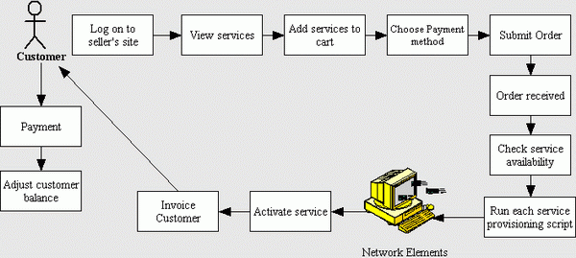
Billing system is very complex starting from network elements that generate usage to the billing system to usage collection, mediation, rating, and invoicing. To simplify the process I will introduce a simple system usage scenario as shown in the following figure. The system user navigates through the company site and views company services, and he decides to order one of the available services. If he has no account, he signs up for a new account, else he signs in. Then the user asks to conduct an order with the selected service. The service may be prepaid where he has to pay to have credits to use the service, or it may be postpaid, where he has to pay if the service has installation or setup fees, and later on he will pay for his usage of each billing cycle.

The billing system should provide service to the user, collect user usage records, and generate invoices of each credit expire, each billing cycle depends on the billing type, collect payments and adjust customers' balances as in the following figure:

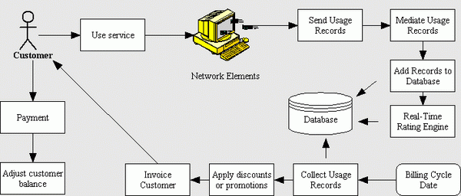

System parts
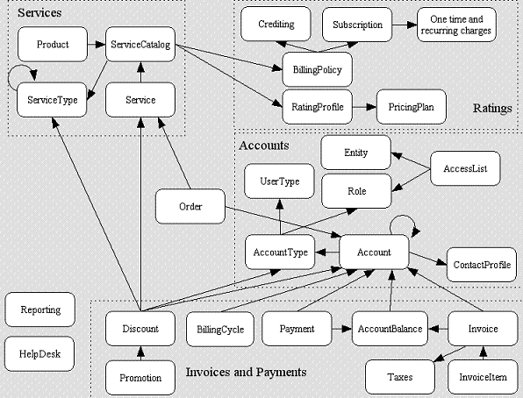
We can divide the system into seven parts as in the following figure:

- Services
- Accounts
- Ratings
- Invoices and payments
- Reporting
- Help Desk
- Devices

Service
Service is the entity offered by the company and targeted to the customers. Each service is defined by an engineering employee as a service catalog which includes service type, name, billing policy, and its default rating profile. All of these attributes are described later in this article. After service ordering by the customer, it takes a unique ID which is attached with the account of the customer, provided by the provisioning system to the customer at a certain date.

Account
The customer account includes customer contact profile information, account type, login information, and payment method. Each customer account is linked in the system with specific services offered to this customer, and the customer will be billed depending on his usage of these services. Customer account belongs to a specific account type, which is related to some price plans determined by discounts and promotions.

Rating
One of the big issues in any billing system is how, when, and where the companies should bill their customers. Rating is the process of converting usage records from one form to another, like converting usage units to its cost. This process is essential in the billing process as it is the point of conversion of the service usage to revenue value to company, which is the target of telecommunication companies.

Invoices and payments
Each customer in the system has an account balance, which affects any invoices requested by the customer and any payments done by the customer. Normally the invoices are generated as a result of service hosting or using, and payments are the customer payments as a result of the invoicing operation.

Invoice
It is the entity generated by the billing system to inform the customer that he must pay for his service usage or ordering. Each invoice includes the customer account, date of payment, line items of the invoice, and invoice sales taxes. Invoices affect the account debits in the billing system.

Payment
It is the process of collecting company money from the customers and adjusting their balances through adjusting the account debits and credits. The customers receive receipts of their payments. Receipt view is shown in the next figure. Each customer account should include its payment method to be used after generating invoices and to ask customers for payments.

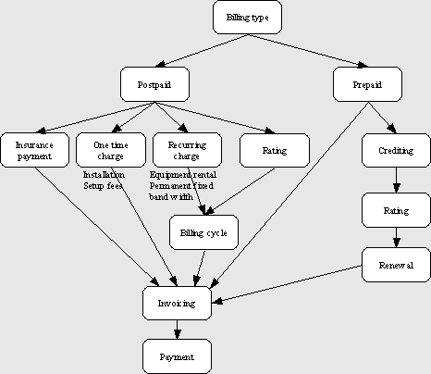
Billing types- Billing types indicate whether and how the users pay to get and use the service.
Postpaid billing
In postpaid billing the customer may pay an insurance payment in advance, and he may pay the installation or setup fees, and in each billing cycle he will be invoiced (receive a bill) to pay for his usage of the service.

Prepaid billing
In prepaid billing the customer buys a given amount of credits (duration, volume, number of events) and is then allowed to use the corresponding network resources as long as their account is in credit. Billing system receives customer usage records from the network elements and adjusts the customer credits. When their credit has been used up, network usage will be restricted. Prepaid corresponds to a real-time process, because transactions are only allowed if the user account is in credit, and this has to be checked in real-time.

2.1.4 Automated Coding, Billing, and Documentation Support for Endoscopy Procedures
Author: Kevin A. Jones
Graduate Program in Allied Medicine
The Ohio State University
Date Published: 2012

Abstract
Clinical documentation has become extremely robust over the last decade with sophisticated algorithms to codify data for quality and operational improvements; however some electronic medical record systems are now adding billing data to create charge by documentation. This not only saves time for staff coding cases but creates an important link between the clinical documentation and charges. This one year retrospective case study analyzes one such application that codes endoscopy procedures based on the documentation to compare the automated coding method with manual physician billing to determine the efficacy of charge by documentation.iii

Chapter 1: Introduction
Background and Setting
Electronic medical records (EMRs) have great potential to improve record keeping and billing performance. Anesthesia has been an early adopter for using EMR documentation to support coding and billing in healthcare. For example, one study in anesthesia found that automated alerts of potential documentation errors decreased records that could never be billed and the median time to correct documentation errors, leading to an estimated increase in revenue of $400,000 per year.
(1) Similarly, automated reminders were found to increase compliance with documentation of arterial catheterization in the perioperative setting, with an estimated increase in revenue of $40,500 per year.
(2) Finally, a system that automatically extracted information from an EMR was found to decrease charge lag by ten days, but no clinically significant impact on revenue in anesthesia.
(3)To date, there has been limited research on directly automating real-time coding, billing, and documentation while providing care to patients. In one systematic review
(4) studies of automated coding and classification systems were assessed. Overall, the review found that there was much variety in terms of how automated tools were used to support coding and classification, and that it is difficult to conduct a meta-analysis across studies or infer from individual studies how they might generalize to other settings. In particular, the review found that the complexity of the task had an impact on performance. A methodological concern with many of the reviewed studies was that manual coding was often compared to automated coding based upon manual coders who were hired only for research purposes and might not have been representative of how the work would have been conducted in an actual time-pressured situation.A natural experiment occurred at the Ohio State University Wexner Medical Center where a better direct comparison could be made between automated coding, billing, and documentation as compared to manual coding. One endoscopy clinic used an application that had the functionality to do automated billing. This clinic continued to use paper charge sheets for billing, selected by the physician using checkmarks on a paper form in Appendix C. Therefore, the automatically generated billing codes could be directly compared to the manually generated codes that were actually used for reimbursement purposes. The purpose of this study was to evaluate discrepancies in billing codes and estimate the revenue impact from these discrepancies.
The capability for the software that was used is presented generally in Figure 1. Figure 1 displays a typical type of data entry technique that prompts the user to select a specific clinical procedure. In this case, the user has already selected colonoscopy as the
procedure so a list of indications for performing a colonoscopy is displayed in a menu
format. The user selects the most appropriate, and more importantly, the most accurate indication, which in this case is screening for colorectal cancer with an average risk. The phrase “Screening for colorectal malignant neoplasm” is added to the documentation due to this selection. In this case, there are four distinct data elements captured in one step. The physician sees the phrase “screen for Colorectal CA, Average Risk”, the report reads a more clinical phrase of “Screening for colorectal malignant neoplasm”, the patient discharge instructions reads a more user-friendly phrase of “cancer screening colonoscopy” and the database stores a discrete value representing both of these with references to both English phrases. Reporting at the very lowest level is now available for data mining.

Relatively easy to use menu items can be created to capture basic and standardized codes such as:
Current Procedural Terminology (CPT) Codes: A code set maintained by the American Medical Association (AMA) to describe medical services, procedures, medical equipment, supplies and implants.4 CPT Modifiers: A code set appended to the CPT codes if applicable to identify descriptors such as reduced or additional services, laterality, etc. (5) This could alter the reimbursement of a CPT code. (6) International Classification of Diseases (ICD-9-CM): The coding system maintained by the Centers for Medicare and Medicaid (CMS) in the United States to classify diseases, complications and comorbidities. (6) This code set is based off the ICD-9 code set maintained by the World Health Organization
The assignment of billing codes is not a trivial task since coding errors directly impact reimbursement and can easily cause compliance issues. To illustrate this complexity, Figure 2 displays a billing code assignment for a simple screening colonoscopy
The consequences of inaccurate coding, especially for reimbursement purposes,can be significant whether the inaccuracy relates to reimbursement of services provided. Billing a CPT code that has a lower reimbursement rate has an obvious impact. On the surface this may seem innocuous but coded data is used for more than just the bill. CPT and ICD-9-CM codes can be powerful metrics used for quality measures, operational improvement and research. Inaccurate coding jeopardizes these downstream efforts.The converse is selecting codes billed at a higher reimbursement rate than what was actually performed. This is often due to maneuvers that are performed but not documented or simply human error in selecting the wrong codes but could be viewed as a way to maximize revenue as well. If there is no automated linkage between clinical documentation and billing data, incorrect codes are often not caught until audits are performed. This could include chart reviews by internal hospital quality departments orthe Joint Commission or it could be a payer such as the Center for
Medicare & Medicaid
Services (CMS) comparing the rates of codes across many like hospitals broken down by physician. If the average of someone taking a biopsy is 80-85% for a given procedure but one physician bills biopsies over 95% of the time, then a review may be warranted. If documentation within the medical record does not support the clinical code(s) used for billing, the compliance of the healthcare provider can be called into question. Fraudulent billing is extremely serious and can result in huge fines or even revocation of the physician‟s license. (9)
To produce accurate coding, a fairly new methodology called Charge by Documentation has been adopted to tie the clinical documentation with the charge codes. While several healthcare application vendors support this in a variety of ways, a standardized name has not really established. This is sometimes labeled a “coding engine” for marketing reasons but this is not reflected in literature.
Purpose of Study
The purpose of this study was to determine the efficacy of charging by documentation automation by verifying the charge data generated to what the physician selects manually on a charge sheet. It analyzes both CPT and ICD-9-CM codes as well as billing modifiers from a case study using an application that codifies the data immediately and stores the information as discrete data from its creation.

Significance of Study
The three data elements (CPT codes, CPT Modifiers, ICD-9-CM codes) are the main driver of revenue. If these are wrong, revenue and/or compliance are affected. Even if the billing codes are correct but the clinical documentation does not support the billing, then the data is essentially wrong. If the charge by documentation is accurate, an automatic tie between clinical documentation and billing information is established which will increase compliance and has some level of impact to the revenue.

Conceptual Frame of Reference
There are several ways that billing codes including CPTs, ICD-9-CM codes and modifiers are added to a patient‟s bill. The first two represent the traditional methods including manual charge sheets and having a certified medical record coder review the documentation and add codes to the case. In the last few years automation tools and highly defined content have been created to add billing detail while meeting CMS and compliance standards. Figure 3 demonstrates the typical types of assignment of billing codes.
Research Questions
The goal of this study is to compare the revenue impacts of charge by
documentation versus traditional physician paper billing. To do this, it will answer the following questions:
1. What is the difference in accuracy between CPT codes generated from charge by documentation as compared to manual generation?9
2. What is the difference in revenue between CPT codes generated from charge by documentation as compared to manual generation?
3. Does charge by documentation functionality result in the capture of additional or more specific ICD-9 codes than ones generated manually?

Definition of Terms
Colonoscopy – A medical diagnostic procedure that extends an endoscope through usually the anus to view the rectum, colon and large intestines for abnormalities.
Coding by Documentation – The function of an application to generate billing codes as a provider is creating clinical documentation.

Computer-assisted Coding – Employing an application to analyze the text of a report and generate billing codes based off of the identification of certain words or key phrases.

CMS – Centers for Medicare and Medicaid, which is the federal agency within the United States Department of Health and Human Services (DHHS) responsible for overseeing the Medicare programs nationally as well as works with state-level Medicaid programs, HIPPA and other healthcare agencies.

CPT – Commonly used abbreviation for Current Procedural Terminology, which is a code set created by the American Medical Association which describes medical procedures and is used to bill insurance payers.

EGD – Esophagogastroduodenoscopy, which is a medical diagnostic procedure that extends a endoscopy through the mouth to the stomach and/or duodenum to view the upper digestive track for abnormalities.10

EMR – Electronic Medical Record, also commonly called an Electronic Health Record (EHR). This is a generally used term to describe applications that generate and/or store patient records.

Flexible Sigmoidoscopy – A medical diagnostic or screening procedure often called a “flex sig” that extends an endoscopy through the anus to view the anus, rectum and prostate for abnormalities.

HIPAA – Health Insurance Portability and Accountability Act which was passed in 1996 in an effort to increase the access to healthcare in the United States.

ICD-9 – International Classification of Diseases, Ninth Revision, Clinical Modification is a diagnosis code set based on the ICD-9 codes created by the World Health Organization to describe diagnosis and procedure codes.

ICD-9-CM – International Classification of Diseases, Ninth Revision, Clinical Modification is based upon the ICD-9 code set maintained by the Centers for Medicare and Medicaid (CMS) for use in the United States.

NCCI Edits – National Correct Coding Initiative effort started in 1996 by CMS to add rules into the diagnosis coding process to identify errors.

Revenue Cycle – The overarching collection of processes within a medical facility such as scheduling, registration, charge capture, billing that handles the financial aspects of patient care.

Limitations of the Study
Although many of the discrepancies are likely due to human error on the part of
the physicians filling out the charge sheets or the clerks typing in the information, it is not possible to discern this based upon the study methods. Therefore, it is only possible to infer that there is a maximum error rate for either approach based upon the discrepancy rate.
This case study was performed at an ambulatory clinic, which provides low acuity exams. Patient conditions such as Barrett‟s, Crohns disease, etc. are generally not treated in this clinic as well as patients not able to undergo sedation. This study is limited to outpatients since inpatients are billed by Diagnosis Related Groups (DRG) as opposed to CPT codes, thus making the comparison much more difficult. It is not expected that the outcome would change but could be an interesting follow-up study.
The study also limits itself to endoscopic procedures. This is meant to serve as a case study and could be expanded to additional procedure areas in the future.

Chapter 2: Review of Literature
Current State
Streamlining the revenue cycle is one of the top priorities at most medical facilities. As insurance payers are reducing payments and the government is pushing incentives for Meaningful Use with EMRs, the revenue cycle is often squeezed to optimize revenue while meeting ever-growing compliance regulations. (10) (11) To do this effectively, capturing the correct CPT and ICD-9-CM codes on a timely basis along with any appropriate modifiers to help ensure compliance is paramount. Insurance payers are requesting documentation to support the coding at a growing rate and variation can result in underpayment or a denial. Technology improvements on the payer side also means recognizing trends for medical facilities that may not be compliant so audits can be better targeted. To improve the chances of receiving a timely reimbursement means sending a clean claim.Fortunately, technology for capturing clean CPT codes, CPT modifiers and ICD-9-CM codes have also advanced allowing more options for medical facilities to implement. In addition to manual charge entry and medical record coders, a fairly broad range of application technology exists in the market to help alleviate the strain. Currently there are several methodologies behind associating billing codes such as manual charge 13entry, medical record coders, charge capture applications, computer-assisted coding and charge by documentation.
Manual Charge Entry
Manual Charge Entry is the oldest and most straightforward method of selecting charge codes simply by checking options on a sheet of paper that includes all possible, or at least the most common billing codes used by a healthcare provider. Problems with this method of charge entry include the following: the physician does not complete the manual paper step, the wrong checkbox may be selected or unclear or the paper form may be misplaced before it is sent to a data entry clerk. In addition, these forms tend to be reproduced in bulk and left unmodified when billing codes are updated. It is, however, the least complicated and still widely used. Appendix C is the billing form that is used as a control for this case study.

Professional Medical Record Coders
There are a variety of certified medical record coding professionals that have the authority to review the clinical documentation and make a determination on the billing codes to be placed on a patient‟s bill. This represents a huge benefit over manual charge entry in the fact that these professionals are required to keep current with billing updates, requirements and compliance. In addition, they review the entire medical chart to review items like comorbidities, family history and previous surgeries. A coder would be able to 14distinguish the difference between a high risk colonoscopy vs. an average risk which might go unnoticed by the physician. While coders are generally unable to make clinical decisions based off the documentation, they often identify potential errors and start a dialog with the provider for clarification when needed. The downside to including medical record coders is the obvious additional labor costs and a delay in the turnaround time to send a claim and receive payments.

Charge Capture Applications
Software applications have been developed to aid in charge capture including PatientKeeper® (www.patientkeeper.com), Ingenious Med™ (www.ingeniousmed.com)
and MedAptus© (www.medaptus.com). In the most simplistic way, it replaces the manual paper form with an application screen but is similar in nature. These applications however generally replace checkboxes with dropdown coded entries, on-line help, filtering and some level of business logic to guide physicians to selecting the correct entries. Applications such as these tend to have patient data interfaces and/or clinical documentation entries to prevent lost charges. A physician will login and find a list of cases that need to be coded. This dramatically improves the capture and accuracy of billing but does have some limitations. The physician needs to accurately select the correct billing codes based on what was performed. Computer-assisted Coding using Natural Language ProcessingAn ever-growing field of study called Natural Language Processing (NLP) includes building applications that in essence “reads” the clinical documentation to find enough segments of words necessary to generate CPT and diagnosis codes. It does this by parsing common vernacular for a particular clinical specialty and segmenting sentences into “tokens” that are matched to codified elements. Computer-assisted coding applications such as LifeCode® by OPTUMInsight™ (www.OptumInsight.com), Quantim® by QuadraMed© (www.quadramed.com) and 3M Coding and Reimbursement Systems by 3M™ (www.3Mhis.com) use NLP to scan clinical documentation to generate CPT and diagnosis codes. While the field has become very sophisticated over time and is in use commercially, the success rate is not very high and usually requires a medical record coder to review difficult cases and perform quality assurance on most or all coded documents and therefore mitigating the benefits.

Charge by Documentation
Finally, the topic that is the focus of this study is charge by documentation. As opposed to the previous methods for charge capture, which rely on a separate step by the physician or a medical record coder, charge by documentation creates codes as the physician is documenting the case. This methodology is used by several procedure documentation systems such as Provation MD® by Wolters Kluwer® (www.Provation Medical.com), EndoSoft® (www.endosoft.com) and gGastro® by GMed®(www.gmed.com). In the application being reviewed, documenting is a series of menu-16 driven choices, which equate to phrases concatenated to create the major sections such as the impression, findings, maneuvers, etc. After the clinical portions have been documented, CPT and diagnosis codes are presented based off these phrases. The physician has the option of modifying the pre-selected codes if necessary. They are also prompted if a billing modifier is appropriate. For instance, if a scope for a colonoscopy was only able to reach the rectum because of poor preparation by the patient, the physician would select the proper “extend scope to” field. The coding module would recognize this and prompt the user for a “52 – Reduced Services” modifier.

Benefits of Charge by Documentation
Charge by documentation holds significant improvements over the other billing mechanisms such as:
1. The billing codes by nature match the documentation, which ensures compliance. If a physician overrides the codes for any reason, it is marked as such and can be audited. Physicians can be trained that if the codes are not correct then they should check the documentation.
2. Workflow is improved by the fact that billing and documentation are done as a single fluid process. It is not uncommon for physicians to document and bill the case before they leave the room, which improves accuracy.
3. The only real way to accidentally omit billing is to forget to document the case entirely. This is very unlikely because the application is used intra-procedurally.17
4. Assuming the software is maintained correctly, CPT, ICD-9-CM and billing modifiers are automatically kept up-to-date.
5. The phrases are coded as dictionary items and need no parsing which eliminates double meanings and variations in human language. The phrases can translate to other languages as well as what is displayed on the document but the discrete database elements are not language dependent making it transferrable to other languages as well.

Future Predictions
EMR vendors see automatic charge capture and/or charge generation based off the provider‟s documentation as a huge selling point. Increasing this selling point means bigger profits and will significantly aid in the return on investment for the medical facility purchasing the software. In addition, the mandate to implement ICD-10-CM means all applications using ICD-9-CM need to rethink their current processes since the changes are so drastic between the two code sets. This gives a push to include charge capture as a part of this rewrite.

Chapter 3: Methodology
The purpose of this chapter is to present the methodology used to conduct this study. The chapter is divided into sections. The first section describes the research design of the study followed by a discussion of the population and sampling design in the second section. The third and fourth sections detail the data collection processed followed by a discussion of the data collection instrument and process for calculating revenue rates.

Research Design
This is a retrospective, cross sectional research design that analyzes endoscopy exams for a single location for one year that compares CPT, CPT modifier and ICD-9-CM codes generated from a charge by documentation application with codes manually entered into an electronic billing system from paper charge sheets. This research study was approved by the Institutional Review Board at The Ohio State University.
Population and Sample Design
This case study uses one endoscopy clinic in a suburb of Columbus, OH, which performs approximately 3,000 exams a year. The clinic purchased a commonly usedapplication in 2003 that includes charge by documentation functionality. Despite having the ability to automate coding, they have not implemented this feature and have remained on paper charge sheets. The physician will manually checkmark all billing codes into the form displayed in Appendix C which is then entered into the professional practice billing system a day later by a data entry clerk. There is no medical record coder involved in this process. Meanwhile, the endoscopy application used to document the procedure note is creating billing codes as part of its standard functionality. Since the charge by documentation feature is standard in the application, it cannot be removed or turned off.
All CPT, ICD-9-CM and billing modifiers have been generated and even approved by the physician but never used by the clinic for billing purposes. More importantly, the workflow at this clinic prevents the codes from being used. This environment creates two distinct sets of billing data that are never cross-referenced but have the same data elements that can be easily compared.

Representation of Sample
The sample includes 100% of the patients seen in the ambulatory endoscopy clinic for fiscal one year, July 1, 2010 to June 30, 2011. Any cases that are missing dataand cannot be compared will be clearly identified.

Data Collection Procedures
There were two extracts involved in this study: 20
1. Endoscopy Application Extract: This file includes the patient‟s medical
record number (MRN), date of service, diagnosis, procedure as well as the
CPT, ICD-9-CM codes and any related CPT modifiers automatically generated from the system. The data in this file represents what would have been coded by the system based off the clinical documentation if the clinic would have implemented a workflow to use the data.

2. Professional Practice Billing Extract: The second extract is essentially the same data set from the professional practice billing system. This represents the data that was captured from the manual charge sheet displayed in Appendix C and hand-keyed into the system by a data entry clerk.
Both data sets were downloaded to a single Excel spreadsheet. At no time wasany patient identifiable information exported with the exception of the MRN, which wasonly used for data linking. The date of service was used to verify that the correct cases were linked since some patients have multiple endoscopic procedures in the same timeframe. By nature, it is not possible to have the same endoscopy exam performed multiple times on the same day without being part of the same procedure.

Data Collection Instrument
Microsoft Excel and the two data exports were the only instruments involved with this study. A database was purposely not created to limit potential for error in creation, importing and analysis. Instead, every record was compared for matches, discrepancies and trends. Tabs within the spreadsheet contain the original unmodified data from both systems for reference. A working tab was added to combine the data in a logical order for analysis. Balancing functions have been added to the spreadsheet wherever possible to help ensure accuracy.

Data Analysis
MRN and dates of service from the two exports were linked to identify matches as well as discrepancies between the two code sets and incorrect coding. The two sets of codes (auto-generated and manually coded) were categorized into 4 groups:

1. Codes that match exactly. This indicates the auto-coding is equally effective as manual coding.
2. Auto-generated codes that had a higher reimbursement rate than the manually inputted codes.
3. Auto-generated codes that had a lower reimbursement rate than the manually inputted codes.
4. Other discrepancies such as omission of charges, incomplete documentation, etc.This study assumes the clinical documentation is the gold standard. If a maneuver was performed but omitted in the documentation then it still cannot be billed. The fundamental principle of charge by documentation is to generate billing codes based on
what was documented. While it should hold true that charge by documentation is the gold standard since documentation drives the billing codes with this process, it will not be assumed that the auto-generated codes are correct. All discrepancies will require the documentation to be reviewed to guarantee that the physician documented correctly in order for the computer to generate the accurate codes. For instance, if a physician billed a biopsy but the computer did not auto-generate a CPT with a biopsy, then a review is needed to verify the biopsy was included with the documentation. The review will verify a correct code and identify the reasoning for any errors.

Payment Estimation Procedure
To determine if there was a difference in payments between the auto-generated and manual codes, estimates were generated based on publicly available national rates from Medicare. The measure for the payment variable was US dollars, rounded to the nearest dollar. In reality, the actual payment would depend upon local details, such as the insurance payer, locality and/or individual managed care contracts. Medicare national rates are arguably the most general since they are generated from the US government and often serve as the basis for private and other governmental payer rates. The rates were downloaded from the 2011 Physician Fee Schedule Search from the CMS website and are attached in Appendix B. (19) Finally, the estimate was based on the physician fee and not the facility fee, which generally does not vary between similar types of cases. When multiple CPT codes are billed for the same date of service and are considered or significant procedures, which include all endoscopy services, the highest relative value unit (RVU) is billed at 100% and the other CPTs codes are billed with the 23difference between the “endoscopy base” and the secondary CPT. For instance, if a colonoscopy is performed with a biopsy (45380) and a polypectomy (45385), which both have the “base endoscopy code” of a diagnostic colonoscopy (45378,) then the highest RVU, in this case the 45385, would be billed at 100% but the 45380 would be billed using the physician fee schedule of $266.35 (45380) - $222.52 (45378) or an additional $43.83. The total payment in this case would then be $316.03 + $43.83 or $359.86. All payment calculations use this formula.

2.1.5 Shoe Store Billing Management System
Author: Manoj Kumar
Date Published: Aug 12, 2013
http://www.scribd.com/doc/159637801/ShoeStoreBillingManagementSystem-docx

The main objective of Shoe Store Billing Management System is to Computerized the billing part of the Bata Store. This project developed using Visual basic 6.0 and Microsoft Access Driver.
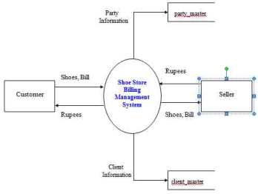

EXISTING MANUAL SYSTEM
Existing system is based on manual work and all the process are done manually, so they maintain registers and files for recording all the details of the system. They maintain several registers for recording the entry of daily transactions such as billing of the shoes to the clients, etc.
They maintain the record for their clients so they keep each and every information regarding their regular clients in the master file. In the similar fashion they maintain the records of their parties so they keep each and every information regarding their parties in the party master file.
They keep the bill book or cash book to maintain the record for each sale of the shoe or transaction in the bata store. They also maintain the personal book for each clients for their personal transactions so when the after the month or year when the client comes for the payment they see the bock and make the bill.
Similarly they maintain the book for their parties so they can pay the money to them after some time.Thus maintaining party information, client information , party transaction and all the things are done manually.

PROBLEMS FACED BY CURRENT MANUAL SYSTEM
The phase of system analysis process deals with problems which are Affecting in the current manual system . The problems are those which are Affecting the Bata store in it daily routine work.
As the growing trend in InfoTech world of computers need of accuracy, Perfect ness , speed and high memory data storage is a must. Each and every Problem must be solved with a least amount of time and energy.
The problems faced by existing system are described as below :
- Difficult in Maintenance of Records.
- Time Consuming.
- Editing of data becomes a tedious job.
- No Security of Data.
- Mistakes Occurring in long Calculations [Total Billing, Grand totals, yearly billing, etc…]
- Proper Generation of Report.
- Lack of Efficiency and Man Power.
- Shoe Maintenance.

Difficult in Maintenance of Records:
It is very difficult to maintain data record in the system as all the records are entered in the register or the respective record books. There are chances of the record books or files in which all the data is kept may be torn or wearied out or some other damages which results in the destroyed data. Also a problem occurs if the data file or register is misplaced somewhere else and is not getting at the time of actual requirement of the data stored. It is also difficult to maintain old files and registers which have data of past years which the ownes has kept for future references.
The problem occurs when the sale of shoe is more and when the monthly report or bill is generated then the owner has to go through lots of record and which is very tedious task.

Time Consuming :
It is very time consuming process to write each and every entry in the database register. Also it takes a lot of time if all the entries are repeated. In the system processes such as making different type of reports, billing, tedious calculations are examples of time consuming process in the system.
It is also time consuming process to know the total number of sale done by the Bata store when written manually but through computerized system it takes less time as it is speedy and accurate.

Editing of Data:

Manual written data cannot be changed or edited once written. If there is a mistake and if we try and write it makes the register very dirty and untidy, which creates a bad impression of the business . If data is entered incorrect whole document gets incorrect whole document gets incorrect while errors cannot be easily solved by editing wrongly entered data.
If one had done some wrong entry then to edit the one has to go through lots of records and, again and again editing the record makes it difficult to read.

Data Insecurity:
As the data is stored in files or registers, it is not in a secure place. As the storage media here are files and books or registers there are chances of getting these storage media lost, torn, or it may go in the hand of wrong person which can destroy the database or it can also be destroyed accidentally. Also in the system data should be shown to the person according to his position and post in the office everybody should not be allowed to use all the data.
If the data goes in the hand of wrong person then he/she may advantage of the data and the Bata store may go in loss. So security is the major aspects of the Bata store.

Report Generation:
After a certain time period if the user wants to checks his total billing or total profit or total expenditure or monthly sale than it becomes very tedious for the owner to check all the respectd data and according to the data creating respective report for the transactions. A computerized system having report making facility can do this job easily and also the owner can different types of charts and diagrams to make him understand the ups and downs of his Bata store.

REQUIREMENT ANALYSIS
This phase of system analysis deals with the requirement needed in the newproposed computer system to overcome problems affecting the manual system.

The owner of the Bata store wants to computerize the system in such a way thatits billing part should be fully computerize.

He wants that when he wants to sale the shoe than he can sale it to the clientsand after selling it the bill should be prepared automatically and the total amounts aswell as the grand total should be calculated.

Billing system for Bata store consists of three main parts:

(1) PARTIES:

(a) Party Information

(b) Party Payment

(2) CLIENTS:

- Client Information
- Client Payment

(3) SEARCH:

- Client Cash Memo

- Party Cash Memo

(4) REPORT GENERATION

- PARTIES:

(a) Party Information:

The owner of the Bata store wants that the information regarding the partyshould be comlete and it should be available as and when required. He wants thatthe party id should be auto generated, Name, Address, city, State, Phone no (R) ,Phone no (O), Fax, Email, Mobile and some special comments He also wants thatthe information of any party should be editable, it should allow to add the new partywith his full details. He can also delete the party and search the party according tothe city.

(b) Party Payment:

The owner of the Bata store wants that the bill no should be auto generated andthese should be a facility that the user can select the party name instead of writing

the name and when the user selects the party name then his/her address should beautomatically come. Now the user has to fill the details of the particular which theparty gives and quantity and rate should be given then amount of a particular item iscalculated automatically and finally the total of all the items should be come.

(2) CLIENTS:

(a) Client information:

The owner of the Bata store wants that the information regarding the clientshould be complete and it should be available as and when required. He wants thatthe client id should be auto generated, Name, Address, City, State, Phone no (R),Phone no (O), Fax, Email, Mobile and some special comments.

He also wants that the information of any client should be editable, it shouldallow to add the new client with his full details. He can also delete the client andsearch the client according to the city.

(b) Client Payment:

The owner of the Bata store wants that the bill no should be auto generated andthere should be a facility that the user can select the client name instead of writingthe name and when the user selects the client name then his/her address should beautomatically come. Now the user has to fill the details of the particular which theclient is going to take and the quantity and should be given then amount of aparticular item is calculated automatically and finally the total of all the items shouldbe come.

(3) SEARCH:

(a)Client Cash Memo:

The owner of the store want that the system should provide the seachfacility.Suppose the user wants to see the Party Cash Memo details than only just
by giving the Bill No the Client cash memo’s total should be shown and if user
wants to see more details than further details should be shown.

(b)Party Cash Memo:

The owner of the store want that the system should provide the seach facility.Suppose the user wants to see The Party Cash Memo details than only just bygiving the Bill No the Party cash memo’s total should be shown and if user wants to see more details than further details should be shown.

(4) REPORT GENERATION:
The owner of the Bata store wants that after each transaction the report or bill should be generation, as well as the report for all the parties and all theclientsshould be displayed.

PROPOSED SYSTEM

The manual system of “Bata store” is to be computerized in order to overcome
the problems which affects the existing manual system. Computerizing the existingsystem with the help of some programming language, database package ease the workof the system up to a great extent.

Generally, there has been a criterion to work on any job or task for a specificpurpose. Nobody works without detailed information about the particular task he isperforming. Thus any transaction can be performed such as sale. In the newcomputerized system the basic and the initial first step is to ask for a specific user loginname and password for it, thus it can also take care of data security, now after when theuser enters the necessary details in the login name and password it checks for thecorrect password and allows the user of the system to enter the main page.

As the user is inside the system, the first screen of the system should be awelcome message and a list of menus. These menus contain the options of either Parties or Clients

In the Party information screen the user can Add, Edit, Delete,Save and search anyparticular record just by selecting the party name from the list and also the user cansearch the party by city.

In the Client information screen the user can Add, Edit, Delete,Save and searchany particular record just by selecting the client name from the list and also the user cansearch the client by city.In the Party payment screen the user can take the particular items and the screen willgive the amount as well as the total amount of the items.

In the similar way the Client Payment is done. The user can sale the particular items and the screen will give the amount as well as the total amount of the items andthe screen will give the amount as well as the total amount of the items.

The user can easily find all the data any time with out wastage of time thoughselecting specific menu used for specific purpose.

After the transaction is completed the user can log off from the system by simplyquitting from the system. Again if the user wants to enter in the system he must input the specific user name and password enter. The system will not allow any wrongpassword and will not allow to enter the system, thus it is safe from unauthorized
access of the Bata store’s data.

The main objectives of the proposed system is to help the user. The system can behandy to the user in the following reasons:

- To provide quick and efficient means for performing billing related activities andto effortlessly generate report of the system.

- To automize the work such as billing, Party record, Client record, etc.

- To automize the different types of reports.

2.1.6 COMPUTERIZED WATER BILLING SYSTEM
SITE BY: Pradeep Gokhale
DATE PUBLISHED: Ssaturday, February 23, 2008
URL: http://totalgravity.blogspot.com/2008/02/computerized-water-billing-system.html
According to Pradeep Gokhale, Water Billing and Revenue Management System is the most important Aspect of any Water Supply Scheme as it governs the financial aspect, which is the most important factor.
Amaravati water supply scheme is the only urban water supply scheme in Maharashtra which has been getting the facility of computerized water billing system continuously since 1991. The operating of the system has been outsourced. The software development has not been in a year or two, but it has been in process years together and proudly contributed by generously from meter readers, counter clerks, fitters, plumbers, clerical staff in the office, and auditors and accountants, to the higher officers, engineers at all levels, and most of consumers of the scheme. It has become most intelligent software in the country and now it is not only utility software but it is management software. It is in use in number of cities in Vidarbha and has to share the experience of managing more than 800000 consumers in the Delhi, the Capital city of the Country, since 1995. Following script has been included in the Maintenance Manual for urban areas.
The base of Water Billing System can be any one or more of the following:-
A. Metered System
1. Actual Consumption of Water
2. Minimum Fixed Charge
B. Non-Metered System
1. Fixed Charge Per Month
2. Fixed Charge Per Family
3. Fixed Charge Per Tap
4. Percentage of Annual Letting Value of Property

The various stages in the Water Billing Process are:-
1. Data Gathering (Meter Reading in case of Metered Billing)
2. Generation of Bill based on this Data
3. Distribution of Bill to Consumer
4. Payment of the Bill by the Consumer
5. Sending the receipt details to Billing Section
6. Related Accounting

Irrespective of the basis of the Billing Metered/Unmetered, the Computerized Billing System needs Three major databases:-

1. Master Data – This is the data, which needs to be entered only one time when the Consumer/Connection is added into the database. This data is relatively static in nature and does not change time to time. Various data required to be stored are:-
Consumer Number, Name of Consumer, Address, Type of Use, Type of Consumer, Tap Size, Date of Connection, Details of Feeder Line, Locality, House No., Ward No., No. of taps, No. of Families, Meter Make, Meter Number, First Reading, Ownership of Meter, Deposit Amount etc.

2. Data for each Billing Round – This data will be entered for every consumer for every round and will be used for calculating the demand of that billing round. Various data items required to be stored are :–
Consumer Number, Date of Meter Reading/Period for which Billed, Status of the Connection and any changes in Master Data etc.
3. Receipt Data – This data will be the data related to the payments made by the consumers against the bill issued. This data will be entered on daily basis irrespective of the billing frequency. Various data required to be stored are:- Consumer Number, Date of Receipt, Receipt Number, Details of the collection Centre, Cash/Cheque (If Cheque- Cheque No., Bank, Branch) Part Payment/Adhoc Payment/Deposit, Account Head for posting etc.

BILLING PROCESS:

A. Data Gathering: - For better administrative control over the complete billing process the City/Town is divided into various Zone/Sections geographically or as per the distribution network ESR wise. It is observed that the Cities already have ward numbers or localities which can be used as they are but if the billing is as per the distribution network the billing system can provide very important feed back as far as Water/Revenue losses are concerned (Water Unaccounted for).
These zones are further divided into smaller areas (Wards) for better control. The Person responsible for gathering data from these is the Meter Reader/Ward Clerk. In case of Metered System the suggested Number of Consumers which can be handled by one Meter Reader may vary from 1000 to 1500 Consumers per month depending on the geographical spread of the area and other office jobs to be performed by the person. In case of unmetered System the Number can be doubled.
The prime responsibility of this person will be,
1. to gather all the data related to the water connections in given area,
2. to collect all the data related to New Connections/Disconnection
3. to point out any change in the Master data of these connections.
This person will also be responsible for communicating this data, in given formats to the Billing Section.

B. Generation of Bills:
The Water Rates/Tariff structure may have one or more aspects from the following – Consumption Based, Flat Rate, Minimum Charges, Fixed Charges, Average Consumption Based etc.
Depending on the data gathered the demand for a particular billing period is calculated by the Computerized System. The outstanding amount is worked out on the basis of details of payments received. The charges for delayed payments or amounts not paid are calculated as per the rules given and the Bills are generated areawise.

C. Distribution of Bills to Consumer:

The distribution of bills can be done using any one of the following
a. By Post or Courier
b. By Persons specially appointed for this purpose
c. By Concerned Meter Readers/Ward Clerks
i) In a special round for distribution of bills
ii) At the time of Meter Reading for next round.
(This option saves effort/manpower but there is delay on one complete cycle in meter reading and distribution of bills)

D. Payment of Bills by the Consumer
The payments can be accepted at any one or more of the following:
a. Counters at various offices of the Board/Corporation
b. Various branches of Bank/Banks authorized for accepting payments
c. Door to door/on the spot recovery by concerned person/team.
d. Electronic fund transfer through various banks offering such option

E. Sending Receipt Details to Billing Section:
The collection counter/Bank/person shall send the receipt details to the billing section periodically (preferably daily basis) and the same is entered into the system and the totals cross checked.

F. Related Accounting:
The billing section also carries out the accounting related to these receipts such as posting of receipts, generation of demand registers or ledgers on periodic basis. The complete accounting related to the Billing is to be carried out by computerized system.

FREQUENCY OF BILLING
The frequency of Billing governs the cash flow of the Water billing system and thus more frequency means regular cash flow. The frequency of billing depends mainly on the type of system used. For Non-metered system the suggested Billing frequency is quarterly and for the Metered Systems the suggested Billing frequency is Bi-monthly. But in both cases all Non-Domestic, Industrial, Bulk Consumers shall preferably by billed Monthly to have a better control. The only other factor which can be considered in the respect is the availability of manpower for billing process and the cost of issuing bills in one complete billing etc.

DELAYED PAYMENTS:
Since water is being treated as a commodity consumed the advance billing is generally not carried out. It is therefore must to levy penalty/interest on the delayed payments of the bills. The minimum rate for such Delayed payments shall be at per with commercial interest rate.
COMPUTERISATION OF WATER BILLING SYSTEM
In this twenty first century Computers have become necessary in the day to day activities also. For the water billing system which is complex, repetitive and has voluminous data, computerization is must. Since various related areas like accounting, banking, consumer services are already computerized at most of the places computerization of the water billing is must.
REQUIREMENTS OF COMPUTERISED WATER BILLING SYSTEM
a. Hardware:- The Computer Hardware required for Water Billing System is as follows:
i) For Towns with 25,000 or less Water Connections the requirements of Hardware for processing of 5,000 Bills Per Month is as follows:-
P-III, 850+MHz, 64 MBRAM, 20GB HDD, 1.44 MB FDD, 2 Nos. 52x CD-ROM, SVGA MONITOR, KEYBOARD, MOUSE etc.
DOT MATRIX PRINTERS 300+ C.P.S., 132 Column – 2 Nos.
U.P.S. 1 KVA (At least 30 minutes battery backup) – 2 Nos.
ii) For Cities with more than 25,000 Water Connections requirement for processing 25,000 Bills Per Month is as follows:-
SERVER – P-4, 1+Ghz, 256 MB RAM, 2x20+ GB SCSI HDD, 1 No.
1.44 MB FDD, 52X CD-ROM, 8/16 GB DAT, SVGA MONITOR, KEYBOARD, MOUSE, ETHERNET CARD, 56.6 KBPS MODEM etc. P-III, 850+MHz, 64 MB RAM, 20 GB HDD, 1.44 MB FD, - 10 Nos. 52X CD-ROM, SVGA MONITOR, KEYBOARD, ETHERNET CARD, MOUSE etc.
16 PORT HUB - 1 No.
LINE PRINTER 1400 LPM - 1 No.
DOT MATRIX PRINTERS 300+C.P.S., 132 Column - 5 Nos.
U.P.S. 5 KVA (At least 30 minutes battery backup) - 1 No.
iii) For Metros with more than 1,00,000 Water Connections requirement the Hardware Setup mentioned in (ii) above needs to be installed at various Zonal Offices and these Servers be interconnected to each other for Data transfer or generation of reports.
b. System Software: The System Software required is as follows:
i) For Towns using stand along Computer systems the System Software required is Windows, FOXPRO
ii) For Cities and Metros using Servers the System Software is as follows:
Windows, UNIX, ORACLE, DEVELOPER 2000 or Visual Basic
c. Application Software: - The Application Software for the Water Billing System is the soul of the Computerized Water Billing System and needs to be developed as per the requirement of the Board/Urban Local Body.
d. Manpower:- The manpower required for the Computerized Water Billing System is as follows:-
i) Manager Data Processing – 1 No. for each Computer Centre
ii) Supervisor Data Processing – 2 Nos. for each Computer Centre
iii) Data Entry Operators – 1 No. for each Computer
PRIVATISATION:
Considering the volume of the work and skills required for the Computer Operations this activity can be entrusted to a private Agency on Contract basis. The Contract can be for complete Out-Sourcing or Data Processing or Deputing Expert Manpower for On – Site Data processing.
ADVANTAGES OF COMPUTERIZATION:
Control of the System
Decision Making
Sky is the limit

FUTURE AVENUES:
The Computerized Water Billing System can be used in future for direct payments through Credit Cards, Internet etc. The information for the consumers can also be made available on Internet or through Kiosks. The advance meters with remote reading techniques may give a system with minimum data entry to be done manually. The distribution network if available as Graphic information on Computers, can be directly be linked with the billing system to locate Water/Revenue losses.
OUTPUT FORMATS:
1. BILL: On Computer Stationary of 15” x 6” Size having three distinct parts which are separated by perforation for easy tear off. The data printed on all three parts is same. The first of leftmost part acts as acknowledgement of the Consumer for having received the bill for and also office copy of the bill issued. The Second or middle part is the Bill Cum Receipt for the consumer. The Third or rightmost part is the copy of the receipt given to consumer for the collection centre.
The contents of the bill are – Period of Billing, Zone, Area, Bill date, Due Date, Bill Number, Consumer No., Consumer Name, Address, Water Charge, Arrears, D.P.C., Meter Details, Previous & Current Reading, Status of Meter, Tap Size, Consumer Type, and Last Payment Details etc.
2. METER READING BOOK:
Consumer No., Name, Previous Reading & Status, Current Reading & Status
3. SCROLL
Receipt No., Date, Collection Centre, Consumer No., Name, Area, Amount, Cheque Details etc.
4. LEDGER
Consumer No., Name, Outstanding amount as on 1st April and following details of each billing round in the year –
Current Reading & Status, Arrears, D.P.C., Water Charge, Receipt No., Date, Amount received.
5. ASSESSMENT / DEMAND
Zone, Area, Meter Reader, Total Water, Total D.P.C.
6. DEFAULTERS LIST
Consumer No., Name, Outstanding Amount, Last Payment Date, Status
7. DISCONNECTION LIST:
Meter Reader, Area, Consumer No., Name, Outstanding Amount

2.2 LOCAL LITERATURE

2.2.1 LAN-Based Assessment and Billing System for Camiling
Author: Anonymous
Date Published: Anonymous
URL:http://www.cerillion.com/en/products?gclid=CLXEzoLJ7L8CFRYIvAodh7cAUw

According to Camiling College, “LAN-based Assessment and Billing System for Camiling Colleges”, presents the possibilities of helping the cashier or person-in-charge by developing a system that enhances the existing manual system to satisfy their clients, the students.

CHAPTER 1 THE PROBLEM AND ITS BACKGROUND
Introduction As people go along through life, it is inevitable to encounter many changes that can help in one’s daily needs. One of these changes is technology. It presents big help to lessens one’s work and make it more efficient especially when applied to business establishments. Information technology plays a big role in processing such needs. Its growing uses are becoming more essential, that it has already become a trend. It is easy to use, fast and accurate, and improves the efficiency of an individual or an organization. One such application that benefits most from computerization is the processing of an assessment and billing for an organization’s clients, since the process ensures that fast and accurate processing of data to accommodate a client’s request the soonest possible time. Camiling Colleges is one of the private schools in Camiling, Tarlac. It consist of primary and secondary level with a population of 900 to 1000 students, because of that, the current Assessment and Billing system for Camiling Colleges which is done manually, hampers the enrollment procedure due to long queue being experienced by students in getting assessment and issuance of official receipts. The study entitled “LAN-based Assessment and Billing System for Camiling Colleges”, presents the possibilities of helping the cashier or person-in-charge by developing a system that enhances the existing manual system to satisfy their clients, the students. Statement of the Problem The manual method of assessing and issuance of receipt during enrollment period at Camiling Colleges is prone to errors, tedious and most often misplaces records or documents. The people concerned could not accommodate more students because of the slow assessment and computation of fees to be paid, thus, causing inconvenience to both teachers who are assisting in the enrollment and the students during enrollment. Significance of the Study Through the implementation of the proposed system, stakeholders would benefit in terms of: A. Cashier and accessing officer: · Provides accurate data, whereby eliminating the tedious job and double-checking the computed amount to be paid by the students. · Speeds up the computation of payments and issuance of receipts. B. Students: · Provides easy to access and updateable student records. · Facilitates the processing of student transactions. School: · Provides enhanced and updated student records. · Provides precise information regarding the different transactions made especially in assessments and billing section during enrollment period. · Avoid misplacing of records or documents.
Scope and Delimitation
The proposed system will be designed to improve the current Assessment and Billing System of Camiling Colleges in terms of: Easy to navigate interface. Assessing the total amount to be paid by the students like tuition fees, miscellaneous fees and other fees. Automatic computation of payments and issuance of receipts. Generates printed reports. Can be installed in a client-server environment. The system will not include the personal information of the students, scheduling of enrollment and the assessment and billing of the elementary students of that Institution. Theoretical Framework Conceptual framework shows the effect of the intervening variable on the dependent as well as with the independent variables. It makes the relation under the study more distinct, providing the researchers direction and basis for data analysis. The elimination of errors in recording data, safe record keeping, faster recording and retrieving of data, accurate and correct data will be the dependent variable, while the independent variable is the data gathered from system fees. Both are influenced by the intervening variable that is the LAN-Based Assessment and Billing System for Camiling Colleges. Planning Phase – First and foremost the user’s capability and knowledge is very essential to take into account. Designing the system must not be simple and not complex to understand. Adaptability and capability of the software is a major component in the systems’ design. Complex features The following are some system requirements to run and maintain the system: a) CPU – Pentium III or higher (Pentium 4 is recommended) b) RAM – 128 MB (256 MB recommended) c) Hard Disk – 40 MB free space (for faster response) d) CD ROM- needed for software installation. e) OS – Microsoft Windows 98/2000/ME/XP f) Program - Microsoft Visual Basic 6.0 g) DATABASE - Microsoft Access 97/2000
CHAPTER 2
REVIEW OF RELATED LITERATURE AND STUDIES
In this chapter, the researchers present a review of different studies and literature, which are related to the proposed study. Related Literature As cited in the article entitled “Computerized Billing for Time Improves Client Communication and Firm Profitability” by Murphy (1996), he stated that, accounting firms can improve their profitability and relation with clients by automating client billing with computers. Accounting firms can use personal computer as an economical means of computerizing the billing process. A Computerized Billing System allows accounting firms to more effectively manage their employee’s productivity and give them the means to analyze the hours available and hours billed of each employee. A Computerized Billing System provides more control over a accounts receivable and client work processes. According to the article entitled, “Computer In Today’s World Philippines” by Bitter (1995), stated that the function performed by the computer division of various organizations has become identified as data processing program expedite many business functions such as the accounts payable system. They keep records of vendor’s number, special accounts and dates of payments. There are many advantages in using an accounts payable package: all information remains in one done automatically; calculations are easily made; the time involved to do work is greatly reduced. According to the article entitled “Information to Computer and Information System” by Syzmanski (1998), Computers are used in business for many tasks that can be grouped into category called data processing. Data processing includes tasks such as word processing, billing, and assembling number and facts associated with general office functions, such as order processing, inventory and billing. Related Studies Foreign Studies In the study of Kumar (1999), entitled “Computer Based Science Assessment Implication of Student with Learning Disabilities”, the author focuses about the implication of computer-based test on student with learning disabilities, he found out that a computer technology can be viable tool for performance assessment, and a potentially powerful the replacing the traditional product oriented paper and pencil tests. He also emphasized the researchers and educators must pay special attention to first, testing and validity of the use of computer technology tools. Cruz (1996), pointed out, the automatic processing of business data has introduced radical changes in the accounting of functions of recording. EDP application in record keeping have been justified by the large number of items that have to be process and the number of kinds of reports that have to be produced out of this records. Some typical example of record keeping application are payroll, customer billing, inventory control of accounts receivable and payable, and production scheduling. EDP has not only reduced the time required to handle this data but has also affected economics by doing the work faster and accurately. In the study of Burton (1999), it was cited that, “Among other information needed for computing Consumer Price information (CPI), prices of many daily required items are collected on a regular basis. This valuable information gives rise to the possibility of constructing a price decision support system, the system that can analyze stored prices and there related information to provide information on price relation and thus the prediction of tendency or the effect of price changes of items into another. Local Studies In the study of Purification (1995), entitled “Billing System of Plaza Hotel”, states that due to probably of manual computation error, computerizing the system will be able to step this probability even it is very rarely experienced in the manual billing system. In the study conducted by Benipayo (1994), entitled “Study on the RM/GS Billing System of the Manila Electronic Hotline Telephone Company”, stated that billing system is an essential component of the revenue generating function of the company. Thus, failure to generate bill on the proper time would effect the retaliation in the collection of revenues. The billing update is actually the revision of the entry of the new accounts in the customer file. Failure to update customer state in the billing records shall in a “no billing” of the consumption and will ultimately cause a non-generation bill. In the study of Bartolome (2000), entitled “A Computer Water Billing System for Teresa Water Supply”, stated that in making a water billing computerized, numerous benefits can be acquired. One of the benefits is that it speeds up the current computation of the bills wherein the operators will not waste their time in computing the bills of every concessionaire because the system computers it automatically.

CHAPTER 3
METHODOLOGY
This chapter aims to discuss the method used in the development of the proposed system. Methods of Study The researchers have adopted Structured System Analysis and Design Methodology (SSADM) in developing the proposed system. The subsequent stages of the methodology are allowed to deliver an effective, efficient and user friendly system for Camiling Colleges. Structured System Analysis and design methodology brings a well-defined activity and specifies the sequence and interaction of activities. It uses diagrammatic and other modeling techniques to give a more precise definition that is both user and developer. This diagram in modeling techniques represented used in the preceding part of the chapter SSADM provides a clear statement of the requirements that anyone can understand. It improves project and planning control and provides a better quality system by making the project very comprehensive and ensures that the resulting system will be a high quality.
Chapter 4
PRESENTATION, INTERPRETATION, AND ANALYSIS OF DATA
This chapter presents the pertinent information gathered by the researchers through the use of questionnaires and interviews being distributed in the target organization or respondents. The researchers are now ready to show interpret and analyzed the exact findings being collected and be treated through the use of statistical tools that pertinent in the development the researchers study. Based on the data gathered, the findings are: on the problems countered with the current system After reviewing the current assessment and billing system of Camiling Colleges the researchers now identify the problem that exist with in the system Computation of bills and making of statement of accounts and receipt requires a lot of time. Cannot easily achieve the accuracy of bills being computed. There’s a possibility in occurrence of mistakes in human written. Difficulties in making the monthly report Identical accounts sometimes occur. The problems numerated above are experience or encounter by the personnel every time the statement of accounts is done due to the manual method of computation On the advantages on Lan-Based Assessment and Billing System Table 1 ACCURACY OF COMPUTED BILLS Rating Frequency Percentage Needs improvement 0
--- Poor 1 10% Satisfactory 2 20% Very Satisfactory 5 50% Excellent 2 20% Total 10 100% In the study of Burton (1999), it was cited that, “Among other information needed for computing Consumer Price information (CPI), prices of many daily required items are collected on a regular basis. This valuable information gives rise to the possibility of constructing a price decision support system, the system that can analyze stored prices and there related information to provide information on price relation and thus the prediction of tendency or the effect of price changes of items into another. Table 2 CONSISTENCY OF COMPUTED AMOUNT Rating Frequency Percentage Needs improvement 0 --- Poor 0 --- Satisfactory 3 30% Very Satisfactory 4 40% Excellent 3 30% Total 10 100% In the study of Purification (1995), entitled “Billing System of Plaza Hotel”, states that due to probably of manual computation error, computerizing the system will be able to step this probability even it is very rarely experienced in the manual billing system. Table 3
NEATNESS OF THE STATEMENT OF ACCOUNT AND RECEIPT
Rating Frequency Percentage Needs improvement 0 --- Poor 0 --- Satisfactory 0 --- Very Satisfactory 0 --- Excellent 10 100% Total 10 100% Cruz (1996), pointed out, the automatic processing of business data has introduced radical changes in the accounting of functions of recording. EDP application in record keeping have been justified by the large number of items that have to be process and the number of kinds of reports that have to be produced out of this records. Some typical example of record keeping application are payroll, customer billing, inventory control of accounts receivable and payable, and production scheduling. EDP has not only reduced the time required to handle this data but has also affected economics by doing the work faster and accurately. Table 4 EFFECTIVENESS OF COMPUTERIZED SYSTEM Rating Frequency Percentage Needs improvement 0 --- Poor 0 --- Satisfactory 2 20% Very Satisfactory 5 50% Excellent 3 30% Total
10 100% In the study conducted by Benipayo (1994), entitled “Study on the RM/GS Billing System of the Manila Electronic Hotline Telephone Company”, stated that billing system is an essential component of the revenue generating function of the company. Thus, failure to generate bill on the proper time would effect the retaliation in the collection of revenues. The billing update is actually the revision of the entry of the new accounts in the customer file. Failure to update customer state in the billing records shall in a “no billing” of the consumption and will ultimately cause a non-generation bill. Table 5 PREPARATION AND DISTRIBUTION OF STATEMENT OF ACCOUNTS Rating Frequency Percentage Needs improvement 0 --- Poor 0 --- Satisfactory 3 30% Very Satisfactory 4 40% Excellent 3 30% Total 10 100% According to the article entitled “Information to Computer and Information System” by Syzmanski (1998), Computers are used in business for many tasks that can be grouped into category called data processing. Data processing includes tasks such as word processing, billing, and assembling number and facts associated with general office functions, such as order processing, inventory and billing.
CHAPTER V
SUMMARY OF FINDING, CONCLUSION AND RECOMMENDATIONS SUMMARY of FINDINGS
The study is all about the Lan-based Assessment and Billing System of Camiling Colleges. This aimed to prove that the automation of work is better than the manual system. On the advantages of the Lan-based Assessment and Billing System After the evaluation of the existing system of the Camiling Colleges. The researchers scheduled an initial testing of the system. The respondents are taken from a sample of personnel and students. The summary of the result is presented below based on: On the accuracy of computed bills Excellent was rated at 20% or a total of 2 respondents while 50% or 5 respondents rated it as very satisfactory. Twenty percent or 2 of the respondents rated it as satisfactory while 10% or 1 of the respondents rated it as poor. None pf the respondents rated it as needs improvement. Consistency of computed amount Thirty percent or 3 or 3 out of 10 respondents rated it as excellent and 40% or 4 respondents rated it as very satisfactory while 30% or a total number of 3 respondents rated it as satisfactory. None of the respondents rated it poor and needs improvement. On the neatness of statement of accounts and receipt All of the respondents rated it as excellent since it is computerized; erasures are eliminated that makes the statement of account and receipt more presentable and credible. On the effectiveness of the system Thirty percent or 3 out of 10 respondents rated it as excellent; very satisfactory was rated by 50%, which have a total number of 5 respondents while satisfactory was rated by 205 or 2 of the total number of respondents. On the preparation and distribution of statement of accounts Thirty percent or a total number of 3 respondents rated excellent, 4 out of 10 respondents or 40% rated it as very satisfactory while 30% or 3 respondents rated it as satisfactory. CONCLUSION Based from the analysis of the system, the researchers concluded that the students especially the personnel in charge would benefit from the proposed system. It is more secure and it ill lessens the processing time of assessment and billing than the manual processes. The transaction is more efficient thus the user will lessen their burden activities like computing bills that sometimes causes errors in writing the Assessment and Billing of the students. RECOMMENDATION An improvement system for processing maintenance and billing is strongly recommends by the researchers. This is much easier to use than the present manual process. This will secure all records and files of the students as well as the Assessment and Billing process. BIBLIOGRAPHY Books: Bitter, Gary G. (1995), “Computer in Today’s World Philippine”; The McMillan Com. Smith, Murphy L. (1996), “Computerized Billing for Time Improves Client Communication and Firm Profitability”; (Management of an Accounting Practice) the CPA Journal Syzmanski, Robert A (1998), “Introduction to Computer and Information Systems”; Merrill Publishing Co.
Unpublished Thesis: Bartolome, Elea S.(2000), “A Computerized Water Billing System for Theresa Water Billing Supply”, (Tibag, Tarlac City) Benipayo, Enrico (1994), “Study on the RM/GS/ Billing System of the Manila Electronic Hotline Telephone Company”. Burton, Has (1999), “Price decision Support System for Cambodia”. (De La Salle University). Cruz, G.A (1995), “Management Uses Of Accounting”; (Manila). Kumar, David D. (1994), “Computer Based Science Assessment Implication of Students with Learning Disabilities”. Purification, Susan (1995). “Billing System of Plaza Hotel,” (De La Salle University,

2.2.2 Online Student Registration and Billing System
Author: arielarnesto
Date Published : 20th Dec 2011
http://www.guides.wikinut.com/Online-Student-Registration-and-Billing-System/21ujyimb/

Introduction
In rapidly emerging world of technological advancement and innovations, computer has become a way of life and a driving force of modern industry and businesses. This becomes one of the most significant tools for more productive operations and accurate results. The web-technology is going through major changes, as a basis of the development of web-based applications and informative systems; web-technology is being matured over the past few years.
Web development is a broad term for the work involved in developing a web site for the Internet or an Intranet or a private network. This can include web design, web content development, client liaison, client-side/server-side scripting, web server and network security configuration, and e-commerce development. Web development can range from developing the simplest static single page of plain text to the most complex web-based internet applications, electronic businesses, or social network services. Web Development can be split into many areas and a typical and basic web development hierarchy might consist of: Client Side Coding, Server Side Coding, Client Side + Server Side, as well as the Database Technology.

Background Of The Study
Many organization and institution increase their investment in web-technology and online system. The scope of web-based application has grown enormously and has moved to become a platform that can support all facets of organizational work (Isakowitz et al., 1998).
For this reason, engineers and IT specialist strive and still vigilant in combining web development to the practical application of scientific investigations and research. But evidently the majority of the institutions still do not adapt with in evolving world of technology particularly the small institution like Kohen Tutorial and Development Center. It is an educational facility with traditional and innovative teaching and learning opportunities. Their aim is to enable students to achieve the full potential of the student in terms of academic competencies by focusing on the emotional, social, and educational needs of each individual.
This educational institution is eager to have a facility integrated with the computer to deliver better service to the students and most especially to the parents. We hope to develop a web-based online system that will minimize all paper works and manual records keeping, therefore allowing administration and staff ease in keeping track of students, and reducing the waiting time of the parents to the process of registration and billing. Thus, the system will increase the number of students/parents served. The system is expected to be fully automated, user-friendly, time effective, and practical.

Statement of the Problem
The researchers seek to provide solution to the following problems:
1. Insufficient amenities and utilities in processing of the registration and payments resulting to unorganized record-keeping and gathering information.
2. The students/parents are taking too much time of long processing of registration for validation.
3. The record was kept into folder which cannot accommodate the growing number of the student.

Objectives of the Study
The objectives of the research project are to:
1. To develop a web-based student registration and billing system for the Kohen Tutorial and Development Center that gives more systematic registration and payment processing.
2. To minimize the paper works and manual record keeping of the students. Thus, reduce the wasting time of the parents/students on the registration process while increasing the number of client serve.
3. To design a system that is secured which cannot be modified or retrieved by unauthorized person.

Scope and Delimitation
The study was focused on the web-based system development. The researcher formulated the scope and limitations of this project to identify the boundaries of this study.
The scope of this project is:
• The system will record all the necessary information with regard from the students.
• The system will determine the payment history of the student regarding their remaining balance.
• The system will display the bill of the student after the registration.
• It has a capability to keep in track the records of the student.
• The system is a username and password protected.
• The system will allow the student/parents to access in their account.
• Student and parents will view some information of the institution.
The limitation of this project is:
• The system will use only for student registration and billing.
• The system requires internet connection; else accessing to the system does not take place.
• The parents/clients are not capable to pay online.
• Only the administrator is capable to edit or modify the records of the student.

Significance of the Study
This project will be implemented and expected to provide good effect and beneficial to the following:
For Kohen Tutorial and Development Center. The institution will be benefited a lot because through this project they are more capable to provide better service for the students/parents.
For the student/researcher. This research study will serve as their reference materials and guide in doing their own research. The student may also use the ideas and findings written therein.
For the parents and their child. This system will help both parents and student to minimize being consumed in registration and billing process.

2.2.3 Computerized Accounting Systems (CAS) in financial reporting among the Small and Medium Enterprises in Lipa City

CHAPTER 1

Research Problem
This chapter presents introduction of the study and its background, statement ofthe problem, the significance of the study, scope and delimitation and definition of terms.

1.1 Background of the Study
Accounting takes an important role in operating an organization. Every businessmust keep track of financial information that relates to its business activities. It also hasnumerous processes; some simple, others complex and burdensome. But as the businessgrows, acquires new customers, enters new markets and keeps pace with constantchanges in information technology, companies need to maintain highly accurate and up-to-date accounting, inventory and statutory records. With a substantial increase in thevolume of accounting transactions and increase in exposure of information to errors dueto complexity of these accounting systems, there was a need for a system which couldstore and process accounting data with increased speed, storage, and processing capacity.This led to the development and introduction of accounting software packages.Accounting Software is a class of computer programs that perform accountingoperations. Accounting Software is an application software that records and processesaccounting transactions within functional modules such as accounts payable, accountsreceivable, payroll, and trial balance. Thus, these software packages allow the whole
accounting system to be run on a computer hence the name Computerised AccountingSystem.A computerized accounting system records accounting transactions using acomputer and accounting software.

It is one of the database-oriented applications whereinthe transaction data is stored in well- organized database. The user operates on suchdatabase using the required interface and also takes the required reports by suitabletransformations of stored data into information. Therefore, the fundamentals ofcomputerised accounting include all the basic requirements of any database-orientedapplication in computers. It helps simplify, integrate, and streamline all the business processes, cost-effectively and easily and helps presents the true picture of all the business undertakings to users of financial reports.Due to the rapid change in technology, many small businesses prefer to trackmonetary transactions with computerized software than keep track of all financial activitymanually through the use of a physical ledger. The advancements in informationtechnology have eventually led to the introduction of Computerised Accounting Systemsto help produce relevant and faithful representative financial reports for bothmanagement and external users for decision making.Computerized accounting tends to involve dedicated accounting software anddigital spreadsheets to keep track of a business or client's financial transactions. It is a beneficial use of current technological advances. Not only has it revolutionized the traditional paper methods of accounting, but it has also created new types of accountingapplications for business. Companies now create entire accounting information systemsthat integrate all business operations, including external suppliers and vendors.Computerized accounting systems have replaced manual-based accounting in virtually all businesses and organizations, providing accountants, managers, employees and
stockholder’s access to vital accounting information at the touch of a button.
Computerized accounting systems automate the accounting process--improvingefficiency and cutting down costs. And it tends to be more accurate, faster to use, and lesssubject to error than its manual counterpart.In today's computerized, interconnected, global business environment,
Computerised Accounting Systems became the ‘engine of growth’ in business
organisations. It therefore involves the computerization of accounting informationsystems which is established in order to facilitate decision making. These are associatedwith a numbers of benefits like speed of carrying out routine transactions, timeliness,quick analysis, accuracy and reporting.

1.2 Statement of the Problem
The primary objective of the study is to explore how Computerized AccountingSystems have changed many aspects of business and accounting practices.1.

What are the major benefits of using the computerized accounting systems infinancial reporting among the Small and Medium Enterprises in Lipa City?2.

What are the problems associated with the use of Computerized AccountingSystem?3.

What factors should be considered before choosing accounting software?
1.3 Significance of the Study
The significance of this study is to provide necessary information about the impact of using Computerized Accounting Systems (CAS) in financial reporting amongthe Small and Medium Enterprises in Lipa City. This study will explain the greatinfluence and effects that CAS can do in financial reporting. Due to our fast changingworld, modernization became a part of the broader technology. Truly, it brings much benefit to the business world nowadays

1.4 Scope and Delimitation of the study
The study focuses on assessing the impact of the use of Computerised AccountingSystems in financial reporting. This will determine the possible impact of computerizeaccounting system in financial reporting and how it can affect in the decision making ofthe company.The respondents of the study are limited only to the Small and MediumEnterprises in Lipa City. It is conducted during the first semester of school year 2013-2014.Also, the study is limited only in financial reporting of a business and will notinclude other aspects of reporting

1.5 Definition of Terms
The following terms are defined operationally/conceptually for the betterunderstanding of the study.

Computerized Accounting System.
It refers to a system used by businesses forrecording their financial information.

Accounting.
The systematic and comprehensive recording of financial transactions pertaining to a business. Accounting also refers to the process of summarizing, analyzing and reporting these transactions.

Financial Report.
It is a formal record of the financial activities of a business, person, or other entity. It is presented in a structured manner and in a form easy tounderstand.

Accounting Software.
It refers to application software that records & processesaccounting transactions within functional modules such as accounts payable, accountsreceivable, payroll, and trial balance.

Manual Accounting System.
A manual that contains pertinent accounting rulesand other information for a business or organization. Accounting manuals can containguidelines for various policies and procedures. They also often specify organizationalrules and standards for corporate accounts.

Bookkeeping.
It is the context of a business is simply the recording of financialtransactions. Transactions

Technology.
It refers to the making, modification, usage, and knowledge of tools,machines, techniques, crafts, systems, and methods of organization, in order to solve a problem, improve a pre existing solution to a problem, achieve a goal, handle an appliedinput/output relation or perform a specific function

Small, and medium enterprises (SMEs).
It is defined as any businessactivity/enterprise engaged in industry, agri-business/services, whether single proprietorship, cooperative, partnership, or corporation.

Conceptual FrameworkResearch Paradigm
This research proposal used the Input Process Output model. As an input, theresearchers will use the Computerized Accounting System. To carry out the study, theresearchers will conduct a survey among the proprietor of small and medium enterprisesin Lipa City, Batangas. As a result, the researchers will enable firms which have not yetincorporated Computerised Accounting Systems in their Financial Reporting to do so.

CHAPTER 2

REVIEW OF RELATED LITERATURE AND STUDIES

This chapter covers the review of related literature and studies which are closelyrelated to the present study, both foreign and local, and provided the researchers some background and information in determining the type of approach used for this study

2.1 Related Literature
The literature below serves as supporting details about the impact ofComputerized Accounting System in financial reporting.Accounting is not only the oldest but also the most stable of the managementdisciplines. In spite of its stability and continuity, accounting has seen major changesduring the past century. It would be surprising if a century from now, accounting is thesame as today. Although we cannot look so far ahead, we can analyze the currentconditions for clues about what to expect in the next decade or two (Sunder 1999).Accounting provides financial information about a business or a not-for-profitorganisation. Owners, managers, investors and other interested parties need financialinformation for decision making. Financial accounting is the art of systematicallyidentifying, measuring, recording, classifying and summarizing in a significant mannerand in terms of money, transactions and events which are, in part at least, of financialnature, and communicating, analysing and interpreting the results there of (Woode&Sangster, 2008).

Every company applies accounting because it is generally accepted thatcompanies have to reveal certain financial and management information to economicusers and of course because accounting is an indispensable tool in business decision-making process. Accounting is an important part of every company thus; businesses arerequired to keep proper books of accounts (Section 123 of the Companies Code (1963),Act 179).Weber (2010) stated that accounting can be divided into two basic categories:those which apply manual accounting and those which prefer computerized accountingsystems.Meigs et al, (1998) Computerized accounting system is a system that usescomputers to input, process, store and output accounting information inform of financialreports. He adds that accounting system records all transactions that routinely deal withevents that affect the financial position and performance of an entity.Marivic (2009) described a computerized accounting system as a method orscheme by which financial information on business transactions are recorded, organised,summarized, analysed, interpreted and communicated to stakeholders through the use ofcomputers and computer based systems such as accounting packages. He emphasised that
it’s a mechanized process of facilitating financial information inflows as well as the automation of accounting tasks such as database recording and report generation.Marivic adds that keeping accurate accounting records is a vital part of anyorganization. Apart from helping it to keep its float financially and legal, it is arequirement of funding bodies or donors.

However computerized accounting system involves the use of computers tohandle large volume of data with speed, efficiency and accuracy aimed at overcomingfundamental challenges which do not change the principle. The principle of accountingremains the limitations of many accounting and hence producing quality and reliablework.McBride (2000) explained that computerized packages can quickly generate alltypes of reports needed by management for instance budget analysis and varianceanalysis. Data processing and analysis are faster and more accurate which meets themanagers need for accurate and timely information for decision making.Frank wood (1999) consented to the speed with which accounting is done andfurther added that a computerized accounting system can retrieve balance sheets, incomestatement or other accounting reports at any moment. He consented that computerizedaccounting system allow managers to easily identify and solve problems instantly.Indira (2008) pronounced the improvement in business performance as a resultcomputerization of the accounting systems as it is a highly integrated application thattransforms the business processes with the performance enhancing features whichencompass accounting, inventory control, reporting and statutory processes. He then says,this helps the company access information faster and takes quicker decisions as it alsoenhances communication.McBride (2000) stated that managers cannot easily satisfy statutory and donorreporting requirements such as profit and loss account, balance sheet and customizedreporting without using computerized accounting systems. With the system in place, this can be done quickly and with less effort

Computerized accounting systems ease auditingand have better access to required information such as cheque numbers, payments, andother transactions which help to reduce the time needed to provide this type ofinformation and documentation during auditing.

According to Carol (2002), it is easy to do accounting functions usingcomputerized accounting systems. Posting transactions to the ledger, the principle ofdouble entry can largely be automated when done through the use of computerizedaccounting system.Meigs (1986) stresses that there is a risk of improper human intervention with thecomputer programs and computer files. Employees in the organization may temper withthe computer programs and computer based records for the purpose of deliberatelyfalsifying accounting information. This may result into distortion of information thatwould essential be for decision making.According to Wahab (2003), another threat and limitation of computerizedsystem is the computer virus. Where a computer virus is a computer code (program)specially designed to damage or cause irregular behaviour in other programs on thecomputer. The adverse effect is that it may lead to breakdown of the hardware thusleading to loss of valuable information (for instance in financial institutions informationsuch as customers accounts, previous financial report, information pertaining loansadvanced among others) already saved on the computer.

Van (2005) stated that financial reporting is the process of presenting financial information or data about a company’s financial position, operating performance and its flow of funds for an accounting period.According to Frank Wood (1999), financial reporting is all about presentinguseful information to users so that proper decisions can be made. His implication aboutfinancial reporting is that financial information should aid in the evaluation of amounts,timing and uncertainties of cash flows. Also financial reporting should furnish information about the entity’s economic resources, claims against those resources,owners’ equity and changes in the resources and claims.
Indira (2008) emphasized that financial reports should provide information aboutfinancial performance during a period management discharge it’s stewardship responsibility to owners. It should likewise be useful to managers and directorsthemselves in making decisions on behalf of the owners.

According to Carl’s et al (1999) the quality of financial repor
ts depends on theintended users of the information and should be evaluated with respect to the needs of theusers. Federation of Accounting Standards Board (FASB) defined quality as a hierarchyof accounting qualities with relevance and reliability considered as the primarycharacteristics while representing faithfulness, verifiability, neutrality, comparability,consistency and understandability considered as secondary characteristics.Frank (1999) stated that information is said to be reliable if it is free from materialerrors and bias and represents faithfully that is purports to represent.
With the substantial increase in the number of transactions and increase in theneed for real time information, maintenance of accounting data on a real time basis.has become essential. This is achievable using computerized systems hence promoting thequality of financial reporting. Carol (2002) says that computerizing business generalledger, payroll and other accounting tasks increases office efficiency.Lancouch (2003) says that computerized accounting systems have also beencredited for their quick processing speed and large storage capacity. Using computerizedaccounting systems ensure up to date account balances are available at any time to aidmanagement in decision making.Lewis (1999) also stated that computerization saves time on transaction henceleading to quality of financial reporting for instance timely, accurate and reliableinformation can be generated.The influence of computerized accounting systems depends on the end userssatisfaction. Mihir (2002) stressed that higher end users satisfaction leads to a positiveattitude towards using the satisfaction and in turn increases the voluntary usage of thesystem. Nash (2003) noted that the quality of accounting information and performance ofthe accounting systems is a great concern to management. A computerized accountingsystem is a delivery system of accounting information for purposes such as providingreliable accounting information to users, protecting the organization from possible risksarising as a result of abuse of accounting data and system among others.

2.2 Related Studies (Foreign)
The related studies below serves as supporting details about the impact ofComputerized Accounting System in financial reporting.In the case study of Bitwabado (2011), he focused on computerized accountingsystems and cash management in financial institutions. The study addressed objectives, benefits, problems associated with computerisation, how cash is managed, impact ofcomputerized accounting on cash management as well as the relationship between twovariables and coming up with the recommendations to the stake holders of the bank.Descriptive and analytical research was used to examine findings and come up withconclusions. Stratified random and purposive sampling was used to select elements fromthe different departments and levels of management with a sample size of 31 respondents.Questionnaires, interviews, sampling and use of related literature from text books, journals, magazines and internet were also used. The findings of the study indicated thatthough computerized accounting systems have impact on cash management, therelationship is weak sending an overall negative signal to the stake holders andmanagement that computerized accounting alone cannot fully manage institutional cash but also strengthening other means because there are some activities which cannot bedetected by computers such as money laundering and other related activities whichrequires tight supervision from the management.Also the research of Dacosta (July 2012) was organised to assess the impact of theuse of Computerised Accounting Systems in financial reporting of rural banks in Ghana.The study also had another objective of bringing out the problems encountered in the use of a Computerised Accounting System. Advancement in technology is now the order ofthe day. Businesses are constantly looking for cost-effective, economic and efficient ways of satisfying customers’ needs. Thus, there is the need for businesses to be abreastof the current issues in technology to enhance their business. This is to help gain acompetitive advantage over their competitors especially in this era where there are more banks springing up. One of the ways to reduce cost in business processes, is to ensure thatresources allocated are well utilised to obtain maximum benefits at minimum cost. Thuswith the use of a resource (input) like a Computerised Accounting System, it is expectedthat, the accounting system will be able to generate relevant and useful reports (output)for making economic decisions by users. Computerised Accounting Systems aretherefore used by these organisations in order to generate timely and accurate reportsthrough a fast and efficient processing of accounting data.The study of Dacosta (2012) revealed that because of the numerous benefits thatare associated with Computerised Accounting System more importantly its ability to produce and present relevant and faithful representative financial reports to end users, thegovernment of Ghana is assisting all Rural Banks to migrate onto a commonComputerised Accounting System known as Terminus 24 through the MillenniumDevelopment Account. This is going to serve as a platform in which all the rural banks inthe country are going to be networked to each other to facilitate faster and efficient banking. Undoubtedly, with the adoption of Computerised Accounting Systems, problems and challenges such as; high purchase, installation and maintenance cost,computer failure, inadequate information technology expertise and time involving are to be expected. However, the advantages from the use of a Computerised Accounting.
System far outweigh the problems and challenges as it has impacted the financialreporting of the banks positively. Hence, there is a need to adopt a ComputerisedAccounting System and more importantly for all rural banks to make the effort to migrateonto the Terminus 24 as it comes with added advantage of being networked with otherrural banks
CHAPTER III

RESEARCH DESIGN AND METHODOLOGY

This chapter presents the design and methodology that the researchers employedin the study. It presents the research locale, research methods used, population andsample, instruments for gathering data and validation and procedure for gathering data.

3.1 Research Locale
The study is conducted to the Small and Medium Enterprises located on LipaCity, Batangas. The respondents of the study included ten (10) proprietors of theenterprises that are using computerized accounting system in presenting their financialreporting.

3.2 Research Method Used
The study used quantitative research design in which the data gathered aresubjected to statistical treatment and corresponding description and explanations are presented.Quantitative data can be transposed into numbers, in a formal, objective,systematic process to obtain information and describe variables and their relationships.

3.3 Population and Sample
The research population for this study composed of ten (10) enterprises that are using computerized accounting system in their financial reporting. The population of the Drafted the title of theresearch proposal Sought for adviser ' sapproval for the title of the research Constructing the Statement of the Problem Revisions made by the advisers Distributied the survey-questionnaire to the Respondents
Administrateredthe respondentsof answeringsurvey-questionnaire
Retrieved theanswered survey-questionnaireTallyingandAnalysis ofthe data
enterprises composed of random sampling was used to select the respondents on the basis of predetermined criteria.

3.4 Research Instrument and Validation
The data gathering instruments used in this study was a survey-questionnaire. The questionnaire contained the letter to the respondents, respondent’s profile and question proper. This questionnaire was answered reliably. The answer given by the respondentswill be kept confidential.

2.2.4 DESIGN AND IMPLEMENTATION OF A COMPUTERIZED HOTEL BUSINESS BILLING SYSTEM
https://www.google.com.ph/search?q=computerized+billing+system+case+study&start=10&bav=on.2,or.r_cp.r_qf.&cad=b&bvm=pv.xjs.s.en.edlJ5F2Rvas.O&ech=1&psi=WmAKVK7vO8nloATx6oB4.1409966231705.3&ei=WmAKVK7vO8nloATx6oB4&emsg=NCSR&noj=1.

INTRODUCTION
Hotel is defined by British law as a place where a binafide traveller can receive food and shelter, provided he is in a position to pay and is in a fit condition to be received. Hence, a hotel provides food and beverages, and lodging to travellers on payment. In turn, it has the right to refuse a traveller is drunk, disorderly, unkempt or is not in a position to pay for the services.
The hotel industry is perhaps, one of the oldest commercial endeavours in the world. The first inns date back to the sixth century be and were the products of the urge to travel, spurred by the invention of the wheel.
The earliest hotels were managed by husband and wife teams, who provided large halls for travellers to make their own bed and sleep on the floor. The entire cooking service and recreation were provided by the husband and wife team and his family.
It was in Europe that the birth of well managed hotel industry took place on the shape of chalets and small hotels which provided variety of services. They were mainly patronized by the aristocracy of the day.
The real growth of the modern hotel industry took place in the United State of America in 1794. the real boom in hotel building came in the early twentieth century. This period also saw the beginning of chain operation under the guidance of E.M stalker. It involved big investments, big profit and trained professional to manage the business.
The management business billing of a hotel system was virtually left in the hands of the front officers. The front office in a hotels is the department responsible for the scale of hotel rooms through systematic method of reservation, followed by registration and assigning of rooms to customers, it was usually done manually. This was boring and cumbersome in hotels that still operate manually today. This development in hotel business billing system continued gradually until recently when computer was invented as an electronic method of processing data, computer can be defined as an electronic device that accept input, manipulated data and produces information which is the output, as required. Computerization of hotel business billing system: a focus on the lodging system of a hotel, therefore, the application of computer in the lodging system of a hotel. A hotel which operated a computerized system will ensure that the program carries provision for different tariffs, locations and individual guest preferences. Details of each room are stored within the memory and as a guest registers the guest list is immediately updated while that particular room is removed from the list of those which are available for letting. Because the system is so accurate, there is little chance of two people being given same room.

BACKGROUND OF THE STUDY
The lodging system of Mooted Hotels Limited Enugu started when this hotel was established in 1986. at its inception, Mooted Hotels Limited inherited three modern hotels. There were ninety three chalets at the time of its establishment. These hotels were located at Enugu, IMO, Anambra. However they have since been improved upon with additional chalets, better management and better services.
The management of Muddle Hotels Limited insists that standard obtainable in its hotels of all types compare favourably with the standards elsewhere. Each chalets is provided with a room stewards, hot and cold water tub, wall-
To-wall carpet, air conditioner, television, refrigerator and inter-com. The Cable News Network (CNN) is received in the hotels through its satellite dish. The body managing the hotel now at the apex of the management include-
1.The general manager
2.The company accountant
3.The company secretary
4.The operational managers
5.The public relations officer
6.The house keeper
7.The food and beverages manager
8.The number of staff are eighty
These are both junior and senior cadres.
1.Administration
2.Accounts
3.Restraurant
4.Bar
5.Kitchen
6.Laundry.

1.2 STATEMENT OF THE PROBLEM.
The introduction of computer in the hotel is to reduce problem encountered on arrival and event at check out time by guest’s customers and visitors to the hotel and by the reception staff on their efforts to manually attend to each guest’s requests going through the reception routine in the front office by the guest is normally frustrating and time wasting. As guest can be kept on his feet for several minutes waiting to be attended to .the billing procedures in the cashier section are similar to that of the front office. The staff at the cashier section are also limited by their human capabilities.

1.3 PURPOSE OF STUDY
The main aim of this study is design a computerized reservation entry and guest billing system for timely services. In hotel services, time is of essence.
Another objective of the to design a computerized system which will ensure that the program carries provisions for different tariffs, locations and individual guest preferences. The computer will select the best available rooms for particular reservation or offer an alternative, if the preferred room is already taken or is not yet ready. The program will be flexible enough to ensure that any special request by a guest can be catered for.

1.4 SCOPE AND LIMITATIONS OF THE STUDY
The computerization of the hotel business billing system is centred on the front office. (i.e. reception and cashier section) of the Modotel hotel limited. A lot of limitations were encounter during this study. Such limitations are:
1. Fiance: this hindered my movement in the process of gathering of facts.
. 2. Time: this is another constraint to my undertaking a more comprehensive fact finding, since the period for this study was very small compared to the actual work.
3. Lack of textbooks: this is also another major constraint in the course of carrying out this work. One had to move one library to another.
. 4. Protocols: I encountered series of protocols, often called red tapism before I was granted interviews.

1.5 IMPORTANCE OF THE STUDY
There is a high hope that this project will solve those problem the reception personnel encounter on the sale of rooms in the hotel. A hotel which is computerized can, with dispatch, answer inquires and write confirmation letters for reservation, keep messages for guest’s ,advice the hotel management about regular guests, improve the level of services the hotel offers to guest and monitor room services to guests. It will greatly help the reception personnel to know the number of room available and how many rooms that have been booked. This helps in updating of reservations. In a situation of efficient services, the hotel will be attractive to guest and visitors and thereby make profit.

1.6 DEFINITIONS OF PROCESSING
REAL TIME PROCESSING: Technique by which enter data for immediate processing.
ON LINE PROCESSING: Also called transaction processing,. It is the collecting and processing of data as transaction occurs.
INFORMATION: When data undergoes certain manipulations like calculation, sorting, amending etc. they eventually become useful meaningful. In other words, they become information.
DATA: Bit and pieces of fact and figures representing an idea or event needed for processing to give out information.
FIED: A unit of information containing a group of related data.
ARRIVAL: Time that a guest registers into the hotels.
ACCOMMODATION: The term simply refers to rooms.
BOOKING: Reservation of rooms.
CANCELLATION: When a room reservation is with drawn by the guest.
CHECK-IN: Arrival of a guest who has registered at the reception.
CHECK-OUT: Department of a guest who has settled his bills.
DEPARTURE: Time when a guest leaves the hotel.
DOUBLE ROOM: Room with one large- size bed.
GUEST: Person who uses the services of a hotel.
RECEPTION: Counter in a hotel that registers guests.
RESERVATION: Counter that receives documents on reservation requests.
SKIPPER: A guest who departs without paying his bill.
SINGLE ROOM: Room with one bed.
When PLDT was incorporated and given the franchise to establish and operate telephone services in the country on November 28, 1928, a typhoon had just ravaged Eastern Visayas, Bicol Peninsula, and Samar. The ability to communicate amongst loved ones and across the country became crucial. Sadly, phone networks then were like disconnected intercom systems and you could only call people within your own small city. Filipinos were disconnected from neighboring towns, disconnected from friends in the other island and, needless to say, disconnected from the rest of the world. It was under this scenario that the law was signed giving birth to PLDT. What the new law hoped to achieve was to interconnect these "intercom" systems into a seamless nationwide network that would facilitate communication and delivery of services to the people, as well as spur economic development in the countryside.
The first president of PLDT was Theodore Vail Halsey while Major J.E. Hamilton Stevenot, who represented the American firm General Telephone and Electronics Corp. (GTE), was elected executive vice president and general manager. Under the American owners of PLDT, many small phone companies in the provinces were acquired by the Company to help speed up the rollout and connection of these different phone systems all over the country. The management of PLDT was then set to lay the groundwork towards linking Filipinos to each other and, more importantly, to the world.

2.2.5 PLDT HISTORY
PROCESS OF PAYMENTS
It is suggested to have a bill image that will show the following ‘must know’ portions of the statement of account to better guide the customer.
Account Number, Invoice Number, Amount Due, and Due Date
Account Number: Is a fixed number assigned to you as customer of the listed telephone number/s. Always quote this number when inquiring or when making a payment.
Invoice Number: Is a distinct reference number for a particular bill for a billing period. Use for BIR purposes.
Amount Due: Is the total unpaid charges for the previous and current month bill.
Due Date: Is the last date of payment for the total amount due. We encourage you to pay earlier than the due date to ensure payments will be credited to the current billing period. Payments after the due date are considered late payment and may cause the service restrictions or disconnections of your telephone.

Credits from Previous Charges, Total Call Charges, Service and other Charges

Credits from Previous Charges: Is the details of transactions such as payments and downward Foreign Currency Adjustments (FCA), which reduce the customer’s previous charges.
Total Call Charges: Is the summary of all your voice calls and data charges, which can include but not limited to NDD, IDD, Cellular, Operator assisted calls and Premium numbers 1-908.
Service and Other Charges: Is the details of recurring monthly charges and one time fee (if applicable) for subscribed products and services. However, on your initial bill, you may receive a pro-rated service rental charge as computation will be based from the date your telephone service was installed.

Sample Computation - Daily Rate
(*P700 ÷ 30days in a month) | P 23.33
No. of days used | X 51
Total bill (Pro-rated) | P 1,189.83

2.3 SYNTHESIS:
Given from the study discussed above, the review focused on implementing modern billing solutions for prominent service worldwide. “Modern billing" is the kind of points service providers need to seriously consider when looking for solutions.
It was explained the process of billing system. It governs financial aspects which is the most important factor. It helps the researchers in their project in terms of billing system including its process and how it was integrated with other sub-systems. It will serve one of the researcher’s guides to implement better billing system.
The researchers found the articles very useful to their project. The kinds of system that they have been also compose of cash receipts, invoice, reports and collection. It process efficient data sharing while limiting the need for redundant data entry.
Some articles support and provides strict monitoring of receive through reports and is configurable to auto-generate number series. And only authorized users are allowed to access the system and manage the sales, company shares, employee, income, taxes due and as well as penalties. It shows clear understanding of the billing operation. It has different functions although almost the same process.
On this case, some problems occurred in terms of billing and needs to apply an action on some problems. That is why developers implement efficient way in terms of billing especially like security agencies. They need accurate billing system because a security agency holds volume of clients. The articles may help the researchers in determining the risk that they may encounter once the system is ready for execution.
Matrix
FEATURES | Foreign Related Studies |  |  |  |  | Local Related Studies |  |  |  |  | Service Management System
 | R1 | R2 | R3 | R4 | R5 | R6 | R7 | R8 | R9 | R10 | Billing and Collection System
Auto-Generated Billing Form | √ |  |  |  | √ |  | √ |  |  |  | √
Report Generation |  | √ |  |  |  | √ |  | √ | √ |  | √
Calculate Bills Automatically |  |  |  |  |  |  |  |  |  | √ | √
Calculate penalties automatically |  |  | √ |  | √ | √ |  | √ |  |  | √
Update client’s status of billing on a system |  |  | √ | √ |  |  |  |  |  |  | √
Notify client’s status |  |  |  |  |  |  |  |  |  | √ | √
Sending notification to client |  |  |  |  |  | √ |  | √ |  | √ | √
Collection process | √ | √ |  |  |  |  |  |  |  |  | √
Modern Billing process |  |  |  | √ | √ |  |  | √ | √ |  | √
Accommodate Volume of Client |  |  | √ |  |  |  |  | √ |  |  | √
Governs Financial Aspects | √ |  |  |  |  |  | √ | √ |  |  | √
Payments Collection process | √ |  |  | √ |  |  |  |  |  |  | √
Invoice Billing process | √ | √ |  | √ |  |  |  |  | √ |  | √
Customer billing process | √ |  | √ |  |  |  |  |  |  |  | √
Efficient and reliable billing process |  |  |  |  |  | √ |  |  |  | √ | √
Generation of Bills |  | √ | √ |  |  |  |  |  |  |  | √
Distribution of Bills to Consumer |  |  | √ |  |  |  |  | √ |  | √ | √
Payment of Bills by the Consumer |  | √ | √ |  |  | √ |  |  | √ |  | √
Sending Receipt Details to Billing Section |  |  |  |  |  |  |  |  |  |  | √
Generate of Receipts |  |  |  | √ |  |  | √ | √ |  | √ | √

CHAPTER 3

3.0 RISK MITIGATION, MONITORING, AND MANAGEMENT PLAN
- Introduction
This section gives a general overview of the Risk Mitigation, Monitoring and Management Plan for the Billing and Collection System (BCS)

  - Scope and intent of RMMM activities
The goal of the risk mitigation, monitoring and management plan is to identify as many potential risks as possible. To help determine what the potential risks are as we evaluate our documents and research materials. So we could identify the potential risk in a generic sense. Then the project will be analyzed to determine if there is any project – specific risk.

When all risk has been identified, we will be evaluating them to determine the chance of their occurrence, and how will it affect the company if the risk occurred. To manage plans to avoid each possible risk, to track and determine its occurrence.

To perform the risk mitigation, monitoring and management is an organizational responsibility to assure quality products. The quicker the risks can be identified and avoided, the smaller the chances of having to face that particular risk’s consequence. The fewer consequences suffered as a result of good RMMM plan, the better the product and the smoother the development process.
  - Risk Management Organizational Role

People involved and may affect in the development of the system project has responsibility of managing the risk. Calling the attention of those who are involved in the system project may avoid high risk possibility.

Team Developers – the group assigned on the creation of the system.
Company – also called as the End-User they provide the efficient process of the system for the clients. Through the help of the automated billing system the clients will be able to serve well by the company through sending invoices to them, calculate customer’s cost for each billing record; periodically generate invoices and collecting payments received from the customer.
Adviser – the person who will be supervising the production team and gives them advises and techniques.

- Functional Data Description
This section describes the risks that are likely to be encountered during this project.
  - Risk Table
The following table describes the risks associated with the project. The appropriate risk category, probability and impact are given.

    - Description of Risk m

- Employee Risk:
It includes attention and willingness of the members doesn’t do their jobs cause deletions in terms of the development of the system. This risk may cause any misunderstanding to the proponents especially when it comes to miscommunication of each other. This risk also depends on the ability and experience of the software development team members to develop fully functional system project accurately. Every members of the team should dedicate their selves wholeheartedly while exerting more effort and skills required finishing the project successfully.

- Development Risk:
It involves problems such as in performing and prevention of project that may appear during the development of the subsystem. It may also cause a big problem from the side of financial if the proponents failed. The client must provide the necessarily needs to create and produce the system that the company needs. Taking quick response on the need of products to produce the system will lessen the risk on developing the system.

- Process Risk:
This risk is regarding with the advisers complained where the proponent has to change the done documentation and software development in to a new process. A system must have a good quality on improving a business. One of the objective of every develop system is to make it efficient and lessen the task rather make it difficult for the users. This can happen because of the client’s failure to describe the true business need or failure of the software development team to understand the project.
- Service Risk
If the service provider fails to provide well service it will cause major problems between client and the agency who serves as the service provider to the client.
- Client Risk
It concern is client’s motivation or willingness in helping the development team. If the client does not participate on this matters, there are chances that the system produced might not be what they need to improve the business
- Technology Risk
Since the technology changes rapidly these days it is necessary to pay attention and importance to this risk. Developing a program meaning innovating its technology used like hardware and software.
- Business Impact
This concerns about not coming up or produced a product that will greatly affect the client’s business. If the software produced can’t meet the expectations and improve the business, the developed system may consider useless.

    - Probability and Impact For Risk M

Category | Risks | Probability | Impact
Employee Risks | Lack of Training and Experience | 40% | 1
Process Risk | Low Product Quality | 35% | 1
Service Risk | Where service does not well provided | 30% | 2
Development Risks | Insufficient resources | 30% | 2
Client Risk | May fail to participate | 20% | 3
Technology Risk | Obsolete Technology | 10% | 2
Business Impact | Service may harm the business | 10% | 3

Table- Risk Table (sorted)

Impact Values Description
- Catastrophic
- Critical
- Marginal
- Negligible
Above is the table that categorizes the risks involved in software development. It gives brief description of the risk in Risks column and also the impact of the risk in the Impact column.

- Risk Mitigation, Monitoring and Management
This Section details and describes Risk Mitigation, Monitoring and Management in every possible risk that may occur, how you will manage to give a solution and monitor if there are other circumstances that the risk might occur again.
3.1 Risk Mitigation for Risk Management
This section identify different risks has been identified, and a plan as encounter measures the risk, so that the risk would never appear again. It is important to have mitigation plan to avoid risks once and for all.
    - Business Impact
As mitigation step we will spend more time with the users to understand business environment and their needs. Business impact concerns about the final product. This will help in upcoming with just right service at right price for the clients,

    - Technology Risk
To avoid risk of using technology that may become obsolete in few years after the product have been developed. Software development team has to make sure that the equipment that will be used in developing the system will not be obsolete in near future. The team must use the latest technology also the equipment must be appropriate on the technology used to avoid the risk on these matters.
    - Client Risk
To avoid this risk the communication between the service provider and the client must be always present so there could better understanding in defining system requirements. Every details must be cleared to avoid problems during system development.
    - Development Risks
Tools are the first priority on a development team. Their work will be affected if they are lack of tools and supplies. To avoid this, the team must summarize the tools and supplies needed on the development process. The client must provide the tools and supplies needed to achieve the desired end product.

    - Service Risk
To avoid this risk, client must provide well-service. As a client they have the right to be served a good service because they pay that service in return.

    - Process Risk
We want provide a high quality product the team must have proper guidelines to follow. To ensure that the task of every member of the team is precise and time managed.
    - Employee Risks
To provide a high class service the team must have proper knowledge, experience and willingness to assure the success of the project. To avoid this, the team should always gather a meeting to talk about their performance and evaluate each other so they know where they should focus on the project.

3.2 Risk Monitoring for Risk Management
In this section, we will identify the conditions to monitor to determine whether risk m is becoming more or less likely.
3.2.1 Employee Risks
This is where team members have to spend more time learning and teaching what others know. Monitoring the teammates with difficulties on their task, this will notify the team on who shall be helped and specify what part of the team should be improved.
3.2.2 Process Risk
To manage this risk our team will be cross checking each of our work, another advantage of this is that we can give each other a suggestion based on our opinions to improve one self and monitor our works.
3.2.3 Service Risk
This is where the service is well monitored. Performance of every employee to the clients is essential. That’s why they are being monitored to avoid risk.
3.2.4 Development Risks
To monitor development risk, we will keep eye on tools being used to see its effectiveness. During this phase of development the team should always been aware of the latest items or gadgets.
3.2.5 Client Risk
To monitor the risk we will monitor the success and happening of the meeting of clients. We’ll be conducting weekly meetings keep the records of their activity. Check the outcome of the activities to acknowledge the people who are attending and active on improving the project.

3.2.5 Technology Risk
During this phase of development the team should always been aware of the latest items or gadgets.
3.2.6 Business Impact
In this phase the team will conduct weekly meetings to monitor the user’s information in the needs of the business this will be a very efficient way to know the users insights in the project that will help the team improve the system requested by the client’s request.
  - Risk Management for Risk Management
Once the mitigation and monitoring has been determined, to find a better solution these risks may prevent possibility risk that occur during the development phase.

Business Impact
When serious error occurs during the user input over the completion of the software can provide the development team the information on how to evaluate and improve the software. The software development has gone a lot of planning and data gathering and meetings with the stakeholders. This should have made an impact on how to deal with the misunderstanding between the development team and the stakeholders. Managing these kinds of difficulties and trials during the development phase will make an adjustment that is necessary to prevent further failure. When there is an adjustment, it will be the same process and business rules as it is but in a different interpretation and analysis.
Client Risk
The risk management of the billing and collection must have a strategic succession planning. It is acquired by identifying key invoices and the records might crop up. Determining the skills and performance standards for these positions is a must, should identify the potential skills for development. When this plan has been succeeded in the strategic planning of the company it helps in a various ways of improvement. It can encourage senior management to conduct a disciplined review of the leadership talent available within the company.
Process Risk
This risk can be avoided by a proper planning strategy on which the business has to execute and maintain its process. The best solution is to develop an alternative strategy on which the development team will come up another method to answers the unwanted uncertainty. It is essential for having a multiple method on planning solution to render the best services that may project a good feedback towards the company.
Technology Risk
Adopting of today’s latest trends regarding with the technology have a major impact on developing the project. If the proponents adopt new skills and techniques to improve what is done without a major changes in the project development is an absolutely an advantage. The project team may change methods on the project development that is up-to-date software using of the latest technology. People now vary on the functionalities of the hardware and software that they are using. That’s why if the proponents adopt the latest trends and the client agrees with those changes, it will be discussed amongst the proponents to make necessary changes throughout the existing technology used.

Development Risk
Many development projects are trying to advance current software capabilities and achieve something that has not been done before. The opportunity for advancement cannot be achieved without taking risks. The use of advanced and, in most cases, unproven technology on software development projects leads to a large number of risks. In order to complete a complex software development project within planned boundaries, risks on the project should be well understood and managed. Every software development project faces a significant amount of uncertainty that is usually manifested as possible risk materialization the success of a software development project is directly connected with the involved risk and the project risks should be successfully managed in order to finish a software development project.

Service Risk
In order to have successful service, might provide things needed by the well handed and well monitored.
Process Risk
In this risk must also know how to prevent mistakes in recording each details that the client given and it should be auto generated in printing receipt. It must efficient in using and have a high effectiveness. To manage this risk our team will be cross checking each of our work, another advantage of this is that we can give each other a suggestion based on our opinions to improve one self and monitor our works.
4.0 Special Conditions
Special conditions that are associated with the software are as follows:
- Using of the desktop or laptop:
The proponents need to make sure that all inspectors at the facility are comfortable with the use of the computer.
- Login:
The software must identify the characteristics between the user and administrator. It is used to segregate the access level of each user. If the person accessed the system with a user type, it can’t be accessed the vital parts of the system. When it comes to the administrator, they should be granted the rights to access the system without any limitation to all the parts including the reports and important part of the application.

3.2 SOFTWARE CONFIGURATION MANAGEMENT PLAN
1.0 Introduction
At the stage of software development there will be a point where the proponent will make a revisions and changes to the concept. SCMP is developed so that we can identify and improve control changes and assure that the plan is implemented and reported the changes to the team.

  - Scope and Intent of SCM Activities
As what has said to the introduction the SCM plans purpose is to report and tract the changes on the software development plan. The procedures will give us an outlook of the software that should be changed and went to changes. For SCM to be successful, all the members of software production team will have to take time to report the changes that they think are necessary and to notify others of changes that they may have made.
SCM Activities are develop to
- Identify changes
- Control changes
- Ensure the changes is being properly implemented
- Also have a way to document the changes

  - SCM Organizational Role
Responsibility of tasks falls out on every member of the team. Each member has a specific task to do. They are the ones who exert they very best effort, time and knowledge to meet the same goal for the system project. Since the proponents have rather a small development team, each member of the team should accept the responsibility for the software configuration management. This is necessary since there are only five members in the team. Supposedly, each of the five members has to report the sudden changes and the remaining three members have to take up a job of authorizing change and to ensure that change is properly implemented. This will ensure that the conflict within the proponents will be reduced or it should be eliminated. The proponents will also keep a member to communicate with the client just to inform that all of the changes for the client to be accepted. The changes that do not really affect user’s knowledge of the software will be presented to a selected member on the client’s side. These changes will be noted in a specific section so that the proponents can refer back to them to know what the original plan was and why the changes were made. If the changes are made or suggested so that the proponents will affect the way customer uses the software, then those changes will be discussed with the entire client team. Once a client has decided to go with the change then and only then will changes be implemented. The proponents extensively report or document all the changes so that client will have access to it after the software is packed and delivered.
      - Production Team
The production team will be the group assigned on
the creation of the system.
      - Company
Also called as the End-User they provide the efficient process of the system for the clients. Through the help of the automated billing system the clients will be able to serve well by the company through sending invoices to them, calculate customer’s cost for each billing record; periodically generate invoices and collecting payments received from the customer.
      - Adviser
The person who will be supervising the production team and gives them advises and techniques.

2.0 SCM Task
In this section we will try to detail all-important SCM tasks and will assign responsibilities for each. All of the SCM tasks will be performed by five members of the software development team members. All changes that affect the use of the software will be discussed with entire team to client during the meeting.

2.1 Identification
In this section, we will describe the way software configuration items will be identified for the software configuration management plan.
    - Description
- Identify change
On identify the change the production team will be discussing about on the system if it is needed or not and will assign a member to work on the suggestion and to figure it out.
    - Approve Change
If the change is needed the team will be discussing the implementation of the change how to document the changes and how the changes will be submitted to the other production team so that they can adjust to the adjustment of your team.
    - Ensure the changes is being properly implemented
Setting a day where the team would conduct a meeting to check each other’s work or if their works are compromising this way we will be reducing the conflict and unnecessary information on the documents and finalize it.

    - Document the change
Since the document has been finalized. we will be using that opportunity to generate the report and pass the work to the software development team to implement it to the product.
2.1.2 Work Product and Documentation
- Identify Change
When the changes has been identified, change request form has been issued and to be given to the SCM team.
- Control change
Often evaluation, the change form will be generated.
- Ensure
The team will be implementing changes and checking each other’s task.
- Document Change
Finalizing all changes and documents then adds it to the compilation.
  - Configuration Control
2.2.1 Description
A discipline applying technical and administrative
direction and surveillance to
- Identify and document the functional and physical characteristics of a configuration item
- Control changes to those characteristic
- Record and report changesto processing and implementation status.
2.3 Version Control
2.3.1 Description
Major documentation have version numbers, such as User Manual or Design Specification.
2.3.2 Increasing Version Number
The team creates a proto type of the system till the process and functions will be completed.
2.3.3 Work Products and Documentation
A part of documentation will be named version revision history this will be used to document the revisions, bug report; system tracking this will be the basis on monitoring the bug fixes and upgrades.
  - Configuration Status Accounting (CSA)
The developers will be using some ways to communicate with the team members and to inform others that changes may concern.
2.4.1 Description
          - Verbal Communication
Whenever the teams settle the schedule of meeting up, there they can talk about the changes.
          - Social Network
This method of communicating the developer is when they are not in same location.
2.4.2 Work Products and Documentation
- Testing of Errors
- All suggestions made during meet up will be noted
- Feedback

3.3 Software Quality Assurance Plan
- Introduction
This section gives a general overview of the Software Quality Assurance Plan for the Billing and Collection System. Software Quality Assurance will focus on the management issues and the process that enable a software organization to ensure that it does the right things at the right time .
  - Scope and Intent of SQA Activities
The objectives of SQA are:
- Control of software documentation and the changes made to it
- Multi testing strategy is draw
- Trial and Error
- Effective Software Development Technology
- Documentation

  - SQA Organizational Role
Lovely P. Gentugao
Project Manager

Billing and Collection
System

Roma Joy A. Baclas
System Analyst

Jomar B. Monsanto
Business Analyst

Mark Anthony V. Ogatis
Lead Programmer

Jaycell D. Pasicolan
Document Specialist

- Project Manager : Lovely P. Gentugao
- System Analyst : Roma Joy A. Baclas
- Business Analyst : Jomar B. Monsanto
- Document Specialist : Jaycell D. Pasicolan
- Lead Programmer : Mark Anthony V. Ogatis

Project manager
The PM is responsible for accomplishing the project objectives within the constraints of the project (Scope, Time, Resources, and Performance Specifications). The PM Also the one who leads the co members and motivate the proponents to work hard.
System Analyst
The one who is assigned for checking the business process and the technology to be used, to obtain mistakes in achieving the objective of the software development
Business Analyst
Will be the one who will communicate with the client and attending the meetings with them and negotiate about the changes that the client might be requested to the development team.
Document Specialist
Will be the one who document every changes and updates regarding with the software development and right down all the corrections to the documents
Lead Programmer
Will be the one who assigned for designing and coding of the programs, it is his/her responsibility for developing the software and revise the software when there are changes just to make sure that the software hits the objective and assess with the quality of the software.
2.0 Software Quality Assurance Task
Here are tasks we have for the SQA:
- Research on the project
- Good Communication with the client
- Gathering of information
- Research, Surveys and Interviews
- Close Contact with Client
- Detailed every information

2.1 Task Overview
Tasks that described above will cover the quality services, saving design time and cost, minimize uncertainty and task execution.
2.2 Standard, Practices and Conventions
- Research on the project
in order to meet the system requirements, the developers used to find more reference for better understanding of the system project.
- Good Communication with the Client
The client was our end user that’s why their cooperation was very needed in order to finish our project. Every meeting with them we propose an agenda on what should be done or what was the process they want to their system.
- Detailed every information
Letting them decide on what should be seen on their interface will lighten the teams work and setting it to their needs is a great success.
- Gathering (brainstorming/meeting)
On every gathering the decision making was decided by hearing every ones opinion on a certain changes and topic. So that every ones idea was acknowledge and summaries to make a conclusion.
3.0 Reviews and Audits
A formal technical review (FTR) is a software quality assurance activity that is performed by software engineers. The objectives of the FTR are:
- To uncover errors in function, logic, or implementation for any representation of the software;
- To verify that the software under review meets its requirements;
- To ensure that the software has been represented according to predefined standards;
- To achieve software that is developed in a uniform manner; To make projects more manageable
- To make the project more manageable
  - Generic Review Guidelines
    - Conducting a Review
Our review will focus first on the clients overview and next was to the project teams overview. Because every meeting with the client there are high chances of changes depending on their needs the teams overview should be presented to the client so that every sides can give their ideas before changing and documenting the details.
3.1.2 Roles and Responsibilities
Project manager
The PM is responsible for accomplishing the project objectives within the constraints of the project (Scope, Time, Resources, and Performance Specifications). The PM Also the one who leads the co members and motivate the proponents to work hard.
System Analyst
The one who is assigned for checking the business process and the technology to be used, to obtain mistakes in achieving the objective of the software development

Business Analyst
Will be the one who will communicate with the client and attending the meetings with them and negotiate about the changes that the client might be requested to the development team.
Document Specialist
Will be the one who document every changes and updates regarding with the software development and right down all the corrections to the documents
Lead Programmer
Will be the one who assigned for designing and coding of the programs, it is his/her responsibility for developing the software and revise the software when there are changes just to make sure that the software hits the objective and assess with the quality of the software.
3.1.3 Review Work Product
The proponents have to make an individual work report. The report includes the assignments for each member for the past weeks, problems encountered, problems that can’t be solved, conflict with the client, changes of plans, execution of the plans and its corresponding personnel involved in every task that is given to each member of the group. The proponents divided the task and being deployed to each member in order to execute the development phase as quick as possible. This work review is very important when it comes to responsibility and finishing the job within the allocated deadline.

3.2Formal Technical Reviews
3.3Software Quality Assurance Audits
- Team members will have a weekly report on their individual performance for the past week. Any problems, question regardless on the performance of other team members will also note there.
- Members will write part of the help menu that relates to their design work. And they also share between members.
- Any changes that will affect the project will be presented to other team members before doing any changes. These are the changes that are minor or require little code change, but still are different from the original architectural design.
- The client should be notified of all changes made to the. For minor changes, we will just notify a reprehensive from the client instead of the whole team from the client. This rule only applies to the minor changes or cosmetic changes, or minor functional changes. Any major functional change will still require the agreement from the whole team from the client side

4.0 Problem Reporting and Corrective Action / Follow-up
This section will clarify the issues, problem reporting mechanism that occur as a consequences of the FTRs that are conducted and the means for corrective action and follow-up.
4.1 Reporting Mechanism
The first change given to the billing and collection system was the cashier changed to our system. We will conducting cashier duties rendering of official Receipt to the clients reimbursement and disbursement funds.
  - Responsibilities
The proponents select a leader which is the Project Manager. The Project Manager is the head of the team, on which he/she is the one that is responsible for creating the final decision. Each member has its own role for the software development life cycle.

Project Manager: Lovely B. Gentugao
- Manages the team
- Project Execution
- Planning Strategy
- Project Initiation
- Project Control throughout the software development
- Risk Management
- Resolving the issues within the client and team members
- Budget the project costing
- Scheduling of tasks for the project team members
- Leader of the team
System Analyst: Roma Joy A. Baclas
- Handling of business Rules
- System Design Document
- Technology Analysis
- Document Framework
- Business Requirements interpreter
- Investigate the business requirements
Business Analyst: Jomar B. Monsanto
- Analyze business process
- Business plans Monitoring
- Translate Business process
- Requirement management
- Requirement Analyst
- Analyze Requirement
- Communicate w/ clients
Document Specialist: Jaycell D. Pasicolan
- Analyze the audience
- Documenting the business process
- Craft the right message
- Distil the message into effective documents
- Release the documentation
- Evaluate the results
- Check the changes in documents
Lead Programmer: Mark Anthony V. Ogatis
- Correct errors on the system coding
- Handling System Software
- Program Development
- Perform System Analysis
- Train subordinates in programming
- Develops programming methods
4.3Data Collection and Valuation
During each meeting, the researchers ask the clients what are the problems they encountered, how the developers could help to give a solutions to those problems has been conducted from time to time to come up a good strategy and procedure to work with. The planning phase has been discussed within the project team members, collection of ideas, brainstorming and then finalizes the scheduling. The next step is to execute the schedule of each team members, everyone have to make a report of their execution of their task. The execution has been done through interviews with the client, research on the library, evaluating a survey result, observation and online researching. Collection of the data and information can acquire through these methods. After the collection of data, the proponents have to make a prototype system to interpret the collected data.

3.4 SYSTEM SPECIFICATION
- Introduction
This section gives a general overview of the Billing and Collection System (BCS) under the Service Management System.
  - Goals and Objectives
The main purpose of the system is to provide automated billing process of the security agency. The goals and objectives of Billing and Collection System are the following:
- To provide an automated calculation of bills
- A system that will create custom invoices for the client
- A system that will automatically calculate bills
- A system that will generate a report as an output of every transactions with the client
- To easily monitor clients’ status whether they are paid or not yet paid.
- A system that will monitor the service provider of the client’s status
- A system that will ensure security to all information in regards to billing and collection
- To produce an outcome such as official receipt once the client pay their account

  - System Statement of Scope
The general statement of the Billing and Collection System (BCS) should be specified and provided in this section.
    - General Requirements
The following general requirements were identified and specified for the Billing and Collection System.
      - Through this, companies may ease their billing process with an auto-generated billing form.
      - The system has an ability to calculate penalties and other charges automatically
      - The system can produce a report not only report of invoices but also other categories
      - This system could create custom invoices
      - This system will monitor or notify the service provider of their clients’ status

Interface Enhancements
The Billing and Collection System will provide an interface enhancement thus will help the end-user operate the system very easy to manipulate.
Database Administrative Interface
The Billing and Collection will provide a secured database where in records will be kept on a centralized database which is the MS SQL database used as the back-end of the system project.
Trainings
Entails trained students and focuses instruction on skills required to perform task. The end-user must have enough knowledge to manipulate the system. But the proposed system has unique interface.
  - System Context
The development of the Billing and Collection System (BCS) is for academic purposes. As part of the school requirements, students who contribute knowledge to finish this system project will serve as an advantage for their future careers and also for the company who will be benefited by using the developed system to be able to help their business growth. All the gathered information that the researchers used as their reference is for academic purpose only.
  - Major Constraints
- Time
Time is one of major constraints during system implementation and development. Before the system execution it took a year to finish the system project. Even the developers has an assigned task to accomplish, they still manage to attend subjects on their respective classes.
- Workforce
Each member of the group contributes knowledge and dedicates their selves wholeheartedly in order to finish system project and meet the same goal. The proponents only have a maximum of five members. The proponents have to double time regarding of the execution of the project documentation and requirements specification regardless of the shortage of the manpower of the project team.
- Funding
Funding is the worst possible constraints for the proponents, the funds that the proponents are only limited considering they are currently dependent as a students who lacks on personal fund to support the expenses for developing the System Project. However, this constraint will not be an issue for not pursuing the objectives for the development of the System Project.
- Resources
The software and hardware that the proponents used to develop the Billing and Collection System are also limited. The proponents only have one laptop and one desktop to be able to use in developing and documenting the software. It is more efficient for having at least one laptop / desktop per member of the project team to be able to execute the software development on time.
- Scope
Identifying the scope of the Billing and Collection System will also be major constraints. It is necessary for clearing and finalizing its scope and limitations especially when the integration of the BCS to the other sub-systems taking place.
- Functional Data Description
In this section, the overall system functions and the information domain of the Billing and Collection System are being identified and described on which it is implemented and operated.
  - System Architecture
    - Architecture Model

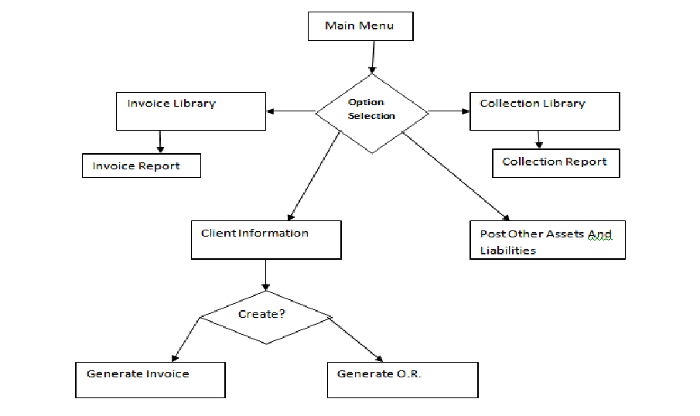
2.1.2 Subsystem Overview
Auto-Generated Billing Form
- This form is convenient and easy to use tool for submitting and managing reports it can transact and create subscription or detailed form for billing reports or receipt for collection.
- This also creates an invoice with an auto-generated form. This includes the calculation of bill and other charges. The BCS will have to provide an up-to-date client status to the service provider. This form varies on a sequence number to avoid data redundancy.

Monitor Client’s Status
- This form where you can add new client information, and for the current client if there some changes in the status the client will automatically updated by the company.
- . This includes the search engine to identify which of the client’s billing transaction information to be viewed and checked.
Issuance of Official Receipt
- The official receipt, on the other hand,, shall serve as principle evidence in the sale of services..

  - Data Description
    - Major Data Objects
- Login Form
Username – This is the name used to enter in the login window in order to make an access to the system
Password – This is a unique codename or anything personalized data used to verify the access attempt of the user or the system administrator.
User Type – This is used to differentiate the accessibility level of the person who wants to enter into the system.

- Main Menu Form
Toolbar - This panel is used to display the icons used to transact the system’s functions
Menu Bar – This panel serves as the menu of all the functions of the system and it is located on the top section of the main window
Status Bar – This panel is used to display the time, username, date and some controls like uppercase and the scrollbar and it is located on the bottom of the main window
- Client data Object
Client ID - unique identifier of the client
Company Name - the name of the company
Contact Number - the contact number of the client
Billing Data Objects
Invoice Number - generated number for client’s billing transaction
Client ID - unique identifier of the client
Amount Bill - total bill of the client
Amount Due - the deadline of the payment
Date Paid - date the client paid
Balance - the remaining bill of the client

Collection Data Object
Client ID - unique identifier of the client
OR Number - the number of transact bills
Amount Paid - the amount paid bills
Date of Payment - the date of payment
Tin - the other payment of the client
Vat - the other payment of the client
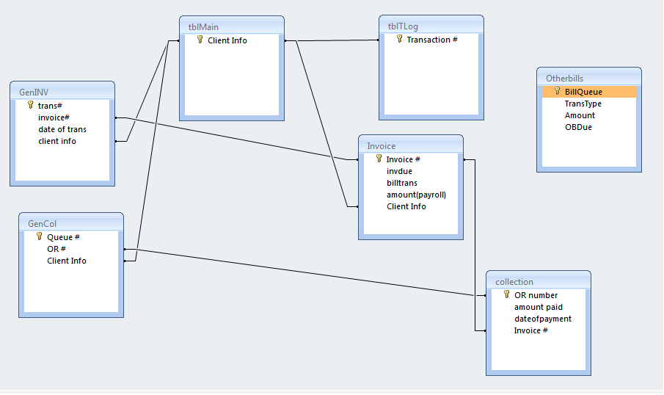
2.2.2Relationship
2.3 Human Interface Description
In the existing flow of the company, the HR manager has to give an application form to the applicant to be filled up and after that the HR personnel encode it to their datasheet which is in a paper format. The HR personnel saved the applicant data in a folder with the documents then put it to the drawer. When the HRMS will be implemented, the HR personnel logs into the system using the username and password in order to connect to the system. The username and password enters to the login window. It will verify into the database if the attempt was valid or invalid depends on the data that has been entered. If the username or password entered is correct, the first window that will appear is the main menu or the main window. The main window contains the menu bar, status bar and the toolbar. The menu bar contains the other window of the system which is ready to use whenever the user wants to
Log in Form
Log-in form is one of the first forms that will pop-up after you run the system. The user or the administrator will have to enter their respective username and password in order to access the system. After entering the username and password, click the LOGIN button to access the system. If the user or the administrator wants to cancel the previous transaction, click the CANCEL button located at the right side of the form window after the LOGIIN button. The user or the administrators have three attempts to enter their correct username and password. If the user fails to enter the correct username and password the system will automatically terminated.
Main form
The main form of the system is the next forms that will pop-up after the user or the administrator entered their correct username and password. It compose search box, collection log button, billing button, log out button, client id no., client name and Client Company.
Collection Log
This form can see the located collection information of the client. It consists of fields such as O.R. no., Client name and amount paid, leaving it blank will cost an error.
Billing Log
This form can see the location of the bill reports of the client. It consists of fields such as Billing Invoice No., client name, Company, Amount, leaving it blank will cost an error.
Receipt Form
This form shows the Receipt Form that consist of O.R Number, Date of transaction, Name of client, name of company, address, amount, VAT, Tax, and total amount.
Billing Records Form
The billing Records form is used when the user or the administrator of the system wants to view records of the clients. Under the billing report form window, there are text namely, Return and Print records. are used when the user wants to filter a certain dates of the said registration have been done. The show all records button is used when the user wants to view all of the existing records saved the system's user or the system's administrator. The print records button is used when the user or the administrator of the system wants to print the membership registration information.
Billing Report
The billing report is the printed output of incoming/ outgoing bills.
4.0 Enhanced Interface Prototyping
4.1 Prototyping Requirements
The proponents would like to minimize the scenario of the HR personnel to generate or create an application form in a word document and then transfer it to the employee records in a form of a document. Therefore, it is actually a double handling process which it takes time to finish the job. That’s why the primary goal of the HRMS is to fill up the application form that is directly saved into the database to securely save the data and information. The following is the proposed new interface for entering an employee records and able to view the employees 201 files in real time. It has been modified from a one step process to a two step process. The first step is to fill up the application form and second step is for editing and saving of the personal information and data of a hired employee. The new interface or rather the proposed interface will allow the user to identify the position designation of an employee together with the saving function of the application form. When the user clicks on the save button, the data that has been filled up will be saved automatically to the database.
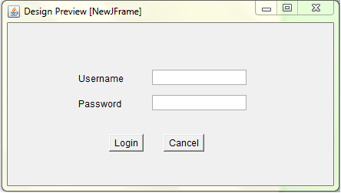
Login Form

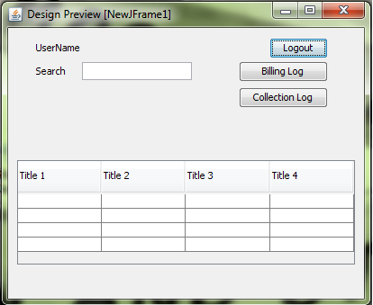
Main Menu Form

Billing Form
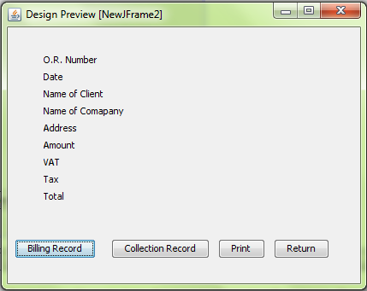

Main Form
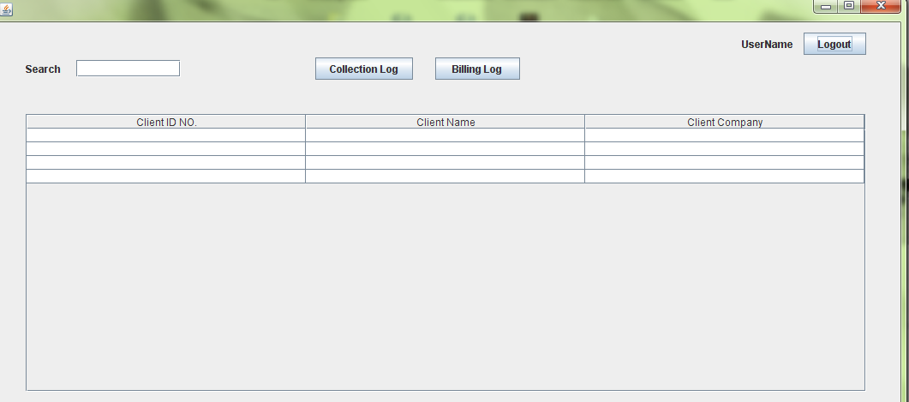

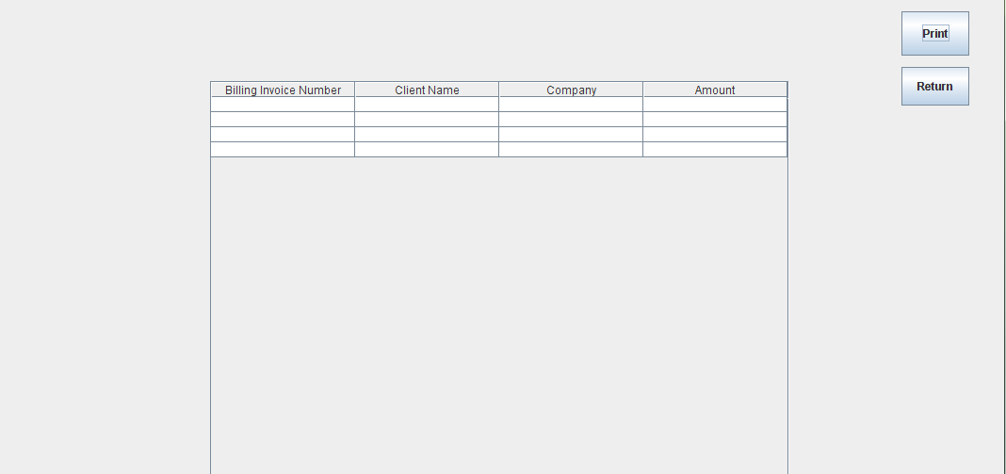
Collection Log

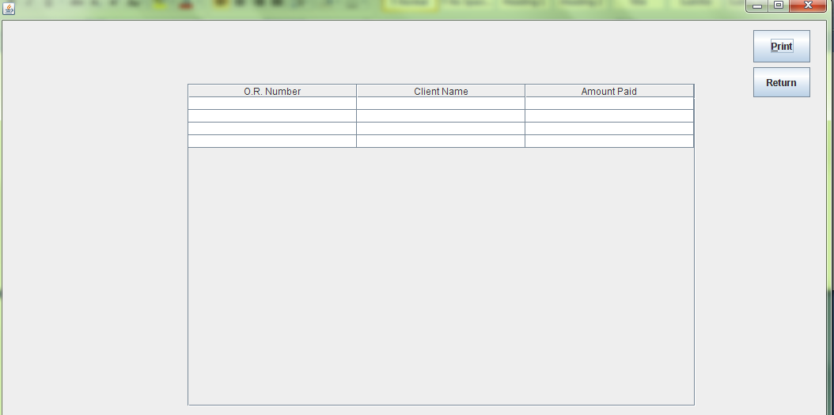
Billing log

Receipt Form
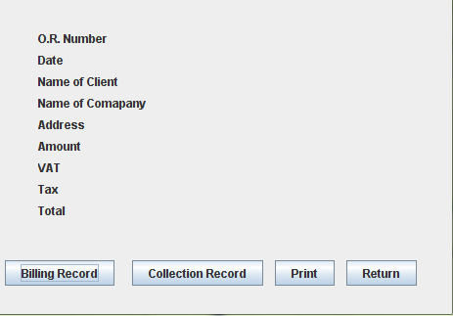

Billing Report Form
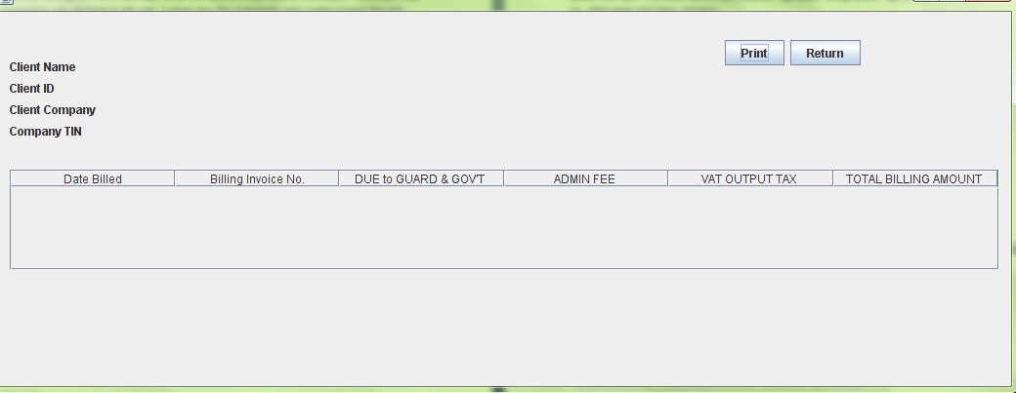

Billing Report
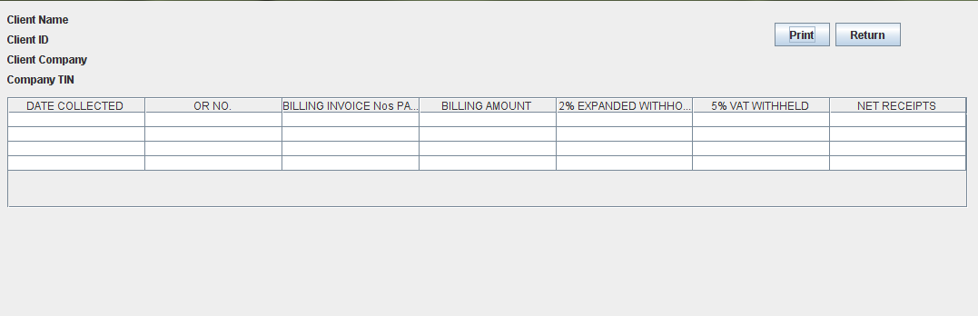

3.5 SOFTWARE REQUIREMENTS SPECIFICATION
1.0 Introduction
1.1 Goals and Objectives
The main purpose of billing and collection system (BCS) is to help
the user on keeping track of bills and payments and to from customer/client and also help the user keep billing records and information up-to-date.
1.2 System Statement Scope
All information with regards to billing must be well calculated inside the billing system. The system will also compute the penalties when the client’s failed to settle their payment on scheduled time on their contract agreement. The system shall generate customs invoices varying sequence of numbers.
1.2.1 General requirements
The following general requirement s were laid out for our project named Billing and Collection System
- A way in which Accounting Staff could create invoices for clients
- A way in which Accounting Staff could generate reports on invoices and collection transactions
- A way to easily compute bills and other charges
- A way to reduce manpower
- A way in which the data and information could be saved in a secured database
- The system could print the necessary information needed by the by clients.
- The system could performance through accessing each profile of the clients

Interface Enhancements
The project team creates a simple but functional design to make the system is easy to handle or to use by the user but still all the process needed are in the system.
1.2.2 Extended Enhancement
The developers have responsibility to improve system interface as well as its process.
- Online Integration
The proposed system will developed using LAN-based system software. This system software is a stand-alone application which is not using an internet connection to operate its function. Today, people are aware of using internet to surf, play, search and communicating other people with the use of the internet sites. This is the reason why the extended enhancement of the BCS will be upgraded from a LAN-based to an Online-based information system. With this, the services of the client would fall into another level of achieving its objectives and goals into a wider span area to a business world.
1.3 System Context
This helps to better understand the system boundary. But it is still in developing stage to make sure the system is free from errors and it very efficient to use and to all the process. Approval of the client is important to avoid a very further conflict from the client and the proponents.
1.4 Major Constraints
Time
System projects has a duration before the system execution and time is limited only for the team who will develop a system.

Funding
Consider as one of the major constraints because when doing a system project, the team needs to provide a fund to meet system requirements.
Man power
Each of the proponents has their own task throughout the development of the system. Considering that there are only five members in the team, completion of tasks may be not a hundred percent for some reasons like tardiness, unwanted situations or sickness.
2.0 Usage Scenario
This section will define the user level of the Billing and Collection System (BCS). This will define the user type and the accessibility level upon logging in into the system
2.1 User Profile
    - Read/View (User)
    - Full Control (Administrator)
    - Read/Write/Modify Own User( Accounting Staff)
2.2Use Cases
Read and View Only Users
The read-only users will only read the database, view its content and cannot insert, delete or modify any records of the employees.
Full Control
This is the system administrative level which will be able to change any information setting, as well as maintaining client’s profile.
Read /Write/Modify Own Users
This level of users will be able to compute all the bills of the clients, they will be also able to update the bills of the clients.

3.0 Data Model and Description
3.1 Data Description
3.1.1 Data Objects and Dictionary
Client ID - Unique identifier of the client
Company Name - The name of the company
Contact Number - The contact number of the client
Billing Data Objects
Invoice Number - generated number for client’s billing transaction
Client ID - Unique identifier of the client
Amount Bill - Total bill of the client
Amount Due - The deadline of the payment
Date Paid - Date the client paid
Balance -The remaining bill of the client
Collection Data Object
Client ID -Unique identifier of the client
OR Number -The number of transact bills
Amount Paid -The amount paid bills
Date of Payment -The date of payment
Tin -The other payment of the client
Vat -The other payment of the clien

3.1.2 Relationship

.

4.0 Functional Model and Function
4.1 Subsystem Flow Diagrams
4.2 Human Interface
Log in Form
Log-in form is one of the first forms that will pop-up after you run the system. The user or the administrator will have to enter their respective username and password in order to access the system. After entering the username and password, click the LOGIN button to access the system. If the user or the administrator wants to cancel the previous transaction, click the CANCEL button located at the right side of the form window after the LOGIIN button. The user or the administrators have three attempts to enter their correct username and password. If the user fails to enter the correct username and password the system will automatically terminated.
Main form
The main form of the system is the next forms that will pop-up after the user or the administrator entered their correct username and password. It compose search box, collection log button, billing button, log out button, client id no., client name and Client Company.
Collection Log
This form can see the located collection information of the client. It consists of fields such as O.R. no., Client name and amount paid, leaving it blank will cost an error.
Billing Log
This form can see the location of the bill reports of the client. It consists of fields such as Billing Invoice No., client name, Company, Amount, leaving it blank will cost an error.
Receipt Form
This form shows the Receipt Form that consist of O.R Number, Date of transaction, Name of client, name of company, address, amount, VAT, Tax, and total amount.
Billing Records Form
The billing Records form is used when the user or the administrator of the system wants to view records of the clients. Under the billing report form window, there are text namely, Return and Print records. are used when the user wants to filter a certain dates of the said registration have been done. The show all records button is used when the user wants to view all of the existing records saved the system's user or the system's administrator. The print records button is used when the user or the administrator of the system wants to print the membership registration information.
Billing Report
The billing report is the printed output of incoming/ outgoing bills.
5.0 Restrictions, Limitations and Constraints
Time
System projects has duration before the system execution and time is limited only for the team who will develop a system.
Funding
Consider as one of the major constraints because when doing a system project, the team needs to provide a fund to meet system requirements.
Man power
Each of the proponents has their own task throughout the development of the system. Considering that there are only five members in the team, completion of tasks may be not a hundred percent for some reasons like tardiness, unwanted situations or sickness.
6.0Validation Criteria
The proponents are creating new user interface using Java Programming to develop the system’s front-end interface and MS SQL for the database or the back-end interface of the BCS. The proponent validate also if the data from system is successfully save to the database. Again the proponent use pop up message to locate the error or show positive result. To clarify or make sure the data was saved the proponent use table that show the whole information of database for the user viewing. The interface that the proponents will design will allow the user to complete the entire application form with a use of single window and be able to save its contents immediately. The proponents are concerned about the input of data into the software and their expected outputs. This is the reason why the proponents will design an interface that is easily read by the user, creating a tool tip text in every fields and buttons to be able to identify the data to be input in every field to avoid errors on the data inputs. Every field must have a character imitations n order to control the maximum characters of data to be input.

3.6 SOFTWARE DESIGN SPECIFICATION
1.0 Introduction
This section describes the software design for the Billing and Collection System
  - Goals and Objectives
The main purpose of Billing and Collection System is to help automate the entire process of Billing and Collection.
- To create a custom invoice for the client
- To provide good service to clients
- To produce auto-generated reports
- To penalties automatically compute
- To help users monitor their client's status
  - System Statement of Scope
The general statement of the Billing and Collection System (BCS) should be specified and provided in this section. That is the information has to be produced, what the major functions are implemented and what data are provided as the input to Billing and Collection System.
1.2 .1 General Requirements
The following general requirement s were laid out for our project named Billing and Collection System\
    - A way in which Accounting Staff could create invoices for clients
    - A way in which Accounting Staff could generate reports on invoices and collection transactions
    - A way to easily compute bills and other charges
    - A way to reduce manpower
    - A way in which the data and information could be saved in a secured database
    - The system could print the necessary information needed by the by clients.
    - The system could performance through accessing each profile of the clients
1.3 System context
This helps to better understand the system boundary should be specified and provided in this section. It is necessary or mandatory for the proponents to have a client on which the proponents will gather data and information needed to establish and develop a correct business processes. If there is no client, the proponents will have a hard time for identifying the needed data and information for the BCS development. Furthermore, if the development of the BCS will be a success, it is a good example of a teaching-learning method provided by the current school on which the proponents are studying while developing. More importantly, the client will be benefitted the most when the BCS will be implemented on their respective company / agency. With this, the client will upgrade their business transaction using the latest technology provided. The system will make sure that the processes of the company are still the same, the thing is, it will now a computerized rather than the previous manual process that they had.

1.4 Major Constraints
Time
System projects has a duration before the system execution and time is limited only for the team who will develop a system.
Funding
Consider as one of the major constraints because when doing a system project, the team needs to provide a fund to meet system requirements.
Man power
Each of the proponents has their own task throughout the development of the system. Considering that there are only five members in the team, completion of tasks may be not a hundred percent for some reasons like tardiness, unwanted situations or sickness.
2.0 Data Design
2.1 Database Description
Access
Staff

Collection
Billing

Invoice
Report
Report
OR
\
3.0. Architectural and Component-Level Design
  - Program Structure
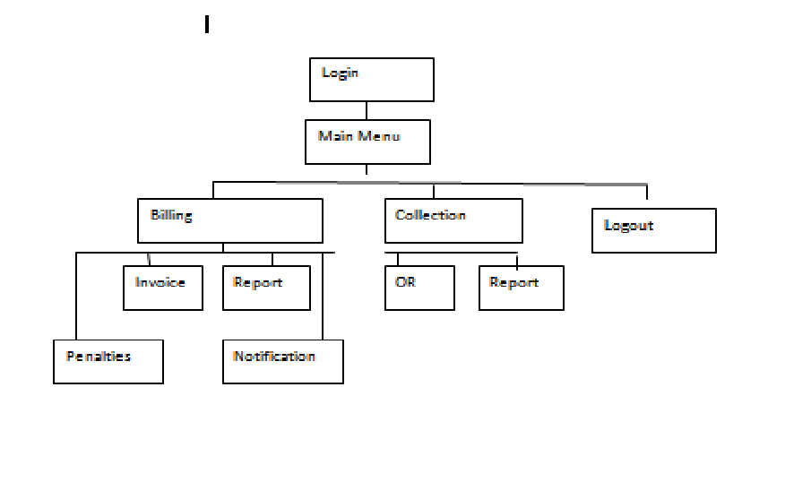
3.1.1 Overall

Menu Items
The following shows the architecture of the main menu:
Billing
    - Invoice
    - Report

Collection
    - OR
    - Report
    - Logout

3.2 Description for Components
Below are some of the forms in the program.
3.2.1 Login Form
Major Form: Log in
Major Action: confirm,userlogin and user password
This is the first form to appear after the user run the system. The user enters their username to the txtUsername and the password to the txtPassword to verify their accounts in order to access the system. The user must click the OK butoon which is the cmdOK. User will be logged in if it is valid username and password pair. If the user clicks the cancel button, the application will end if they confirmed their action.
3.2.2 Main Form
Auto-Generated Invoice Number
This field is an auto-generated varying sequence of numbering or invoice number
Tax Update
A field where the user updates a tax on client’s billing form
Date
A specific date on the date of the transaction was made

Client Name
Other fields will be filled as soon as the client name has a name on its field.
Total Amount
Filed wherein the total amount will display
3.2.3 Collection log
3.2.4 Billing Form
3.2.5 Receipt
3.2.6 Billing Records Form
Help the user to find or search the all the client’s status or information just type the id no. or client’s name.
Collection log
When the collection clicked by the user there will be a form will pop out and it consists of O.R. no., Client name, and Amount paid.
O.R. no.
It is automatically appear in the client’s receipt, it also important for the client and to the company as a proof if there is a missing file.
Client Name
It is clickable and the clients profile will be shown.
Amount Paid
The amount paid by the client.
Return Button
If you click this button it will turn back to previous form.
Print
To printed out the created reports.

Billing Invoice No.
This is the bill no. for the client.
Client Name
This Is the clients name.
Company
The company name.
Amount
The amount paid by the client.
Log Out Button
Use to end in processing the whole system.
Client Id No.
It is the unique identifier for the client.
Client Name
Name of the clients
Client Company
The name of the clients company

    - Billing Report
4.0 User Interface Design

The BCS have a lot of interface that hasn’t to be designed yet. The proponents are still researching for the additional scope of the system and obviously other interface will be developed also. The client also have a lot of ideas for the interface that’s why the proponents have to discuss to see rather they can be combined form of the forms for the BCS project.
4.1 Description of the User Interface
The following image represents the forms in the BCS. After running the BCS, the login screen will appear. If the user enters the right username and password, it will immediately take them to the main interface of the HRMS which is the main menu window.
4.1.1 Screen Images
Login Form
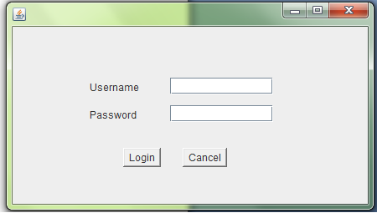

Main Form

Collection Log

Billing Log

Receipt Form

Billing Records Form

    - Objects and Actions
Username – This is the name used to enter in the login window in order to make an access to the system
Password – This is a unique codename or anything personalized data used to verify the access attempt of the user or the system administrator.
Toolbar - This panel is used to display the icons used to transact the system’s functions
Menu Bar – This panel serves as the menu of all the functions of the system and it is located on the top section of the main window
Status Bar – This panel is used to display the time, username, date and some controls like uppercase and the scrollbar and it is located on the bottom of the main window.
4.2 Interface Design Rules
Interface design focuses on three areas of concern:
- The design of interfaces between software modules;
- The design of interfaces between the software and other nonhuman producers and consumers of information
- The design of the interface a human and the computer
- Easy to learn
- Readability
- Easy to navigate between interfaces
4.3 Components Available
The proponents are required to use the Java Programming Language. For that matter, it is decided that the proponents will be using Java Netbeans. So here is the following list of controls that the proponents will be using for the PMS.
4.3.1 Java Swing Controls
- JTextField
- JLabel
- JButton
- JPanel
- JFrame
- JPasswordField
- Etc.
4.3.2 Java Swing Menus
- Menu Bar
- Menu Item
4.3.3 Java Swing Container
JPanel
Toolbar
5.0 Restriction, Limitation and Constraints
Time
Time is so far the biggest restriction or constraints for the proponents to developed the proposed system. The proponents only have an approximately five months to finish the entire project. It is very important for the proponents to watch the time to spend over the phase of the software development project. The proponents could have included many components to the project like online HRMS but time restricts the project team from doing so.
Employee Skills
Skills in computer programming and design skills are also one of the restrictions. It does not have as big of an impact on the project as time but it sure does limit the proponents from doing more addition to the project functions and components.
6.0 Testing Issue
To validate the system we need to test it with another process. During the testing of connection, the project team concerned about the data from another process must be correct. Getting wrong data from other process make the project system did not work properly.

6.1 Classes of test

System Interface
The proponents will create an interface easy to operate and understand design must be compose of tables, buttons, text field pictures and menus.
The proposed system is basically made up of major components that the proponents are required to do so. It will use Java Netbeans for front-end and MS SQL for back-end.
Login Form
Start of the process, in this form categorized the user of the system, Login name and password Field must have correct information to proceed to the next process based on the level user
Admin form
Admin form shows the function that the admin of company can do this Form link to many processes of system, main function purchase order request, reports and management personnel.
Personnel Form
This form shows the information of the user, it also link to another process, but the personnel has a limited action to the project system.
Main Function
Main Function is the main process of project, in this form shows the request from another process, this form connected to another transaction. Main function is home form of all transaction
6.2 Performance Bounds
The proponents have to setup a certain performance bounds or criteria for the PMS so that by following those criteria, the proponents will be able to maintain quality, user friendliness and usability of the software.
Login
The user should be able to log on within 0.1 second
Save Function
Best Case Scenario – Immediate
Worst Case Scenario – 3 seconds
Search Function
Best Case Scenario – Immediate
Worst Case Scenario – 3 seconds
Print Function
Best Case Scenario – Immediate
Worst Case Scenario – 2 seconds
Browse Function
Best Case Scenario – Immediate
Worst Case Scenario – 2 seconds
Delete Function
Best Case Scenario – Immediate
Worst Case Scenario – 3 seconds
Exit Function
Best Case Scenario – Immediate
Worst Case Scenario – 3 seconds
Cancel Function
Best Case Scenario – Immediate
Worst Case Scenario – 2 seconds
6.3 Identification of Critical Components
User Access
The proponents will make sure that the accessibility of the system is limited if only if the person is an authorized user for the system.

Print Generator
Making sure that the reports that can be generated into print-outs is correct. The reports should generate right amount of data and can be accessed in different type of document formats.
3.7 TESTING SPECIFICATION
- Introduction
This section gives a general overview of the test Specification for the Property Management System (PMS).
  - Goals and Objectives
The goal of the proponents is to do the right thing, though perfection is what everyone wants but to do the right thing for a purpose is more powerful than anything. Many constraints will be applied to the system. The testing process for BCS has a number of goals and will be thoroughly tested for logic errors and coding bugs. In addition BCS will also test the friendliness of the user interface to ensure that it is of the outmost quality: efficient, powerful, and user-friendly.
1.2 Statement of Scope
An overall plan for integration of the software and a description of specific tests are documented in this section. Below are the different kinds of tests that the team will take to ensure the quality of the software.

- Unit Testing
- MS SQL Database
- PC Application
- Java Net Beans
Unit test will be performed using black box testing methods.
- Integration Testing
- MS SQL Database
- PC Application
- Java Net Beans
- Validation Testing
- MS SQL Database
- PMS
- PC Application
- High-order Testing
- MS SQL Database
- PMS
- PC Application
1.3 Major Constraints
In this section the proponents discussed the related constraints that can affect the testing.
- The proponents has limited time to meet the clients for testing purposes
- The proponents may encounter insufficiencies of funds
- The proponents only got five members in a group.

- Testing Plan
This is the reason why the proponents have to spend large amount of the total software development time on the testing. The following are the description of the testing procedure and strategy. The proponents also be presenting the timing and scheduled of the tests to be carried out.

2.1 Software (SCIs) to be tested
2.1.1 Interfaces
Login form
For login project team set a restriction for login. Developer use button in checking of verification of user
Menus
Menu bar (all process)
- Help – tips or information about the process using buttons to view
- Sign out – function of this button log out the user and back to the log in process
2.2 Testing Strategy
In the following section, the proponents will describe the testing strategy and will use four different methods to test the proposed system
2.2.1 Unit Testing
This type of testing is performed by the developers before the setup is handed over to the testing team to formally execute the test cases. Unit testing is performed by the respective developers on the individual units of source code assigned areas. The developers use test data that is separate from the test data of the quality assurance team.
The goal of unit testing is to isolate each part of the program and show that individual parts are correct in terms of requirements and functionality.

2.2.2 Integration Testing
The testing of combined parts of an application to determine if they function correctly together is Integration testing. There are two methods of doing Integration Testing Bottom-up Integration testing and Top down Integration testing.
After all individual modules have been unit tested, and are properly functioning, they will be put together to form a program. This program will then be tested for general errors including compiler and runtime errors, input errors, and efficiency. Any errors will be corrected at this stage. If the program is inefficient in some computation, the cause of the inefficiency will be isolated and fixed, whether it be at the unit level or the integration level.
2.2.3 Validation Testing
As the program is starting to take shape, lead programmers will make sure it adheres to customer guidelines. If any guideline cannot be followed exactly, then the program will be modified to suit the nearest reasonable alternative.
2.2.4 High-order Testing
PMS will be system tested to ensure that all programming packages integrate with each other as intended, and that the final software is integrated well into the native environment.
Alpha testing will follow, where the software interface will be delivered to a few people to test. The alpha testers will use the software as it was intended, to make sure no problems exist. Here any issues with the interface, computation, or graphs will be fixed.
The software will then be tested for security and performance. During security testing, we will attempt to run known exploits against the interface and test security of the software. Security is vital to a user interface, so as to keep user data confidential, and so any security issues will be given special attention. During performance testing we will test the runtime performance of the software and make sure that the interface performs well in a variety of conditions.
2.3 Testing Resources and Staffing
The proponents will use several different resources to carry out the test on the BCS. Since the time is a part of project constraint, the proponents will try to use help from everyone that is essential to take the responsibility and evaluate the software during the testing phase.
- The Company Staff
- The Proponents
- Laptop / Desktop
- Software Applications

2.4 Test Record Keeping
Test record keeping and test work products are described in section 3.4 of the test specification document. For more information regarding these topics, please refer to section 3.4 of the Test specification Document.

2.5 Testing tools and Environment
Java Netbeans will be used as testing tools as well as the testing environment. As stated above, a test date will be constructed for unit and integration testing.
2.6 Test Schedule
Following is the tentative schedule for the testing of the PMS.
Project Test Plan
- To be scheduled
System Testing
- To be scheduled
Generating the test reports
- To be scheduled
System Implementation
- To be scheduled
3.0Test Procedure
In this section the proponents will describe the test procedures in detail.
3.1 Software (SCIs) to be tested
For detailed list of the software component items please refer to section 2.1 from Test Specification document.
3.2 Testing Procedure
In this section the proponents will try to describe overall software specification and describe the methods for the different test to be performed and will also declare the expected outputs.
Login form
For login project team set a restriction for login. Developer use button in checking of verification of user
Menus
Menu bar (all process)
- Help – tips or information about the process using buttons to view
- Sign out – function of this button log out the user and back to the log in process

    - Unit Testing

3.2.1 Unit test cases
3.2.1.1 Login
Test Case | Input | Expected Result
Valid Login | Valid Username & Password | Logged in to user interface
Invalid Login | Invalid Username & Password | Refresh login page and prompt for valid credentials
3.2.1.2 Logout
Test Case | Input | Expected Result
Logout | User clicks logout | Prompt “Are you sure you want to logout?”
3.2.1.3 Help
Test Case | Input | Expected Result
Select topic | User selects a topic | Display topic contents
3.2.1.4 Report
Test Case | Input | Expected Result
Specify function | Function, variables, data | Function is generated according to inputs
Specify invalid function | Invalid function, and/or variables, and/or data | Prompt ‘Function could not be generated due to invalid inputs’
Graph | Type of graph | Graph is displayed
Invalid Graph |  | Prompt ‘Graph cannot be displayed’

    - Integration Testing
Test Case | Input | Expected Result
Valid Login | Valid Username & Password | Logged in to user interface; taken to main page, cookie enabled.
Invalid Login | Invalid Username & Password | Refresh login page and prompt for valid credentials
Select help topic | Help topic | Display topic contents
Begin Report | Click ‘New Report’ | Function page is displayed
Specify function | Function, variables, data | Function is generated according to inputs
Specify invalid function | Invalid function, and/or variables, and/or data | Prompt ‘Function could not be generated due to invalid inputs’
Graph | Type of graph, data generated from function | Graph is displayed
Invalid Graph |  | Prompt ‘Graph cannot be displayed’
Request Account | Username which is already taken | Prompt “Choose another username”
Request Account | Password shorter than specified length | Prompt “Password too short”
Request Account | Unique username, and valid password | Account created
Logout | User clicks logout | Prompt “Are you sure you want to logout?”
Links Correct | Click on each and every link | Link goes to proper location

    - Validation Testing
Functionality | Test Case | Input | Expected Result
Login | Valid Login | Valid Username & Password | Logged in to user interface; taken to main page, cookie enabled.
 | Invalid Login | Invalid Username & Password | Refresh login page and prompt for valid credentials
Help | Select help topic | Help topic | Display topic contents
Report | Begin Report | Click ‘New Report’ | Function page is displayed
 | Specify function | Function, variables, data | Function is generated according to inputs
 | Specify invalid function | Invalid function, and/or variables, and/or data | Prompt ‘Function could not be generated due to invalid inputs’
Output | Graph | Type of graph, data generated from function | Graph is displayed
 | Invalid Graph |  | Prompt ‘Graph cannot be displayed’
Account Request | Request Account | Username which is already taken | Prompt “Choose another username”
 | Request Account | Password shorter than specified length | Prompt “Password too short”
 | Request Account | Unique username, and valid password | Account created
Logout | Logout | User clicks logout | Prompt “Are you sure you want to logout?”

    - High Order Testing
The high-order testing procedure is specified. For each of the high order tests specified below, the test procedure, test cases, purpose, specialized requirements and pass/fail criteria are specified. It should be noted that not all high-order test methods noted in Sections 3.2.4.n will be conducted for every project.
3.2.4.1 Recovery testing
No recovery testing will be required. Since all the data are accessed using a web browser, in the event of a system crash, the user can always reboot their computer and log in to the website again and reload everything.
3.2.4.2 Security testing
Security will be tested thoroughly. Only registered and authorized users should be allowed access to use the analysis functions provided by PMS
3.2.4.3 Stress testing
Different sizes of data will be tested. Amount of user flow will also be tested. The PMS should be able to allow a reasonable amount of user to use the website at the same time without causing any traffic and loading speed of the website.
3.2.4.4 Performance testing
A timer will be set for each report generated. These times will be recorded and studied to see if the software is sufficient enough to handle all types of reports the users might request on different size of data.
3.2.4.5 Alpha/beta testing
Alpha testing will be based on the software developers. Members of the team will each go through the website thoroughly and use the analysis functions on a testing database to ensure quality and correctness.
Beta testing will be public. Selected pre-registered users will be given a username and password and their data will be loaded to the database. They will each go through the website and submit a report of any bugs, ease of use.
The proponents have a limited manpower to be able to test the HRMS properly. This is PMS.
3.2.4.6 Pass/fail criterion for all validation tests
If there are many complaints and errors of the website, it will not pass the test.

3.3 Testing Resources the reason why the proponents will use help from several different people to be able to tests the functionalities of the BCS. The following are the people that involves in this task.

- Client Staff / Employees
The proponents ask for help to test the BCS with the participation of the security agency personnel. The employees / staff are allowed to use the full function of the BCS as part of its validation testing. The employee tries to add the aspiring applicant and then be able to save the info of the employee. The employees are allowed to record any errors that they encounter during the software testing on hand.

- Handheld PC / Desktop / Laptop
The proponents will have to use the clients PC or laptops after installing. This will allow the user / employee to test the HRMS with one or more tester at the same time. With this, the data from one computer to the other are also identified through the system integration functionalities of PMS.

- Error Reporting
The proponents provide a reports manual on which the employee and staff are required to list down the error and bugs that they may encounter during the testing activity.
3.4 Test Record Keeping and Log
A test record keeping document will be used to evaluate immediate test result for each of the testing. For example:
Test Record Form
Test Type :____________
Tester :____________
Date :____________
Test Case | Test Report | Enhancement Report | Comments
Valid Login
Invalid Login
Select help topic
Begin Report
Specify function
Specify invalid function
Graph
Invalid Graph
Request Account1
Request Account2
Request Account3
Logout
Links correct
A test log will be kept to monitor the tests that have been applied. An error, or “bug” log is kept to monitor any problems that have arisen during testing.

Test Log

Date | Defect report | Test Type | Test Case | Result | Comments

CHAPTER 4

CHAPTER 5

LOVELY PALCISO GENTUGAO
#23 San Antonio de Padua St., Villa Subd., Talipapa, Novaliches, Quezon City
Contact #: 09083091505
e-mail: gentugaolovely@yahoo.com

PROFILE

Age : 21 years old
Date of Birth : July 17, 1993
Place of Birth : Caloocan City
Civil Status : Single
Religion : Roman Catholic

ROMA JOY ARINAZA BACLAS
#34 Buenamar Street Buenamar Subdivision Novaliches Proper Quezon City
Contact #: 09102081158
e-mail: Baclasromajoy_12@yahoo.com

PROFILE

Age : 21 years old
Date of Birth : November 12, 1992
Place of Birth : Pilar Capiz
Civil Status : Single
Religion : Roman Catholic

JAYCELL DALIMAG PASICOLAN
#212 Sitio Baesa Quezon, City
Contact #: 09083091505
e-mail: gentugaolovely@yahoo.com

PROFILE

Age : 19 years old
Date of Birth : November 18, 1994
Place of Birth : Quezon City
Civil Status : Single
Religion : Roman Catholic

MARK ANTHONY VOLANTE OGATIS
P4 P3 B10 L16 Bagong Silang Caloocan, City
Contact #: 09279255016
e-mail: mark_ogatis@hotmail.co.uk

PROFILE

Age : 25 years old
Date of Birth : July 19, 1989
Place of Birth : Manila
Civil Status : Single
Religion : Roman Catholic

JOMAR BUENAAGUA MONSANTO
Blk.2 Lot.38 Champaca St. Maligaya Park Subdivision Novaliches Quezon City
Contact #: 09261026625
e-mail: monsantojomarb@Gmail.com

PROFILE

Age : 21 years old
Date of Birth : November 22, 1992
Place of Birth : Maliga
Civil Status : Single
Religion : Christian

